The Village of Nelsonville Board of Trustees Meeting Minutes
Monday, December 19, 2022

CCA Presentation with Jeff Domanski – 7:00pm

The Village of Nelsonville Board of Trustees, met at 7:30pm, on Monday, December 19, 2022, for their regular meeting, with Mayor Winward presiding, Trustees Campanile, Maloney, Moroney and Zhynovitch present.

Pledge to the Flag

Mayor Winward opened the meeting with the Pledge of Allegiance.

Approval of Vouchers

Abstract #7, in the amount of $25,757.42 was audited and ordered paid by a motion from Trustee Moroney, seconded by Trustee Campanile, enacted all in favor.

Approval of Minutes

The minutes of the November 21, 2022 meeting were approved by a motion from Trustee Zhynovitch, seconded by Trustee Moroney, enacted all in favor.

Correspondence

The Mayor summarized letters from three area residents regarding the Hometown Heroes Flags.

Reports

Clerk Harris

Clerk Harris read the Treasurers’ Report. Mayor Winward
The mayor reported that Philipstown Fights Dirty will add the Village of Nelsonville’s top bullet points to their ad, to show that our community is being climate smart.

Mayor Winward reported that the Sewer Feasibility Study meeting with the consultant from LaBella had to be rescheduled, and stated that the ARPA funding is in place for the study.

Trustee Moroney

Trustee Moroney reported that the Pearl Street sewer backed up again just before Thanksgiving. Cook came to water jet the blockage, and subsequently broke a piece of their hose off in the sewer line. Sal Pidala was able to install a new pipe with a clean out for future clogs. Mayor Winward thanked the Pearl Street residents for their patience and Sal Pidala for his work.

Trustee Moroney also reported that the trees that were particularly dangerous in the Nelsonville Woods near the corner of Secor and Crown were cut down by Philipstown Tree.

Trustee Campanile

Trustee Campanile reported that the wooden bridge in the woods was noted on the Facebook page Philipstown Locals as being partially submerged in water. Trustee Campanile explained that the bridge was placed in its current location by the Scouts during drought conditions, so the water level in the brook has changed. He and the Scouts will look at the bridge this weekend and see if they can remediate the problem.

New Business

There was no new business.

Old Business

Capital Asset Threshold Resolution

Trustee Campanile explained that a resolution is needed to approve the $5,000 capital asset threshold. Mayor Winward read the following resolution:

Resolution to Set Threshold for Capitalization

Whereas, the Village’s external auditors have recommended that the Village create and maintain a current capital asset listing as a basis for the balances of land and buildings in the Village governmental activities financial statements; and

Whereas, the Local Government Management Guide on Capital Assets dated October 2022 and published by the Office of the New York State Comptroller, Division of Local Government and School Accountability provides guidance on establishing and maintaining a capital asset listing; and

Whereas, this Resolution establishes a threshold that dictates when expenditures may be capitalized in accordance with generally accepted accounting principles; and

Whereas, the Village needs to establish a threshold for asset classes in order to maintain effective managerial control; and

Therefore, the Village resolves that these dollar levels set the thresholds that apply to these asset classes:

LAND $5,000 BUILDINGS: $5,000
IMPROVEMENTS OTHER THAN BUILDINGS: $5,000 EQUIPMENT: $5,000
This resolution will take effect immediately upon passage, and the Village Treasurer will prepare the capital assets listing for the Village fiscal year ending May 31, 2023.

The Board members voted on the Resolution by roll call, and the resulting votes of the board members were as follows:

Member of Board Voting

Mayor Winward Aye
Trustee Campanile Aye
Trustee Maloney Aye
Trustee Moroney Aye
Trustee Zhynovitch Aye

Total Ayes and Nays Five Ayes

Certification
I, Melissa Harris, the duly qualified Village Clerk of the Village of Nelsonville, Putnam County, New York, do hereby certify that attached hereto is a true and correct copy of the extract from the minutes of a Monthly Meeting of the Board of Trustees of the Village of Nelsonville, held on December 19, 2022, and that the Resolution set forth herein is a true and correct copy of the Resolution of the Board of Trustees of said Village adopted at said meeting.

I FURTHER CERTIFY that pursuant to section 103 of the Public Officers Law (Open Meetings Law), said meeting was open to the general public.

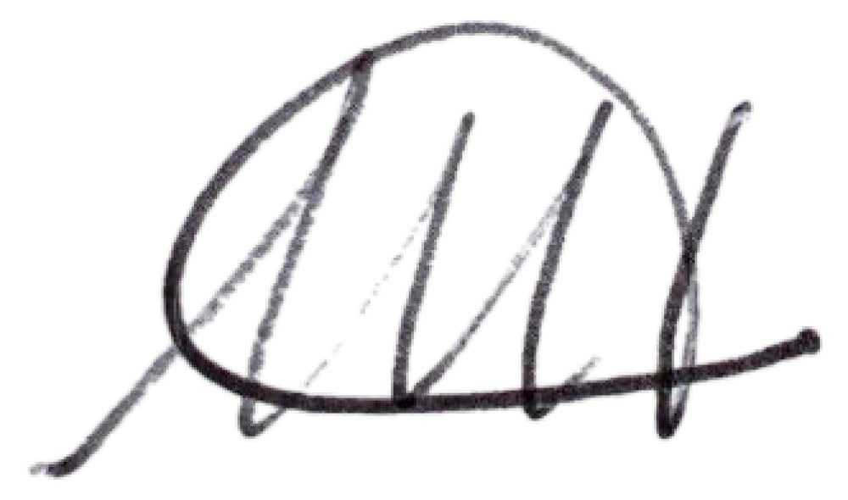
IN WITNESS WHEREOF, I have hereunto set my hand and the seal of the said Village on this 19th day of December, 2022.

Melissa Harris Village Clerk

Lawsuit

Trustee Zhynovitch gave a brief recap of the conclusion of the lawsuit filed by Plaintiff Mark Kushner against a Village resident, the Village, and Village employees. The Notice to Dismiss that was filed by the Village was granted in its entirety. Mayor Winward added that Mr. Kushner has recently filed an Article 78 against the ZBA decision to deny his appeal of the building permit renewal at 13 Gatehouse Road. That lawsuit is still pending.

Trail Kiosk

Trustee Moroney stated that the Eagle Scout who was going to begin the work on the kiosk has been ill, so the work has been delayed. It had been decided that asphalt shingles will be used instead of cedar shakes, to save on the cost. The hope is for the project to be completed before March of 2023, and the Village will help to obtain materials and get the project set up.

Open to Floor

A member of the public had some questions about the Sewer Feasibility consultant. Mayor Winward explained that the company, LaBella, is a firm that can provide not only the Feasibility Study, but can help with obtaining grants and funding, engineering, legal, as well as construction. The mayor will give updates at future meetings.

A resident asked if a sign, which she provided, could be placed in the pollinator garden. She also asked about the possibility of solarizing Village Hall. Mayor Winward stated that the project is still being considered. A discussion ensued among the board members about the need for electric usage data by the solar companies, and how the new heating system would affect that data. Mayor Winward reminded the board that the ARPA funding does not have to be earmarked for any specific project until December of 2024, so there is still time to make decisions.

Adjournment

Upon motion of Trustee Moroney, seconded by Trustee Campanile, enacted all in favor, the meeting was adjourned at 8:15pm.

Respectfully presented,

Melissa Harris Village Clerk

