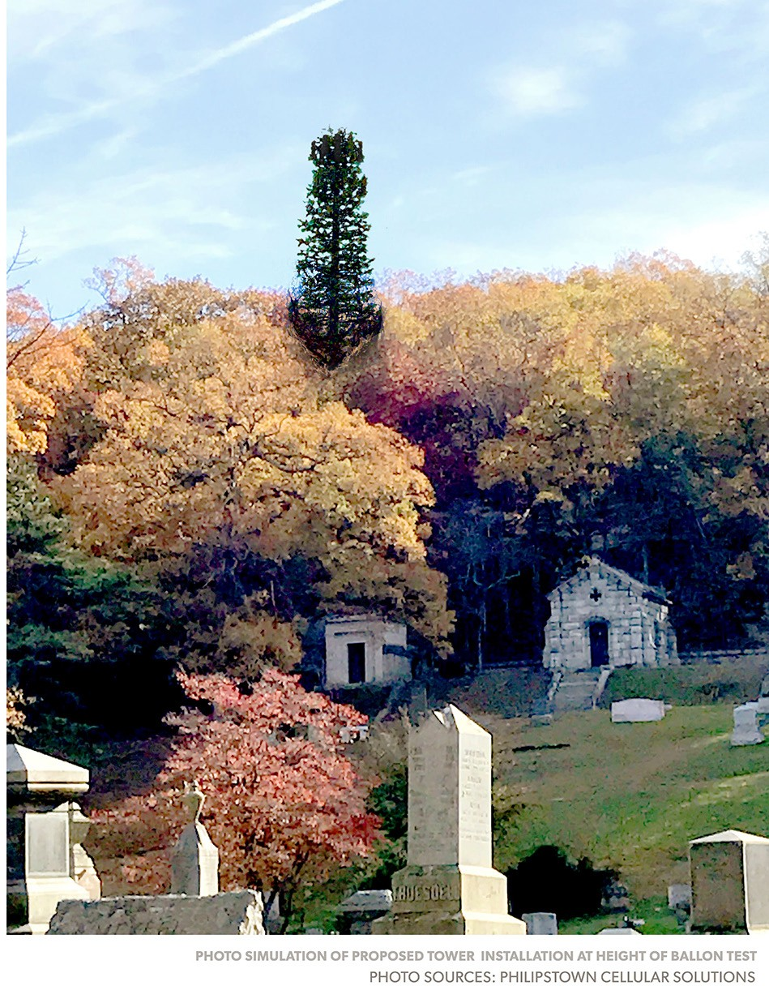

Statement II in Opposition to the Homeland Towers Application for 15 Rockledge Road, Nelsonville, NY

Submitted to the Village of Nelsonville Zoning Board of Appeals BY

JANUARY 9, 2018

TABLE OF CONTENTS
- Executive Summary

  - Introduction: Village Code Requires Denial of 15 Rockledge Rd. Application 1

  - No Actual Need 2
  - Significant Adverse Visual Impact 7
  - Site is Not the Least Detrimental Option 19
  - Case Law Supports Denial Based on Aesthetics Alone 24
  - Additional Reasons to Deny 26

- Preliminary Responses to Dec 27, 2017 Applicant Filing and other New Reports
  - Introduction 27
  - Piercon Report Dec 18, 2017 28
  - Saratoga Associates Report Dec 19, 2017 29
  - Reply to: 35

    - Email from Chairman Rice to PCS Member J. Biafore 12/22/2017
    - Snyder & Snyder Letter Dec 27, 2017
    - Cuddy & Feder Letter Dec 28, 2017

  - Applicant’s Alternative Site Analysis Dec 27, 2017 50

  - Letter from Mr. Graiff Dec 9, 2017 52

  - Ms. Mancuso, CBRE Letter Dec 18, 2017 55

  - Mr. Trelstad, AKRF Report Jan 2017 55
  - Letter from Mr. Graiff Jan 8 2017_ 55
  - Inconsistencies 57

- Additional Exhibits A-0 58

EXECUTIVE SUMMARY

- INTRODUCTION

There is substantial evidence in the record before the Boards to deny the Rockledge application based on failure to meet ALL the criteria delineated in Nelsonville’s Code §188- 70 “Standards for issuing special permits” section A.

We emphasize that it is the burden of the applicant to prove, with substantial evidence, that their proposal meets all the requirements of village code. The below report and exhibits, along with our previous work submitted to the Boards, clearly and decisively shows that Homeland Towers did not meet this burden.

We respectfully remind board members that any decision or action of the Boards will be upheld by a reviewing court so long as it is “rationally based” —does the action or decision make sense, and is it supported by the record?

In the below discussion, we offer substantial evidence demonstrating that the applicant has failed to meet Criteria #3, #2, #6 in the Nelsonville Village Code §188-70 A.

- NO ACTUAL NEED

“That, where a new tower is proposed, the applicant has shown an actual need for construction of the new tower.”
§188-70 (a) (3), Nelsonville Village Code

The evidence submitted by the applicant does not amount to substantial evidence showing “an actual need” for a telecommunications tower in Nelsonville, NY.

- FCC Regulatory Treatment of Broadband Internet

In Homeland Towers’ initial filing of July 19, 2017, Robert Gaudioso prefaces the application—and Nelsonville’s obligation to consider it—by referencing the FCC regulatory treatment afforded to personal wireless services under the Telecommunications Act (TCA) Section 332c Regulatory treatment of mobile services. In his cover letter, he writes that “the Facility is regulated as a personal wireless service facility under the Telecommunications Act of 1996."

Please note that “personal wireless services” under the TCA of 1996 is defined as follows:

  - the term “personal wireless services” means commercial mobile services, unlicensed wireless services, and common carrier wireless exchange access services;
  - the term “personal wireless service facilities” means facilities for the provision of personal wireless services.

After months of signaling its intent to do so, the FCC announced an end to public-utility regulation of the internet in its December 14, 2017 Restoring Internet Freedom Declaratory Ruling. It issued the following regulatory notices:

  - It reclassified broadband wireless internet from a “telecommunication service” to an "information service."
  - It reinstated the determination that mobile broadband internet service is not a commercial mobile service. (In his December 18 PierCon report Adam Feehan makes the factual error that LTE is a commercial mobile service.)

As such, mobile broadband internet is not regulated as a personal wireless service under the TCA. The shot clock and special status provisions for a personal wireless service facility under Section 332c, do not apply to the Homeland Towers application.

In fact, Homeland Towers’ propagation maps do not show a coverage gap for any service regulated under the TCA of 1996. The applicant has provided no evidence that its mobile voice and data service coverage in Nelsonville is inadequate, i.e. that it suffers from any significant gap. No drive tests documenting current cellular coverage on the ground or reports cataloging dropped calls have been provided. To the contrary, Homeland Towers has made it clear that the proposed tower at 15 Rockledge Road is designed to increase carrier data capacity in other frequency bands, not to improve supposedly insufficient voice and data coverage that is currently provided principally at 850 MHz. In his letter of December 9, 2017, Ronald Graiff confirms that the proposed tower will not include transmitters for the 850 MHz cellular band. The reason, he explains, is that 850 MHz “is not well suited for information transmission, but rather voice transmission.”

We ask, does the omission of 850 MHz cellular frequency bands at 15 Rockledge Road indicate that there is no actual need for additional coverage in Nelsonville as no significant gaps exist?

In this same letter, Mr. Graiff states that the “issue before your board is whether there is sufficient in building and in vehicle coverage in the alleged gap in coverage for the LTE system.” We respectfully disagree with his characterization of the principal issue at hand. Because LTE is an information service principally designed to carry data, there is no federal mandate requiring Nelsonville to consider any alleged gaps in its coverage.

- Case Law Distinction Between Voice and Data

Recent case law distinguishes between mobile voice cellular and voice over data frequency bands. Specifically, the application of §332(c)(7) to wireless siting applications where only wireless broadband facilities are proposed—such as with the Homeland application.

In distinguishing 4G LTE broadband from “personal wireless services,” the 4th Circuit case Cellco Partnership d/b/a Verizon Wireless and CWS VII, LLC v. The Board of Supervisors of Fairfax County, Virginia (2015) holds:

“…Plaintiffs do not show that the proposed facility would provide both 4G LTE coverage and “personal wireless services” at the same site, using the same infrastructure. Plaintiffs' contentions about "Voice over LTE and High Definition Voice" similarly fail to show that the proposed facility would commingle “personal wireless services” and “information services,” because … “Voice Over LTE" is simply another type of wireless broadband Internet service.”

As the court in Cellco held, Voice over LTE is not a “personal wireless service,” but rather another form of wireless broadband, and is thus properly considered an “information service” not covered under §332(c)(7).

Mr. Gaudioso submitted the FCC’s 2009 Declaratory Ruling to Clarify Section Provisions of Section 332, but did not reference the 2nd Circuit case from the Eastern District of New York Clear Wireless LLC V. Bldg. Dep't of The Village of Lynbrook (2012) which acknowledges the 2009 ruling but ultimately determines that broadband communications is still not regulated by the TCA:

“…Although the 2009 Declaration speaks in favor of broadband in dicta, it in no way states that broadband communications are encompassed by the TCA.”

In his November 22, 2017 letter to the Boards Mr. Gaudioso states “… there is no legal basis for the Zoning Board to consider whether the service being provided is voice as opposed to broadband data service.” Mr. Gaudioso also went on record before the Boards at the public hearing of November 28, 2017 to describe the voice vs. data issue as “a red herring” and claimed the TCA “doesn’t distinguish between voice service, data service, and so forth…” As has been laid out above, that is a complete misstatement of the controlling jurisprudence.

We note that the carriers themselves often make this distinction when it serves their economic interests. In 2015, these carriers argued to the FCC:

AT&T:

“The recent rollout by some wireless carriers of Voice-over-LTE (“VoLTE”) does not change matters. VoLTE calls do not travel over the public Internet and, therefore, do not use the wireless broadband Internet access service. Wireless carriers’ investment in upgrading their voice networks to provide more efficient and higher quality voice service therefore provides no basis for reclassifying the separate wireless broadband Internet access service as an interconnected service Wireless broadband Internet access is not a substitute for
CMRS [Commercial Mobile Radio Services]—and, therefore, not the functional equivalent of CMRS—under that test, as it is instead a complementary service, typically purchased alongside CMRS voice service. [ EXHIBIT A ]

Verizon1:
“Verizon supports the open Internet. To apply 1930s-era utility regulation to the Internet under Title II reclassification, would be a radical reversal for what has been an open, competitive and innovative Internet economy. Such an approach would be particularly harmful to wireless broadband, which unlike traditional voice services, developed free of legacy Title II regulations.”

CTIA:
"CTIA and its member companies want, and continue to support, an open Internet. However, comparisons to mobile voice are misplaced. While Congress created a
regulatory regime for mobile voice under Section 332 and Title II, Congress also created a separate regulatory regime—explicitly outside Title II—for other services like mobile broadband.”

We urge the Boards to inquire with Mr. Gaudioso whether he maintains that there is no legal basis for the voice vs. data issue to be duly considered, and if so if he can provide controlling legal authority that would overrule or even distinguish the cases PCS has presented here.

- Unreliability of RF Engineering Testimony; Speculative Nature of Applicant’s Alleged Gap

The applicant’s RF engineer has made misleading claims in the public record pertaining to carrier use of the 850 MHz bandwidth, casting doubt on the reliability of his expertise.

- https://arstechnica.com/information-technology/2015/01/on-net-neutrality-internet-providers-are- betrayed-by-one-of-their-own/

Engineer Daniel Penesso gave testimony at the November 28, 2017 Nelsonville ZBA meeting. His statements are available to watch on Video Part 1 (timestamp: 1:01:37) via this link http://bit.ly/2BQrPme

Here, Mr. Penesso states both that the proposed tower at 15 Rockledge Road will not include 850 MHz transmitters (something Mr. Graiff also confirms in his letter of December 9, 2017) and that this frequency is not currently being utilized:

Mr. Penesso: "There is no plan for that spectrum [850 MHz] to be utilized in this area."
Nelsonville ZBA: "Has it been used in this area previously"? Mr. Penesso: "Not to my knowledge, no."

However, in Mr. Penesso’s Pinnacle Telecom report of June 8, 2017, he writes that both Verizon and AT&T are licensed in the 850 MHz frequency cellular band. PCS has confirmed that AT&T is indeed licensed in this frequency band in New York State; please see the attached list of licensed spectrum data for Nelsonville, NY courtesy of Mosaik Solutions, LLC. [ EXHIBIT B ]

We also find it problematic that in its filing of December 28, 2017, Cuddy and Feder writes, “the plots included herein and the record for this application demonstrates that AT&T has a gap in coverage in the 850 MHz spectrum.” Indeed the filing includes propagation maps produced by Mr. Penesso allegedly showing that the new tower will improve 850 MHz coverage—when he is on the record claiming that there is no plan to use this spectrum at the proposed site. Equally puzzling is Mr. Penesso’s ability to produce a map of current 850 MHz coverage in the area when on November 28, 2017 he testified that this frequency is not currently deployed here.

Also concerning is the fact that the 700 MHz drive test PierCon recorded in December 2017 shows different results for Nelsonville than the 700 MHz drive test PierCon recorded in February 2017, submitted for Homeland Towers’ Philipstown Vineyard Road application. [EXHIBIT C ] Overlapping areas on the two maps present different wintertime results, when one would expect them to be equivalent. So either this type of test is inherently unreliable, or the December test showed the same good coverage as the Philipstown application results but PierCon subtracted the 5dB (which it acknowledges doing) to give the appearance of poorer coverage.

We note that the Village Engineer Ronald Graiff reviewed and references the drive tests for both the Nelsonville and Philipstown applications2 in his various letters to the board, but does not comment on the discrepancy of their results. We would have desired greater attention to this matter from a consultant hired by the Village for his engineering expertise.

Thus, with concerns about the reliability of the engineering testimony supplied by the applicant, we submit:

  - Expert testimony of computer modeler Dr. Chris Marrison who explains the limitations of the propagation models submitted by the applicant. He states that the propagation models submitted by the applicant cannot establish a gap unless they are verified against actual data—whether that be drive tests from the carriers or user-generated call/text logs. He responds to the 700 MHz drive test PierCon includes in its December 18, 2017 report, asserting that their decision to modify the drive result by 5dB due to foliage loss is a perfect illustration of the speculative nature of the applicant’s submissions. [EXHIBIT D ]

  - Expert evidence from engineering and telecommunications consultant Richard Comi who questions the rationale for a new tower designed solely to increase data capacity. He makes clear that a constraint in capacity does not constitute a significant gap or actual need in coverage. Addressing the December 2017 drive test produced by PierCon, Mr. Comi explains that for the maps to be useful, they should not be done as a yes/no binary analysis of whether the site signal strength exceeds the arbitrarily selected number. A proper drive test would show the actual measurement at each location. Also, PierCon’s 5db adjustment is a significant one in that every change of -3db is a doubling of signal strength. Thus, a 5db change is almost a 4-fold increase in power. [EXHIBIT E and EXHIBIT F]

  - A report by PCS addressing statements made by Ronald Graiff in his December 9, 2017 letter. (see section II. F. on page 49 herein)

- Mr. Graiff told this Board in his October 2, 2017 report, footnote 1, that he had been retained by Philipstown for a similar proposal, but that he had terminated his engagement with the Town. In his December 9, 2017 report, footnote 2, he clarifies that his involvement had been terminated. We have since learned that this termination resulted from concerns that, together with his wife, Mr. Graiff, is owner of a cell tower in Pawling, NY through his capacity as CEO of Tri Valley Broadcasting Corp https://opencorpdata.com/us-ny/1047376; http://www.rhobserver.com/20131/proposed-milan-cell-tower-still-focus-of-contention/

Together this testimony demonstrates the speculative nature of the applicant’s alleged service gap, driven presumably by a financial incentive to seek new markets/revenue in mobile broadband information services. It underscores that the engineering reports submitted by Homeland Towers represent alleged broadband capacity and projected future capacity needs only, not actual need in the “personal wireless services” bandwidths. Even if LTE was entitled to consideration under TCA, there is no cogent evidence in the record of any significant gaps in LTE coverage; the propagation maps and drive tests to support the notion of a gap in that frequency band are deeply flawed.

- SIGNIFICANT ADVERSE VISUAL IMPACT

“That the proposed antenna installation or tower will not have a significant adverse impact on scenic or historic resources. If a significant adverse visual impact is identified, the applicant shall demonstrate that suitable landscaping, buffering or other techniques will be used, and that they are able to minimize such impacts to a level of insignificance.”
§188-70 (a) (6) Nelsonville Village Code

The materials submitted by the applicant do not amount to substantial evidence that the proposed tower “will not have a significant adverse visual impact” on the Village of Nelsonville, a Scenic Area of Statewide Significance, and its scenic and historic resources.

  - Regulatory Framework for Determining Significant Visual Impact

NYS Department of Environmental Conservation

As the lead agency of a Type 1 Action, the Nelsonville ZBA oversees the SEQR process. The NYS Department of Environmental Conservation (DEC) authorizes the lead agency to

determine a proposed project’s impact on aesthetic, historic, and environmental resources, community character, among other considerations.

The DEC considers the determination of significance to be “the most critical step in the SEQR process” and the most important item the lead agency is tasked with deciding. The DEC states on its website that “the lead agency will need to know, for example, whether the resource is designated as important, is viewed by thousands of people annually when they use the resource (e.g. park), or if the potential impact is adjacent to that resource.3”

To assist municipalities in their deliberation, the DEC makes available on its website the guide “Assessing and Measuring Visual Impacts.” [EXHIBIT G ] It is written for DEC staff, but offered as a model to any local municipality tasked with overseeing SEQR:

“The DEC guidance may be used as a model by other agencies or municipalities. Once local authorities have officially identified locally important visual resources, the guidance may be used to assist a lead agency in systematically evaluating potential visual and aesthetic impacts from a proposed development.”

The guide specifically asks the lead agency to consider resources with Scenic Area of Statewide Significance (SASS) and Register of Historic Places designations:

“The cornerstone of the DEC guidance document is its inventory of aesthetic resources of statewide or national significance. The scenic and aesthetic resources identified in the guidance have all been protected by law or regulation, and are therefore special places that the public has deemed worthy of protection due to the inherent aesthetic value associated with the resource.”

The guide provides a systematic framework for assessing impact on New York State’s environmental resources. It distinguishes between areas of “local significance” and those state-designated resources with “designated value under the public domain”:

“With respect to aesthetics, an individual citizen’s expression of concern is usually based on the belief that a property or particular “neighborhood” lies within the viewshed of a proposed project. This is different from the concerns of the public at large which has a stake in aesthetic resources recognized as having designated value under the public domain.”

- http://www.dec.ny.gov/permits/47716.html

The guide instructs readers to measure impact by a project’s proximity to a state or federal “inventoried resource,” such is the case with Nelsonville, NY which is located within the NYS SASS Hudson Highlands and adjacent to historic landmarks.

The December 19, 2017 report from Saratoga Associates references the “Assessing and Measuring Visual Impacts” guidelines, but curiously fails to quote the essential passages that address the special consideration reserved for resources whose significant value has received formal state or federal designation. Saratoga’s selective omission of these passages is concerning. We encourage the ZBA to read the entire “Assessing and Measuring Visual Impacts” guidelines to understand its full relevance to the Rockledge Road application. In asserting the relevance of the DEC Visual Impacts guidelines to our Village Code, Saratoga Associates refers to a DEC definition for “Significant Adverse Visual Impact” that we could not find anywhere in the guidelines4.

Equally troubling are Saratoga’s abridged definitions of key concepts from the “Assessing and Measuring Visual Impacts” guidelines. Saratoga Associates omits parts of the definitions that pertain to the significant impact on “inventoried” resources such as SASS. We include the definitions in full and put in bold those items we find particularly relevant:

Aesthetic impact: Aesthetic impact occurs when there is a detrimental effect on the perceived beauty of a place or structure. Mere visibility, even startling visibility of a project proposal, should not be a threshold for decision making. Instead a project, by virtue of its visibility, must clearly interfere with or reduce the public's enjoyment and/or appreciation of the appearance of an inventoried resource (e.g. cooling tower plume blocks a view from a State Park overlook).

Significant aesthetic impacts are those that may cause a diminishment of the public enjoyment and appreciation of an inventoried resource, or one that impairs the character or quality of such a place. Proposed large facilities by themselves should not be a trigger for a declaration of significance. Instead, a project by virtue of its siting in visual

- Saratoga Associates writes: “when considered within the framework of the DEC Visual Policy’s definition of ‘significant adverse visual impact’, it is clear the project will not cause a diminishment of the public enjoyment and appreciation of any scenic or historic resource, or one that impairs the character or quality of such a place. Since the project does not result in a significant adverse visual impact as defined by SEQRA it meets the criteria of approval under §188-70 A(6) of the Nelsonville Zoning Code.” We find this logic specious since the DEC glossary in “Assessing and Measuring Visual Impacts” defines ‘visual impact’ but includes no reference to the terms ‘significant adverse visual impact’ found in our Village Code. It appears that Saratoga Associates may be conflating two DEC definitions. On the question of the proposed project meeting the “moderate to large impact” threshold as defined by the DEC, we encourage the ZBA to read http://www.dec.ny.gov/permits/91750.html.

proximity to an inventoried resource may lead staff to conclude that there may be a significant impact. For example, a cooling tower plume may drift between viewers standing on an overlook at a State Park thereby blocking the view of the panorama. Staff must verify the potential significance of the impact using the qualities of the resource and the juxtaposition (using viewshed and or line-of-sight profiles) of the proposal as the guide for the determination.

Visual impact: Visual impact occurs when the mitigating effects of perspective do not reduce the visibility of an object to insignificant levels. Beauty plays no role in this concept. A visual impact may also be considered in the context of contrast. For instance, all other things being equal, a blue object seen against an orange background has greater visual impact than a blue object seen against the same colored blue background.
Again, beauty plays no role in this concept.

Aesthetically significant place: A formally designated place visited by recreationists and others for the express purpose of enjoying its beauty. For example, millions of people visit Niagara Falls on an annual basis. They come from around the country and even from around the world. By these measurements, one can make the case that Niagara Falls (a designated State Park) is an aesthetic resource of national significance. Similarly, a resource that is visited by large numbers who come from across the state probably has statewide significance. A place visited primarily by people whose place of origin is local generally is generally of local significance. Unvisited places either have no significance or are "no trespass" places.

Note the importance given to locations that function as a place of “public enjoyment,” drawing visitors from across the state. The Villages of Nelsonville and Cold Spring are considered scenic destinations, offering some of the Hudson Valley’s most popular outdoor recreation. In an October 26, 2017 article entitled “Choose Your Own Hudson Valley Adventure5,” The Wall Street Journal travel section lists hiking the Hudson Highland trails as one of five “weekend worthy” pursuits:

“On weekends you’ll see troops of urban escapees marching from the Metro North train station, water bottles dangling from daypacks, to the Hudson Highlands State Park trailheads just outside this village. The easy-level Little Stony Point trail quickly ascends to a dramatic view of the Hudson and, down the road, the Cornish trail leads to the crumbling remains of a once-grand estate. One of the area’s most popular day hikes, Breakneck Ridge, is just north and as the name suggests, not for the novice.”

- https://www.wsj.com/articles/choose-your-own-hudson-valley-adventure-1509031613

We contend that Nelsonville and the surrounding area including the village of Cold Spring meets the DEC definition of “aesthetically significant place” with “statewide significance” as referenced in DEP-00-2. Indeed the area that surrounds the proposed cell tower, from perspectives near and far, is specifically designated by NY State as one of a very few Scenic Areas of Statewide Significance.

NYS Department of State Coastal Management Program / SASS

Both Robert Gaudioso and Saratoga Associates, on behalf of Homeland Towers, have written that the New York State Scenic Areas of Statewide Significance guidelines (Policy
24) are not applicable for consideration by our ZBA because the Village does not have an active Local Waterfront Revitalization Program (LWRP) in place.

Saratoga has gone so far as to claim that "applying CMP Policy 24 as criteria for determining visual significance would be arbitrary and inappropriate." We dispute this and include here our exchange with a specialist in the NYS Department of State’s Coastal Management Program.

Because the 15 Rockledge Road tower proposal does not require a state or federal permit, the NYS Department of State is not authorized to conduct a Consistency Review to ensure that the Rockledge Road project abides by its Policy 24.6 That said, the Nelsonville ZBA is tasked with determining impacts on scenic resources under the Nelsonville Village code and in its role as lead agency in the SEQR process. Because Nelsonville is located within the geographic area considered by Policy 24, it is entirely reasonable for the Village to consult it when reviewing applications that might impact our scenic resources.

On November 29, 2017 we emailed Jennifer Street, Coastal Resources Specialist, Consistency Review Unit, New York State Coastal Management Program to clarify this point. In response, she offered her personal expert opinion that

“[the SASS guidelines are] a helpful management tool that the Board can use, if they so choose, to inform their decision when considering visual impacts. Many impacts have already been evaluated and described within the framework of the SASS document and can aid significantly in a municipality’s review. The SASS’s were developed with the help of all of

- The AKRF letter of January 2, 2018 incorrectly states that “concurrence from NYS DOS must be obtained prior to the FCC being able to grant a license or permit for the facility.” NYS DOS does not oversee consistency review for projects that do not require a permit from a state or federal agency.

the interested communities in the planning areas and it would be a shame not to use them as a visioning document at every level of government.” [EXHIBIT H ]

The Village of Nelsonville is nestled in one of the few NYS-designated Scenic Areas of Statewide Significance. New York State provides public policy guidelines such as Policy 24 to help municipalities such as ours understand the relevance of this SASS designation.
Village code requires that review boards carefully consider the impact of communications towers on our scenic resources, and a staff specialist at the Department of State offered her personal expert opinion that NYS municipalities consider the SASS guidelines “as a visioning document” for these deliberations.

In making a determination of impact on our scenic resources as authorized under SEQR and Village Code, the Board’s choice to use the DEC and SASS assessment framework for guidance is entirely rational. In a subsequent letter from the Department of State dated January 9, 2017, Special Deputy Secretary of State William Sharp confirms that while it does not impinge on local government decisions, “the SASS designation can be used by the ZBA as at most persuasive, but not binding, authority on the scenic quality of the area.”

Saratoga’s claim that use of these guidelines by the Nelsonville ZBA would be “arbitrary” and “inappropriate” is not supported by the specialists in the Department of State who administer the Coastal Management Program. They concur that SASS guidelines serve as a persuasive authority on the scenic quality of this area.

In fact, the very “Assessing and Measuring Visual Impacts” guidelines Saratoga Associates asks the Nelsonville ZBA to adhere to in its December 19, 2017 letter, make explicit reference to SASS and Policy 24 in its section on Inventory of Aesthetic Resources. In a footnote, the DEC explains that Policy 24 is “consistent with the review mechanisms contained in this DEC policy,” and directs the reader to “reference” the July 1993 DOS SASS publication.

Thus the DEC advises lead agencies to review the SASS guidelines, but Saratoga Associates does not. The ZBA must determine which of these sources is most credible.

Saratoga Associates’ grasp of the primary relevance of the SASS designation is questionable. Saratoga writes in its December 19, 2017 letter:

“The only identified scenic or historic resource within the SASS with direct project visibility is the Cold Spring Cemetery and associated gatehouse structure.”

It is true that the Cemetery demands special consideration due to its eligibility for inclusion in the National Register of Historic Places. But to claim that it is the only scenic or historic resource within SASS with direct project visibility, ignores the fact that the entire Hudson Highlands unit is a state-identified scenic resource. Scholars at the SUNY Department of Landscape Architecture have drawn the same conclusion about the review of visual impacts produced by AKRF in their Jan 5 2018 letter:

“The Hudson Highlands region is being referenced here in connection to the character of these two significant sites. However, it should be unmistakably pointed out that this line of argumentation does not comprise a holistic view of the entire region, but only speaks to the overemphasized Cold Spring Rural Cemetery site….Therefore, the reductionist view of assessing and prioritizing the cemetery site to be representative of the entire study area’s experienced visual impact is a negligent misappropriation of the basic premise of a VRA: which is ideally intended to assess the proposed tower’s visual and aesthetic impacts on the entirety of the nearby area – not just the cemetery, as stressed here.” [EXHIBIT I ]

Clearly, narrowing the consideration of impact to just the cemetery is not supported by best practice. Doing so ignores the fact that the Villages of Nelsonville and Cold Spring are—in their entirety—state-designated scenic resources. As such, we encourage the Nelsonville ZBA to consider the defining qualities and character of the entire SASS region when determining visual impact.

  - DEFINING AND ASSESSING “VISUAL IMPACT”: WHAT VILLAGE CODE REQUIRES

The relevant regulatory framework and possible guidance documents for determining significant visual impact are ultimately limited in scope and authority: they simply represent useful frameworks and guidance to assist the Board in their deliberations. We cannot stress enough that it is ultimately Nelsonville’s Village Code that contains the standards that must be applied in making a determination on this application. Notably, the Nelsonville Village Code §188 Article VII only uses the term “visual impact” and does not use Saratoga Associates’ preferred term “aesthetic impact” when outlining the requirements for the granting of special permits for commercial communications towers.7

- “Commercial Communications Tower” is defined by our Village Code as “a freestanding or building-mounted structure, including appurtenances and antennas, intended for commercial airway communication purposes,

Although the two terms are closely related, we submit that code requires the board to perform its assessment using the “visual impact” standard contained in the code and defined in guiding documents like the DEC’s “Assessing and Measuring Visual Impacts.”

  - VISUAL IMPACT ANALYSES SUBMITTED BY THE APPLICANT DO NOT PROVIDE ENOUGH INFORMATION TO DETERMINE IMPACT ON THE ENTIRE SASS REGION OR ITS FULL RESOURCES

Ultimately, the DEC “Assessing and Measuring Visual Impacts” guidelines place the burden of evidence on the applicant:

“It is the burden of the applicant to provide clear and convincing evidence that the proposed design does not diminish the public enjoyment and appreciation of the qualities of the listed aesthetic resource. Staff can and should review the strength or merit of such proof. An applicant’s mere assertion that the design is in harmony with or does not diminish the values of the listed resource is insufficient for the purposes of reaching findings.”

We submit that the applicant has not met this burden of “clear and convincing evidence.” The flaws in logic in portions of the applicant’s submitted visual assessment reports by Saratoga Associates indicate that several of their key conclusions should be discounted.8 Most notably, the applicant has failed to adequately document the impact of the tower from all significant visual resources and within the wider SASS region. Please see our detailed response to Saratoga Associates’ reports under seconds C below. To support this claim, we have previously submitted an expert report dated January 1, 2018 from Dr. Robin E. Hoffman PhD, Associate Professor and Bachelor of Landscape Architecture Curriculum

such as a television antenna, satellite dish or receiving and transmitting facility. A commercial communications cell tower shall not be considered an accessory use in any zoning district.” §188-18
- In Omnipoint Communs., Inc. v. City of White Plains, 430 F.3d 529 2nd Cir., 2005 the court held that “the Board was free to discount Omnipoint's study because it was conducted in a defective manner. The study concluded that the tower "would be visible from only one property outside the Golf Course." However, because the study was conducted without notice to the Board or community, the observation points upon which its conclusion was based were limited to locations accessible to the public—mostly public roads—and no observations were made from the residents' backyards, much less from their second story windows.
Moreover, the study suffered from the further defect that it failed to consider the tower's visibility in winter, when deciduous trees are bare. Accordingly, the study did not foreclose a finding that the tower would be widely visible. Second, the Board was not bound to accept Omnipoint's expert testimony simply because (as Omnipoint contends) it was insufficiently contested by properly credentialed expert testimony. True, the residents' visual impact study was prepared by a landscape architect with limited qualification for that task; but the residents were not required to offer any expert testimony at all. More broadly, this Court has refused ‘to create by fiat a constitutional requirement that all zoning boards in this Circuit use expert testimony or written studies to support their decisions.’”

Director, and Mr. Connor Neville, Department of Landscape Architecture, School of Environmental Science and Forestry, State University of New York. A copy is enclosed here for your reference [EXHIBIT J ]. As stated on her CV included in her report, Dr. Hoffman’s area of research expertise is "Visual Resource Management, specifically the juxtaposition of the cultural and ecological significance of a view."

Hoffman and Neville provide an excellent impartial review of Saratoga Associate’s original Visual Resource Assessment of June 2, 2017. We hope the boards will find it helpful.
Among many important points, Hoffman and Neville note that the VRA is missing important assessment components. They write:

“It is with great caution [...] that we suggest you proceed in the review process by seriously considering the incompleteness of the assessed visual (among other) impacts that this tower could impose upon the landscape of Nelsonville and the greater Hudson Highlands region. “ (PG 9-10)

They suggest that best practice standards have not been met by Saratoga in several areas, and suggest the board require more information including:

- Additional photo simulations from additional vantage points in the Cold Spring Cemetery

- Additional renderings of the proposed tower be conducted from birds-eye views, orthographic sectional views, and especially from farther distances to give landscape context to the vegetative character of the site as it relates to the tower

- vistas and vantage points from the surface of Hudson River looking toward the tower and from additional vantage points across the river

- Expand the 2-mile zone of analysis to 5 miles, and provide vistas and vantage points which may be significant to the regional landscape.

Adding to this list of key information missing from the applicant’s visual assessment, Michelle Smith, Executive Director of the Hudson Highlands Land Trust writes on behalf of the entire organization in a 12/29/2017 letter to the board [EXHIBIT K ]:

“Based on the viewshed and visual simulation materials submitted by the applicant and by Philipstown Cell Solutions, we believe the current proposal includes a structure that is discordant with the landscape because of inappropriate scale and form. Furthermore, we find the applicant’s scenic analysis lacking in terms of the

important viewpoints that were not included, but where the Rockledge Road area is clearly visible. Examples include [number formatting added for clarity]:

- many points along the Hudson River

- key scenic areas in State Parks – both on Storm King Mountain and Mount Taurus trails heading up from Nelsonville

- in Constitution Marsh

- and various points along the designated Scenic Route 9D” (PG 2)

We thank these professional organizations for their recommendations and ask that the Board request these missing items. These are needed in order to assess the impact of the proposed tower on our very special Hudson Highlands SASS region--a region which all of us who live here cherish and wish to protect from significant aesthetic impacts that would impair its unique character. It is the scenic and historic significance of our region which drew many of us to make our home here, and it continues to draw significant numbers of visitors to our village and our neighboring village and wider region every weekend. We encourage the board to request these missing items of the applicant so that that the wider impact of the tower on the wider SASS region and its numerous resources can be adequately accounted for and understood.

4. VISUAL IMPACT ANALYSES SUBMITTED BY THE APPLICANT DO NOT PROVIDE CREDIBLE EVIDENCE OF “NO SIGNIFICANT ADVERSE VISUAL IMPACT” ON THE COLD SPRING CEMETERY

The Cold Spring Cemetery is a significant aesthetic resource treasured by our community. Thanks to the work of the tireless citizen group “Save the Cold Spring Cemetery” it has been judged by SHPO to be eligible for the National Register of Historic places--further confirmation of its local and regional significance and a testament to its unique character and national value.

By all accounts of the applicant’s consultants and the several independent professional opinions on the record, the most immediate visual impacts of the tower will likely be on the cemetery property.

In a second analysis letter to the Board, SUNY faculty Dr. Hoffman and Mr. Neville make the point that community values and opinions “largely” determine the enjoyment of a treasured resource such as the Cold Spring Cemetery. They caution the board that expert advice is important but this advice should be judged on its merits and “ought to be considered in the context of all presented evidence and stakeholder concerns” (Jan 5 2017 Letter, pg 3-4). They write:

“The recommendations and implications of a design firm or a standalone consultant are ultimately just educated suggestions, and ought to be considered in the context of all presented evidence as well as stakeholder concerns.” (Jan 5 2017 letter pg 4)

It is clear to us, after consulting independent experts and gaining their advice on the opinions submitted by the Applicant’s consultants—namely Saratoga Associates and Ms. Mancuso of CBRE—that Homeland’s consultants’ central opinion on the the aesthetic impact of the proposed tower on the Cold Spring Cemetery are not based on any referenced standard of evidence and should be discounted as mere conjecture.

To longtime residents of our village, and any regular cemetery visitor, it honestly appears that these consultants have not spent enough quality time in the cemetery, and they certainly don’t adequately understand it’s significance to our community. Worse than this, they have not even adequately tried to do so. It is not acceptable, for example, that Ms.
Mancuso of CBRE in her 12/18/17 letter points to low response rate from the public to a tiny legal ad she placed in a local paper in compliance with the FCC’s Section 106 Process as evidence that she “invited the public” to become a “consulting party” in the process.
While this may minimally fulfill her professional obligation under the law, it is not representative of a diligent and honest effort to take public feedback into account before forming professional opinions about how our community experiences and uses and values the cemetery. Similarly a simple unanswered letter to the village clerk and our local historical society does fulfill the letter of the law, but definitely not the spirit of it. Indeed it was the local citizen group, “Save the Cold Spring Cemetery” that actually made a legitimate effort to spread the word and alerted our community to register their opinion by using social media announcements, posting flyers in public places, and holding meetings to discuss the project. But by that time, a mere 15 days after the tiny legal 8/9/17 notice “invited” us to become a “consulting party” on this complicated and lengthy proposal, Ms.
Mancuso’s review had already been sealed and submitted.

The spontaneous formation of the citizen group “Save the Cold Spring Cemetery,” as well as our 250+ member group “Philipstown Cell Solutions,” the hundreds of signatures on

opposition petitions as well as the scores of individual letters/emails that the Board has received in opposition to this tower proposal all testify, in the voice of our own citizens, to the negative impact it will likely have on our personal and community use and enjoyment of the cemetery property and surroundings. Why do these hired consultants not care to make us a “consulting partner” now that we have taken the time to understand the proposal? Why do they only only seem to surface again to write letters in opposition to the expressed will of the people of Nelsonville and to the expert advice we’ve gathered for the benefit of our Zoning and Planning Boards? Why does the applicant make absolutely no change to the ineffective mitigation techniques they submitted in their very first June application in light of the overwhelming community concern about visual and significant aesthetic impacts that would impair our enjoyment of the cemetery? They have not shown us that they understand or care about how we value and use the cemetery and the impact of the tower on our community. They have not taken stock of our feedback and incorporated it in any meaningful way we can see. As such, these professional opinions that purport to make a judgement about how the average visitor to the cemetery (that is, WE citizens of Nelsonville and the surrounding community) will experience the visual and aesthetic impact of the tower should be discounted as they are not based on sufficient familiarity with the local public or their opinion and feelings about the cemetery.

In addition to the baseless nature of the applicant’s consultants’ opinion about the impact of the tower on the way our community members’ use and experience the cemetery, we submit strong evidence that these professionals do not understand the basic and character-defining features of this significant local example of the important Rural Cemetery Movement. This cemetery is defined by something much more than a cold inventory of headstones and monuments as we know from the draft National Register document now being refined by SHPO. There is no way that a consultant can expect the Board to trust his or her opinion about the “significant adverse aesthetic impacts” on the character of the cemetery without providing evidence to substantiate that opinion in the eyes of the Board. We respectfully submit a thorough report/letter by Liz Campbell Kelly, ASLA, Landscape designer that provides a professional opinion along with substantial evidence that shows beyond any doubt that the proposed tower will have a significant visual impact and a significant aesthetic impact that impairs the central character-defining features of the Cold Spring Cemetery and likely will diminish our enjoyment and experience of this treasured resource. [Exhibit L]

Ms. Kelly provides evidence of the central importance of landscape design to the Rural Cemetery Movement, providing scholarship that testifies that landscape is “arguably their most character defining feature.” She outlines, with reference to professional scholarship

by landscape architect and historian Jack Goodnoe RLA, ASLA , the defining aspects of the “Landscape Character” and “Design Principles” of cemeteries in the Rural (sometimes called “garden”) Cemetery Movement style. She then persuasively shows how the visual impact produced by the siting, scale and design choices of the tower company becomes quite significant and intrusive when it is juxtaposed to the character-defining traits of the Cold Spring Cemetery and the user-experience built into the landscape design. This is an experience familiar to any of us who have visited the cemetery! We all understand the importance of the Butterfield resting place. So many of us have strolled up to the ridge in exactly the way Ms. Kelly describes. All of have attended the Memorial Day ceremony held annually around the flagpole near the entrance [Exhibit M]. So many of regularly stroll through the paths, examining historic graves and taking in the scenic vistas in a place that is defined by its bucolic, natural setting. It is delightful to understand our familiar experience of the cemetery in the context of the Rural Cemetery Movement and we thank Ms. Kelly for enlightening us. We urge the Board to give careful weight to this entire report. Ms. Kelly ultimately argues:

“In my professional opinion, the view of this proposed tower from the gatehouse entryway, the view from the central flagpole where the entire community gathers for ceremonies like Memorial Day, the multiple and significant discordant views from the designed open space of the entire northern portion of the cemetery along with other views not fully examined here will be significant and would impair one of the central experiences of the cemetery’s historic landscape design. The significant visual and aesthetic impact of the proposed tower on these key views diminishes several of the character-defining features of the cemetery and in my opinion is likely to result in a diminishment of the public's appreciation of the cemetery within the context of the Rural Cemetery Movement.” (PG 3)

We ask that the board credit this opinion that has clearly been thoroughly researched and evidenced. This report goes far in casting doubt on the “no significant aesthetic impact” jugements of the two tower consultants as well as the opinion of the ARKF consultant retained by the Board. Taken together with SUNY scholars Dr. Hoffman’s and Mr. Neville’s two reports to the board, Ms. Kelly’s testimony amounts to substantial evidence of “significant adverse aesthetic impact” on a treasured resource and by the standards of Nelsonville’s Village Code §188-70 (a) (6) the application for special permit should be denied.

- ROCKLEDGE PROPOSAL IS NOT THE LEAST DETRIMENTAL OPTION

“That the application meets the requirements of §188-67 for collocation or placement on an eligible building or structure or § 188-68 for a new tower, including the siting objectives.”

The applicant fails to meet the siting objectives required by §188-70(a) and delineated in
§188-68 (11) in that they do not demonstrate that the proposed tower facility would “be sited where their visual impact is least detrimental” and that the tower’s design has managed to minimize its visual impact to a “level of insignificance.”

- The Monopine Structure Fails to Provide True Camouflage

Three independent assessments of Homeland Towers’ application conclude that the design methods proposed are inadequate for true camouflage.

Dr. Hoffman and Mr. Neville of the SUNY Department of Landscape Architecture examined the site plans along with Saratoga Associates’s Visual Assessment and provided their expert objective opinion on its merits and weaknesses.

While they agree that a fir monopine can be an effective technique when installed among other conifers, they question its suitability at 15 Rockledge Road:

“Pine trees, being coniferous and evergreen, make for an intelligent design basis in many settings because of how paralleled the real trees’ characteristics are to the artificial branches and foliage of the synthetic tower, both of which will persist throughout the year as “ever-green.” These characteristics are in direct contrast to deciduous trees, which lose their leaves annually and leave behind bare tree limbs without foliage during over half of the year in the northeastern US. This feature is of crucial concern for the design specification of this monopine tower in the Nelsonville landscape, being as the forest composition is predominantly deciduous trees. Thus, the choice of a pine-like camouflage design is scarcely minimizing visual impact, whether during leaf-on or leaf-off seasons.”

Similarly, AKRF Consultants noted the impact the design would introduce into the landscape:

“In my opinion, mitigation of the visual impact can be better achieved through alternative design measures such as internal mounting of antenna panels or use of a “flagpole” installation (although it would have to be without lighting to avoid impacts to protected bat species). Either design would be less noticeably different from other structures within the study area and would be more consistent from a character point of view. The proposed “stealth mono-pine,” in my opinion, has the unintended effect of drawing greater attention to the installation.”

Finally, in her detailed 1/9/2017 letter to the board Liz Campbell Kelly notes:

“The discordant nature of the monopine design as well as its stark difference in height from the surrounding treeline is in my opinion ineffective at buffering and camouflaging the tower views among a much shorter deciduous forest. The level of camouflage achieved is low, and the tower will stand out as a modern and artificial intrusion on a key ridgeline…”

No objective observer would claim that a synthetic fir tree protruding dozens of feet above the natural tree line is a solution that “reduce[s] the visibility of an object to insignificant levels.” The clear difference in scale, in addition to the discord resulting from the monopine’s placement among deciduous trees with extended leaf-off seasons, creates a significant visual impact on a state-designated scenic resource. Furthermore, as we detail in section C (4) above, this significant visual impact interacts in such a way with the defining character of the Cold Spring Cemetery that it most definitely creates an adverse aesthetic impact that will impair the appreciation and enjoyment of the cemetery. We ask the ZBA to require a less intrusive solution that effectively minimizes any significant visual or aesthetic impact to a true level of insignificance.

In an effort to bring some balance to this issue and assist the Boards in visualizing the likely impact of the proposed tower, we submit photographs of other “stealth” monopine cell towers in our area, taken from roadways and public vantage points that are similar to what would be imposed upon our community if the instant application is approved as well as an example of a monopine design that is sited and use in a landscape context that affects reasonably successful camouflage [Exhibit N].

Again, we ask the board to please give careful attention to Liz Campbell Kelly’s January 9, 2018 letter detailing the site-specific evidence of this significant aesthetic impact.

- No Evidence the Board or the Applicant Properly Eliminated Emerging Small Cell Technology or DAS, Which Can Be Less Intrusive to Communities Where Historic and/or Aesthetic Considerations are Paramount

Nelsonville’s status as “an inventoried resource” in the eyes of New York State makes it relevant to ask: How might we expand wireless technology without sacrificing the integrity of our state-designated resources? It is reasonable to request that stakeholders in SASS areas think creatively when devising a telecommunications solution. DAS and emerging small cell technologies are capable of providing reliable wireless services while remaining less intrusive to communities where historic and/or aesthetic considerations are paramount. Please see attached examples [EXHIBIT O] of actual design and concealment solutions designed by the same manufacturer of the applicant’s proposed “Monopine” concealment and in use in other communities.

We note the September 2017 remarks by FCC Chairman Ajit Pai in which he discussed how technological innovation is reshaping infrastructure requirements:

“Here’s the critical thing about 5G: it will require massive investments in physical infrastructure. As we move to 5G, network architecture will shift from large, macro-cell towers to densely-deployed small cells, operating at lower power.9”

Bill Hogg, AT&T’s president of technology operations, has told investors that “the tower model is unsustainable10.”

If industry leaders are claiming that infrastructure trends are shifting from the macro tower toward alternative structures, we question why our community should not position itself at the forefront of this innovation. Especially when considering the small size of Nelsonville (roughly one square mile with ~630 residents) and relative low number of cars on our roads, it would seem that a few micro sites could provide increased data capacity if, in the future, the Village deems it necessary. We are particularly impressed with the way the historic town of Cambridge, England built custom light posts to house its wi-fi infrastructure.11 The island of Martha’s Vineyard, similarly recognized for its historic and

- https://apps.fcc.gov/edocs_public/attachmatch/DOC-346600A1.pdf 10https://www.fiercewireless.com/wireless/at-t-s-hogg-tower-model-unsustainable 11 https://help.uis.cam.ac.uk/features/news-archive/wireless-network-launch

scenic resources, has successfully launched a DAS network to ensure wireless coverage for public safety communications and private residents alike12.

Our village code requires the applicant to demonstrate that the telecommunications infrastructure will not have a significant adverse visual impact and that its siting is one in which the impact is “least detrimental.” Homeland Towers has not submitted credible evidence showing it has met these requirements. They have not adequately eliminated all alternate tower sites, they have not submitted evidence eliminating the option of lower tower height, or eliminating alternative infrastructure solutions like . Circumstances call for minimally intrusive designs and, when appropriate, the implementation of more innovative technologies to preserve the scenic resources of the SASS region and reduce visual impact to levels of insignificance as required under the Code.

- No Evidence as to Why Other Techniques to Mitigate the Significant Visual Impacts of the Proposal were Not Used

DEP-2-00-1 “Assessing and Mitigating Visual Impacts” lists a range of mitigation techniques under the category of “Professional Design and Siting” strategies to reduce visual impacts. These include (Page 6):

  - Screening
  - Relocation
  - Camouflage/Disguise
  - Low Profile
  - Downsizing
  - Alternate Technologies
  - Non-specular materials
  - Lighting

We respectfully submit that the applicant has not successfully implemented “a) Screening” or “c) Camouflage/Disguise.” The proposed tower achieves neither of these to any reasonable degree. Nor have they shown that relocating the tower (b), reducing is height or design to achieve a less intrusive lower profile (d), downsizing (e) or Alternative Technologies (f) were substantially considered as possible ways to meet the “least intrusive” requirement of the code. Indeed, aside from the roadbed modifications the

- http://www.mvtimes.com/2012/05/30/aquinnah-chilmark-throw-switch-improved-wireless-service-
10870

applicant has not changed any significant design, height, or siting components of their proposal since their initial submission. No significant changes, even after the large public outcry about the visual and aesthetic impact of the tower on the cemetery and the legitimate objections of professionals to their original proposal. Instead the latest letters from Saratoga simply defend the original design and siting decisions the applicant made long before any members of our community provided feedback. We are the people who are going to have to live with this tower in our midst if it is approved, not the applicant or their attorneys or consultants. We bear the burden of the tower’s impact, and a reasonable and honest business owner would attempt to address our concerns.

We plead with you, the Zoning Board Members who are our representatives: require the applicant to adhere to the full letter of the law! The applicant must take a hard look at the mitigation techniques listed above and propose an alternative design, height or more successful camouflage. If they claim these can’t be done they should submit actual evidence to you that proves beyond a reasonable doubt that other mitigation techniques are not possible. If the visual and aesthetic impact at Rockledge road cannot be reduced to a level of “insignificance” as required by the code, the applicant should be required to relocate the site or to propose alternate, less intrusive, technologies. If the applicant has no interest in these latter two mitigation techniques, the application should be rejected.

The burden is on the applicant to propose the least intrusive means to achieve their objectives. This proposed facility at the Rockledge Road site does not meet that standard.

- CASE LAW SUPPORTS DENIAL OF THE APPLICATION ON AESTHETICS ALONE

Philipstown Cell Solutions (hereinafter “PCS”) submits the following in opposition to the above-noted application and in further guidance to the Boards.

- Case Law Supports Denial of the Application Based on Aesthetics Without Considering Need

The case law is clear that a local zoning authority may deny an application for a special use permit to construct a telecommunications tower on aesthetic grounds, and may even do so without considering other issues such as an applicant’s “need”. See, T-Mobile Northeast LLC
v. Town of Islip, 893 F. Supp. 2d 338 (E.D.N.Y.) 2012; citing, SiteTech Group Ltd. v. Bd. of Zoning Appeals of Town of Brookhaven, 140 F. Supp. 2d 255, 263 (E.D.N.Y. 2001), and, Sprint Spectrum L.P. v. Bd. of Zoning Appeals of Town of Brookhaven, 244 F. Supp. 2d 108, 115 (E.D.N.Y. 2003). Indeed, the court in Islip held, “a number of courts have held that a negative aesthetic impact is alone sufficient to uphold the denial of a siting application, without any consideration of existing alternatives or the wireless carrier's "need" for the facility.”

- Board’s Denial Decision Must be Based on Substantial Evidence in the Record

In order to support such a denial, however, the Board’s decision must be rooted in the substantial evidence of the record. In the Brookhaven case, for example, such substantial evidence included:

…testimony by residents and members of civic, historical, and senior citizen organizations, sufficiently knowledgeable as to the historic heritage and nature of the community and the prevailing architecture and appearance of the immediate and surrounding area and community, and the incompatibility
of the proposed monopole with that historic nature and heritage and prevailing architecture and appearance.

In opposition to the instant application, PCS has submitted to the record substantial evidence in the form of expert opinion from Landscape Architect Liz Campbell Kelly, ASLA, attesting to the “historic heritage and nature” of the Cold Spring Rural Cemetery and “the incompatibility of the proposed monopole with [its] historic nature and heritage and prevailing architecture and appearance.” PCS asks that the Board give full weight to this expert opinion in denying the instant application.

- Boards Have Discretion to Choose Opposition Experts Over Applicant’s Experts

Courts have also upheld denials of siting applications on aesthetic grounds where the Board’s decision relied on opposition testimony and/or expert reports that contradicted expert opinion submitted by the applicants. For example, the Second Circuit Court of Appeals in Omnipoint Communications, Inc. v. City of White Plains, 430 F.3d 529 (2d Cir.

2005) held, “…the Board was free to discount Omnipoint's study because it was conducted in a defective manner … [and] … the Board was not bound to accept Omnipoint's expert testimony simply because (as Omnipoint contends) it was insufficiently contested by properly credentialed expert testimony.” The White Plains court went on to hold:

…the residents' visual impact study was prepared by a landscape architect with limited qualification for that task; but the residents were not required to offer any expert testimony at all. More broadly, this Court has refused "to create by fiat a constitutional requirement that all zoning boards in this Circuit use expert testimony or written studies to support their decisions.

Accordingly, PCS submits that even though our opposition need not be based in expert testimony to support a denial decision, we have in fact provided such credentialed testimony, reports and opinion. As noted in our initial submissions, PCS maintains that the Applicants’ balloon test component of its Visual Resource Assessment (“VRA”) was not carried out in accordance with Code requirements and is therefore defective. In addition, PCS has submitted an in-depth analysis of the Applicants’ VRA, prepared by Dr. Robin Hoffman of the SUNY College of Environmental Science and Forestry, Department of Landscape Architecture that indicates defective methodologies and outcomes.

In addition, PCS has submitted to the record additional substantial evidence such as a supporting letter from Michelle Smith, Executive Director of the Hudson Highlands Land Trust, a New York State Department of State Advisory Opinion as well as extensive submissions on the legal basis supporting utilization of DEC and SASS guidelines in determining the negative visual impact at the heart of this application.

In viewing the record in its entirety, including the aforementioned submissions as well as specific public testimony in opposition, PCS urges the Board to deny the instant application on aesthetic grounds as supported by the case law referenced above.

- ADDITIONAL REASONS TO DENY

The application should be denied because there is not adequate access to the site from the nearest public road.

The applicant proposes to provide access to the site from the nearest public road, Moffatt Road, by “right of way” across neighboring privately-owned property at 16 Rockledge Road (the “Villella residence”) and over privately-owned Rockledge Road. Other neighbors share the right of way over Rockledge Road to reach their homes. Rockledge Road and the path across the Villella residence is unimproved and could not support traverse by heavy-duty construction vehicles, cranes, heavy-weight delivery vehicles, heavy-duty emergency vehicles that are all necessary to erect and maintain a tower. Applicant has been willing to rebuild the road, to cut down the mature and old-growth trees that are in the way of the expansion and to trench and construct a utility corridor across the Villella residence, but has not obtained the owner’s consent. Indeed, it claims they don’t need consent to rebuild the right of way on the Villella property or to dig up a trench or fell a number of mature trees there; trees that are irreplaceable in our lifetimes. Counsel for the owner, Richard Blanchard, has set forth controlling legal authority [cite to controlling legal authority] that the applicant enjoys a right of passage only. All other rights are reserved to the owners including the right to rebuild the road or trench and construct utility corridors under it or under the pathway on the Villella residence or to destroy mature trees. Mr. Gaudioso on behalf of the applicant has failed to rebut Mr. Blanchard’s contention and legal authorities. In fact, at the November 28 hearing, Mr. Gaudioso responded that the applicant was prepared to proceed with the tower without upgrading the road and without trenching and constructing a utility corridor.

Safety and the village code require that any variance be conditioned on, among other things, the health, welfare and safety of the community. Our Village engineers and inspectors and representatives of our Emergency Services in their various capacities, expertise and wisdom have determined that Rockledge Road and the path across the Villella residence should be upgraded to a code-compliant road with an underground utility corridor were a tower to be constructed there. The owner of the Villella residence and the neighbors who hold the same rights of way over Rockledge Road as applicant all firmly oppose this transformation of the property from a bucolic private country lane that supports the homes built on Rockledge Road to an industrial-grade code-compliant asphalt or gravel-surfaced road spur, and they are firmly within their rights to do so.

It is incumbent on the Village to deny this application if the requisite safety construction improvements can't be made. Applicant stated it was prepared to build the tower without

the requisite improvements to Rockledge Road but that would eviscerate all the safety concerns expressed by the Village’s Engineer, Building Inspector, Police and Fire Departments. That too must be prevented by denial of this application.

PRELIMINARY RESPONSES TO DEC 27, 2017 APPLICANT FILINGS AND NEW REPORTS

- INTRODUCTION

We understand the Boards are in receipt of an additional filing by the Applicant on Dec 27 2017 containing several documents largely responding to PCS’s previous report as well as various additional reports by other consultants. Because the applicant reports were submitted in the midst of the busy holiday, and because many of the latter reports were submitted to the boards or were first made public only a few days ago, we have not had a reasonable amount to time to fully review all of them.
Below we submit what should be considered preliminary comments in response to some of the new opinions on record. Failure to engage with points or address certain reports at this time should not be taken as any sort of concession.

We respectfully ask the Board to continue the public hearing beyond Jan 10 in order to properly and reasonably allow the public time to thoroughly read these new reports and respond on the record.
In the event that this does not occur we have done our best to address as many points as possible in the responses below. We note that it is the false and unreasonable pressure brought by Mr. Guadioso under cover of the requirements of the purported “shot clock” that is the source of this impossible deadline for full and reasoned public comments on significant amounts of new information which was submitted only days ago by the applicant. As a result of this pressure, PCS has had to delay submission of our report until the last possible day in order to allow at least some response before the public comment may be closed.
We hope, however, that these remarks may be of service to the Boards in their deliberation.

Thank you.

- PIERCON REPORT DEC 18, 2017

PCS contends that the applicant has completely failed to prove that a significant gap in coverage for voice or data exists in Nelsonville. The applicant has submitted simply computer-generated modeling programs showing a putative gap in coverage on some new frequencies they are currently rolling out.
In response, PCS has conducted a Call Log for our square mile village and established adequate service throughout Nelsonville. To date, that represents the only evidence before this board on the subject of whether an actual significant gap exists. The applicant has access to “actual drive tests” in Nelsonville in the 850 MHz band, but won’t make them available to this Board. PierCon criticizes the Call Log we produced, but offers no evidence in response. Yet Mr. Comi and Mr. Graiff state (and many federal courts have agreed) that “actual drive tests” are the gold standard for determining whether an actual significant gap in coverage exists. Board member Chris Keeley specifically asked for these tests and they have not been produced.
PierCon points to its propagation reports for support. PierCon failed to understand Dr. Chris Marrison’s contention: PierCon’s computer-generated propagation maps must be validated with reference to “ground truth data”. In this proceeding, ground truth data are the “actual drive tests”. Once validated, then one can rely on the propagation maps. Both Mr. Comi and Mr. Graiff agree with Dr. Marrison on this issue. Yet again, no “actual drive data” has been submitted. (The remainder of PierCon’s discussion of Dr. Marrison’s letter is off the point.)
Dr. Marrison and PCS submitted actual advertised coverage maps extant on Verizon’s own website. Unbelievably, PierCon asks us to ignore the Verizon coverage map on Verizon’s own web site and points to a legal disclaimer that would exonerate its apparently false advertising. Verizon seems to have coverage maps for the same area in any specification to show what they like. Here they would apply a much higher standard in Nelsonville for adequate signal strength than Verizon does in other areas to help generate a gap in coverage.

Finally, PierCon would excuse its failure to produce maps in 850 MHz because they produced in 700 MHz, a frequency that in theory travels farther than 850 MHz. More sleight of hand. Mr. Comi explains that the actual coverage generated in the 2 disparate frequencies is a function of many other factors like number and placement of antenna for each of the 2 frequencies.
In sum, Applicant has completely failed to meet its burden of showing a significant gap in coverage and the only cogent evidence on the record i.e Call Logs and Coverage Maps shown on the websites of Verizon and AT&T, is to the contrary.

- SARATOGA ASSOCIATES REPORT DEC 19, 2017

Below please find responses to some of the points made in Saratoga Associates letter of Dec 19, 2017 responding to our Opposition Report and At A Glance Reports. These responses are preliminary and don’t represent any complete response to the 12/19 letter, which was actually not submitted until Dec 27.

PHILIPSTOWN CELL SOLUTIONS (PCS) COMMENT 1: “Since the Nelsonville Code does not provide a definition for terms “insignificance”, “significant adverse visual impact”, and “scenic or historic resources” it is within the ZBA’s discretion to look for outside sources to assist with defining these terms (Statement in Opposition, p. 2 and p. 17).”
SA RESPONSE 1: “We disagree. The appropriate source for definition of these terms is the State Environmental Quality Review Act (SEQRA).” SA 12/19/17 Page 2
OUR REPLY:
Response 1 is not logical. Surely Saratoga Associates is not contending that our local village code expressly defines these terms? If they mean to assert that State-produced documentation related to SEQRA is a source the ZBA should consult when seeking the appropriate definition of these terms, then there seems to be no area of disagreement.
Indeed Saratoga Associates’ contention that SEQRA is the appropriate source outside the local code to which the ZBA may turn to help define terms not defined in the Village Code itself actually confirms our assertion that “it is within the ZBA’s discretion to look for outside sources to assist with defining these terms (Statement in Opposition, p. 2 and p. 17).” SEQRA guidance documents such as the DEC Program Policy on Assessing and

Mitigating Visual Impact (DEP-00-2) (DEC Visual Policy) which SA references repeatedly in this letter are exactly the kind of source “outside” the Village Code that may assist the ZBA. Also we note that in asserting the relevance of the DEC Visual Impacts guidelines to our Village Code, Saratoga Associates refers to a DEC definition for “Significant Adverse Visual Impact” that we could not find anywhere in the guidelines13.
We do submit however that the applicant’s explanation of their “mitigation” techniques on PG 3 of this report is inadequate. They claim a good-faith effort to mitigate the adverse impacts of the tower, yet they have not made any significant changes to their original visual impact mitigation plan, even when faced with a preponderance of evidence of the inadequacy of several of these strategies.
They claim the following design elements were emplyed at the start of the project:
“Siting the project outside of the village center to avoid visibility from scenic and historic resources and to minimize the number of affected properties and viewers;”
The location of the tower is not in the center of the the village, true, but it is substantially adjacent to a treasured historic resource, used and valued by much of our community as evidenced by the overwhelming number of letters, petition signatures and comments received in opposition to the tower at this site since the review of this proposal began. The applicant now understands that the cemetery is eligible to be listed on the National Register of Historic places in part due to its Landscape Character within the context of the Rural Cemetery Movement. How does the applicant propose to change the siting of the project to avoid a significant adverse aesthetic impact on this listed resource?

“Locating the project within a densely forested area to maximize vegetative screening. Additional [sic] of landscaping to supplement forest screening is also part of the proposal;”
This “densely forested area immediately adjacent to the site consists almost exclusively of relatively young deciduous trees of a form, size and scale vastly different than the proposed
- Saratoga Associates writes: “when considered within the framework of the DEC Visual Policy’s definition of ‘significant adverse visual impact’, it is clear the project will not cause a diminishment of the public enjoyment and appreciation of any scenic or historic resource, or one that impairs the character or quality of such a place. Since the project does not result in a significant adverse visual impact as defined by SEQRA it meets the criteria of approval under §188-70 A(6) of the Nelsonville Zoning Code.” We find this logic specious since the DEC glossary in “Assessing and Measuring Visual Impacts” defines ‘visual impact’ but includes no reference to the terms ‘significant adverse visual impact’ found in our Village Code. It is possible that Saratoga Associates is conflating two DEC definitions.

scale and form of the monopine. We have experts Ms. Kelly of Hudson Garden Studio, Dr. Hoffman and Mr. Neville of SUNY , and Mr. Trelstad of AKRF all registering an opinion that this siting among this type and height of forest does not achieve effective screening of the project to minimize the visual and/or aesthetic impact.

“Limiting the tower height to 110 feet (the lowest height possible to retain the required coverage while still meeting the express height limitation of the zoning code) to minimize the geographic extent of the project viewshed and the portion of the tower visible above intervening vegetation;”
110 ft is the maximum height allowable under the special permit process. The claim made here is nonsensical and frankly insulting of our intelligence and the intelligence of the Board. The applicant chose the maximum height allowable under our code (so out of scale with our community that it requires a special permit) in order “to minimize” the views of the tower? Right. Futher we submit at length in the report above that the applicant has not proven that 110 is the height they need to “retain the required coverage”. We have demonstrated that there is no proof this coverage they desire is “required”.

“ Locating the tower in a low lying area (e.g., away from hilltops) to avoid visibility above ridgelines; ”
The tower is sited on a significant ridgeline above the cemetery property and its stark visibility on that ridge amounts to a significant aesthetic impairment of character-defining features of the National Register eligible property. Please see Liz Campbell Kelly report 1/9/2018 [Exhibit L] for a full disproval of this claim.
“Use of a stealth monopine design to make the structure as visually unobtrusive as possible by minimizing visual contrast with the surrounding landscape.”
Again, there is expert testimony in record of Mr. Trelstad of AKRF, Dr. Hoffman and Mr. Neville of SUNY and Ms. Kelly of Hudson Garden Studio that refutes this claim. We have also refuted it at length in the report above. There are other, better mitigation techniques that would be more appropriate in this application and the applicant has not provided convincing evidence that these other techniques aren’t reasonable or possible.
Saratoga claims that:
“These design techniques effectively minimize the degree of project visibility and

modify the visual character of the project to be more compatible with the surrounding landscape and minimize visual impact to the maximum extent practicable, consistent with the NYS DEC Visual Policy and the requirements of §188-70 A(6) of the Nelsonville Zoning Code.” (PG 4)
For the above stated reasons, this is a completely false claim and not supported by substantial evidence or even common sense.
Likewise the report submitted by Liz Campbell Kelly on 1/9/2018 renders false the following claim by proving beyond a doubt that several of the character-defining features of a National Register eligible resource are significantly impaired by the tower visibility as proposed such that public enjoyment and experience of the cemetery as a historic and scenic resource would most likely be impaired. The applicant claims:
“it is clear the project will not cause a diminishment of the public enjoyment and appreciation of any scenic or historic resource, or one that impairs the character or quality of such a place. Since the project does not result in a significant adverse visual impact as defined by SEQRA it meets the criteria of approval under §188-70 A(6) of the Nelsonville Zoning Code.”
Again, there is substantial evidence in the record that shows this claim to be false by virtue of the same standards set by the authorities cited in this very passage (SEQRA and the Nelsonville Code §188-70 A(6) ) .

PCS COMMENT2: (paraphrasing) SASS guidelines are applicable; Tower proposal may be considered in light of Policy 24
SA RESPONSE 2: Because Nelsonville does not have an LWRP, “Applying CMP Policy 24 as criteria for determining visual significance would be arbitrary and inappropriate.” SA 12/19/17 Page 5
OUR REPLY:
We concede that Nelsonville does not have an LWRP and as far as we understand is not subject to a review and ruling by NY STATE CMP officials. However, SA’s claim that use of SASS guidelines and Policy 24 by the Nelsonville ZBA would be “arbitrary” and “inappropriate” is not supported by the specialists in the Department of State who administer the Coastal Management Program.
On November 29, 2017 as mentioned in this full report above, we emailed Jennifer Street,

Coastal Resources Specialist, Consistency Review Unit, New York State Coastal Management Program to clarify this point. In response, she offered her personal expert opinion that:
“[the SASS guidelines are] a helpful management tool that the Board can use, if they so choose, to inform their decision when considering visual impacts. Many impacts have already been evaluated and described within the framework of the SASS document and can aid significantly in a municipality’s review. The SASS’s were developed with the help of all of the interested communities in the planning areas and it would be a shame not to use them as a visioning document at every level of government.” [See EXHIBIT H]
We are also in receipt of a DOS “Advisory Opinion” authored by Mr. William Sharp, Special Deputy Secretary of State, addressed to the Mayor of Nelsonville on Jan 9, 2018 in which Mr. Sharp confirms the opinion contained in Ms. Street’s above quoted email and states that “the SASS designation can be used by the ZBA as at most persuasive, but not binding, authority on the scenic quality of the area.”
These official opinions align with what PCS has consistently contended from the beginning: that the SASS guidelines are one (very good) resource that the boards can turn to for guidance on making their determination. The SASS guidelines may be used as “persuasive” source of information on the scenic quality of our area, but not a “binding” authority that usurps the ultimate authority of the Zoning and Planning Boards to make their determination.
We note that in Saratoga’s Response 3 to PCS Comment 3 on pg 8, the technique used to estimate size and placement of the simulation is not revealed and thus cannot be evaluated. We submit that this is not sufficient evidence to prove no impact, and that a leaf-off and other seasonal views from all of the missing vantage points outlined in Dr. Hoffman and Mr Neville’s report of Jan 1 2017 and the Hudson Highland Land Trust letter of Dec 29, 2017 must be done in order to assess the larger impact of the project.
“Response 4: The proposed telecommunications facility will be located in a low lying area of the Hudson Highlands region. It is not located on a ridgeline and will not be visible above any ridgeline.”
Again, Dr. Hoffman and Mr. Neville strongly urge the board to require the applicant to do their due diligence before making an assertion like this. The applicant has not performed a visual analysis to accepted standards that evaluates the views from the Hudson river, Constitution Marsh, and a number of scenic overlooks already listed in our report above.
“Response 5: ... this color photo is artificially desaturated to a black and white image with the notable exception of the red balloon - which remains in full color. This photo

manipulation devalues the visual prominence of the foreground landscape to deliberately draw attention to the balloon.”
We were trying to give the board an understanding of how we produced the photo simulation next to this photo. The orange dot is meant to show that the balloon was the reference point for the simulation. We deliberately made this black and white photo quite small so that it would function as a key to the main photo simulation. No nefarious purpose here.
Response 6 [perceived problems with PCS photo simulation]
We submit that the record shows that the 110’ tower, if approved, can automatically and without further oversight of out local boards be raised another 20’ and stay within the limits of the law. Therefore the added height above the tower was intended to account for this potential visual impact. We also submit that the applicant has provided no scientific basis for adding the leaves and branches in front of the tower on our photo-simulation, it is just as much a subjective interpretation of conditions as our photo-simulation is. We further remind the board that the tower is would enjoy increased visibility of its lower regions in spring and winter. Even if we accept Saratoga’s interpretive correction of our photo simulation, we argue that the simulation still represents a significant visual impact.

Response 9
Please see Dr. Hoffman and Mr. Neville and Ms. Smith of Hudson Highlands Land Trust on this issue. They urge the board to require the applicant to provide a more adequate inventory and assessment than they ‘ve provided thus far.

“Response 11: As a representative of the ZBA we believe Mr. Gainer’s field review of the locations presented in the June 2, 2017 VRA and expressed direction for Saratoga Associates to visit additional vantage points during the November 1 balloon test constitutes Board participation in, and concurrence with selection of significant vantage points.”
The Board did not select the vantage points which originally defined the scope of work of the VRA as required in the code.
“the balloon test was well noticed”
Please see out objections to this contained in item II. D of this report.

- Reply to:
EMAIL FROM CHAIRMAN RICE TO PCS MEMBER JASON BIAFORE DEC 22, 2017; SNYDER & SNYDER LETTER DEC 27, 2017;
CUDDY & FEDER LETTER DEC 28, 2017

Honorable Chairman William Rice, Special Counsel Todd Steckler,
Members of the Zoning Board of Appeals, and Planning Board
Village of Nelsonville 258 Main Street
Nelsonville, NY 10516

January 9, 2018

RE: Application by Homeland Towers, LLC for a Special Use Permit to Construct a
Telecommunications Facility at 15 Rockledge Rd., Nelsonville, NY

Dear Honorable Chairman Rice, Special Counsel Todd Steckler,
Members of the Zoning Board of Appeals, and Planning Board

Philipstown Cell Solutions (hereinafter “PCS”) submits the following in reply to: the December 27, 2017 letter submitted by Robert Gaudioso of Snyder & Snyder, LLP, as attorneys for Homeland Towers LLC, and New York SMSA Limited Partnership d/b/a Verizon Wireless (hereinafter referred to as “Homeland”, "Verizon" or the “Applicant” individually, or the “Applicants” collectively); the December 28, 2017 letter submitted on behalf of New Cingular Wireless PCS LLC (hereinafter "AT&T", the “Applicant” or the “Applicants”) by Cuddy & Feder LLP; and, the email to PCS sent from the Nelsonville Zoning Board of Appeals and Planning Board (hereinafter the “Boards”) dated December 22, 2017 .

Introduction

PCS asks that the Boards keep the following two points in mind as they read this submission:

- any action or decision taken by these Boards will be reviewed upon appeal as to whether such action or decision was rationally based on the substantial evidence on the record; and,

- it is the Applicants’ burden to prove with substantial evidence that they have an “actual need” for the proposed wireless services not based on future speculation, AND, that if a negative visual impact on historic or scenic resources is identified, any such impact is reduced to a level of insignificance.

To be clear, the burden is not on PCS to prove on substantial evidence that the Applicant has not shown an actual non-speculative need, or that the Applicant has failed to show that a negative visual impact on a resource has been reduced to insignificance. Although PCS submits that we have in fact put forward substantial evidence on the record to make such findings, it is not our burden to do so. Accordingly, there is substantial evidence on the record for the Boards to find that the Applicants have failed to meet their burdens, and as such PCS respectfully requests that the instant application be denied in its entirety.

Response to the Boards’ Email to PCS dated December 22, 2017

PCS would like to briefly address two points raised by the Boards in their email to PCS dated December 22, 2017. The first point is in reference to the Applicants’ submissions and

conduct before the Boards, and the second is with respect to how the balloon test component of the Visual Impact Assessment (“VIA”) was conducted.

Applicants’ Submissions to the Board

PCS maintains that in a number of respects the Applicants’ conduct and submissions in this application have not been accurate, and have at best been the result of misapplication of the law or at worst made with the intent to misinform the public and the Boards. In consequence, the public in particular has perceived that the Boards have been pressured into acquiescing to the Applicants’ demands without viewing the public’s widespread opposition to this application with the same deference. While we are heartened to hear that the Boards have rebuffed such claims and that the “dialogue between the Applicant and Boards has been civil,” it is not in fact the manner of communication from Applicant to the Boards that has proved so alarming, but rather the content of those communications. As PCS set out in our initial Statement of Opposition (hereinafter “Opposition”), and as we further detail herein, there have been numerous examples where the Applicants’ conduct and statements with respect to case law, statutory interpretation and procedural matters, is best described as being simply wrong. PCS will leave it to the Boards to determine whether these inaccurate submissions are based merely upon misinterpretation or incompetence, or whether in fact they stem from more dubious motives.
Applicants’ Failure to Provide Public Notice of the Balloon Test is a Due Process Violation

In the Boards’ December 22, 2017 email, reference is made to an informal agreement made at a “public hearing” between the Applicants and local residents in the vicinity of the proposed tower facility to conduct a balloon test on a given date. PCS contests the categorization of the October meeting as a “public hearing”. Our understanding is that this meeting was a “workshop” that allowed public comment. The first public hearing was not scheduled, and indeed noticed as such, until mid-November 2017. Most members of the community were not aware of, nor present at, the earlier workshops and thus had no opportunity to even be aware of any such agreement, let alone participate in it. It is important to note that one cannot contract out of due process rights (particularly when one is not even party to such a contract), and perhaps most significantly, one of the chief complaints raised at the first public hearing on November 15, 2017 was that many had not seen either notice of the balloon test or the test itself, and that they had felt left out of this important component of the application process.

As PCS sets out in our Opposition, the Nelsonville Code (hereinafter the “Code”) is clear

regarding the requisite public notice period prior to conducting a balloon test (no earlier than 14 days, and no later than 7 days prior). Clearly, that the Code requires “public” notice, suggests an intent for the public at large, not just those residents in the immediate vicinity of a proposed telecommunications facility, to be given opportunity to view a balloon test and to speak to its impact (or lack of impact) at subsequently noticed public hearings as required. The very purpose then of the balloon test (with its public notice requirement), and of the properly noticed public hearings that follow, is to ensure that the entire community potentially affected by a telecommunications tower has the opportunity to physically witness its impact and speak to it in a public forum. Thus, the Applicants’ failure to provide the requisite public notice under the Code can only be seen as an attempt to undermine the requirement and intent of the local law and to sabotage the due process rights of this community.

The Applicants, being sophisticated and experienced in these types of applications and proceedings, must have known that limiting the viewing of the balloon test to the smallest number of community members as possible would only serve their purposes and minimize community opposition. The Applicants have repeatedly evinced an in-depth knowledge of the Code in speaking to its various requirements openly on the record. Surely the Applicants were aware of the public notice requirements for the balloon test and that by entering into an unlawful side agreement with immediate neighbors they would be circumventing them for their own narrow purpose and with complete disregard for the due process rights of this community. This is a most egregious example, though by no means the only one, of the Applicants’ aforementioned questionable conduct within this application process.

Reply to the Snyder & Snyder, LLP Letter of December 27, 2017

PCS submits the following in reply to the Snyder & Snyder, LLP letter dated December 27, 2017.

Actual Need vs. Significant Gap

As PCS makes clear in our Opposition, any basis for denial of a zoning application must be found in the local zoning ordinance (See, Opposition, Section II a., pg. 3). This point is conceded by counsel for the Applicant in his letter when he cites a number of cases that hold a municipality may not impose a burden not required in the local zoning ordinance. Counsel also correctly states that the Code requires only a showing of “actual need” for a

communications tower, and not a need based on future speculation. Accordingly, counsel goes on to claim that the Applicant need not show a “significant gap” in coverage, as that is not what the Code requires.
PCS’ Opposition discusses the interpretive discretion that a Board may exercise to interpret and apply undefined terms in the Code. This assertion, supported by proper legal authority, has not been challenged by the Applicants and thus it is reasonable to conclude that they concede this point. As “actual need” is not a defined term within the Code, the Board may exercise its interpretive discretion to look to case law or other outside sources for guidance on how to interpret this criterion. Indeed, a Board should consider applicable case law wherever appropriate when reaching decisions. As is more fully discussed below, to do otherwise could give rise to a state-based Article 78 claim for error in law. Regarding how to interpret “actual need” in a local zoning ordinance, case law does in fact provide some guidance.
For example, in Orange County-Poughkeepsie Ltd. P'ship v. Town of E. Fishkill, 84 F. Supp. 3d 274, 2015 U.S. Dist. LEXIS 11303 (S.D.N.Y., 2015), the court considered a local zoning board’s interpretation of its Code that also required a showing of “actual need” for the siting of a wireless facility. In that case, the zoning board applied a “significant gap” analysis as a basis to determine whether an “actual need” had been shown. The Court in Fishkill went on to analyse the zoning board’s determination at length and at no point reasoned or held that to apply a “significant gap” analysis in interpreting an “actual need” criterion under a local zoning ordinance was unreasonable or not based in substantial evidence, as counsel for the Applicant would suggest. Rather, the court in Fishkill held that “the three reasons offered by the Board to support its conclusion that there is not a significant gap in coverage, and, therefore, presumably that Plaintiffs did not demonstrate actual need as required by the Code, are not supported by substantial evidence.” (Emphasis added). Thus, there is legal precedent for the application of a “significant gap” analysis in determining whether an applicant has demonstrated an “actual need”.
Throughout the entirety of these proceedings, the Applicants have consistently referred to their need for this facility in terms of filling a significant gap in coverage. Whether in their RF reports, written correspondence (including the very letter to which we now respond) or in public testimony, the Applicants have routinely couched their need for the proposed facility in terms of filling a significant gap. Yet counsel maintains no showing of a significant gap is required, only a showing of an actual need not based in speculation. Who then, determines what is an “actual need”? Is it sufficient for an applicant to claim that it desires additional broadband wireless capacity as it seeks to build out new technologies, in order to meet the “actual need” requirement? Presumably, the Applicants would support such an

interpretation, but that cannot be the legislative intent behind the Code where criteria such as requiring co-location, advance public noticing of balloon tests and public hearings, mitigating adverse visual impacts and showing non-speculative actual need, among others, are meant to protect the public interest. The Applicant would have you believe that they determine what constitutes an “actual need”, which of course is absurd and not permitted under the Code.

In addition, the Board’s RF engineer, Mr. Graiff, asserts in his December 9, 2017 letter that the design of the proposed tower will allow for “off-loading” of internet traffic on occasions when peak periods of web-browsing “overload” the system. Yet, there is no data provided by any of the Applicants to indicate how often or even if such overloading presently occurs such that it amounts to a current “actual need” not based in future speculation. In addition, Applicants’ RF engineers state openly in their reports that the design of the facility incorporates capacity as a primary concern, and defines capacity as the ability to “support simultaneous user traffic.” As such, much of the design of the proposed facility is based on anticipated or speculated need, not actual need, which is not allowed under the Code.
Furthermore, the submissions of both Mr. Comi and Dr. Chris Marrison call into question the methodology by which the Applicants’ propagation maps were generated such that the results are easily manipulated and thus are speculative in nature. In response, Applicants’ RF engineer, as well as the Boards’ RF engineer Mr. Graiff, contend that it is safe to assume that the methodologies used were accurate and in compliance with common engineering protocols. PCS submits that assumptions, particularly with respect to such a fundamental issue as demonstrating actual need, do not amount to substantial evidence.

It should also be noted that publicly available marketing maps published by the Applicants show clear contradictions with the propagation maps submitted herein. Courts have held that such contradictions between marketing and propagation maps, without supporting data and analyses of methodologies amount to speculation. (See, Cellco P'ship v. Bd. of Supervisors of Fairfax Cnty., 140 F. Supp. 3d 548 (Eastern Virgina District Court, 2015). The Cellco decision found that the “applicant did not provide any data or other evidentiary basis for propagation maps and conclusions, and Verizon did not provide any additional data beyond maps and testimony to demonstrate an effective absence of coverage, and that marketing coverage maps evinced discrepancies and called into question the applicant’s submissions.”

Accordingly, whether the Applicant frames the requirement as a “significant gap” or not, they have failed in their burden to show an actual need for the proposed facility, and have instead only shown a need based in speculation not permitted by the Code.

“Information Services” vs. “Personal Wireless Services”

In our email to the Board of December 29, 2017, PCS outlines conclusively the argument in support of a finding that the instant application is for an “information services” facility not regulated by the Telecommunications Act (“TCA”). As noted in that email, and as we reiterate here, counsel for the Applicants has failed to rebut our argument with any countervailing case law or other legal authority. A close reading of the decision in Clear Wireless LLC v Bldg. Dept. of Vii. of Lynbrook, 55 Communications Reg. (P&F) 740 (E.D.N.Y. 2012), which counsel himself cites, indicates clearly that the court is not bound by the dicta of FCC pronouncements on wireless broadband services. Rather, as the court reasoned, “the Court has scrutinized such opinion, and agrees with Defendants that it does not overrule the 2007 ruling, nor does it hold that wireless broadband communication services are covered by the TCA. Although the 2009 Declaration speaks in favor of broadband in dicta, it in no way states that broadband communications are encompassed by the TCA.” There are in fact a line of court decisions that underlie and follow the reasoning in Clear Wireless, including cases that have determined technologies such as LTE or Voice over LTE (VoLTE), as with the exclusive technologies proposed by the Applicants herein, are but another form of “information services” technology, and are not “personal wireless services” as contemplated under the TCA and are thus not subject to it. (See, in addition, Arcadia Towers LLC v. Colerain Township Board. of Zoning Appeals, 2011 U.S. Dist. LEXIS 66623 (2011), WWC Holding Company v. Sopkin, 488 F.3d 1262 (2007), and, Cellco P'ship v. Bd. of Supervisors of Fairfax Cnty., 140 F. Supp. 3d 548 (Eastern Virgina District Court, 2015). This line of jurisprudence, along with the applicable FCC rulings, belies the assertion of Applicants’ counsel that “there is no legal basis” to consider the distinction between voice and wireless broadband services. Indeed, there is such a legal basis. It has been presented to the Boards for due consideration by PCS and remains unopposed by Applicants’ counsel.

Counsel for the Applicants, while stating on the one hand that there is no legal basis to consider the distinction between voice and data, goes on to attempt to argue in support of a finding that the Applicant has “commingled” voice and data services to get around the very legal distinction that he insists does not exist. The technologies proposed for this site have been classified by the FCC and applicable case law as information services not subject to the TCA.[1] While it is true that a wireless provider that commingles both “information services” and “personal wireless services” at a facility using the same infrastructure will be subject to the regulatory provisions of the TCA, the record is devoid of anything to indicate the Applicants have proposed or are planning to incorporate any such commingling of “personal wireless services” with “information services”. In every respect, the Applicants

have made submissions that the entirety of their proposed facility will be used for wireless broadband “information services” not subject to the TCA. Indeed, the Board’s RF engineer, Mr. Graiff, attests to this in his December 9, 2017 letter when he confirms that the proposed facility will be using exclusively wireless broadband spectra. In addition, contrary to the case law precedents cited above, the Applicant’s RF engineer, Mr. Penesso, mischaracterizes LTE as a “commercial wireless service” regulated by the TCA in his December 18, 2017 PierCon submission, further eroding the credibility of Applicant’s submissions overall. Accordingly, the Board should discount entirely Applicant’s assertions that there is no legal basis to distinguish between voice and data, but should rather find that the proposed facility is in fact an “information services” facility not subject to the limitations on local authority found in the TCA.

Finally, it should be noted that counsel’s submissions with respect to Mr. Comi, PCS’ RF consultant, are at best misleading. The purported news article meant to undermine Mr. Comi’s credibility and credentials, was published in a wireless industry trade publication obviously hostile to Mr. Comi’s work in consulting with municipalities and communities with respect to wireless facility siting. In addition, the transcript submitted in an effort to further undermine Mr. Comi’s credibility, is presented wholly out of context and in a misleading fashion. The facts of that particular case (MetroPCS New York, LLC v. Mount Vernon) are such that Mr. Comi was retained late in the application process by the municipality which itself was hostile toward the wireless provider and sought to unreasonably delay the proceedings. In addition, it should be noted that Mr. Comi has on many occasions in fact recommended to municipalities that a wireless provider’s siting plan be approved, when all appropriate conditions and requirements have been met, and this serves to illustrate that Mr. Comi is not in fact hostile to wireless providers. (See for example, Helcher v. Dearborn County, 595 F.3d 710, 7th Cir. (2008)). Put into context, and in light of Mr. Comi’s vast experience in the area of RF and wireless siting consulting, the Board should discount Applicant’s dubious efforts to undermine Mr. Comi’s credibility and consider them with the requisite weight.

New York State Public Utility Standard

As the Applicants have proposed an “information services” facility not subject to the TCA, should the Boards deny the instant application and the Applicants choose to pursue judicial review of that decision, the Applicants’ claim will rest in a New York state-based Article 78 proceeding. Wireless providers are afforded public utility status in New York, and the review standard is one of “need”. To meet this standard, the applicant must show a) a gap in service, b) the proposed facility remedies the gap, and, c) the proposed facility is

minimally intrusive to the community. Thus, the New York public utility standard is another example where courts have interpreted “need” in terms of a requirement to show a “gap” in service.

In addition, in applying the public utility standard to wireless providers, courts have held that a balancing of interest approach is required and that “this has never meant that a utility may place a facility wherever it chooses within the community.” (See, Cellular Tel. Co.
v. Rosenberg, 82 N.Y.2d 364 (1993). Furthermore, courts have consistently held that “wireless service providers are not required, nor are they legally guaranteed the ability, to provide seamless coverage for all customers.” (See, Sprint Spectrum, L.P. v. Willoth, 176 F.3d 630 (1999). In the instant matter, the Applicants have failed to show an actual gap in service in Nelsonville not based in mere speculation. Moreover, the purported gaps that Applicants’ speculative propagation maps simulate are not in fact remedied by the proposed facility, as is evidenced both by the Applicants’ testimony before the Boards, and as confirmed by RF engineer Mr. Graiff and the Applicants’ own RF engineers. Finally, the proposed facility is not minimally intrusive to the community, as supported by the substantial evidence submitted by PCS and members of the community alike. Accordingly, the Applicants have failed to demonstrate a need for the proposed facility under New York’s public utility standard.

Access by Right-of-Way to the Proposed Site

As individual residents in close proximity to the proposed facility have retained independent counsel, PCS will to a limited extent offer comment on whether the Applicant can legally alter the right-of-way to the landlocked parcel of the proposed facility. To the extent that counsel for the Applicant claims that the case law supports their ability to make substantial alterations to the right-of-way, as required to ensure fire and emergency personnel have sufficient access to the proposed facility, and in order to lay required utilities, PCS submits that Applicant’s claim is incorrect. Mr. Blanchard, counsel for one of the Rockledge neighbors, has referenced the leading New York Court of Appeal decision on this issue, Lewis v. Young, 92 N.Y.2d 443 (1998), in support of a finding that the Applicant does not have a physical right in the right of way. In response, counsel for the Applicant suggests that the Lewis decision merely deals with the issue of an owner’s right to relocate the right-of-way. While that is the main legal issue addressed in that case, the court in Lewis discusses at length the history of the law with respect to rights-of-way and easements generally in New York. The court is clear in Lewis when it holds: “as a rule, where the intention in granting an easement is to afford only a right of ingress and egress, it is the right of passage, and not any right in a physical passageway itself, that is granted to the

easement holder.” In addition, the court in Lewis goes on to cite century-old precedent that holds: “a right of way along a private road belonging to another person does not give the easement holder a right that the road shall be in no respect altered or the width decreased, for his right is merely a right to pass with the convenience to which he has been accustomed.” Accordingly, Applicant’s counsel appears to have misconstrued the holding in Lewis and in fact the applicant has no legal right to alter the right-of-way at issue.

It should also be noted that the record is devoid of any substantial evidence supporting a finding that the Applicants have any ownership interest or leasehold in the subject property. To date, only a cursory statement made by Applicant’s counsel to the effect that the Applicant “will have a property interest” in the subject property constitutes the evidence on the record on this issue. Upon information and belief, the Applicants have a conditional purchase and sale agreement with the current owner of the acreage at 15 Rockledge Road. One must question the Applicants’ motives in not being forthcoming with the exact property interest they may (or may not) have in the subject property. PCS submits that were the interest in fact to be one of full ownership of the property, public disclosure of such might further galvanize public opposition to the proposed project given that a telecommunications corporation would own nearly 10 acres of private land in the heart of this community and surrounding an historic and treasured cemetery. How that land would likely be further developed in future would irreparably harm the very nature of this community, and speaks to the exceptionally high degree of intrusiveness this project imposes on this community.

Reply to the Cuddy & Feder, LLP letter dated December 28, 2017

PCS submits the following in reply to the Cuddy & Feder, LLP letter dated December 28, 2017.

Public Benefit of Wireless Services

The letter from Cuddy and Feder, LLP, on behalf of AT&T (hereinafter the “Applicant” or “AT&T”) dated December 28, 2017, begins with a passage lauding the public benefits of reliable wireless service and cites a number of national statistics and generalized assumptions pertaining to wireless usage apparently in an attempt to support an “actual need” for the services they are proposing in Nelsonville. As such, this reference to generalized trends has no application to support the immediate actual need in this community as required under the Code. There is no provision of statistics pertaining to

local wireless usage that would indicate increased reliance or demand that has given rise to an actual need in Nelsonville. Accordingly, while these generalized statistics and assumptions might very well be true on a broad or national scale, they serve no purpose in establishing an actual need here in Nelsonville as required under the Code. Also, a public benefit does not equate to an actual need, and as the Code does not require an Applicant to show a public benefit of wireless service, this portion of the submission should be disregarded as irrelevant.

No Showing of Actual Need Within Nelsonville

While the Applicant claims its RF submissions are sufficient to show an actual need, as more fully detailed herein, PCS maintains that these submissions are speculative in nature and fail to establish the requisite showing under the Code. Accordingly, PCS refers to any such showing as a purported need, coverage gain or gap in service.

In the December 28, 2017 letter, the Applicant asserts it has shown an actual need within Nelsonville. The letter goes on, however, to cite the geographical extent of the purported gained coverage from the proposed facility (as included in the initial and supplemental submissions), and shows clearly that the vast majority of said purported coverage gain would fall almost entirely outside the Village of Nelsonville (approximately 87% of the purported coverage gain falls outside Nelsonville. See, Comi Report). Again, the submissions relied upon by the Applicant clearly show that any purported actual need exists in large part beyond the boundaries of this village. In addition, the Applicant states that the purported actual need has come about by the decommissioning of a cell site in a neighboring municipality, which belies a claim of existing actual need in Nelsonville. It should be understood that any such public benefit or remedy of purported actual need, will accrue for the most part to residents or customers outside of Nelsonville, particularly as the Applicant concedes, to those who will be “travelling through” the surrounding area, in spite of the fact that it is the residents of Nelsonville who will bear the most substantial burden and hardship of the negative visual impact of the tower being located in its proposed location – an historic cemetery eligible for listing on the National Historic Registry.

Courts have in fact held that a decision to deny a permit under the applicable zoning ordinance was supported by substantial evidence because granting it was not in the public interest as the proposed tower provided more coverage to a neighboring town and constituted a hardship. (See, USCOC of N.H. RSA 2 v Town of Hopkinton, (2001, DC NH) 137 F Supp 2d 9, where the court reasoned “nothing in the … zoning ordinance or in the TCA

requires the local zoning authority to permit the construction of a facility within its community in order to service neighboring jurisdictions. See e.g., Ho-Ho-Kus, 197 F.3d at 70 (local zoning decisions have the effect of prohibiting wireless communication services if they result in significant gaps in service within the jurisdiction); Sprint Spectrum L.P. v.
Willoth, 176 F.3d 630, 643-44 (2d Cir. 1999) (same); Town of Lincoln, 107 F. Supp. 2d at 117 (an effective prohibition can occur when a town's zoning policies result in incomplete wireless services "within the town").” As in the Hopkinton decision, nothing in the Code requires the local zoning authority here to permit construction of a facility within its community in order to service neighboring jurisdictions. Accordingly, Applicants’ submissions indicating a purported actual need that is principally located outside the boundaries of Nelsonville should be disregarded and fail to show an actual need within Nelsonville as required by the Code.

Failure to Consider Alternatives

The foregoing speaks to the efforts, or lack thereof, of the Applicants to pursue reasonable alternatives to the proposed tower site that would be better suited to meeting the purported actual need within Nelsonville. While PCS maintains that no actual need has been demonstrated by the Applicant, were such an actual need to in fact exist, which is not here admitted by denied, better-suited alternatives exist that would remedy such a need. DAS and Small Cell Systems (“SCS”) wireless technologies have emerged, for example, particularly with respect to next generation wireless 5G broadband services.[2] As the Applicant concedes, Nelsonville is situated in an area of difficult topographical terrain, and DAS/SCS technologies are uniquely capable of providing reliable wireless services in these areas and can be much less intrusive to communities, particularly where historic and/or aesthetic considerations are paramount, as they are in the instant matter.[3] A local ZBA does have discretion to state a preference for alternative technology, such as DAS/SCS, though it has been held unlawful for a local ordinance to require such alternatives (See, Nextel Comm. v. Town of Brookline, 520 F.Supp.2d 238, 252-53 (D.Mass. 2007) and, MetroPCS N.Y., LLC v. City of Mt. Vernon, 739 F. Supp. 2d 409 (2010)). As the Code does not require DAS/SCS, it is within the Boards’ discretion to declare a preference for DAS/SCS or other similar alternatives for this application in order to remedy a purported actual need within the geographic and topographical limitations of Nelsonville. Should it be found that the Applicant has shown an actual need, PCS urges the Boards to specify a preference for such alternative technologies that would impose a much less and minimally intrusive burden upon this community.

Board has Discretion to Consider Case Law and Outside Authority

The Applicant’s letter wrongly contends that PCS has advised the Boards to deny the instant application based on standards found in case law rather than the Code. As PCS makes clear in our Opposition, any basis for denial of an application must be found in the local zoning ordinance (Opposition Section II a., pg. 3) – an assertion that the letter’s drafter then goes on to effectively concede as correct. The letter continues to say that the Board may not consider case law in applying the standards of actual need, but then turns itself to case law as a basis to support the Applicant’s particular view of how the Code’s standards should or should not be applied. Apparently, the Applicant is thus suggesting that it is not the Boards’ reliance on case law that is problematic, but rather their reliance on case law that the Applicant happens to disagree with, or more to the point, does not support their position. Moreover, PCS’ Opposition discusses the interpretive discretion that a Board has to interpret and apply undefined terms in the Code. This assertion, supported by proper legal authority, has not been challenged by the Applicants and thus it is reasonable to conclude that they concede this point. As “actual need” is not a defined term within the Code, the Board may exercise its interpretive discretion to look to case law and other outside authority for guidance on how to interpret this criterion. As discussed above, courts have upheld a “significant gap” analysis in applying “actual need” criteria and have ruled consistently that the TCA does not apply to wireless “information services”. To find otherwise would constitute an error of law, and the Applicants have failed to provide any countervailing legal authority in rebuttal.

The Applicant asserts that the Board may not decide that “broadband technology is not applicable to filling gaps in wireless coverage” as that is a standard based in case law (namely the decision in Clear Wireless LLC v. Building Department of Lynbrook, 2012 WL826749 (E.D.N.Y.) and its corresponding line of cases) and not the Code. To emphasize this point, the Applicant itself goes on to cite case law in support. Not only does this statement reveal an inconsistency in Applicant’s reasoning, it completely misconstrues PCS’ argument with respect to the “information service” vs. “personal wireless service” issue.
Moreover, the Applicant’s claim that the court in Orange County-Poughkeepsie Ltd. P'ship v. Town of E. Fishkill, 84 F. Supp. 3d 274, 2015 U.S. Dist. LEXIS 11303 (S.D.N.Y., 2015), rejected the broadband versus cellular argument, is a complete misrepresentation of that court decision. The court in Fishkill did not consider the broadband versus cellular issue whatsoever, and the decision is utterly silent on the matter. Accordingly, the case law that the Applicant provides in support utterly fails to countervail the decisions PCS has relied on in support of the position that “information services” such as wireless broadband are not

considered “personal wireless services” by courts of law AND the FCC for the purposes of application of the Telecommunications Act to wireless siting applications.

Thus, the Applicant has failed to provide legal authority challenging PCS’ argument with respect to broadband versus cellular coverage, has misapplied case law it attempts to rely on in arguing that the Board should not be swayed by case law, and has misinterpreted PCS’ submissions to the Boards on points raised in its Opposition. Suffice to say that PCS will defer to the Boards on how much weight should be given to Applicants’ submissions and to what extent, if any, they are credible.

Applicant’s Submissions for 850 MHz Spectrum

Finally, we address the last, and perhaps most disconcerting line in Applicant’s correspondence where it is stated “AT&T has a gap in coverage in the 850 MHz spectrum.” This statement also references to attached propagation maps indicating existing purported gaps in coverage as well as maps showing how the proposed “information services” facility will purportedly fill these gaps in the 850 MHz frequency. This statement, and its purportedly supporting documentation, is contradictory and in conflict with statements and submissions the Applicants have made to the Boards in support throughout the instant application. For example, Daniel Penesso, the Applicant’s RF engineer, gave testimony before the Boards at the November 28, 2017 public hearing stating that the proposed facility at 15 Rockledge will not include 850 MHz transmitters (Daniel Penesso statement available to watch at “Video Part 1” timestamp: 1:06:10 via this link – http://bit.ly/2BQrPme). The transcript reads:

Mr. Penesso: “There is no plan for that spectrum [850] to be utilized in this area.” ZBA: “Has it been used in this area previously?”
Mr. Penesso: “Not to my knowledge, no.”

Five months prior, however, in Mr. Penesso’s Pinnacle Telecom report of June 8, 2017, he writes that both Verizon and AT&T are licensed in the 850 MHz frequency cellular band. PCS has confirmed that AT&T is indeed licensed in this frequency band in New York State (See, attached list of licensed spectrum data for Nelsonville, NY provided by Mosaik Solutions, LLC). It is highly problematic that the Applicant only now, when challenged on legal grounds, submits propagation maps purportedly showing how the proposed facility will remedy 850 MHz coverage, when to date the Applicant has represented openly that there is no plan in fact to use this spectrum and that the spectrum is currently not used in the area.

In addition, the Boards’ own RF engineer confirms in his December 9, 2017 and January 8, 2017 correspondence that wireless providers “are no longer actively utilizing that frequency for new builds” and that there will not be any 850 MHz transmitters at the proposed site. Adding to these discrepancies and contradictions, is the fact that no mention of utilizing the 850 MHz bandwidth at the proposed facility is made in the initial application or supplemental materials. It is only now, at a late stage in the application process, when confronted with the legal issue pertaining to “information services” versus “personal wireless services” that portends to be problematic for the Applicants, and on the eve no less of the purported shot clock’s expiration, that the Applicant hastily produces submissions with respect to purported gaps in 850 MHz coverage and speculative maps showing the proposed facility will remedy those gaps. To say that these submissions are highly suspect would be an understatement. It is respectfully submitted that the Boards view them with particular scrutiny and afford them the requisite weight.

Conclusion – The Significance of Organized Opposition

PCS maintains that the Applicants have failed to make the requisite showing that there exists an actual need, not based in speculation, for provision of wireless services in Nelsonville. PCS further maintains that the proposed facility will be highly intrusive, creates exceptionally detrimental and negative visual impacts on cherished scenic and historic resources, and represents an extreme hardship on this community. That there exist much less and minimally intrusive alternatives that the Applicants have failed to pursue in good faith, speaks to the level of disregard the Applicants have shown the residents of Nelsonville, many of whom happen to be their own customers.

PCS has said from the outset that we are a highly diverse group of community members interested in promoting development of sensible wireless technology in Nelsonville and the surrounding area. PCS is not anti-wireless or even necessarily anti-cell tower. We are not Luddites. Rather, PCS is pro-development so long as it is sensible and reflects the needs and desires of this community. The proposed facility is not what this community needs or desires, and it is certainly not sensible. Thus, our group, composed of many individuals each bringing forward particular skills and approaches, has come together to unite in opposition to the Homeland application. We represent a wide cross-section of this community, and in our organization and commitment have submitted to the Boards the substantial evidence required to deny this specific application, given its replete failures, contradictions, inconsistencies and inadequacies. Perhaps most significantly, we have accomplished this in spite of limited time and resources, while up against the well-funded

and “expert-laden” barrage that the Applicants have brought to bear. As one court reasoned, in giving particular weight to the opposition of an organized community:

[Applicants] of course had numerous experts touting both the necessity and the minimal impact of [the tower]. Such evidence … may even amount to a preponderance of the evidence in favor of the application, but the repeated and widespread opposition of a majority of the citizens … who voiced their views … amounts to far more than a “mere scintilla” of evidence to persuade a reasonable mind to oppose the application…

… In all cases of this sort, those seeking to build will come armed with exhibits, experts and evaluations. [Applicants],
by urging us to hold that such a predictable barrage mandates that local governments approve applications, effectively demand that we interpret the Act so as always to thwart the average, nonexpert citizens; that is, to thwart democracy. The district court dismissed citizen opposition as “generalized concerns.”
Congress, in refusing to abolish local authority over zoning of personal wireless services, categorically rejected this scornful approach. (See, AT&T Wireless PCS v. City Council of Virginia Beach, 155 F.3d 423, 4th Cir. (1998)).

Thus, courts have been receptive and supportive of community opposition to wireless facilities that is “specific, organized, and grounded in valid concerns,” and have found the quality of the opposition to be determinative. (See, New Cingular Wireless PCS, LLC v.
Fairfax County Bd. Of Supervisors, 2010 U.S. Dist. LEXIS 120083, (E. D. Virginia) (2010)), PCS respectfully submits that our opposition to the application herein is grounded in valid concerns, and is specific and qualitative such that it supports a finding that the Applicant has failed to meet its requisite burdens under the Code in all respects.

For all the reasons stated herein, and based on the substantial evidence on the record, PCS respectfully requests that the application for an information services wireless facility as proposed, be denied in its entirety.
Sincerely, PCS By: Jason Biafore

- See above-referenced case law and FCC rulings with respect to 4G and LTE/VoLTE being defined as information services not subject to the TCA. In addition, in submissions to the FCC in 2015, both Applicants AT&T and Verizon as well as the Cellular Telecommunications and Internet Association (CTIA), stated that VoLTE as not in fact a personal wireless service subject to regulation under the TCA. AT&T stated “VoLTE calls do not travel over the public Internet and, therefore, do not use the wireless broadband Internet access service. Wireless carriers’ investment in upgrading their voice networks to provide more efficient and higher quality voice service therefore provides no basis for reclassifying the separate wireless broadband Internet access service as an interconnected service Wireless broadband Internet access is not a substitute for CMRS
[Commercial Mobile Radio Services] — and, therefore, not the functional equivalent of CMRS.” See, AT&T letter Exhibit to PCS January 10, 2017 submission. In addition, CTIA stated in its submission to the FCC, that “comparisons to mobile voice are misplaced. While Congress created a regulatory regime for mobile voice under Section 332 and Title II, Congress also created a separate regulatory regime—explicitly outside Title II—for other services like mobile broadband.” See, https://arstechnica.com/information- technology/2015/01/on-net-neutrality-internet-providers-are-betrayed-by-one-of-their-own/.
- As FCC Chairman Ajit Pai recently observed during a September 2017 speech before the Institute for Policy Innovation’s Hatton W. Sumners Distinguished Lecture Series – "As we move to 5G, network architecture will shift from large, macro-cell towers to densely-deployed small cells, operating at lower power."
See, https://apps.fcc.gov/edocs_public/attachmatch/DOC-346600A1.docx

- (See: https://sacw.com/das/; http://www.crowncastle.com/projects/wesley-hills-ny.aspx; and, https://harriscommunications.com/bi-directional-amplifier).

- APPLICANT ALTERNATIVE SITE ANALYSIS DEC 27, 2017

Mr. Xavier's response to our assertion that the application does not adequately eliminate all alternate site possibilities is unconvincing. His vague explanations lack crucial detail proving Homeland Tower has performed due diligence in seeking less intrusive alternate sites on which to locate a cell tower. In fact, Mr. Xavier’s reasoning reveals there was no good faith effort by Homeland Towers to determine the feasibility of several alternate sites, including: the Village Garage site at 50 Fishkill Ave, lot 38.-1-2 owned by New York City, 38.-1-3.1 owned by New York State, and other privately owned property.
The entire village of Nelsonville encompasses only one square mile and is home to approximately 600 people. Our village is so small, and the potential intrusiveness on the community is so great, that the Applicant’s required good faith effort to find an alternative

should be highly scrutinized.

50 Fishkill Ave
Mr. Xavier’s letter makes no mention of this property. As Mr. Graiff’s advisement letter of November 7, 2017 states, the applicant has not provided any “direct comparison of standalone coverage.” Additionally, as Mr. Richard Comi explains in his letter of December 29, 2017, there have been no coverage maps provided to determine the maximum heights necessary for this coverage. The complete lack of due diligence prevents an adequate assessment of the feasibility of a tower in this location.

McKeels Corner
Mr. Xavier’s letter neglects to address the possibility of adjusting the already existing tower at McKeels Corner. Within the area served by the Gamma Sector of the 140 foot tower situated at McKeels Corner, service is apparently provided to Nelsonville. (See Report of Adam Feehan, dated January 3, 2018.) Applicant now states that they may decommission their antennas at McKeels Corner if they can get approval to erect a new tower at Rockledge Road. Since McKeels corner already bears a tower without objection, Applicant should have instead evaluated the far less intrusive solution of raising the McKeels Corner tower to as high as 190 feet to remedy whatever gaps they perceive to be in Nelsonville.

LOT 38.-1-2, 18.02 acres, owned by New York City
Mr. Xavier states “it is highly unlikely that the city would permit a tower on aqueduct property.” Mr. Xavier’s statement indicates there was never any contact with New York City confirming the property was unavailable. This proves a lack of good faith effort in determining the feasibility of building the tower on this large non-residential property.
In fact, Mr. Xavier then examines a site on this property that would be feasible, but admits “this site has not been reviewed from an RF engineering standpoint.”
Mr. Xavier then concludes “Homeland Towers does not recommend placing a tower foundation in such close proximity to an aqueduct due to concerns of damaging the aqueduct.” Homeland gives no citation to law or safety standard, no zoning rules or policy statement indicating any known danger of locating a cell tower near an aqueduct. Tower companies cannot exclude alternate sites because of additional expense or additional time

involved in preparing a less intrusive site.

LOT 38.-1-3.1, 72.4 acres, owned by New York State
This large vacant lot was not appropriately examined as an alternate site by Homeland Towers. Again, Mr. Xavier obviously had no contact with the owners of the property: "It is my understanding that this property is managed by the Open Space Institute ("OSI")." Homeland never attempted to contact New York State, the owner of this parcel vacant land. Instead, Mr. Xavier learned third hand, through discussions with Nelsonville’s mayor, that there may be legal issues in acquiring this land.
Again, Homeland Towers did not in good faith pursue this alternative, never directly contacting OSI or New York State to confirm the availability of the parcel. As this parcel is the largest piece of vacant of land in Nelsonville, Homeland Tower has neglected their responsibility to seriously consider this alternate site.

Other Private Property
Furthermore, Mr. Xavier admits his original submission, “Exhibit B”, showing wide swaths colored yellow and labeled “precluded from consideration based on Village Code,” was inaccurate. In fact, Homeland now finds, “[t]here is a small area on this property shown with a blue circle that would appear to meet setback requirements.”
Mr. Xavier claims he “called this property and visited this property and have not received any response.” His reported attempts at reaching the property owners lack specificity and cannot be considered a good faith effort. No voicemail messages were left, no offer letters were mailed or returned, there is absolutely no evidence the property owners were ever aware of Mr. Xavier’s attempts to reach them.

- LETTER FROM Mr. GRAIFF DEC 9, 2017

We are in receipt of Ronald Graiff's response to our Statement in Opposition to the

Homeland Towers Application for 15 Rockledge Road, Nelsonville, New York.14 We submit that Mr. Graiff’s letter indicates a serious lack of due diligence on the part of our village’s “independent” engineer. We believe Mr. Graiff has not executed his responsibilities to the ZBA, Planning Board and the citizens of Nelsonville.

Mr. Graiff’s letter suggests he did not, as the town’s RF engineer, request propagation maps for 850 MHZ because “the carriers are no longer actively utilizing that frequency for new builds.” This admission not only reveals a deficiency in Homeland’s application, but also calls into question Mr. Graiff’s own due diligence as our village’s independent engineer.
Propagation maps are used to show a gap in service, or as the zoning board code requires, an “actual need”. What the applicant plans to use in its “new builds” is irrelevant.
Additionally, Mr. Graiff’s supposition that, had he done his due diligence and requested these propagation maps, the gaps in coverage “might very well be larger” does not fulfill this “actual need” requirement.

In addition, the applicants have not been forthcoming when asked specifically about the coverage frequencies, and were not corrected or questioned by Mr. Graiff. The AT&T engineer Daniel Penesso gave testimony at the November 28, 2017 Nelsonville ZBA meeting. His statements are available to watch on Video Part 1 (timestamp: 1:01:37) via this link http://bit.ly/2BQrPme

Mr. Penesso: "There is no plan for that spectrum [850] to be utilized in this area." ZBA: "Has it been used in this area previously"?
Mr. Penesso: "Not to my knowledge, no."

However, five months earlier, in Mr. Penesso’s Pinnacle Telecom report of June 8, 2017, he writes that both Verizon and AT&T are licensed in the 850 MHz frequency cellular band.
PCS has confirmed that AT&T is indeed licensed in this frequency band in New York State; please see the attached list of licensed spectrum data for Nelsonville, NY provided by Mosaik Solutions, LLC.

Therefore, in order for the ZBA to determine if there is indeed a significant gap in cellular service, the current data relevant for the 850 MHz frequency band must be submitted for review.

- While we appreciate Mr. Graiff's extensive, legally conscious response to our report, we question the suitability of a formal response in defense of Homeland's application written by the “independent” engineer hired by our village.

Mr. Graiff again reveals his lack of due diligence when he states he “does not recall any drive test data being submitted for this application”. Although Mr. Graiff indicates he may have relied on drive tests submitted for a nearby municipality (Philipstown), this reliance was never referenced or approved by the Nelsonville ZBA. Having served as a consultant on both projects, he still fails to mention the conflicting "data" for the winter drive tests submitted by Piercon in the respective Philipstown and Nelsonville applications.
Mr. Graiff offers no actual knowledge of these tests to reasonably conclude anything about the value of the propagation reports submitted by the applicants. PCS submits that engineer Chris Marrison (letter attached) and wireless telecommunications consultant Richard Comi (see below) have both placed in doubt the value of those propagation reports unless they are validated by ‘actual drive tests’. In fact, despite considering drive tests the “gold standard”, Mr. Graiff never informed our board of the importance of drive tests, nor pointed out the absence of these tests in the application. As Mr. Graiff was hired as our “independent” engineer, the board relied on him to thoroughly examine the application from an engineer’s perspective. Unfortunately, less than a month before the board is set to vote on the application, Mr. Graiff admits “Your Board may wish to have existing system or proposed drive tests provided to support the need.”

Our research has now shown that ‘actual drive tests’15 already exist for Nelsonville’s service at 850 Mhz, the service we all believe is adequate as demonstrated by our call logs. Actual call maps also exist for Nelsonville service at the other frequencies for which applicants provided propagation reports. It is through PCS prior submission in this matter that the Boards have been made aware of this fact. At the November 28, 2017, Joint Board Meeting, Board Member Chris Keeley specifically asked Mr. Gaudioso to produce those ‘actual drive tests’. Unfortunately, the request was not granted. These ‘actual drive tests’ have still not been produced. Mr. Graiff never requested them nor advised the Boards to request them; and as discussed, not until his December 9, 2017 letter did he finally concede that these tests are nearly the “gold standard” for determining this seminal issue.

Although Mr. Graiff does not discuss alternative sites in his letter, PCS has examined his lack of due diligence with respect to the least intrusive site requirement in the code. In fact, Mr. Graiff has not offered any expertise in finding the least intrusive means of the placement of a cell tower in Nelsonville. Instead, he readily accepted an offhand assertion that the Fishkill Road site with 210’ tower might not be able to cover the same area as the

- Actual drive tests would not be done as a yes/no binary analysis of whether the site signal strength exceeds the arbitrarily selected number. A proper drive test would show the actual measurement at each location.

Rockledge Road site. In fact, an engineer hired by our village studied whether the tower would serve Nelsonville, not the 86% of the area that would be served by Rockledge Road tower that lies outside of Nelsonville. Mr. Graiff presented mere speculation and never questioned or studied potential heights and/or results. Nor has he taken a proactive role in finding other sites or solutions like DAS and small cell technology.

Mr. Graiff’s very formal three-page response, replete with significant footnotes16 and references to himself in the third person, although impressive in length and language, is meant to obscure several obvious engineering defects. As we stated previously, we believe Mr. Graiff has not executed his responsibilities to the ZBA, Planning Board and the citizens of Nelsonville. As the Board is aware, we concerned residents of Nelsonville raised our own money to hire an independent consultant, Mr. Richard Comi, to do the due diligence that has been lacking. We now submit the attached report of his findings and conclusions. We have also asked Mr. Comi to respond to the above mentioned letter submitted on December 9, 2017. Please see his response included herein.

We, the members of PCS, submit that the Board should credit Mr. Comi’s report on the issues of whether there is a significant gap in cellular coverage in Nelsonville, and whether there are less intrusive alternatives than the proposal at hand. To the extent that there is any conflict with Mr. Graiff’s report, we submit that Mr. Graiff’s report should not be credited.

- Ms. Mancuso, CBRE Letter Dec 18, 2017

Please see testimony rebutting aspects of this testimony by Liz Campbell Kelly ASLA, Jan 9 2018 [EXHIBIT L ]. Additional response will be forthcoming if an extension of the public hearing is granted beyond Jan 10 2018

- Please see, i.e., fn. 2, in which Mr. Graiff reveals he has been terminated from his position as Philipstown's independent engineer without further explanation.

- Mr. Trelstad, AKRF REPORT JAN 2, 2018

Please see testimony rebutting aspects of this testimony by Liz Campbell Kelly ASLA, Jan 9 2018 [EXHIBIT L ]. Additional response will be forthcoming if an extension of the public hearing is granted beyond Jan 10 2018.

- LETTER FROM MR. GRAIFF JANUARY 8, 2017

We are in receipt of a letter submitted by Ronald Graiff dated January 8, and would like to respond briefly to a few of its claims.
- Mr. Graiff appears to have made certain incorrect assumptions about the intent of this proposal which he now frames as a “misunderstanding”:
“Curiously, however, [Adam Feehan] does not agree that Verizon will not employ 850 MHz system (no matter what technology is utilized) as this engineer believes from learning from reviews in countless other recent Verizon applications…The letter from PierCon deals with a misunderstanding regarding the need for the facility. It was this engineer's belief, as is in the majority of Verizon Wireless applications reviews that it was claiming, in addition to coverage, that there was capacity issues. Mr. Fehan notes that it is poor coverage that is the purpose of the application. ”

We are concerned that our Village Engineer had misunderstood the purpose or “need” documented in the application. We are not sure if this is the result of error on his part, or miscommunication on the part of the applicant. It appears that in the final hour the applicant has conveyed its intention to use the 850 MHz frequency band at the new site, which comes as a surprise to Mr. Graiff and conflicts with statements made by the applicant's other engineer Daniel Penesso.
- We note the very wide latitude he gives the applicant to state a fact without providing material proof. He writes that “it would certainly be unscrupulous and not in good engineering practice to prepare false or misleading evidence about an engineering fact. It must be assumed that the data utilized for such calculations of coverage (terrain,

power transmitted, antenna characteristics and height above ground) all of which can easily be verified were utilized,” while failing to hold them to the numerous inconsistencies we’ve documented in our report—including the conflicting "data" for the winter drive tests submitted by Piercon in the respective Philipstown and Nelsonville applications, for which he served as consultant on both projects. He claims that because it would not be in good engineering practice for the applicant’s engineer to demonstrate bias, we must assume the propagation maps were done correctly. We would have expected a more cautious, if not skeptical, attitude from the Village Engineer when reviewing submissions from the applicant. We do not trust their propagation reports in light of the conflicting maps produced for Philipstown, the carriers’ own advertised coverage maps which depict great coverage, a drive test with no actual measurements recorded, and our own call log proving coverage in locations where their propagation maps indicated none.
- He concedes that the in-vehicle coverage is adequate, but asserts that the tower is “needed to provide high speed data (which includes voice which is now predominantly transmitted over LTE as well as other IP services) for in building needs in the Village.” We dispute the idea that the applicant has proven the need for “high speed data” or additional cellular coverage. Mr. Graiff’s position has been premised on evaluating coverage in each frequency, while ours is premised on no gap in voice/data coverage regardless of which frequency it is provided under.
- Mr. Graiff’s discussion of DAS technology does not negate its possible utility for our one square mile area. His reference to another town where they preferred a tower is inapposite. We have a unique posture because of SASS issues that would have us prefer a minimally intrusive technology on our scenic and historic resources. His speculation, without real study of how many nodes would be needed for coverage in this one square mile, is entitled to no weight. Dick Comi has reviewed our Village topography and believes three nodes would suffice while leaving our scenic resources completely unaffected.

- INCONSISTENCIES
Mr. Gaudioso, attorney, Homeland Towers
Actual drive tests are the gold standard of definitive information about a gap in coverage. Mr. Gaudioso has heard this statement in testimony and it is reinforced through caselaw. Yet he did not produce any report of his own volition or in response to a request from Board Member Keeley. Suddenly, at the end of the period prior to the expiration of the shot clock, Homeland submitted a purported drive test, recently produced for the Philipstown proceeding, with an arbitrary adjustment of -5dB; changing a map showing coverage to a

map showing gaps in coverage. Mr. Gaudioso has never produced actual drive tests conducted by the Applicant in the ordinary course of business. Only creative map-making.
Mr. Gaudioso claimed in his submissions there was no legal basis for the personal vs. information distinction. He dismissed the distinction as a red herring. Now he admits there is a distinction. (But without basis, claims commingling voice and data somehow erases that distinction)
Mr. Gaudioso claimed many times at board meetings Homeland did not need to show a gap. However there is legal precedent for a gap analysis when determining "actual need". In fact, this analysis is the public utility standard that is applied in New York.
Mr. Gaudioso claims Homeland has a property interest in the Rockledge site. There is no evidence of this interest on the record.
Mr. Gaudioso and his engineers have said VoLTE is protected personal wireless service. But this protection is not supported by case law. Additionally, the AT&T letter of 2015 says the opposite: that VoLTE is a non-regulated private mobile service.
Mr. Gaudioso has repeatedly threatened court action if the Zoning Board does not comply with the shot clock. However according to case law, the shot clock does not apply to this application.
Mr. Gaudioso informs the Board that the McKeels tower is going to be decommissioned. However, during a December 11, 2017 public hearing, Mr. Gaudioso admits that Verizon Wireless equipment is going to be removed from the McKeels tower.

Mr. Penesso, Engineer, AT&T
June 8, 2017: Mr. Panesso submits a report stating Verizon and AT&T are licensed in the 850 MHz frequency cellular band.
November 28, 2017: Mr. Panesso informs the board there is “no plan” for the 850 spectrum to be used in this area, and furthermore, the frequency has not been used in this area previously.
In its filing of December 28, 2017, Cuddy and Feder includes propagation maps produced by Mr. Penesso allegedly showing that the new tower will improve 850 MHz coverage— when he is on the record claiming that there is no plan to use this spectrum at the proposed site. Equally puzzling is Mr. Penesso’s ability to produce a map of current 850 MHz coverage in the area when on November 28, 2017 he testified that this frequency is not

currently deployed here.

Mr. Feehan, Engineer, PierCon Solutions
Mr. Feehan writes that the need for a new tower is not based on a need for capacity, however, Engineer Graiff's letter describes the tower as fulfilling the need for off-loading of high web-browsing demand (ie. capacity).
Also, although the January 3, 2018 PierCon letter states there is no capacity problem, only a coverage problem, their early submissions state clearly that one of the key design principles will be to balance coverage and capacity concerns, and that the AWS (2100) frequency will be used for capacity.

ADDITIONAL EXHIBITS A-O

EXHIBIT A

0

at&t
G a ry L . Phillip s General Attomey & Assoc. General CoU1lSel
AT&T Ser vices, Inc.
1120 201h Street NW, Suite 1000
Washington, D.C. 20036
Phone 202 457-3055
Fax 202 457-3074

Januaiy 8, 2015

VIA ELECTRONIC FILING

Ms. Marlene H. Dortch Secretaiy
Federal Communications Commission 445 12th Street, S.W.
Washington, D.C. 20554

Re: Protecting and Promoting the Open Internet; Framework for Broadband
Services - GN Docket Nos. 14-28 & 10-127

Dear Ms. Do1i ch:

In§ 332, Congress drew a bright line between the regulato1y treatment of commercial mobile radio services ("CMRS") and private mobile radio services ("PMRS"). See 47 U.S.C.
§ 332(d). In paiiiculai·, an entity engaged in providing CMRS "shall, insofar as [it] is so engaged, be treated as a common caiTier ," bu t an en tity engaged in providing PMRS"shall not
... be treated as a common caiTierf or any purpose." Id. § 332(c)( l )(A), (c)(2) (emphases added).

In 2007, the Commission con ectly classified mobile wireless broadband Internet access services as both PMRS under Title III and as infonnation services under Title II. See Wireless Broadband Declarat01y Ruling ¹ ,, 19-34 (info1m ation service), , , 37-47 (PMRS). Those separate findings constitute independent and equally sufficient ban iers to regulating wireless broadband Internet access as a common caiTier service . As the D.C. Circuit recognized, in light of those findings,"mobile-data providers ai·e statutorily immune, perhaps twice over, from treatment as common caiTiers." Cellco Partnership v. FCC, 700 F.3d 534, 538 (D.C. Cir. 2012); see Verizon v. FCC, 740 F.3d 623, 650 (D.C. Cir. 2014) (saine).
Both of the Commission's rnlings were con ect. We have discussed in other filings why wireless broadband Internet access was then - and remains today - an integrated service that satisfies the statuto1y definition of info1m ation service and, therefore, cannot be re-classified as a telecommunications service.2 H ere, we focus on recent claims from Public Knowledge and

1 Declarato1y Ruling, Appropriate Regulatory Treatment for Broadband Access to the Internet Over Wireless Networks, 22 FCC Red 5901 (2007 ) ("Wireless Broadband Declaratory Ruling" ).
2 See, e.g. , AT&T Comments at 19-25, 44-49, GN Docket Nos. 14 -28 & 10-127 (July 15, 2014); AT&T
Reply Comments at 24-42, 60-90, GN Dockets No. 14-28 & 10-127 (Sept. 15, 20 14).

Ms. Dortch January 8, 2015

others that the Commission should reclassify wireless broadband Internet access as CMRS so that it can impose common carrier obligations on wireless broadband providers.³ As explained below, the Commission could not do so as either a procedural or substantive matter: the Commission has provided no notice that it might amend those regulations, and the amendments that would be necessary to reclassify wireless broadband Internet access as CMRS conflict with the terms of the statute.

First, Public Knowledge urges the Commission to “update” its regulations defining key terms in Congress’s definition of CMRS: “interconnected service” and “public switched network.” Public Knowledge Ex Parte at 3-4. By “update,” however, Public Knowledge means “amend.” The Commission’s current regulations define an interconnected service as one that “gives subscribers the capability to communicate to or receive communication from all other users on the public switched network,” which is the “common carrier switched network[s]” that “use the North American Numbering Plan in connection with the provision of switched services.” 47 C.F.R. § 20.3. Public Knowledge contends that the Commission should “add” to that “regulatory definition” networks that use the Internet’s “IP addressing system.” Public Knowledge Ex Parte at 4.

The Commission, like all administrative agencies, is bound by its regulations unless and until it amends or repeals them. See, e.g., American Fed’n of Gov’t Employees, AFL-CIO, Local 3090 v. FLRA, 777 F.2d 751, 759 (D.C. Cir. 1985). Adding text to the existing definition in
§ 20.3 could be accomplished only through an amendment. See, e.g., Homemakers N. Shore, Inc. v. Bowen, 832 F.2d 408, 413 (7th Cir. 1987) (Easterbrook, J.). The process for amending a rule is the same as the one for promulgating a rule: public notice and the opportunity for comment. See, e.g., id. But the Commission has not given any public notice that it might amend its regulations defining these key statutory terms, nor has it proposed any revised rules that it might adopt.

Public Knowledge nevertheless contends (at 1-2) that the Commission has given adequate notice. However, it can cite nothing that indicates that the Commission has proposed to amend its rules in this respect. The Commission asked whether wireless broadband Internet access “fit[s] within the definition of ‘commercial mobile service,’” citing § 332 and § 20.3.
Notice of Proposed Rulemaking, Protecting and Promoting the Open Internet, 29 FCC Rcd 5561, ¶ 150 & n.307 (2014). Asking about classification under the current rules provides no notice of an intention to amend those rules. See, e.g., Solite Corp. v. EPA, 952 F.2d 473, 499- 500 (D.C. Cir. 1991) (finding that agency violated notice-and-comment requirement where, as here, “[n]othing . . . indicated that EPA was going to reconsider its” existing rule). The Commission, therefore, could not amend its definitions of “interconnected service” or “public switched network” without first issuing a notice of proposed rulemaking. Indeed, as demonstrated below, Public Knowledge’s arguments in favor of such amendments are subject to substantial legal, factual, and policy rebuttal, which further demonstrates why a notice and comment rulemaking would be necessary before any such change can or should be contemplated.

3 See Letter from Harold Feld, Public Knowledge, et al. to Marlene H. Dortch, Secretary, FCC, GN Docket Nos. 14-28, 10-127 (Dec. 11, 2014) (“Public Knowledge Ex Parte”).

Ms. Dortch January 8, 2015

In all events, Public Knowledge’s proposed amendment is based on statutory language that the Commission fully considered when it adopted the current rules. The Commission specifically noted that in 1993 Congress used “the term ‘public switched network,’ rather than
. . . ‘public switched telephone network’” in § 332(d)(2). Second Report and Order, Implementation of Sections 3(n) and 332 of the Communications Act; Regulatory Treatment of Mobile Services, 9 FCC Rcd 1411, ¶ 59 (1994) (“Second Report and Order”). Furthermore, the FCC noted that the public switched network was “continuously growing and changing because of new technology.” Id. With all of that knowledge, the Commission defined the term to include “the traditional local exchange or interexchange switched network,” and viewed the use of NANP numbers as “a key element in defining the [public switched] network.” Id. ¶¶ 59-60.
Revisiting the issue in 2007, the Commission explained that its references in the Second Report and Order to the “growing and changing” public switched network did not include the Internet, stating that both “section 332 and our implementing rules did not contemplate wireless broadband Internet access service as provided today.” Wireless Broadband Declaratory Ruling
¶ 45 n.119 (emphasis added). Indeed, Public Knowledge concedes (at 4) that “mobile broadband Internet access was unknown” when Congress enacted § 332.

Nothing in the legislative history supports Public Knowledge’s assertion (at 3) that — contrary to the Commission’s express conclusion — Congress chose the term “public switched network” rather than “public switched telephone network” because Congress was contemplating that the Internet might become the public switched network. In fact, Public Knowledge’s assertion is based on the fundamentally erroneous assumption that Congress, in choosing the Senate’s definition of CMRS rather than the House’s definition, was rejecting a bill that used the term “public switched telephone network” in defining CMRS. Instead, like the Senate’s version, the House version used the term “public switched network” in defining CMRS. H.R. 2264,
§ 5205 (May 27, 1993). Therefore, when Conference Committee “adopt[ed] the Senate definitions with minor changes,” H.R. Conf. Rep. 103-213 at 496, it was not choosing between competing definitions that used different terms to describe the network with which a CMRS service is interconnected. Nor does anything in the Conference Report suggest that the conferees viewed “public switched network” as having a meaning different from “public switched telephone network.” On the contrary, the conferees’ use of the two terms interchangeably — the conferees used “public switched telephone network” to describe the House bill, which actually used “public switched network,” see id. at 495-96 — demonstrates that they saw no substantive difference between the terms. Prior to 1993, courts and the Commission had likewise treated the terms interchangeably.⁴
Therefore, although Congress authorized the Commission to define the term “the public switched network,” 47 U.S.C. § 332(d)(2), that authority remains bounded by the text of the statute which — as the Commission correctly found in 1994 — is “the traditional local exchange or interexchange switched network.” Second Report and Order ¶ 59. Furthermore, Congress’s use of the definite article “the” and the singular “network” makes clear that there is a single “public switched network,” which forecloses Public Knowledge’s claim that the Commission

4 See, e.g., Memorandum Opinion and Order, Petition for Declaratory Ruling and Expedited Relief Filed by Aeronautical Radio, Inc. and the Air Transport Association of America, FCC 86-123, 1986 WL 291339, ¶¶ 7-8 (Mar. 18, 1986) (using the terms interchangeably); Public Util. Comm’n of Tex. v. FCC, 886 F.2d 1325, 1327, 1330 (D.C. Cir. 1989) (same).

Ms. Dortch January 8, 2015

could redefine that term to include two separate networks — the PSTN and the Internet. When Congress recently established the nationwide public safety broadband network, Congress required that the safety system’s “core network” connect the radio access network to “the public Internet or the public switched network, or both.” 47 U.S.C. § 1422(b)(1). Congress’s use of the term “public switched network” in this context, which also involves interconnection, further confirms that the “public switched network” and the “public Internet” are two separate things.
See, e.g., New Hampshire v. Ramsey, 366 F.3d 1, 26 (1st Cir. 2004).

Second, Public Knowledge urges the Commission to re-interpret its rule defining “interconnected service” so that it would treat consumers’ ability to use over-the-top VoIP and messaging applications to communicate with PSTN users as a capability of wireless providers’ broadband Internet access service itself. See Public Knowledge Ex Parte at 4-6.⁵ But, as the Commission has previously found, although some VoIP and messaging services are interconnected with the PSTN, the broadband Internet access service by itself is not. See Wireless Broadband Declaratory Ruling ¶ 45. In fact, providers of over-the-top VoIP and messaging services rely on other telecommunications carriers — normally CLECs — to provide users of over-the-top services with connectivity to the PSTN. It is those CLECs that are interconnected with the public switched network, and the VoIP and messaging providers that are interconnected with the CLECs. That consumers today are making greater use of these over-the- top services, or that some such services are now bundled with popular smartphone operating systems, does not change the fact that it is the over-the-top service, through its separate arrangement with a CLEC, that interconnects with the public switched network — not the broadband Internet access service. Indeed, the Commission recently reaffirmed that these over- the-top, interconnected applications are distinct from the underlying wireless broadband Internet access service in asserting authority to require those services to provide 911 bounceback messages. See Report and Order, Facilitating the Deployment of Text-to-911 and Other Next Generation 911 Applications, 28 FCC Rcd 7556, ¶¶ 131-132 (2013).

Contrary to Public Knowledge’s claim (at 5), the recent rollout by some wireless carriers of Voice-over-LTE (“VoLTE”) does not change matters. VoLTE calls do not travel over the public Internet and, therefore, do not use the wireless broadband Internet access service.
Wireless carriers’ investment in upgrading their voice networks to provide more efficient and higher quality voice service therefore provides no basis for reclassifying the separate wireless broadband Internet access service as an interconnected service.

Third, Public Knowledge urges the Commission to find that wireless broadband Internet access is the functional equivalent of CMRS and, therefore, not PMRS. See Public Knowledge Ex Parte at 6-8. In making this claim, Public Knowledge ignores what the Commission has previously described as the “principal inquiry” in determining whether a service is functionally equivalent to CMRS: “whether the service is a close substitute for CMRS.” Second Report and Order ¶ 80. The Commission used “substitute” there in the same way it is used in defining product markets in antitrust analysis: “whether changes in price for the service under

5 The rule defines interconnected service, in pertinent part, as one “[t]hat is interconnected with the public switched network, or interconnected with the public switched network through an interconnected service provider, that gives subscribers the capability to communicate to or receive communication from all other users on the public switched network.” 47 C.F.R. § 20.3.

Ms. Dortch January 8, 2015

examination, or for the comparable commercial [mobile radio] service, would prompt customers to change from one service to the other.” Id. Wireless broadband Internet access is not a substitute for CMRS — and, therefore, not the functional equivalent of CMRS — under that test, as it is instead a complementary service, typically purchased alongside CMRS voice service.
Public Knowledge points to no economic evidence of substitution to support its claim of functional equivalence, nor is there any in the record here. Public Knowledge is also wrong in claiming (at 8) that, as a procedural matter, the Commission could deem a declaration that wireless broadband Internet access is the functional equivalent of CMRS an interpretive rule that does not require notice and comment. Congress specifically directed that a service deemed the functional equivalent of CMRS would be “specified by regulation by the Commission.” 47
U.S.C. § 332(d)(3). Where a “statute defines a duty in terms of agency regulations, those regulations are considered legislative rules.” USTA v. FCC, 400 F.3d 29, 38 (D.C. Cir. 2005). Moreover, a rule declaring a service that is not CMRS to be the functional equivalent of CMRS is legislative because, in the “absence of the rule there would not be an adequate legislative basis for . . . agency action to confer benefits or ensure the performance of duties” — here, common carrier duties. American Min. Cong. v. Mine Safety & Health Admin., 995 F.2d 1106, 1112 (D.C. Cir. 1993). The Commission has not provided the required notice and opportunity to comment on a new legislative rule declaring wireless broadband Internet access to be the functional equivalent of CMRS. As discussed above, any such inquiry would require, among other things, notice seeking development of a full factual record as to whether wireless broadband Internet access is a substitute for CMRS. Neither Public Knowledge’s recent ex parte letter nor the earlier ex parte letter that it cites (at 8 n.28) identifies any instance in which the Commission anywhere even suggested that it might invoke its authority under § 332(d)(3) to promulgate such a rule, much less any attempt to seek comment as to the factual predicates that would be relevant to such a change.

Finally, Public Knowledge briefly suggests that classifying wireless broadband Internet access as CMRS or its functional equivalent is necessary to avoid a “statutory contradiction” if the Commission generally reclassifies broadband Internet access as a telecommunications service under Title II. See Public Knowledge Ex Parte at 8-9. As an initial matter, Public Knowledge is looking at things through the wrong end of the telescope: if there were any conflicting commands in the statute, they should lead the Commission to adhere to its correct conclusion that broadband Internet access is an integrated information service, rather than to ignore the plain language of § 332, under which wireless broadband Internet access is PMRS and not CMRS or its functional equivalent. In addition, the canon of construction that a “specific provision controls over one of more general application,” e.g., Golon-Peretz v. United States, 498 U.S.
395, 407 (1991), requires the Commission to give effect to the more specific requirements of
§ 332 over its more general classification of broadband services under Title II. In § 332, which specifically governs wireless providers, Congress decided that common carrier status would turn not on whether a wireless provider’s service meets the definition of telecommunications service in § 153(53), but instead on whether that service meets the narrower definition of CMRS in
§ 332(d)(1) or is its functional equivalent. Because wireless broadband Internet access is PMRS, the Commission must enforce Congress’s specific and unambiguous command that PMRS “shall not . . . be treated as a common carrier for any purpose.” 47 U.S.C. § 332(c)(2) (emphases added). In sum, retaining the existing classification of broadband Internet access services as information services — and using the Commission’s authority under § 706 to adopt rules for

Ms. Dortch January 8, 2015

those services — is the best (and only) means of ensuring the uniform treatment of all broadband services.

Sincerely,

/s/ Gary L Phillips

EXHIBIT B

Name | Type | Marketing Name | Entity Name | Block | Market | Market Name | Licensee
AT&T Mobility | CELL-850 MHz | AT&T | AT&T Mobility | A | CMA 001 | New York | NEW CINGULAR
AT&T Mobility | PCS-1900 MHz | AT&T | AT&T Mobility | A | BTA321 | New York | NEW CINGULAR
AT&T Mobility | PCS-1900 MHz | AT&T | AT&T Mobility | E | BTA321 | New York | NEW CINGULAR
AT&T Mobility | 700 MHz Lower | AT&T | AT&T Mobility | B | CMA001 | New York | NEW CINGULAR
AT&T Mobility | 700 MHz Lower | AT&T | AT&T Mobility | C | CMA001 | New York | NEW CINGULAR
AT&T Mobility | 700 MHz Lower | AT&T | AT&T Mobility | D | BEA010 | New York | NEW CINGULAR
AT&T Mobility | 700 MHz Lower | AT&T | AT&T Mobility | E | BEA010 | New York | NEW CINGULAR
AT&T Mobility | WCS-2300 MHz | AT&T | AT&T Mobility | A | BEA010 | New York | NEW CINGULAR
AT&T Mobility | WCS-2300 MHz | AT&T | AT&T Mobility | B | BEA010 | New York | NEW CINGULAR
AT&T Mobility | WCS-2300 MHz | AT&T | AT&T Mobility | C | BEA010 | New York | NEW CINGULAR
AT&T Mobility | WCS-2300 MHz | AT&T | AT&T Mobility | D | BEA010 | New York | NEW CINGULAR
AT&T Mobility | AWS-3 1700/2100 MHz | AT&T | AT&T Mobility | J | BEA010 | New York | AT&T WIRELESS
Comcast (CC | 600 MHz | Comcast | CC Wireless | A | PEA001 | New York, NY | CC WIRELESS
Dish Network | 600 MHz | Dish Network | Dish Network | D | PEA001 | New York, NY | PARKERS.COM
Dish Network | 600 MHz | Dish Network | Dish Network | E | PEA001 | New York, NY | PARKERS.COM
Dish Network | 600 MHz | Dish Network | Dish Network | F | PEA001 | New York, NY | PARKERS.COM
Dish Network | 600 MHz | Dish Network | Dish Network | G | PEA001 | New York, NY | PARKERS.COM
Dish Network | AWS-4 2000/2800 MHz | Dish Network | Dish Network | A | BEA010 | New York | GAMMA ACQUISITION
Dish Network | AWS-4 2000/2800 MHz | Dish Network | Dish Network | B | BEA010 | New York | DBSD SERVICES
Dish Network | AWS-1700/2100 MHz | Dish Network | Dish Network | H | BEA010 | New York | AMERICAN H BLOCK
Dish Network | AWS-3 1700/2100 MHz | Dish Network | Dish Network | A1 | BEA010 | New York | NORTHSTAR WIRELESS,
Dish Network | AWS-3 1700/2100 MHz | Dish Network | Dish Network | B1 | BEA010 | New York | NORTHSTAR WIRELESS,
Dish Network | AWS-3 1700/2100 MHz | Dish Network | Dish Network | G | CMA001 | New York | NORTHSTAR WIRELESS,
Dish Network | AWS-3 1700/2100 MHz | Dish Network | Dish Network | H | BEA010 | New York | SNR WIRELESS
Sprint | PCS-1900 MHz | Sprint | Sprint | B | BTA321 | New York | SPRINT SPECTRUM L.P. -
Sprint | PCS-1900 MHz | Sprint | Sprint | G | BEA010 | New York | NEXTEL
Sprint | SMR-800 MHz | Sprint | Sprint | B | BEA010 | New York | NEXTEL OF NEW YORK,
Sprint | SMR-800 MHz | Sprint | Sprint | X | BEA010 | New York | NEXTEL OF NEW YORK,
T-Mobile | 700 MHz Lower | T-Mobile | T-Mobile USA | A | BEA010 | New York | T-MOBILE LICENSE LLC -
T-Mobile | 600 MHz | T-Mobile | T-Mobile USA | B | PEA001 | New York, NY | T-MOBILE LICENSE LLC -
T-Mobile | 600 MHz | T-Mobile | T-Mobile USA | C | PEA001 | New York, NY | T-MOBILE LICENSE LLC -
T-Mobile | AWS-1700/2100 MHz | T-Mobile | T-Mobile USA | C | BEA010 | New York | T-MOBILE LICENSE LLC -
T-Mobile | AWS-1700/2100 MHz | T-Mobile | T-Mobile USA | D | BEA010 | New York | T-MOBILE LICENSE LLC -
T-Mobile | AWS-1700/2100 MHz | T-Mobile | T-Mobile USA | E | BEA010 | New York | T-MOBILE LICENSE LLC -

T-Mobile T-Mobile  T-Mobile | AWS-1700/2100 MHz PCS-1900 MHz  PCS-1900 MHz | T-Mobile T-Mobile  T-Mobile | T-Mobile USA T-Mobile USA  T-Mobile USA | F A  D | BEA010 BTA321  BTA321 | New York New York  New York | T-MOBILE LICENSE LLC - T-MOBILE LICENSE LLC -  T-MOBILE LICENSE LLC -
Unknown | 700 MHz Upper | Unknown | UNLICENSED | B | BEA010 | New York
Unknown | AWS-3 1700/2100 MHz | Unknown | UNLICENSED | I | BEA010 | New York
Verizon Wireless | 700 MHz Upper | Verizon Wireless | Verizon Wireless | C | BEA010 | New York | NORTHEAST
Verizon Wireless | CELL-850 MHz | Verizon Wireless | Verizon Wireless | B | CMA001 | New York | NEW YORK SMSA
Verizon Wireless | AWS-1700/2100 MHz | Verizon Wireless | Verizon Wireless | A | CMA001 | New York | CELLCO PARTNERSHIP -
Verizon Wireless | AWS-1700/2100 MHz | Verizon Wireless | Verizon Wireless | B | BEA010 | New York | CELLCO PARTNERSHIP -
Verizon Wireless | PCS-1900 MHz | Verizon Wireless | Verizon Wireless | C | BTA321 | New York | CELLCO PARTNERSHIP -
Verizon Wireless | PCS-1900 MHz | Verizon Wireless | Verizon Wireless | F | BTA321 | New York | CELLCO PARTNERSHIP -
Xanadoo | 700 MHz Upper | Xanadoo | Xanadoo Company | A | BEA010 | New York | BPC SPECTRUM LLC -
Copyright © 2017 Mosaik Solutions, LLC.

EXHIBIT C

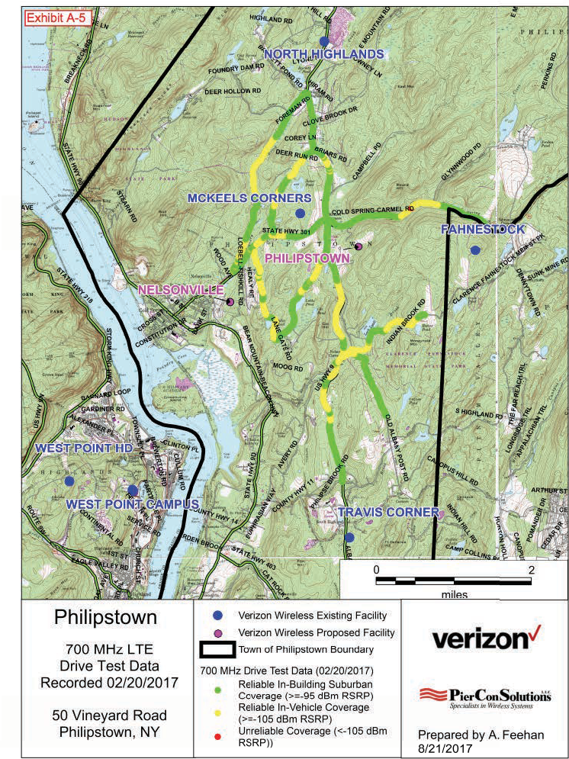

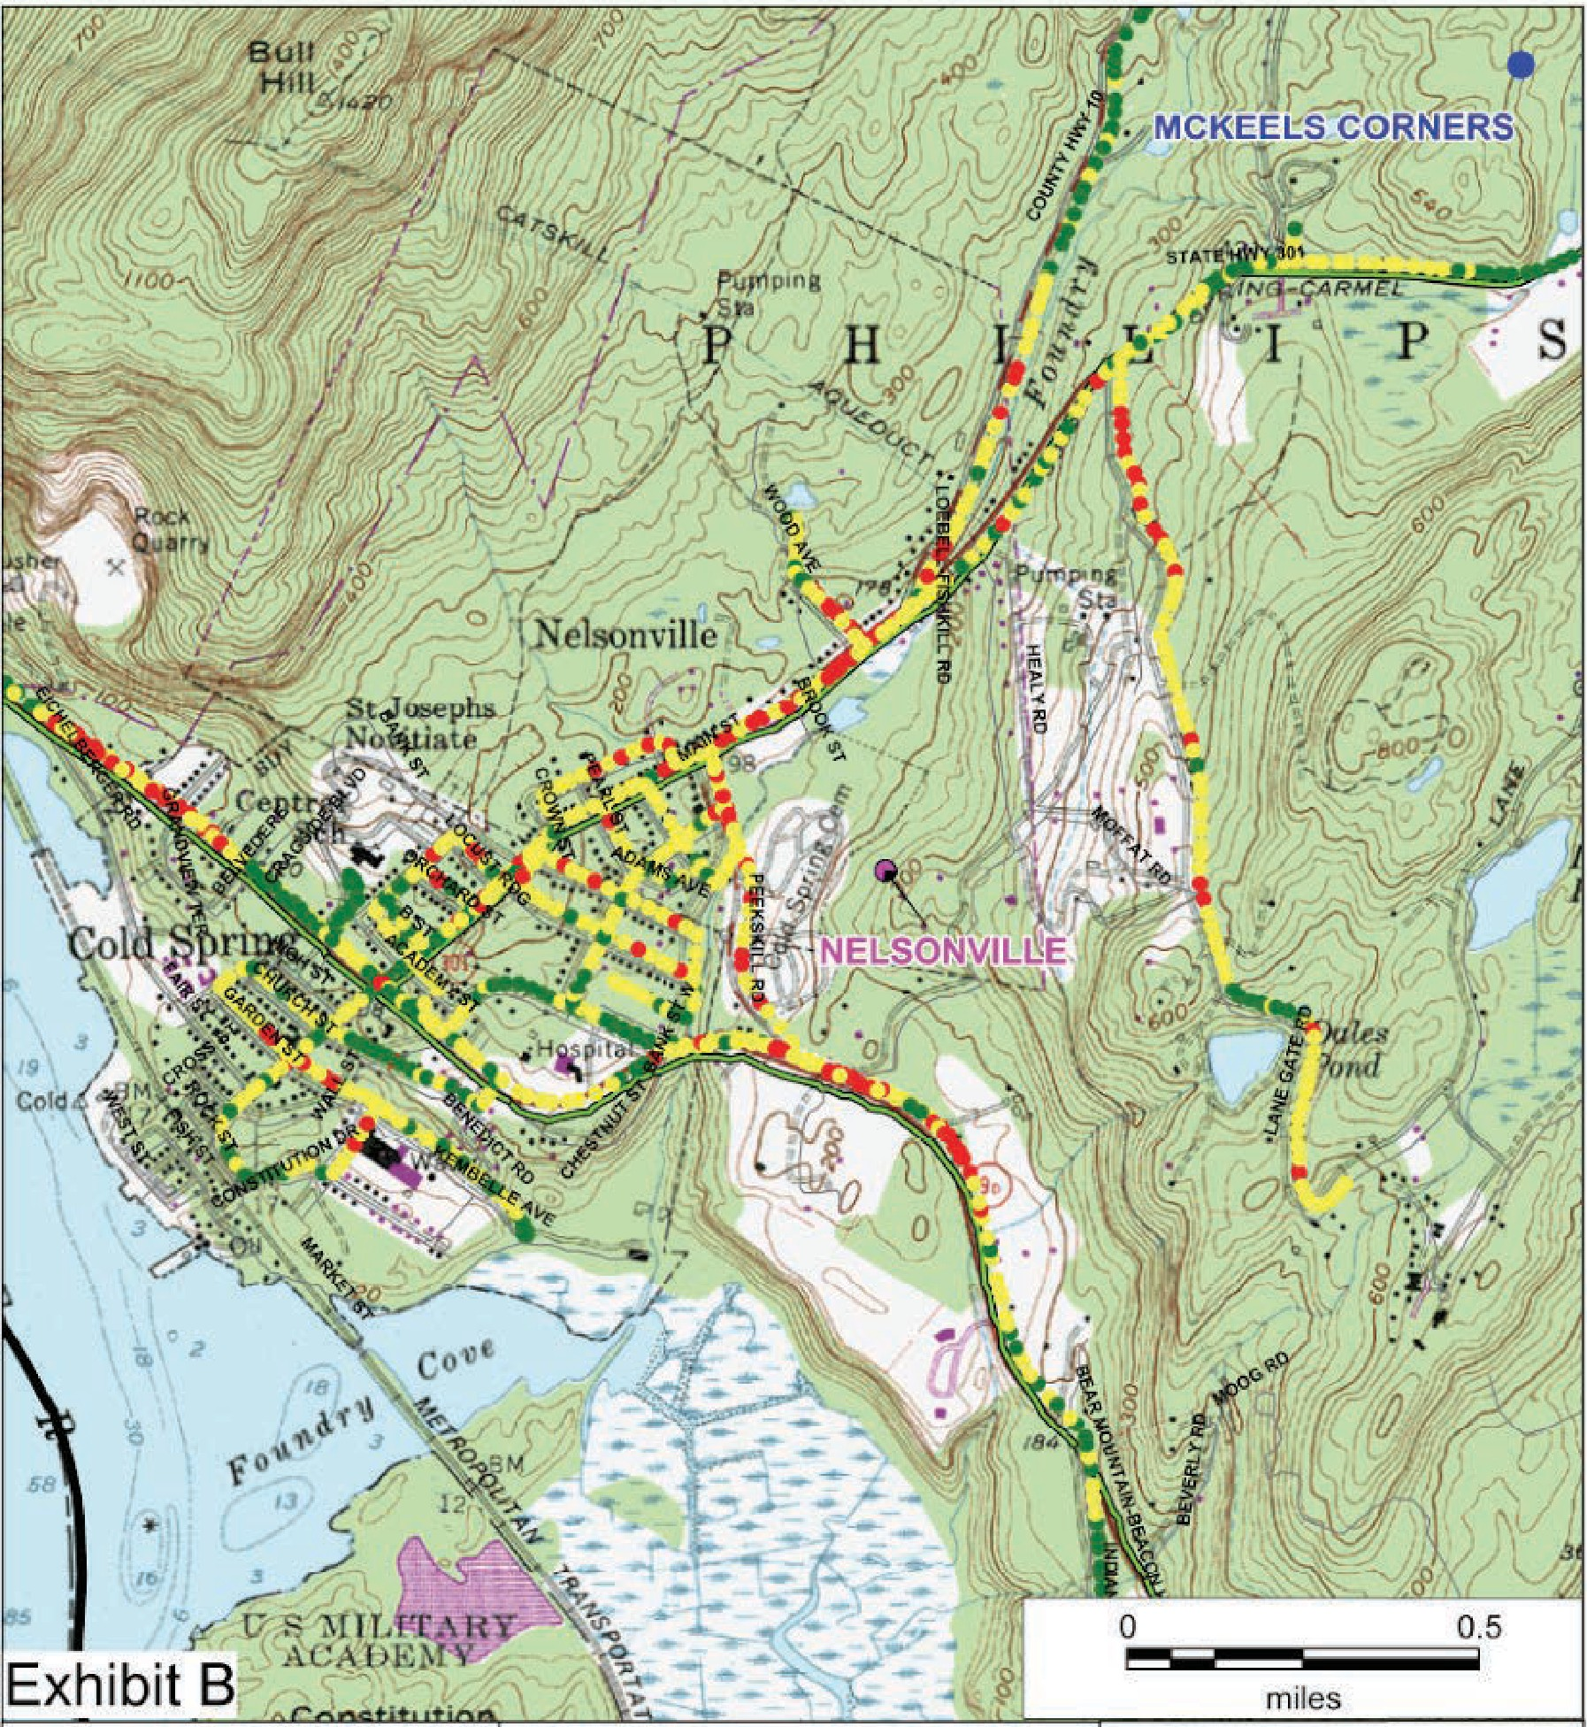Nelsonville
700 MHz LTE
Drive T est
Performed 12/15/17

Village of Ne'lsonville, NY

- Veri.1on Wireless Existing Facillity
e Veriz,on Wireless Proposed Facility
c::Jio wn of Philipstown Boundary
Drive Test Data (12/15/17}
- Reli able In-Building Suburban Cove rage (>=-95 dBm RSR P)
- Rel iable In-Vehicle Coverage (>: . 1Q5 dB m RSRP) Unreliable In-Vehicle Cov,er age
- (<•105 ciBm RSRP)
verizon

Prepared by A. Feehan
11 2/18/2017

EXHIBIT D

Dr Chris Marrison 31 December 2017
7 Old Manitou Road, Garrison, NY 10524

Nelsonville Zoning Board and Nelsonville Planning Board
℅ Village Clerk, Village of Nelsonville 258 Main Street, Nelsonville, NY 10516

Re: Homeland Towers Application for A Special Use Permit
Dear Board,
This note covers points raised in the PierCon letter of December 18, 2017 responding to my letter of November 27, 2017.

Section 3, The Handheld Call Test performed by Residents
PierCon gives reasons as to why the RF industry does not use such tests in designing networks. Those reasons are valid, but they do not invalidate the results of the call-tests in this case.
The call-tests were not made to design a network, but were made to test the accuracy of the estimated coverage given in the maps. The call-tests directly address the question as to whether the coverage is sufficient in the area. The tests showed that in areas where the maps show no coverage, there is in reality sufficient coverage, and the tests therefore make the maps deeply questionable.
The fact that call-tests are not typically used to design RF networks does not invalidate the empirical evidence that coverage is sufficient in the area.

Section 6, Possibility 1
PierCon lists a handful of factors included in the software and then concludes “Thus Coverage maps accurately predict the RF signal.” That is a leap of faith, because there are many factors not included in the software such as the composition of the ground, the actual “close in clutter,” and the actual effect of the buildings. Software modelling of a complex system can produce a wide range of results and cannot be relied upon without being verified by ground truth data.

In Section 6, Possibility 2
The RF engineer asserts that in his opinion the data is adequate. The data is only adequate if it is sufficiently comprehensive, detailed, and recent that in conjunction with the software it leads to accurate results. This has not been proven and is therefore just an assertion.

Section 6, Possibility 3
Here the RF engineer asserts that he knows the software well. This may well be correct, in which case we need to look elsewhere to understand why his maps show no coverage in areas where, in reality, there is coverage as shown in the call logs.

Section 6, Possibility 4
The RF engineer states he did not use his intimate knowledge of the software to bias the results. He may well believe this, but the alternative maps discussed in Section 5 neatly illustrate how different software assumptions create results that are favourable to the user’s case.

After these sections, a drive test is discussed. This drive test was not independent because it was conducted by PierCon. The fact that they then chose to modify the drive result by 5dB due to foliage is another illustration of the way in which the software is only a model of reality and does not take into account all the elements that affect RF propagation. Even after this modification, this non- independent drive test shows coverage that is significantly better than that shown by the original propagation maps.

Yours faithfully,
Dr Chris Marrison (submitted electronically)

18 December 2017
Dr Chri s M arr ison
7 Old Manitou Ro ad Garrison, NY 10524

To

Nelsonvill e Zoning Board and Nelsonville Planning Board
¼ Village Clerk Village of Nelsonville 258 Main Street Nelsonville , NY 10516

Re: Homeland Towers Application for A Special Use Permit

Dear Board,

The RF studi es commissioned for Homeland Towers are based on the use of mathematical mod elling software. I am an expert in complex mat hemat ical mod elli ng sof tware : I have a PhD in aerospace engineering from Princ eton University and have spe nt the last three decades modelling complex engineering and financi al syste m s, including the use of Geographica l Info rm ation Systems (GIS is the basis of the software used for the RF studies).
Complex software such as that used in th e RF studies can be used to create resul ts that seem to have a scientific sophi st ication and certai nty but the resu lt s are only estimates dependingon the qualit y of the software, the underlying data, and the assumptions made by the users.
As an example, suppose th ere was some softw are to estimate the value of the homes in Nelsonvi lle. Simp le software might just take the square footage of each home and mul tiply it by the average value per-squar e-foot in New York State. If you wanted to improve the estimat e you might add factors to adjust for things like the number of bedrooms and the acreage. That would give a better estimate but it would still not be accurate because it does not capture elements such as the qualit y of the finishings, the view, or the neighbour hood . Worse still , if t he software was being used by someone buying your home to set the price, they would have a fi nan cial incentive to make diff erent assumptions in the sof t war e, for example instead of taki ng the average value per-square-foot in New York, t hey might take the national average and get result s t hat show a lower estimate of the value.
Complex soft ware models have so many moving parts and assumpt ion s that they can give a wide range of result s, so a software model's validity must be tested by comparing the results with reality. This rea lit y is called ground truth data. In the house-valua tion example, if you t ook 100 houses and showed that the soft w are result s were always wit hin 2% of t he act ual sale price, you would think it was good soft ware. But if there were many cases w here the software results did not match the ground truth data, then you would have to conclude that the results from the soft ware were relati vely meaningless.
If we look at the RF propagat io n map s, t he y seem to show gaps in coverage,but that is ju st spec ul at i on until it is checked with ground truth dat a. In the RF ind u stry, one type of ground truth dat a is provid ed

by drive-tests to show the expected serv icefor cell phones. An.even more direct form of ground truth is to te st whether cell phones actually have adequate reception.
For Nelsonville, the ground truth data shows that in reality there is already sufficient coverage: we can make calls, send texts and get pictur es in t he areas where the soft ware maps suggest there is no coverage. For example, the maps predict no coverage in Phi lipstown Town Hall, yet in realit y we can reliably receive calls and text s in the Hall. For Nelsonvi lle, the ground truth data shows that these maps do not reflect realit y, either because of limi tat ions in the software or choices made by t he users.
The Village Cod e requires:

"S pecial permits are to be based on actual need and not on speculation of possible future needs which may or may not materialize".
The evidence they sub m itt ed in the form of these maps appears to be incorrect and cannot suppor t the tower company' s speculation that there is a significant gap in coverage.

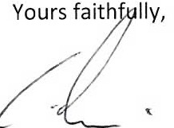
Dr Chris Marrison

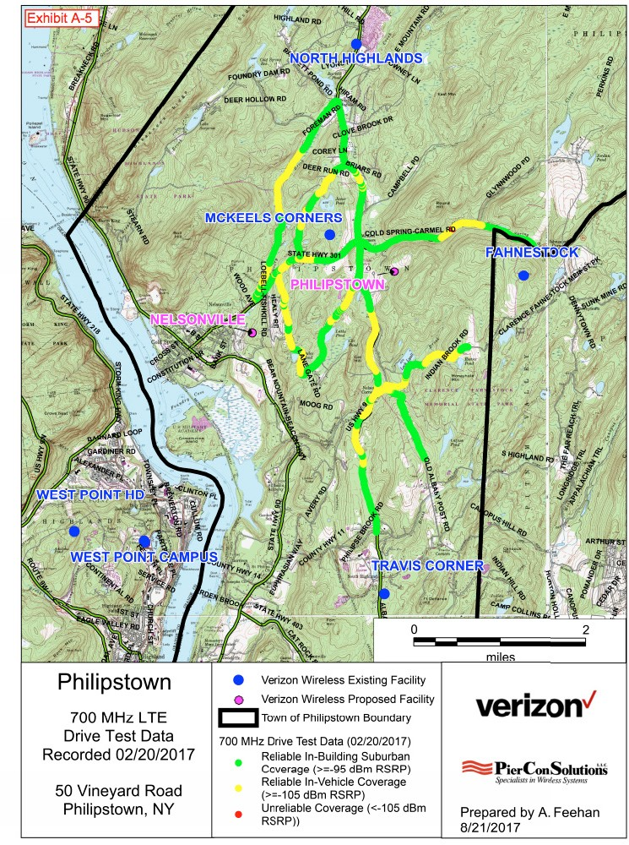

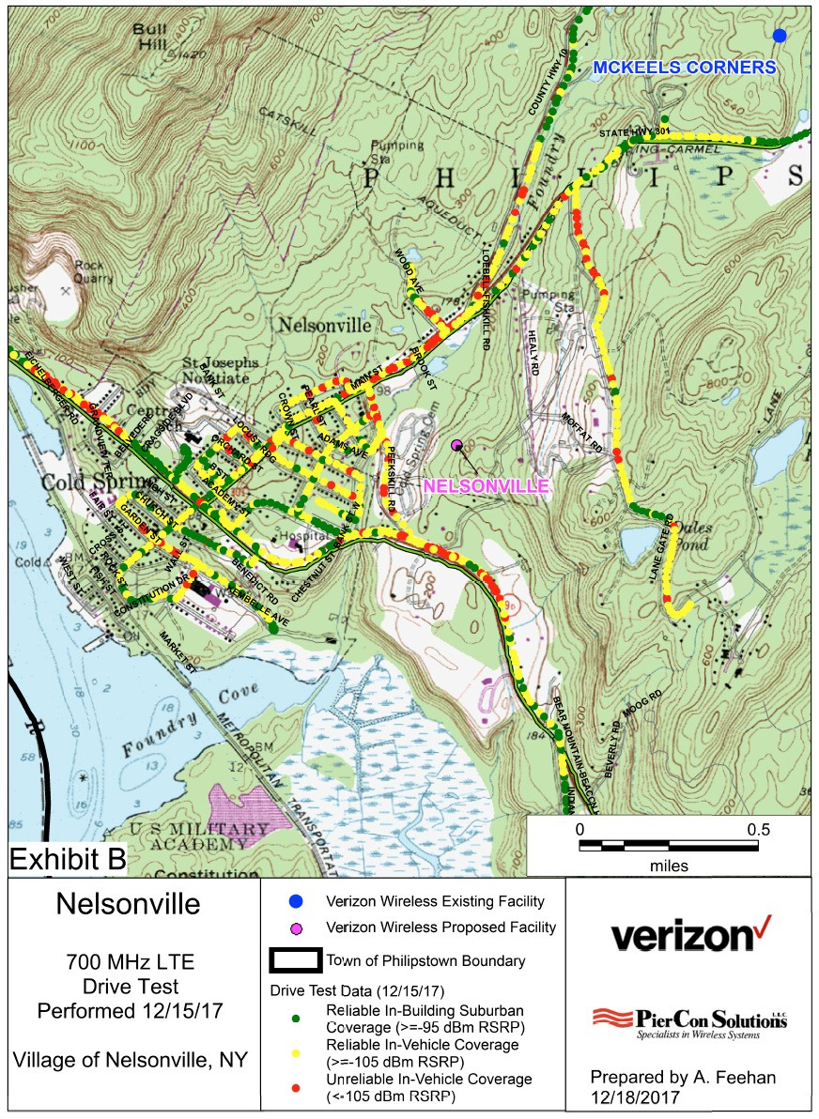

(518) 439-3079
EXHIBIT E

CENTER FOR MUNICIPAL SOLUTIONS 70 CAMBRIDGE DRIVE
CMS'
GLENMONT. NEW YORK 12077 FAX (518) 478-0909

January 8, 2018 (via e-mail and regular mail)

Zoning Board of Appeals/Planning Board Village of Nelsonville, New York
258 Main Street
Nelsonville, NY 10516

Dear Board Members:

I have been retained by the Philipstown Cell Solutions Group to provide documentation to both of your Boards to assist so that you are able to make an informeddecision on the application for a proposed new tower at15 Rockledge Road. I provided an overall report on December 29, 2017. In that report I stated;

No drive test data has been submitted by either carrier. Drive test data shows the actual service level at locations throughout the Village. Mr. Graiff in his December 9, 2017 submittal states "Such drive tests are nearly the "gold standard" for determining coverage be it existing or new." It is the existing drive test results that should be provided by both carriers for the frequency bands they are stating will be at the proposed site, as well as the 850 MHz band.

I recently received some drive test material that I believe needs to be commented on.

Verizon had PierCon conduct a drive test in Nelsonville and the surrounding area on December 15, 2017. Verizon had PierCon conduct a drive test in Philipstown on February 20, 2017. Both tests are attached. Both tests were done in the winter. The tests have some overlapping areas. (Lane Gate road and near the junction of County Hwy 10 and State Hwy 301) The December 15, 2017 test for Nelsonville shows considerably less coverage. Why?

On page 8 of the December 2017 PierCon report, Mr. Feehan states "PierCon determined that a correction factor of 5 dB, which is the least conservative, is appropriate to correct measured signal levels due to foliage loss in this environment." They offer no proof for this correction. The -5 dBm adjustment is a significant change in that every change of -3 dBm is a doubling of signal strength. Thus, a -5 dBm change is almost a 4-fold decrease in power. They apparently made no correction in the

Philipstown test. Drive test data is supposed to be recorded data, not corrected data. For the maps to be useful, they should not be simply done at a fixed measurement with a yes/no binary analysis of whether the location signal strength exceeds a selected number they would show actual signal strength measurements at every location.
This is not valid drive test data and there is still no AT&T drive test data and no test for all frequency bands they are stating will be at the proposed site, as well as the 850 MHz band.

Sincerely,

R. A. Comi (electronic signature) Richard A. Comi
CMS

CC: Philipstown Cell Solutions Group (via e-mail) Todd Steckler, Esq. (via e-mail)

2

EXHIBIT F

CENTER FOR MUNICIPAL SOLUTIONS
70 CAMBRIDGE DRIVE
C

(518) 439-3079
GLENMON,T
NEW YORK 12077 FAX (518) 478-0909

December 29, 2017 (via e-mail and regular mail)

Zoning Board of Appeals/Planning Board Village of Nelsonville, New York
258 Main Street
Nelsonville, NY 10516 Dear Board Members:
I have been retained by the Philipstown Cell Solutions Group to provide documentation
to both of your Boards to assist so that you are able to make an informed decision on the application for a proposed new tower at15 Rockledge Road. I am one of the owners for the Center of Municipal Solutions (CMS). I have testified in front of hundreds of Boards across the Country as an expert in the siting of Wireless Facilities. My resume is attached at the end of this document. I have reviewed all of the documents provided on the Nelsonville web site as well as all documents provided by Ronald Graiff and offer the following comments:

THE APPLICANTS HAVE FAILED TO DEMONSTRATE THAT THEY HAVE A SIGNIFICANT GAP IN COVERAGE IN NELSONVILLE.

No significant gap in coverage has been provided by either carrier as no 850 MHz maps (original and ubiquitous cellular frequency band which can handle text and data) have been provided by either carrier. If the carriers have coverage in Nelsonville in the 850 MHz band, there is no "significant gap in coverage". Maps of the 850 MHZ band need to be provided by both AT&T and Verizon, for without these maps there is no way for the Board(s) to determine how much service they presently have in the Village and if there is a significant gap in service. In his December 9, 2017 report on page 2 Mr. Graiff states that the request for 850 MHz maps is "somewhat flawed for two reasons: (1) the carriers are no longer actively utilizing that frequency for new builds (there will be no 850 MHz transmitters at the proposed site); (2) the science of radio frequency propagation is such that a higher frequency, i.e. 850 MHz will have poorer coverage than the lower frequency, i.e. 700 MHz. Indeed if such 850 MHz propagation plots were provided, the gaps in coverage might very well be even larger." Mr. Graiff s reasons are not sound and he apparently has not verified his assumptions. Firstly, carriers are utilizing 850 MHz for new builds in areas where they do not presently have reliable 850 MHz service.
Secondly, in that 700 MHz service has only been available to the carriers for a few years, their 850 MHz service is operating at more locations, thus providing better coverage.
No drive test data has been submitted by either carrier. Drive test data shows the actual service level at locations throughout the Village. Mr. Graiff in his December 9, 2017 submittal states "Such drive tests are nearly the "gold standard" for determining coverage be it existing or new." It is the existing drive test results that should be provided by both carriers for the

frequency bands they are stating will be at the proposed site, as well as the 850 MHz band. I believe that both carriers have this information readily available for Nelsonville for all frequency bands including the 850 MHz band. Contrary to Mr. Graiff’s note 1 at the bottom of page two in his December 9, 2017, we are not suggesting or seeking a crane test for 15 Rockledge Road. In regards to his note 2, the only way to verify the calculated plots for Nelsonville is to have the drive test data for the Village of Nelsonville Roads. “Close proximity” drive test data in Philipstown does not verify the Nelsonville plots.
Why is -95 dBm service required in rural Nelsonville? Signal strength is measured in negative (-) dBm. For each less negative 3 dBm, the power doubles. (Ex. -102 dBm is double the power of -105 dBm and -99 dBm is 4 times the power of -105dBm) Thus -95 dBm is more than 10 times stronger than -105dBm. We have reviewed other Verizon applications were Verizon engineers have that stated that -105 dBm service is sufficient for in building coverage in rural areas. In the RF data in Verizon’s August 30, 2017 report (page 15 of 46) it shows complete -105 dBm 700MHz coverage in Nelsonville and even shows (page 14 of 46) some limited -95 dBm coverage.
The PierCon report dated 8/30/17 on page 3 states “For Verizon Wireless, the Cellular frequency band (850 MHz) handles mostly voice traffic”. This must mean that there is data usage in that band. Having the data provided for Verizon coverage in the 850 MHz band will show where there is service (voice and data) for Verizon in Nelsonville. This then raises the question as to why Verizon needs ubiquitous in-building 700 MHz coverage in Nelsonville for data only.
On November 25 and 26, 2017 over 120 voice and text calls were made by citizens using Verizon and AT&T phones. (See Philipstown Cell Solutions Group November 28, 2017 report Exhibit E pages 108 to 113) The calls were made at numerous locations, they were interior, exterior and in car. This volume of calls and text demonstrates that there is substantial, perhaps even ubiquitous service presently in Nelsonville. This is another reason why the drive test data and 850 MHz maps need to be provided.
Attorney Gaudioso made a statement on record that there is a significant gap. In his 11/22/17 letter he states the applicant does not have to demonstrate a significant gap in service and should the application be denied the applicants could bring a prohibition of service claim.
The Village is not intending on prohibiting service for Verizon. The Village is merely asking for the need of the proposed site to be proven. To be “prohibiting service” the Village will have to say that NO Verizon facility or facilities can be located in the Village. There has not been any issue raised on prohibiting service.

CONSTRAINTS IN CAPACITY DO NOT CREATE A SIGNIFICANT GAP.

Is this site really a “need” for additional data capacity? In the technical reports provided, the frequency bands (700 MHz and 1900 MHz for AT&T, and the 700MHz and or 2100MHz for Verizon) are essentially used for data. If so, no capacity data has been provided. I have previously discussed that it does not appear that there is a significant gap in wireless service in Nelsonville. Mr. Graiff’s December 9, 2017 report confirms that the proposed site will be a data site meant to increase capacity, not to actually fill a gap in coverage.
To the best of our knowledge, sites are required based on a significant gap in coverage and the courts have ruled thusly. Capacity need does not demonstrate a significant gap in coverage.

THE APPLICATION BY VERIZON CANNOT BE CONSIDERED UNLESS THE “COVERAGE MAPS” HAVE BEEN PROVIDED AND THIS WAS NOT DONE UNTIL AUGUST 30, 2017 THUS THE SHOT CLOCK FOR VERIZON DID NOT START UNTIL THAT DATE

It is my understanding that at the last meeting that the shot clock was extended until January 8, 2018 I do not believe that this was necessary. Verizon’s submittal was on August

30, 2017 not July 19, 2017. In fact the Verizon coverage maps were not prepared until August 23, 2017 and August 24, 2017. Thus if Verizon is considered part of the application, then the clock must have started on 8/30/17 (The shot clock starts at the time the application is submitted but can be tolled if within 30 days the Village notifies the applicant that it is incomplete.) Thus, the shot clock could not expire any earlier than January 27, 2018. In addition, there was a September meeting at which the applicant was asked for additional material that should have stopped the shot clock until the material was supplied. As long as the community is actively pursuing that information that it needs to make an informed decision, then the shot clock should not be a major stumbling block. If the applicant says in writing that they will not provide any additional material and that they believe that their application is complete, the Board(s) should make a decision on what material they have.

OTHER LESS INTRUSIVE MEANS OF PROVIDING SERVICE HAVE NOT BEEN FULLY INVESTIGATED.

There are four churches in the area listed in the October 31, 2017 letter to the ZBA from Vincent Xavier of Homeland Towers. For numerous reasons, Mr. Xavier has dismissed all of these sites as possible facility locations. No propagation maps were provided for either carrier at any of the locations. No consideration was given to perhaps the use of multiple stealth unobtrusive sites. It is not in Homeland Towers’ best interest to identify a non tower solution.
There is also the possibility of an alternate location at 50 Fishkill Road. It is my understanding that the Philipstown Supervisor has agreed that a facility at this location is amenable with Philipstown. Back in an August 22, 2014 in a letter to Philipstown, Mr. Vincent of Homeland Towers stated: I believe the Town owned property located at 50 Fishkill Road (Philipstown Highway Department) would be suitable.” Coverage maps at that location need to be provided to determine the minimum height necessary for coverage in the Village.
Why hasn’t a possible small Distributed Antenna system (DAS) system been proposed?
The DAS antennas are placed in the right of way on existing utility poles or new poles if required. They are below the tree line and are significantly less obtrusive than the proposed tower. Both carriers are implementing DAS systems throughout the country and many are in residential areas where the siting of a “tower” would be obtrusive. (For example, Mount Vernon and Pelham Manor) The DAS system can handle multiple carriers and could be expanded to cover outside the Village. (for example Cold Spring) This solution would eliminate any threat by Mr. Gaudioso of the Village “prohibiting service”. Multiple, less obtrusive locations and options exist which Homeland Towers has failed to pursue in good faith or with any serious diligence.

WHAT AREA WILL THE PROPOSED SITE COVER IF PERMITTED?

In order for the coverage maps to show how much of the coverage is for the Village of Nelsonville there should be village boundaries shown on all maps. The AT&T report prepared by Mr. Penesso states on page 5 that 7.18 square miles of coverage will result from this site. The Nelsonville web site says Village is 1.004 square miles. Thus AT&T’s coverage is less than 14% in Nelsonville even if it covers all of Nelsonville. Why must Nelsonville have an obtrusive tower, the coverage from which will be more than eighty six (86) percent outside of the Village?

THE HEIGHT OF THE FACILITY AS PROPOSED COULD EVENTUALLY BE ONE HUNDRED AND THIRTY (130) FEET.

If the tower is approved, Federal Law states that a height increase of up to twenty (20) feet can still qualify as an “eligible” facility. This “eligible” facility collocation must be approved by the Village and a “proof of need” is not required by the applicant. Based on what has been

requested, the tower could go up to per Federal Law and tower can be increased by up to 20 feet and still qualify as an “eligible” facility. This would mean that the tower could eventually be one hundred and thirty (130) feet tall.
If, as requested, Verizon is at 105 and AT&T at 96, and these are the minimum heights needed (I do not agree with this proposal) then if other carriers wanted to go on the tower, (as stated above they do not have to prove height) they could request an increase of up to twenty
(20) feet and the Village must approve.

ADDITIONAL DETAILS IN THE RECORD

AT&T says they need to replace a site that was at the hospital in Cold Spring - Mr.
Penesso states in his July 19, 2017 RF submittal “A significant gap in reliable wireless service exists in the Village of Nelsonville and neighboring communities as a result of the decommissioning of AT&T’s facility at the Hospital Facility.” Had AT&T not lost the site at the hospital, the RF engineer states that AT&T would not need the Nelsonville site. (If this is true then why is the new site not having the 850 MHz service and only having frequency bands used for data?)Why does Nelsonville have to replace coverage for a site that was decommissioned in Cold Spring?
The loss of the McKeel Corners site should not be included as a reason for needing the proposed site in Nelsonville. A new site is being proposed in that area that will provide similar coverage as the McKeel Corners site. Why does Nelsonville have to replace coverage for a site that was decommissioned in Philipstown?

TESTIMONY

To the best of my knowledge there has been no testimony by Verizon or AT&T’s RF engineers. Why is technical data being presented by someone other than the person who provided the data? This would allow for the Boards to ask questions of the individuals who prepared the reports and thus get a full understanding of the application material provided. Should the Board(s) decide, I remain available to cross examine the applicant’s engineers.

In conclusion the applicants have not demonstrated a significant gap in coverage, have not reviewed all lesser intrusive means of providing the service they state they need and have not proven the need for a tower at the proposed location.

Sincerely,

R.A. Comi (electronic signature) Richard A. Comi
CMS

CC: Philipstown Cell Solutions Group (via e-mail) Todd Steckler, Esq. (via e-mail)

RICHARD ANGELO COMI

70 Cambridge Road Glenmont, New York 12077 (518)439-3079

SUMMARY OF RELATED SKILLS AND QUALIFICATIONS
Systems

Excellent understanding, from a practical use and technical perspective, of telecommunications systems including hardware, line systems and data/voice system enhancements.
Recognized for ability to analyze system needs, determine appropriate technical and organizational enhancements and implement to achieve results.
Practical, hands-on experience in on-line management of systems including switches, interfaces and other equipment requiring attention to detail, responsiveness and accountability for in-filed operations.
Experienced in troubleshooting; strong skills in managing networks and complex system/line configurations.

Management/Administration

Significant senior level management experience with bottom-line accountability for sales, marketing, finance, profitability, operations and distribution.
Skilled in business development; initiated new business reaching sales level of $3 million in 18 months and profitability in nine months.
Excellent record of accomplishment in managing cost reduction programs while concurrently improving service to the users.
Able to manage multiple organizational units and priorities with efficiency and results. Experienced in supervising craft, management and support personnel.
Fiscally accountable… managed with accountability operating budgets in excess of $17 million. Skilled in budget preparation, analysis and subsequent management to profit and cost standards.
Skilled in personnel/human resource development including training, career planning and organizational development. Specific focus on determining training and development needs and implementing targeted programs to meet needs.

EXPERIENCE REVIEW

COMI TELECOMMUNICATION SERVICES/ THE CENTER FOR MUNICIPAL SOLUTIONS
Glenmont, New York 1995-Present
Owner/Founder

Utilizing his extensive industry background, he established a municipal consulting and master agent organization.

With his in depth knowledge of cellular, PCS and other wireless industries, he provides leadership and organizational skills to a nationwide group on independent municipal consultants. As a zealous advocate of local government, he is virtually unique in the wireless consulting arena, as he exclusively serves local governments. He has worked with over a hundred communities on Wireless Ordinances, Siting issues, and municipal leases. He has prevented numerous communities from making drastic mistakes, some of which would have been virtually irreversible. In addition, his ability to deal with operators as a true equal has resulted in gains for municipalities that they never expected. His knowledge goes well beyond the mere technology and operations of a company, and includes the legal and procedural requirements associated with telephony, cellular and PCS applications and permitting.

…continued…

RICHARD ANGELO COMI
Page two

GFCC (GLENS FALLS COMMUNICATION CORP.)
Glens Falls, New York 1993-1995 President, Owner
Responsible for all aspects of established business including financial, management, sales and operations. Purchased business as 100% owner; developed staff of 16 including management, technical and clerical support; negotiated large customer contracts, purchase equipment to include new DSC600 and new PC LAN billing system.

CELLULAR ONE OF UPSTATE NEW YORK
Delmar, New York 1990-1993 Vice President-Chief Operating Officer
Retained to organize, launch and manage this start-up cellular phone service organization. Established cellular system in five months. Brought to level of profitability in first nine months… exceeded sales objective by 42% in year one… negotiated major contracts with vendors, suppliers and joint venture partners resulting in rapid growth, profitability and overall market share.
Developed distribution base (dealer) and directed sales force management. Recruited and directed executive management staff with accountability for finance, sales, marketing, dealer services, customer service and technical operations.

Directed business operations employing 20 and generating $3 million in annual revenues. Organized administrative, finance, customer service and operational units with bottom-line responsibility for budgeting and control.

During tenure, served as
NEW YORK TELEPHONE COMPANY
Syracuse and Albany, New York 1971-1989

Director, Network Operations, Maintenance-Northeast
Director of Operations, Network Services Administration-Northeast and Central Operations Supervisor-Upstate New York
Traffic Superintendent- Syracuse Dial Service Supervisor-Syracuse

In most recent management capacity, assumed responsibility for operations, maintenance and general management of system involving 95 switches, 100K special services (private line, data, voice, 1.5 service and DDS) and various switching technologies. Administratively responsible for staff of 365 and budget resource allocation of over $17 million. In previous capacity as Director of Operations, Network Services Administration, managed a 2 million subscriber network, 225 employees and budget over $8 million.

Recognized for accomplishments in planning and implementing central office consolidations, reducing labor and operations costs and concurrently improving service levels. Contributed to technical enhancement of systems, networks and service levels.

EDUCATIONAL/SPECIALIZED TRAINING

Masters in Business Administration SYRACUSE UNIVERSITY, 1977

Bachelor of Science
UNITED STATES MILITARY ACAMEMY, WEST POINT, 1967

MILITARY

UNITED STATES ARMY, 1967-1971
Captain; Honorable Discharge; Vietnam Era Veteran
*Received Bronze Medal for Meritorious Service and Army Commendation for Achievement

RICHARD A. COMI

My name is Richard A. Comi. I am owner of Comi Telecommunication Services and co-founder of the Center for Municipal Solutions (“CMS”), which provides services exclusively to local government, relative to regulation of the siting, placement, construction, and modification of wireless telecommunications facilities.

I hold a Bachelor of Science in engineering from the United States Military Academy at West Point; and a Masters of Business Administration from Syracuse University. I have over thirty-two years of experience in the telecommunications industry.

During my career in the telecommunications industry, I have attended hundreds of hours of training on network design and operation of telecommunication systems. Moreover, as a Chief Operating Officer, I had complete responsibility for the design, construction, marketing, and operation of one of the largest Cellular RSA’s in the country.

I have been asked, as an industry expert, to conduct seminars at numerous conferences for municipal organizations on the regulation of the siting, placement, construction, and modification of wireless telecommunications facilities. Some of these organizations include the National Association of Small Towns; the New York State Association of Towns; The Florida Municipal League; The New Mexico League of Cities; the New Mexico Association of Counties; and numerous other municipal counties and groups. By request I have also conducted seminars on these subjects for scores of individual local governments.

I have drafted and designed wireless siting ordinances that are now in effect in hundreds of communities, and have further reviewed hundreds of other wireless ordinances. I have reviewed thousands of wireless siting applications, including inspecting the construction of the site when appropriate. The “siting process” used by CMS, including preparation of ordinance and review of applications and site construction, when permitted, are endorsed “services” of the West Virginia Municipal League.

Expert Witness Experience:

Court Testimony: Nextel v City of New Rochelle; NY, Federal District Court Manhattan New York; November 2001: Provided expert testimony on proof of need, site value, call and drive testing and Ordinance preparation

Court Testimony: American Tower v. City of Huntsville, Alabama, United States District Court for the Northern District of Alabama Northeastern Division, June 2005; Provided expert testimony on proof of need, RF emissions, structural, aesthetics, and nearby property value.

Affidavit Testimony: Nextel v City of Mount Vernon, NY, U.S. District Court of Southern New York; November 2003: Provided affidavit on proof of need, call and drive testing.

Affidavit Testimony: American Tower v. City of Huntsville, Alabama, United States District Court for the Northern District of Alabama Northeastern Division, March 2004: Provided affidavit on proof of need, RF emissions, structural, aesthetics, and nearby property value.

Affidavit Testimony: New Cingular Wireless v City of Rye, NY, United States District Court Southern District of New York, January 2006: Provided affidavit on proof of need, RF emissions, structural, aesthetics, and nearby property value

Publications:
Towers and Wireless Facilities . . . 1 Million More - Are You Prepared to Deal with the Situation? Co-authored for PSATS (The Pennsylvania State Association of Township Supervisors); 2002
TOWERS AND WIRELESS FACILITIES . . . THEIR IMPACT AND HOW TO
DEAL WITH IT (Co-authored originally for the CMS web site, but subsequently picked up and widely distributed in the Internet); 2003

TOWER AND WIRELESS ORDINANCES – Co-authored for The Missouri Municipal Review; 2008

EXHIBIT G

THE DEC POLICY SYSTEM
New York State
Department of Environmental Conservation
PROGRAM POLICY |  | Department ID: DEP-00-2 | Program ID: n/a
Title: Assessing and Mitigating Visual Impacts
Issuing Authority: Article 8, 49 |  | Originating Unit: Division of Environmental
 |  | Permits
Name: Jeffrey Sama |  | Office/Division: Environmental Permits
Title: Director |  | Unit:
Signature: /s/ | Date: 7/31/00 | Phone: (518) 402-9167
Issuance Date: 7/31/00 |  | Latest Review Date (Office Use):

Abstract: Facilities regulated by the Department of Environmental Conservation located in visual proximity to sensitive land uses can produce significant visual impacts. This policy and guidance defines what visual and aesthetic impacts are, describes when a visual assessment is necessary and how to review a visual impact assessment, differentiates State and local concerns, and defines avoidance, mitigation and offset measures that eliminate, reduce, or compensate for negative visual effects. A glossary of terms is provided for reference.

- Purpose

This memorandum provides direction to Department staff for evaluating visual and aesthetic impacts generated from proposed facilities. This guidance defines State regulatory concerns and separates them from local concerns. There is nothing in this program policy that eliminates or reduces the responsibility of an applicant to local agencies to address local visual or aesthetic concerns. In addition, this program policy does not relieve applicants from requirements of other State agencies, such as Department of State Coastal Zone Program or Department of Public Service. This guidance will also define important technical concepts and provide a mechanism for complying with the balancing provisions of the State Environmental Quality Review Act (SEQR) with respect to environmental aesthetics.

- Background

An ever expanding body of research has demonstrated that environmental aesthetic values are shared among the general population. This research finds that such values are not idiosyncratic, random, or arbitrary. For example, millions of people visit Niagara Falls for our shared appreciation of its beauty.

Many places have been recognized for their beauty and designated through Federal or State democratic political processes, reinforcing the notion that environmental aesthetic values are shared. Recognition of aesthetic resources also occurs at local levels through zoning, planning or other public means. That these special places are formally recognized is a matter of public record. This guidance contains a

generic listing of all aesthetic resources of statewide significance and serves as the template from which aesthetic issues of State concern can be distinguished from local issues. Generally, it is staff’s responsibility to identify and mitigate impacts to Federal and State designated aesthetic resources. With respect to local resources, Department staff should defer to local decision makers, who are likely to be more familiar with and best suited to address them.

- Policy

In the review of an application for a permit, Department staff must evaluate the potential for adverse visual and aesthetic impacts on receptors outside of the facility or property. When a facility is potentially within the viewshed of a designated aesthetic resource, the Department will require a visual assessment, and in the case where significant impacts are identified, require the applicant to employ reasonable and necessary measures to either eliminate, mitigate or compensate for adverse aesthetic effects.

- Responsibility

The environmental analyst, acting as project manager, for review of a new application must assure that visual and aesthetic impacts are properly evaluated by the applicant. For new permits or significantly modified permits, staff must determine the potential significance of the action pursuant to SEQR.

In the review of an application for a permit, staff must evaluate the potential for adverse aesthetic impacts to sensitive places. Sensitive places of statewide concern are listed in this guidance (see V. Procedure). From the State’s perspective there may be a significant impact if one or more of the listed places lies within the viewshed of a proposed project. From a local perspective there may be a significant impact if a local resource lies within the project’s viewshed. This simple concept may help staff and decision makers distinguish local concerns from State concerns, and public concerns from individual expressions of concern.

With respect to aesthetics, an individual citizen’s expression of concern is usually based on the belief that a property or particular "neighborhood" lies within the viewshed of a proposed project. This is different from the concerns of the public at large which has a stake in aesthetic resources recognized as having designated value under the public domain.

Significant impacts are identified and confirmed by staff during the review of an application. SEQR obligates the Department to mitigate such impacts to the maximum extent practicable [6NYCRR Part 617.11(d)(5)]. Local involved agencies must do the same with respect to local resources and likewise comply with Article 8 of the ECL and 6NYCCR Part 617. Impacts to aesthetic resources of statewide concern may require more substantial mitigation strategies to achieve project approval. Mitigation costs and practicality of the mitigative measures must be weighed in the balancing required by the State Environmental Quality Review Act.

Local resources are frequently designated through local zoning and planning processes. Accordingly, local jurisdictions may require additional and somewhat different information than the Department. The legislature has recently recognized and addressed this jurisdictional difference. In 1999, the Legislature, revised Article X of the Public Service Law to eliminate a DEC requirement to testify on behalf of local

jurisdictions concerning the impacts of power plant siting. In doing so, they explicitly eliminated the requirement that DEC staff testify with regard to local jurisdictional needs.

- Procedure

Staff must assure that the full scope of visual and aesthetic concerns are addressed. This includes impacts from all project components and their operation on all inventoried resources. In addition, an equitable level of expectations between the potential significance of the impact, the degree of sophistication of the analysis required of applicant and appropriate level of mitigation strategies must be established. The goal of visual assessment is to reveal impacts and effective mitigation strategies. Small scale, low budget projects should not be burdened with the costs of sophisticated visual analyses. In these instances, it is generally more effective to reserve applicant investments for mitigation rather than complex visual assessments. Simple line-of-sight profiles may suffice for revealing impacts and potential mitigation strategies (see appendix A for an illustration of their use).

Staff must take certain basic steps to assure that visual concerns have been fully addressed in each application. Those steps are:

- Verify the applicant’s inventory of aesthetic resources.

- Verify the applicant’s visual assessment, using either graphic viewshed and line-of-sight profile analysis as illustrated in Appendix A, or more sophisticated visual simulations and digital viewshed analysis, as needed.

- Determine or verify the applicant’s assessment of the potential significance of the impact.

- Confirm that applicant’s mitigation strategies are reasonable and are likely to be effective, or
assure mitigation by requiring the applicant to submit a design that includes the required mitigation, or, impose permit conditions consistent with those mitigation requirements.

A discussion of each follows:

- Inventory of Aesthetic Resources.

It is important to note that all significant scenic and aesthetic resources may not have yet been designated in New York State. However, for the purposes of this policy all aesthetic resources of statewide significance may be derived from one or more of the following categories:

- A property on or eligible for inclusion in the National or State Register of Historic Places [16 U.S.C.
§ 470a et seq., Parks, Recreation and Historic Preservation Law Section 14.07]; e.g. Trinity Church in Manhattan, Schuyler Mansion in Albany;

- State Parks [Parks, Recreation and Historic Preservation Law Section 3.09]; e.g. Grafton Lakes State Park, Rensselaer County;

- Urban Cultural Parks [Parks, Recreation and Historic Preservation Law Section 35.15];

- The State Forest Preserve [NYS Constitution Article XIV]; Adirondack and Catskill Parks;

- National Wildlife Refuges [16 U.S.C. 668dd], State Game Refuges and State Wildlife Management Areas [ECL 11-2105]; e.g. Montezuma National Wildlife refuge; Perch River Wildlife Management Area, Jefferson County;

- National Natural Landmarks [36 CFR Part 62]; e.g. Iona Island Marsh, Hudson River, Rockland County;

- The National Park System, Recreation Areas, Seashores, Forests [16 U.S.C. 1c]; e.g. Gateway National Recreation Area, Staten Island; Finger Lakes National Forest, Schuyler County;

- Rivers designated as National or State Wild, Scenic or Recreational [16 U.S.C. Chapter 28, ECL 15- 2701 et seq.]; e.g.Cedar River (Wild), Ampersand Brook (Scenic); West Branch of the Ausable River (Recreational);

- A site, area, lake, reservoir or highway designated or eligible for designation as scenic [ECL Article 49 or DOT equivalent and APA.Designated State Highway Roadside; e.g. Storm King Highway (Article 49 Scenic Road), Rockland county;

- Scenic Areas of Statewide Significance [of Article 42 of Executive Law]1; e.g. Catskill-Olana SASS;

- A State or federally designated trail, or one proposed for designation [16 U.S.C. Chapter 27 or equivalent]; e.g. Appalachian Trail;

- Adirondack Park Scenic Vistas; [Adirondack Park Land Use and Development Map]

- State Nature and Historic Preserve Areas; [Section 4 of Article XIV of the State Constitution];

- Palisades Park; [Palisades Interstate Park Commission]; e.g. Harriman State Park;

- Bond Act Properties purchased under Exceptional Scenic Beauty or Open Space category; e.g. Star Hill, Oneida County.

Note: The Hudson River has recently been designated an “American Heritage River” by a Presidential Order under [PL 91-190]. The details and criteria of the program as they may relate to this policy are currently under review.

- Visual Assessments.

1 State Coastal Policies number 24 and 25 derived in part from Section 912 of Article 42 of the Executive Law define the criteria that, when properly employed, assure project consistency with coastal zone management objectives. Such policies are consistent with the review mechanisms contained in this DEC policy. Also for reference is the July 1993 DOS SASS publication for Columbia-Greene, Catskill- Olana, Estates District, Ulster North, Esopus-Lloyd, and the Hudson Highlands.

In all visual assessments, significant resources must be identified along with any potential adverse effects on those resources from the proposed project. If, in staff’s judgement, a place designated in any of the above categories may lie in the viewshed of the proposed project then a visual assessment should be required to confirm or refute this potential. At a minimum a line-of-sight-profile, or, depending upon the scope and potential significance of the activity, a digital viewshed may be used to determine if a significant property is within the potential viewshed of the proposed project (see the Appendix A attached for guidance on how to construct and use a line-of-sight profile). Staff must then review the applicant’s visual assessment for adequacy, accuracy and thoroughness. The control points (see glossary for definition) must be established by staff and should include a worst case scenario. Worst case here means establishing the control points that reveal any project visibility at an aesthetically significant place. Most of the time, though not always, high points reveal worst case. For example, the tallest facility component (e.g. combustion exhaust stack), may be the control point at the project end of the profile, while a high point of ground upon which the observer stands within a State Park may be the control point at the resource end of the profile.

With respect to determining the radius of the impact area to be analyzed, there has been a general guideline for large actions that it is usually “safe” to use 5 miles. The 5 mile distance probably owes its origins to the U.S. Forest Service “distance zones” set forth in their landscape management journal written in 19732 (5 miles is still largely considered “background,” i.e. distances at which most activities are not a point of interest to the casual observer). However, for very large activities, such as power plants (particularly those that generate wet cooling tower plumes), and large landscape alterations, greater distances have been shown to be important in some landscape settings, and must be considered. In those instances, applicants must document to the satisfaction of staff that impacts beyond five miles to listed resources have been considered. They must also provide a clear demonstration that impact to any resource of statewide concern is insignificant. Such demonstrations may be convincing if resource inventories beyond 5 miles are coupled with line-of-sight profiles (see Appendix A for a complete discussion of these graphic tools) or other accepted visual criteria, such as computer simulations, analogous comparative studies or worst case presentations.

- Significance.

Aesthetic impact occurs when there is a detrimental effect on the perceived beauty of a place or structure. Significant aesthetic impacts are those that may cause a diminishment of the public enjoyment and appreciation of an inventoried resource, or one that impairs the character or quality of such a place. Proposed large facilities by themselves should not be a trigger for a declaration of significance. Instead, a project by virtue of its siting in visual proximity to an inventoried resource may lead staff to conclude that there may be a significant impact. For example, a cooling tower plume may drift between viewers standing on an overlook at a State Park thereby blocking the view of the panorama. Staff must verify the potential significance of the impact using the qualities of the resource and the juxtaposition (using viewshed and or line-of-sight profiles) of the proposal as the guide for the determination.

- Mitigation.

2 U.S. Forest Service, Agricultural Handbook Number 434, Feb. 1973

Mitigation may reduce or eliminate the visibility of the project or alter the project’s effect on the scenic or aesthetic resource in some way. It is usually easier to deal with the visibility of the project than its composition to achieve mitigation. Altering the composition of a project lies within the realm of professional designers. When given the opportunity, however, staff should encourage applicants to design aesthetically compatible projects that incorporate environmentally friendly design principles and components, as may be employed from the mitigation menu below.

Mitigation strategies can be categorized into three general groups as outlined below.

  - Professional Design and Siting.
    - Screening
    - Relocation
    - Camouflage/Disguise
    - Low Profile
    - Downsizing
    - Alternate Technologies
    - Non-specular materials
f) Lighting

  - Maintenance
    - Decommissioning

  - Offsets

A discussion of each follows:

- Professional Design and Siting. A properly sited and designed project is the best way to mitigate potential impacts. Under optimum circumstances a project can be sited in a location which precludes the possibility of having an aesthetic resource within its viewshed. Also, through sensitive design treatment, elements of particular concern may be sited or dimensioned in a way that reduces or eliminates impacts on significant resources. Sometimes circumstances prevent the realization of optimal siting and sometimes engineering, economic or other constraints preclude optimum dimensioning or other appropriate design treatments. Under those circumstances, other mitigation strategies should be considered.

Staff should assure effective mitigation is thoroughly explored by requiring project sponsors to consider the following tools to mitigate impacts:

  - Screening. Screens are objects that conceal other objects from view. They may be constructed of soil, rocks, bricks, or almost anything opaque. Vegetation can, despite its visual porosity, function as a screen when a sufficient mass is employed. Screens may be natural, e.g. vegetation, or artificial, e.g. fences and walls. Screens may appear natural e.g. wood, stone, or may appear artificial, e.g. plastic, metal. In natural settings it is generally better to employ natural materials, while in urban places designers may employ a broader range of materials.

Screens constructed from soil are called berms. Berms may appear natural e.g. blend with nearby topography, or appear artificial e.g. geometrical or symmetrical shape. Each

may be employed depending upon the overall design intent. Berms may be vegetated or not vegetated depending upon their particular function, e.g. spill containment and/or screening.

Properly sized and placed screens may completely conceal an object, while improperly sized and placed screens may fail to conceal. Screens may block desirable views when improperly placed (see Appendix A to see how screen placement is important).

Screens are not necessarily buffers and buffers are not necessarily screens. A buffer may attenuate noise, soften a landscape or provide other functions that may or may not include screening.

Screens possess line, form, texture, planes and color, and therefore, have their own aesthetic qualities. At times, they may be more impacting than the object to be concealed. Screens may draw attention to the object to be concealed. Screens may physically connect two similar or dissimilar areas.

  - Relocation. A facility component may be relocated to another place within the site to take advantage of the mitigating effects of topography and vegetation.

  - Camouflage/Disguise. Colors and patterns of color may conceal an object or its identity. Disguise may take many forms, and is limited only by the imagination of the project designers. As an example, communication towers can be disguised as trees, flagploles, barn silos, church steeples, or any other “in-character” structure depending upon circumstances.

  - Low Profile. Reducing the height of an object reduces its viewshed area.

  - Downsizing. Reducing the number, area or density of objects may reduce impacts.

  - Alternate Technologies. Substituting one technology for another may reduce impacts (e.g. dry cooling tower technology versus wet cooling tower technology).

  - Non-Specular Materials. Using building materials that do not shine may reduce visual impacts.

  - Lighting. With respect to regional issues, such as a tall combustion exhaust stack or radio tower, the Federal Aviation Administration (FAA) requires certain lighting for public transportation safety. These impacts may be considered unavoidable unless lower profiles can be achieved. Applicants should also document that they have consulted with and met all applicable lighting standards under local jurisdiction. Consideration should be given to off-site light migration, glare and “sky glow” light pollution. Lighting requirements, through best engineering practices, should not exceed the functional requirements of the project.

- Maintenance. How a landscape and structures in the landscape are maintained has aesthetic implications. “Eyesores” result from neglect. This should be part of any mitigation strategy.

  - Decommissioning. Removing an object from the landscape after its useful life is over, reduces the duration of a visual impact (see page 9 for further discussion).

- Offsets. Correction of an existing aesthetic problem identified within the viewshed of a proposed project may qualify as an offset or compensation for project impacts. A decline in the landscape quality associated with a proposed project can, at least partially, be "offset" by the correction. In some circumstances a net improvement may be realized (see page 9 for further discussion).

An applicant may assert that all economic and effective mitigation strategies have been incorporated into the proposed design and, when properly designed, such self-imposed mitigation should effectively mitigate any negative effects on a listed resource. However, if staff concludes that significant impacts remain then staff must still ensure that impacts are minimized. In this regard, staff should first investigate visibility mitigation strategies. Manipulating design elements to achieve adequate mitigation usually lies within the purview of professional designers.

Staff should not try to judge the quality of a design nor its effect on the aesthetics of the listed resource unless they are qualified to do so. Such qualifications normally include academic or other accepted credentials in architecture or landscape architecture. Nevertheless, it is the burden of the applicant to provide clear and convincing evidence that the proposed design does not diminish the public enjoyment and appreciation of the qualities of the listed aesthetic resource. Staff can and should review the strength or merit of such proof. An applicant’s mere assertion that the design is in harmony with or does not diminish the values of the listed resource is insufficient for the purposes of reaching findings. Instead, an applicant must demonstrate through evidence provided by others e.g. recognized architectural review boards, comparative studies that are clearly analogous, or other similar techniques, that the public’s enjoyment and appreciation of the qualities of the aesthetic resource are not compromised.

Staff must be assured that consistent with social, economic and other essential considerations, the action is one that avoids or minimizes adverse impacts to the maximum extent practicable. This can be accomplished by asking and responding affirmatively to the following questions.

- Was the full mitigation menu considered?

- Will those mitigation strategies selected be effective?

- Were the costs of mitigation for impacts to other media considered and were those mitigation investments prioritized accordingly?

- Are the estimated costs of all mitigation insignificant (for example, are the costs of visual mitigation taken together with all other mitigation less than10% of the total project cost?)

- Were the mitigation strategies employed consistent with previous similar applications? If not, was the reasoning for any changes reasonable and justified?

- Was the mitigation cost effective? For example, if fully mature vegetation with an immediate screening effect costs 10 times the amount that less mature vegetation would cost, is it appropriate to require the less costly option if its full screening effect can be realized in just, say, 3 years? (See Appendix A for details concerning this subject).

- Were offsets and decommissioning considered?

It is important to bring the project sponsor into the discussion of mitigation strategies. If more than one mitigation strategy meets all environmental protection needs, the applicant’s needs and preferences should be considered.

It is preferred that all mitigation options selected be specified in the applicant’s plans for Department review. The plans should sufficiently depict readily understandable and enforceable details. Adherence to such plans should then become a permit condition. During and after facility construction, staff should visit the site and ensure that all mitigation strategies detailed in the plans and specifications have been adequately incorporated into the facility design.

If all mitigation options available from the menu are considered, applied where appropriate, and those applied are cost effective, then one can assert that impacts have been minimized to the maximum extent practicable. However, the residual impact after all such strategies have been employed may still be significant. Offsets should then be considered to help achieve the balancing required of SEQR. Finally, decommissioning options may be considered that reduce the duration of impacts for projects with severe residual impacts. A discussion of each follows:

- Offsets.

Offsets should be employed in sensitive locations where significant impacts from the proposal are unavoidable, or mitigation of other types would be uneconomic and mitigation to be used is only partially effective. Offsets should be employed when significant improvement can be expected at reasonable cost. An example of an offset might be the removal of an existing abandoned structure that is in disrepair (i.e. an “eyesore”) to offset impacts from a proposal within visual proximity to the same sensitive resource.

- Decommissioning.

Decommissioning may take many forms, and other disciplines in Department program areas may have an interest in decommissioning. However, from the perspective of aesthetics, three are of most significance: 1) the total removal from the site of all facility components and restoration to an acceptable condition, usually with attendant revegetation; 2) partial removal of facility components, such as elimination of visually impacting structures; and 3) conditions designed to maintain an abandoned facility and site in an acceptable condition that precludes “eyesores”or site and structural deterioration.
Applicants should provide such plans when deemed necessary.

Glossary

Aesthetic impact: Aesthetic impact occurs when there is a detrimental effect on the perceived beauty of a place or structure. Mere visibility, even startling visibility of a project proposal, should not be a threshold for decision making. Instead a project, by virtue of its visibility, must clearly interfere with or reduce the public's enjoyment and/or appreciation of the appearance of an inventoried resource (e.g. cooling tower plume blocks a view from a State Park overlook).

Aesthetically significant place: A formally designated place visited by recreationists and others for the express purpose of enjoying its beauty. For example, millions of people visit Niagara Falls on an annual basis. They come from around the country and even from around the world. By these measurements,

one can make the case that Niagara Falls (a designated State Park) is an aesthetic resource of national significance. Similarly, a resource that is visited by large numbers who come from across the state probably has statewide significance. A place visited primarily by people whose place of origin is local generally is generally of local significance. Unvisited places either have no significance or are "no trespass" places.

Aesthetic Quality: There is a difference between the quality of a resource and its significance level. The quality of the resource has to do with its component parts and their arrangement. The arrangement of the component parts is referred to as composition. The quality of the resource and the significance level are generally, though not always, correlated.

Atmospheric perspective: Even on the clearest of days, the sky is not entirely transparent because of the presence of atmospheric particulate matter. The light scattering effect of these particles causes atmospheric or aerial perspective, the second important form of perspective. In this form of perspective there is a reduction in the intensity of colors and the contrast between light and dark as the distance of objects from the observer increases. Contrast depends upon the position of the sun and the reflectance of the object, among other items. The net effect is that objects appear "washed out" over great distances.

Control Points: The two end points of a line-of-sight. One end is always the elevation of an observer’s eyes at a place of interest (e.g. a high point in a State Park) and the other end is always an elevation of a project component of interest (e.g. top of a stack of a combustion facility or the finished grade of a landfill).

Line-of-sight profile: A profile is a graphic depiction of the depressions and elevations one would encounter walking along a straight path between two selected locations. A straight line depicting the path of light received by the eye of an imaginary viewer standing on the path and looking towards a predetermined spot along that path constitutes a line-of-sight. The locations along the path where the viewer stands and looks are the control points of the line-of- sight profile.

Scientific Perspective: Scientific, linear, or size perspective is the reduction in the apparent size of objects as the distance from the observer increases. An object appears smaller and smaller as an observer moves further and further from it. At some distance, depending upon the size and degree of contrast between the object and its surroundings, the object may not be a point of interest for most people. At this hypothetical distance it can be argued that the object has little impact on the composition of the landscape of which it is a tiny part. Eventually, at even greater distances, the human eye is incapable of seeing the object at all.

Viewshed: A map that shows the geographic area from which a proposed action may be seen is a viewshed.

Visual Assessments: Analytical techniques that employ viewsheds, and/or line-of-sight profiles, and descriptions of aesthetic resources, to determine the impact of development upon aesthetic resources; and potential mitigation strategies to avoid, eliminate or reduce impacts on those resources.

Visual impact: Visual impact occurs when the mitigating effects of perspective do not reduce the visibility of an object to insignificant levels. Beauty plays no role in this concept. A visual impact may also be considered in the context of contrast. For instance, all other things being equal, a blue object

seen against an orange background has greater visual impact than a blue object seen against the same colored blue background. Again, beauty plays no role in this concept.

APPENDIX A

t,

b
0
I
N
SCREENS

THE RELATIONSHIP BETWEEN SCIENTIFIC PERSPECTIVE AND A LINE OF SIGHT PROFILE.
Scientific or linear perspective is a geometric procedure that projects space onto a plane. This technique provides the analyst with a simplified way to verify the effectiveness of applicants
2 3 mitigation proposal.

2 D
USE THE D!AGRAM BELOH TO ANSWER THESE SAMPLE QUEST!ONS

. Q: At what height should a screen be constructed to com letely conceal a 23 foot object from an observer standing 80 feet from the object?
Constraint: Screen must be located 10 feet inside property line.
A: About 17 feet.
Q: l·Jhat is the maximum height of an object to be concealed behind a 10 foot screen that is located 80 feet from an observer?
Constraint: The observer is standing about 18½ feet behind the screen.
A: About 23 feet.
Q: In approximately how many years would a vegetative screen 6 feet in height planted on a berm 4 feet in height completely conceal a 23 foot object?
Constraints: Berm must be located 10 feet inside property line; object is 80 feet from observer; expected vegetation growth rate of approximately
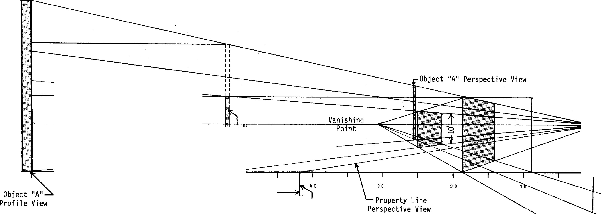1 foot per year.
A: Approximately 7 years.

15
-

t,.)
10

Eye Level
(Horizon Line) |  | C:  (Q)/  Q)4  O  U <
70 60 |  | 50  K

0
.--<

- lt
) , -------==
- Q)
•.­
->

-- yr< =r•

C:
0
.µ C:
>"' · 0
<- +'
f ·

10'

I QJ
s... QJ r- 3
- C: •r- QJ C..•r- 't-- •r- 0 .JO>
'<
LJ 0
oa_

a_<- a_<-

"<
t,.)

N
0
0
0

VIEWSHEDS

For illustrative purposes only, a "partial" viewshed has been constructed below.
A partial viewshed is distinguished from a full viewshed in that it only shows a selected area from which an object may be seen. A full viewshed shows all such areas.
The shaded area in the northwest corner of the lake is the only area within the lake that a hypothetical object 100 feet in height and situated at A (where the profile radii converge) may be seen.
The defined viewing area has been constructed by connecting each point along each profile where a viewer just begins to see the hypothetical object. To add realism to the viewshed, 40' vegetation has been factored into the lines of sight. The vegetation alters the viewing angle and hence the initial viewpoint indicated by the large black dots at the intersection of the shaded area with each profile radii.

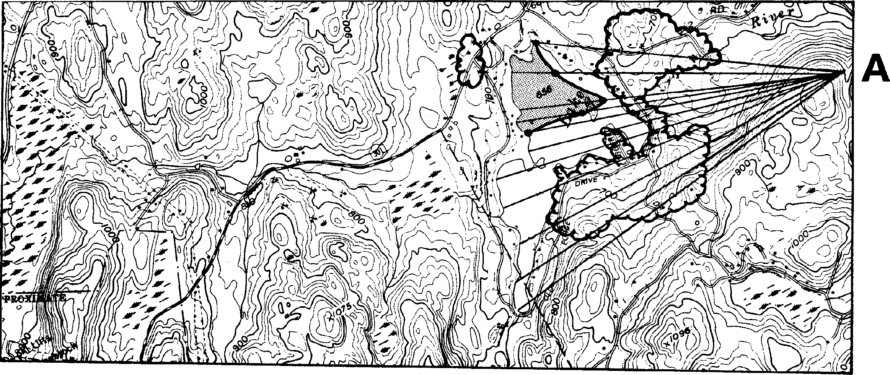

LEGEND

VIEWSHED
(Area within lake from which a hypothetical 100 foot object located at "A" may be seen)
A

N
SCALE l" = 2,000'

PROFILES
To construct a profile, first position the graph paper parallel and contiguous to the hori zontal alignment of the desired profile (indicated by line A-B). Proceed by extending vertical lines (indicated by dashed lines) to the correct height accordin g to any selected convenient vertical scale (in this case l" = 100'). This must be done from each spot where the horizontal alignment crosses a contour line. It is the elevation of the intersected contour that determines the height of
each vertical line. Then, simply connect the top of each vertical line to form the profile (indicated by line C-D). The profile C-D depicts the depressions and elevations one would encounter walking a straight path from Point A to Bon the plan map. To add realism add vegetation at the proper locations at the proper height (in this case 40').

Sample Questions and Answers According to the profile:
Q. Can an observer at location "Z"
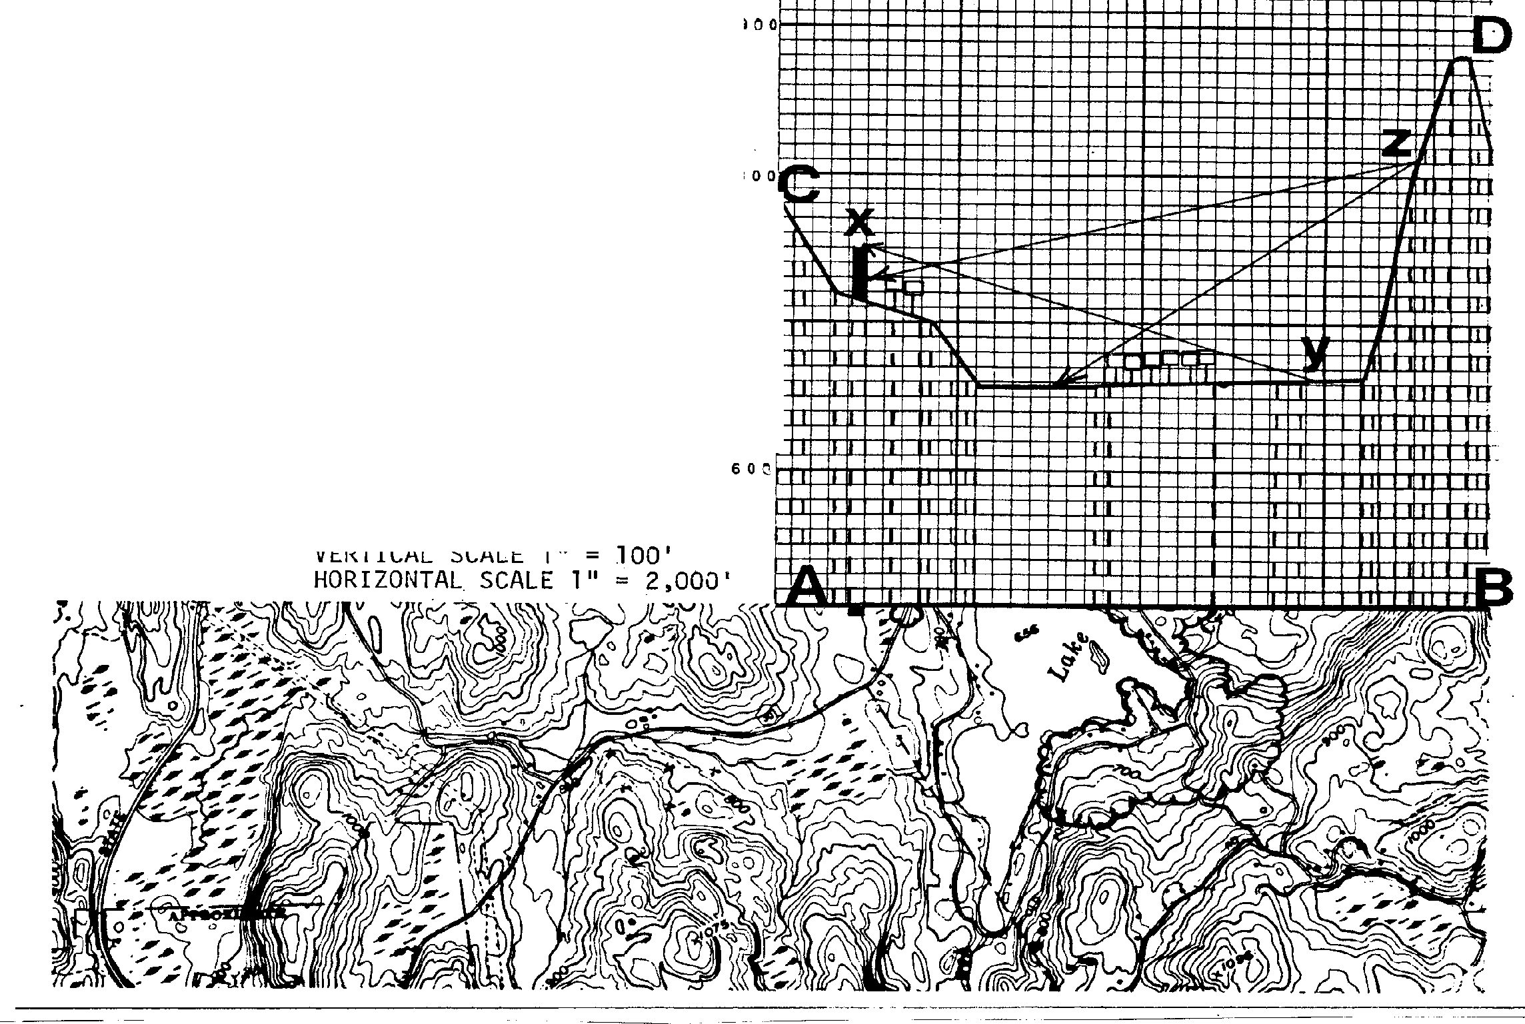see the east shore of the lake?

A. No

Q. At what point will the observer no longer be able to see
object "X"?

A. At point "Y".

Q. What is the visible portion of object "X" to an observer at

700

location "Z"? N
- About 20 feet. i

M Gmail
EXHIBIT H

Dove Helena Pedlosky

question about consistency review for project within NYS Coastal Management Program

dos.sm.Cstl.CR <dosCstlCR@dos.ny.gov> To: Dove Pedlosky
Wed, Nov 29, 2017 at 2:32 PM

You are correct in that it is not legally binding, but I also agree that it is a helpful management tool that the Board can use, if they so choose, to inform their decision when considering visual impacts. Many impacts have already been evaluated and described within the framework of the SASS document and can aid significantly in a municipality's review. The SASS's were developed with the help of all of the interested communities in the planning areas and it would be a shame not to use them as a visioning document at every level of government.

From: Dove Pedlosky [mailto
Sent: Wednesday, November 29, 2017 2:04 PM
To: dos.sm.Cstl.CR <dosCstlCR@dos.ny.gov>
Subject: Re: question about consistency review for project within NYS Coastal Management Program

(Quoted texthidden)

EXHIBIT I

5 January 2018

To: Zoning Board of Appeals & Planning Board Village of Nelsonville
258 Main Street
Nelsonville NY 10516

Re: AKRF, INC.’s review of the Saratoga Associates Visual Resource Assessment (VRA) and related materials, prepared by Homeland Towers, LLC in relation to its application for a telecommunication tower at 15 Rockledge Road, Nelsonville, New York.

The statements of this letter are intended to inform and aid the Nelsonville Zoning Board of Appeals (ZBA) and Planning Board (PB) members in their decision-making process by providing this clarifying response to the additional VRA Review conducted by AKRF, INC (“AKRF”). Their review is hereafter considered for its validity, accuracy, and compliance with the standards of VRA best management practices and in reference to our previously submitted Review of the Saratoga Associates Visual Resource Assessment (“VRA”). All assessments and conclusions reached within this response letter are based upon the information presented, and to the best of the undersigned’s knowledge and belief, that the information contained herein is true, accurate, and complete.

The AKRF review, authored by Mr. Graham L. Trelstad, AICP, provides a superb overview of the VRA in the conclusions and findings that are able to be gleaned, while offering his respectable opinion from a professional background. This response letter is intended to note some of the discrepancies between our VRA Review (“Review of VRA_Final_01Jan2018” submitted document package) and the AKRF’s Review as each relates to the potential visual and aesthetic impacts of the proposed telecommunications tower (“tower”) at two spatial scales:
- Landscape and 2) Village.

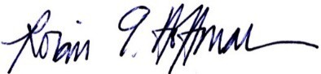
Response letter prepared by:
Dr. Robin Hoffman
Mr. Connor Neville

Department of Landscape Architecture
1 Forestry Drive
Syracuse, NY 13210

Response to AKRF Review of Saratoga Associates VRA
Nelsonville, NY. Report

  - Landscape scale discrepancies
"I believe that both resources [Cold Spring Rural Cemetery and Cold Spring Rural Cemete1y Gatehouse] can still be experienced and interpreted within an overall landscape consistent with the mral cemetery movement and the Hudson Highlands SASS, even if there are ve1y few, if any, comparable modem visual intrnsions, within the smrnunding study area."
-AKRF Review, Page 4
Comments:

- This statement asserts the subjective claim that the village' s most potentially-impacted scenic resources - the views and experiences had by visitors within the nearby site of the Cold Spring Rura l Cemetery and its Gatehouse - wou ld be re lative ly unaffected by the imposition of a 110-foot tower within a distance of 500 feet. More specifically, the defense of th is claim appea ls to the likeness and preservation of the greater Hudson Highlands Scenic Areas of Statewide Significance (SASS) b eing unchanged. Incidentally, this position is essentially self-refuted in the AKRF Review on page 5, where arguments are drawn from the SASS r eport that clearly articulat e how such a tower "'...would introduce discordant elements into the landscape and impair the scenic quality of the SASS' (page 279)."
- The Hudson Highlands regio n is being referenced here in connection to the character of these two significant sites. However, it should be unmistakably pointed out that this line of argumentation does not comprise a holistic view of the entire region, but only speaks to the overemphasized Cold Spring Rural Cemetery site .
- The reviewer ' s professiona l opinion and assertion of minimal impact for this site must t he n be held accountable in light of his experiences: Does he have experience assessing impact s on community-centered histor ic cemet eries? Does he have knowledge of how the community alt ernatively uses this site for festivals and gatherings?
- Therefore, the reductionist view of assessing and prioritizing the cemetery site to be representative of the entire study area's experienced visual impact is a negligent misappropriation of the basic premise of a VRA: which is ideally intended to assess the proposed tower's visual and aesthetic impacts on the entirety of the nearby area - not just the cemetery, as stressed here.
"Similarly, the study area for analysis would vary by the context and scale of the proposed project. While DEP-00-2 identifies a "safe" study area of a five (5) mile radius for "large" projects, no recommendation is provided for "small" projects. fumy professional experience assessing potential visual impacts of telecommunication towers of up to 150 feet in height, I have detennined that most visibility of such towers is within½ to one (1) mile, with ve1y limited visibility beyond that due to intervening topography, vegetation, and strnctures. The Nationwide Programmatic Agreement between the Federal Communications Commission and the State

Response to AKRF Review of Saratoga Associates VRA
Nelsonville, NY. Report

Historic Preservation Officers cites a study area (or "Area of Potential Effect") for assessing visual effects of½ mile for towers of 200 feet or less."
-AKRF Review, Page 3
Comments:

- When referring to the entirety of nearby areas being important for assessment when conducting a VRA, the AKRF pro f essiona l repo rt correctly mentions the best practice of using a 5-mile radius of study. The AKRF Review's follow ing statements are misdirecting, in that they project a persona l stance on the Saratoga Associates VRA which assumes the proposed Nelsonvill e t ower is not subject to adhere to the same guide lines of surveying and analysis- but wou ld rather be considered sufficient in studying only a nar row ed area of focused impact (½-1mile radi us).
- The reviewer ' s r espectable and professional opinions/experiences are offered here and are supported by the claim that topographic and vegetative factors have im peded views in other circumstances and on other projects that he has reviewed. This, howeve r, is not defensible as a universal met hodology by which one could disregard best practice guidelines in all/ dissimilar projects. The assumed study area of ½-mile and 2-mile radii mig ht be sufficiently justified from past experiences elsewhere, but even the Saratoga Associates' viewshed analysis suggested valley-vista vantage points were possible beyond those focused buffer zones.
- The narrative that is formed in the AKRF review is one that seems to narrow the area of consideration for the proposed tower's visual impact to just the cemetery site, at large. This review's consideration largely overlooks the f act that the Villages of Nelsonville and Cold Spring, NY, are - in the ir entirety - state-designated scenic resources on a great er/ landscape scale that have int rinsic merit to be managed for.

11. Village scale discrepancies
"I believe that the project would not have an aesthetic impact on the Cemetery or Gatehouse as the underlying historic integrity of both resources, including the setting, would not be affected in such a way as to 'clearly interfere with or reduce the public's enjoyment and/or appreciation' of the Cemete1y or Gatehouse."
-AKRF Review, Page 4
Comments:

- Mr. Trelstad' s (AKRF r eviewing author) resume documents his credent ials and professional experiences in environmental assessment and community planning project s. The statement of "I believe" with respect to visual and/or aesthetic impact from the

Response to AKRF Review of Saratoga Associates VRA
Nelsonville, NY. Report

proposed telecommunication tower - and the degree of that impact - is a matter of professional opinion, albeit well respected, Mr. Trelstad's opinion.
- Mr. Trelstad' s recognition of the difference between visual impact and aesthetic impact is commendable. In noting that difference, his vocabulary speaks to visual impacts as those concerned with features or qualities that are experienced through the sense of sight; no such vocabu lary, explanation, or definition is provided for aesthetic impacts. This is underst andab le as the subjects of aesthetic , scenic beauty, and visual reso urce management have an extensive history with discourse across mu ltiple discip lines: phi losophy , app lied and fine arts, and environmental resource management. The scope of the discourse ranges fr om debates focused on how beauty is defined to why beauty should be protected to methods for assessing beauty.
- The definition of aesthetics grounded in the philosophy of beauty speaks to a comp lete sensory experience; an experience inclusive of all senses, for example, auditory, t act ile, etc. Aldo Leopold1 wrote that aesthetic value of the land should have lessto do with its colors and shapes or its scenic expanses and picturesque proportions, but have greater concern about the integrity of its heritage and ecological processes. In this case, the aesthetics of Nelsonvi lle, NY, is much more than what anyone sees on the surface. The aesthetic quality of this place is roote d in all of its qualities and features - for example, cultural (architecture, history, scenery), social (community) , ecologica l (topography , vegetation, habit at, scenery) and its place within the context of the Hudson Highlands.
- The features of the Cold Spring Cemetery and Gatehouse are highly valued by the Nelsonville community and are recognized nationally by the National Register of Hist oric Places. These features contribute to the aesthetic value of Nelsonv ille in terms of historic ,
cultura l, and social paradigms. Therefore, from the provided evidence, it is more reasonable to determine that the proposed project would have a negative impact on the aesthetic value of Nelsonville, New York.
- Com munit y-held opinions and values are societally relevant and largely determine what is or is not enjoyable and appreciated.
- The subjectivity of professional opinions - especially within a topic such as aesthetic preference - makes deliberations over issues like the proposed tower very diffi cult for review ing bodies to decide how to weight advice and expert t estimonials. This, however, does not mean that a consensus cannot be reached by either the reviewing Boards or the voting body of citizens.

1 Co nsidered by many to be t he fat her of wildlife ecology and t he Unite d States' wilderness system, Aldo Leo pold was a conserv ation ist, fo res te r, philos o pher, educator, write r, and outd oor ent husia s t . Amo ng his best known ideas is the "la nd ethic," which calls fo r a n ethical, cari ng re la t ion ship between people and nature. <
htt ps://www.aldoleo pold.org/about/ a ldo-leo pold/>

Response to AKRF Review of Saratoga Associates VRA
Nelsonville, NY. Report

- The recommendations and implications of a design firm or a standalone consultant are ultimately just educated suggestions, and ought to be considered in context of all presented evidence as well as stakeholder concerns.

"Finally, although only a minor point on nuance, I feel that the VRA mischaracterizes the lack of an adverse visual impact by using the definition of an 'aesthetic impact' instead. In my professional opinion, the project would have a visual impact on the Cold Spring Rural Cemetery and Cold Spring Rural Cemetery Gatehouse, as defined by DEP-00-2, but agree that it would not have a significant aesthetic impact on either resource. The visual impact is likely not avoidable given the close distance between the project and the Cemetery and Gatehouse and the visibility of the pole above treeline and the ridgeline."
-AK.RF Review, Page 4
Comments:

- Mr. Trelstad' sstatement that the proposed t ower, "...would not have an aesthetic impact on the Cemetery or Gat ehouse" is a contradiction to his conclusion that the public's experience of this place, "...would not be affected in such a way as to 'clearly interfere with or reduce the public's enjoyment and/or appre ciation' of the Cemetery or Gatehouse."
- This concession of visual impact is, in itself, verification that there could possibly be aesthetic impact. The defi nition of each term ('visua l impact' and 'aesthetic impact') is almos t inseparable from one another, being that there must be a perceived visual impact in order to experience decreased enjoyment or interpretive utility of a site, and vise versa.
- The AKRF report affirms the likelihood of expectable visual impact for a tower installation , yet it disregards the pot entia l possibility for the public to experience decreased enjoyment or appreciation of the affected sites with vantage points of the inst allat ion. These two phenomena validate the possibi lity/ impossibility of one another, but are nevert helessseparated in the AKRF report.
- Again, th is over emphasizes the Cold Spring Cemetery site/scenic resources as the prin ciple focus for the VRA, which in no way is a comprehensive review or analysis of the Hudson HighlandsSASS-designated area nor the collective villages of Nelsonvi lle, NY and its neighboring municipalities.

Response to AKRF Review of Saratoga Associates VRA
Nelsonville, NY. Report
"'Mere visibility, even startling visibility of a project proposal, should not be the threshold for decision making. Instead a project, by vi.i1ue of its visibility, must clearly interfere with or reduce the public's enjoyment and/or appreciation in the appearance of an inventoried resource' (DEP- 00-2, p. 9)."
-AK.RF Review, Page 4
Comments:

- Likewise, any one person's perceived degree of aesthetic impacts is never fully able to be considered as a presently-creditable accounting of what is yet to be actualized over the course of time as the public's opinion is formed.
- Logically speaking, speculative expectations of value-based impact and enjoyment upon a scenic resource are temporary predictions unless t hey are undergirded by quantifiab le data and measurable factors (which, ephemeral prefe rences and pleasurescannot easily yield). Thus, these personally-forecasted outcomes of enjoyment and appreciation cannot, and should not, be afforded very heavy influence upon the sway of a decision for future development, due to their inabilit y to accurat ely speak to t he uniqueness and context of this community's inclinations towards aesthetic beauty. Eq ua lly so, a community's collective opinion must not sway decision making beyond that of responsible adherence to law, code, or regulat ory authority.

"I feel that, in its current form, the VRA does not provide enough supporting evidence to document lack of visual impact or aesthetic impact to either the Hudson Highlands State Park or the Hudson River."
-AK.RF Review, Page 2
Comments:

- With all the aforementioned discrepancies accounted for, the unmentio ned portion of the AKRF review is to be regarded as acceptable by this respo nse letter's valuation, as agreeable in the point s that it puts forward in suggesting additional supporting evidence is needed to document lack of visual/ aesthetic impact, and as a thorough ly descriptive assessment of the Saratoga Associates VRA and its affi liated app lication doc ume nts.
- Con versely, it should also be noted that a majority of the AKRF review was simply quoting and representing the VRA findings, which is not confirming or denying their implications - more directly, the ir review was primarily a summary of the VRA with occasional statements of critique or support .

EXHIBIT J

1 January 2018
To: Zoning Board of Appeals & Planning Board Village of Nelsonville
258 Main Street
Nelsonville NY 10516

Re: The application of Homeland Towers, LLC, New York SMSA Limited Partnership d/b/a Verizon Wireless and New Cingular Wireless PCS, LLC (“AT&T”) collectively (hereafter “Applicant”) to construct a wireless telecommunications facility at 15 Rockledge Road, Village of Nelsonville, New York (41° 25’ 20.32”N, 73° 56’ 27.56”W).

The conclusions of this assessment review are intended to inform and aid the Nelsonville Zoning Board of Appeals (ZBA) and Planning Board (PB) members in their decision-making process by providing this third-party analysis in the form of a technical report. The resultant maps, images, and simulations of the Applicant’s visual resource assessment (VRA) and additionally-submitted documents are considered in this review for their validity, accuracy, and compliance with the standards of VRA best management practices. All assessments and conclusions reached within this review are based upon the information presented, and to the best of the undersigned’s knowledge and belief, that the information contained therein is true, accurate, and complete.

This assessment of the Applicant’s VRA and design proposal is based upon the evaluation criteria, foundational concepts, and best practices described in the National Cooperative Highway Research Program (NCHRP) REPORT 741: Evaluation of Methodologies for Visual Impact Assessments (Churchward et al. 2013), among other respectable sources and manuals. This assessment discusses the potential visual impact of the proposed telecommunications tower (hereafter “tower”) at two spatial scales: 1) Landscape and 2) Village.

LANDSCAPE
Example - The Hudson Highlands (Nelsonville, NY) valley has a notable, topographic change from the ridgelines down to the Hudson River corridor, affording the valley with open vistas. What is the extent of the visual impact of the proposed tower to the open vistas of the Hudson River Valley and to the character of the surrounding areas?
VILLAGE
Example - The proposed installation of the tower and the associated access road will require the removal of existing trees. (JMC drawing entitled: TREE REMOVAL PLAN, ZD-4, dated 07/11/2017). How will the proposed removal of trees impact the visibility of the tower – and associated support features – within the Village of Nelsonville?

Assessment report prepared by:
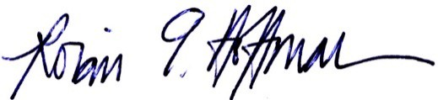
Dr. Robin Hoffman
Mr. Connor Neville

Department of Landscape Architecture
1 Forestry Drive
Syracuse, NY 13210

Review of Methodologies for Visual Resource Assessment:
Nelsonville, NY (Homeland Towers LLC application)

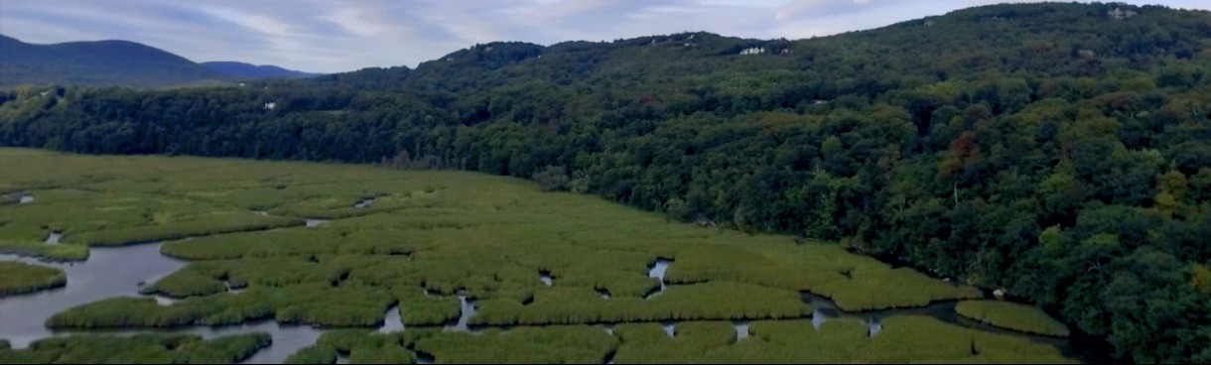Photo source: Ani Drone - www.youtube.com

T.O.C.

Table of Contents

Page

1

1

2

5

6

7

7

7

8

9

9

11

11

12
19
20
Content

  - Landscape scale

    - Regional distinction

  - Vegetative character

  - Valley vistas

  - Topography

  - Village scale

    - Village of Nelsonville, NY

  - Site effects

  - Cold Spring Cemetery

Ill. Conclusions: Saratoga Associates VRA

- Fina l comments to ZBA & PB

- Appendix

  - Eva luation criteria

  - Tower design principles

  - Referenced attachments

  - Descriptive bio and resumes

1 of 22

I. Landscape scale

  - Regional disti nct ion

"The tower site is located within the Hudson Highlands Scenic Area of Statewide Significance (SASS) as designated by the New York State Coastal Management Program (CMP). This is a regional designation which takes into account the unique scenic characteristics of the smrnunding steep tenain, dense forest and grandeur of the Hudson River itself. The relatively minor addition of a low profile and slender stealth monopine teleco1mnunications tower is unlikely to create a point of visual distinction that would be considered detrimental to the scenic quality of the regional landscape."

- Matthew W. Allen, RLA. Saratoga Associates VRA " Proposed Wireless Telecommunications Facility. Site Name: Cold Spring Site, NY- 170. 15 Rockledge Road Nelsonville, NY'' , page 7.

Com me nts:

    - The designation of being a Sceni c Area of Statewide Sign ificanc e (SASS) is principally relevant when conducti ng a VRA. As a result of that determination for an area, the scenic views and resources are accordingly aff irmed as valuab le and import ant factors to consider when planning potential development wit hin the landscape.Any development plann ing - be it mi nor or major - is then burdened with justifyi ng its visual impact upon such a landscape with much-greater scrut iny and crit icism than in a non-SASS designated area. Notably, it is inferable from the Saratoga Associates VRA that their report was completed in a predo minantly-comp liant way to nationall y recognized te mplates of procedures and met hodologies for conducti ng visual resour ce analyses.
However, the following comm ents identify some insuffi cient practices that are of considerable import ance:
    - ECl: Object ivit y (See Appendix V.a Evaluation Crit eria) - The term "unlikely" in the statement above represents a subject ive prediction that is neithe r tied to statistical data (consensus of community standpoint by means of surveys), re ferenced standards (SASS des ignation guidelines for sceni c quality), nor regional landscapepatterns (identification of adjacent forest canopy cover or average tree height ). The presumpt ive impact of this tower design is not mentioned in any cont ext of previous test imonials from similar ly­ impacted communit ies, but rat her, is posed here as an assumed statement of fact.

2 of 22

    - Qualifying adjectives such as " relat ively minor addition", " low profi le", " slender" , and " stealth" are ultimate ly subject ively-valued descriptive t erminologies that hold litt le credibility in the conveyance of realized scenic impacts. Ideall y, to adhere to purely technical guide lines, a VRA' s results cannot wage unquanti fiab le aesthetic descriptions when referring to "scenic qua lit y"; only quantifiable data would be defensible in the presentation of a VRA. Once that data is produced, the affected people, community, and represent ative councils may then collectively determine the aesthetic impact for their best int erests(See Referenced att achments: Sa /kin 2012 and T- Mobi/e Ne. LLC v. Town of Islip ). In this subjectivity/ objectivit y-predicament, the defining respo nsib il ities of an 'expert opinion' are crucial to break the tension. Here, these responsibilities are in question as to whether an offered description in a report - such as the case with Mr. Matthew W. Allen of Saratoga Associates - is able to be reinforced by supporting data and referenced standards of the profession. In this example, those descriptive terminologies are indeed able to be used; however, one could argue that they are not justifiable nor defensible when it comes to defined standards of best design prin ciples and visual resource contrast ratings.
(See Refer enced attachments: BLM Visual Resource Contrast Rat ings , 1986 )

Regiona l imp lications :

Appro val/ disappro val of this communications tower will inevit ably set a precedent case for other municipalit ies along the Hudson Riv er faced with similar development projects. Therefore, approving this application may pot entiall y foster a cumulative negative impact on the Hudson Riv er Valley regional landscape, due to an amassing of towers along the riparian corr idor' s recogn izably-valuable sceni c ri dge lines. Disapproving the proposed tower would likewiseset a precedent example for nearby villages, in that it may afford the empowerment of communities to legally wield a greater measure of contro l and preservation ability towards high-visib ilit y structures becoming int roduced among the SASS-designated sceni c reso urces .
  - Vegetative Character
" .,;. e· .._ 1::.1c:eL .; 1.11:: .).h., ._ ••!m:c1:....1 . :.1.::ic.1.1 ••1 t c.1:: the proposed ea.t.l monopine tower will be seen at extended distance through intervening deciduous vegetation. ac.1 :..11::.el views will be substantially or completely screened during summer leaf-on season. :v.1::,..,.·e .
1 e -.. a s <?< ".!1....1... pine " t ·ve1 design helps to blend the structure with the visual characteristics of the surrounding forest further reducing visual impact."
- Saratoga Associates VRA, page 8.

3 of 22

Comments:

- Pine trees, being coniferous and evergreen, make for an intelligent design basis in many settings because of how paralleled the real trees' characteristics are to the art ificia l branches and fo liage of the synthetic t ower, both of which will persist th roughout the year as " ever-green". These characteristics are in direct contrast to deciduous trees, which lose thei r leaves annually and leave behind bare tree limbs without foliageduring over half of the year in t he northeaste rn US. This f eature is of crucial concern for the design specification of this monopi ne tower in the Nelsonvill e landscape,being as the forest composition is predominant ly deciduous t rees. Thus, the choice of a pine-like camouflage design is scarcely minimizing visual impact, whether during leaf-on or leaf-off seasons.
"The two-mile study area is heavily wooded ,..1c _{ulv\.} _{.-,} e:_ )L _)U., tee •• mature tree canopy
covers approximately 4,930 acres of the 6,590 acre of land area within 2 miles of the Project
site (74.8%). -:'.:'.1e ··" e. a• ..'.', c.e •• 1e::-;.k · ..R. e, c.c ')lt.l •• , ,.. ctc'•• ,n, ...... v K:e - ·· ••1...
1.11:: 2-.!l. e _{,k} I ak1 Mature tree cover generally ranges from approximately 50 to 75 feet in height."

- Saratoga Associates VRA, page 1.
Comments:

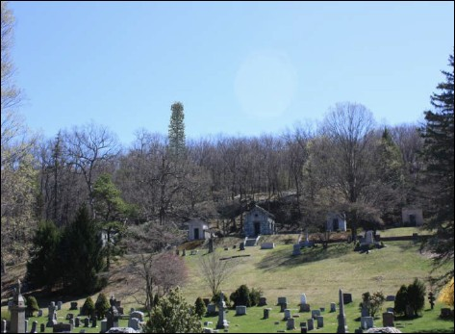
- The vert ical height of the proposed tower (110 feet) will be inconsistent with the average height of most of the forest trees that encompass the landscape vegetation along the valley's hillside (<75 feet ). The visual
rende ring in the Saratoga Associates VRA (see image right ) clearly depicts this, which is misaligned with the best design prin ciples outlined in the Planning and Design Manual for the Review of App lications for Wireless Telecommunications Facilit ies (see Appendix V.b).
- Additionally, the proposed removal of trees (JMC drawing entit led: TREE REMOVAL PLAN, ZD-4, dated
07/11/2017) would leavea distinct scar Photo source: Saratoga Associates VRA - VP11:
Cold Spring Cemetery (near historic Gatehouse) - "FigureSb"
upon the vegetative character of the
hill sid e landscape. This site-based impact is not portrayed in the VRA photo simulations , nor is it revealed in the statements made when referring to the visual impact s of the tower .

4 of 22

":.1 _:: <.• c ec..c u ,u ·· 1dlands provide 1 ·r 1.1 <• : a":· •1 .- e ..1 < •. e< -..,.1· Since the
digitized forest cover -.verlay genera••., identifies only larger stands of woodland vegetation 1.1"• · c..e1.-.:· c'. ..1 u.• 1" .e :.- -..!. 1e.-.1. ;.1.., !!I<) ., . the ·"·1c <. ·e. viewshed map is substantially representative of both leaf-on and leaf-off seasons

- , ..e.:1 ,e. ·e·. the viewshed maps do not determine how much of the proposed wireless telecommunications tower would be visible above intervening landform or vegetation e £•:
• CC O 0, 5( 0 0, • C O O e C -.: • 1. re ..e. t . n •'- ..e. .le ge ::.<-)il.c. <..t::< _{·:v}.t.1..1 ....1C.l ,._,.:1e
) .1.'"'11 -.. the :< c.... :· 1.1eL.et <.1.. ., ·,· 1 c )e •·• • e Their primary purpose is to provide a
general understanding of a project's potential visibility and identify areas where further investigation is appropriate."

- Saratoga Associates VRA, page 3.
Comments:

  - The above statement in bold presents a logica l fallacy of inconsistent reasoning, which gives way for the potentially-misleading statement that the viewshed map is accurate ly depicting seasonal variations of visibility. The syllogism of 'since A then B' does not follow in the reasoning presented, whereby "forest cover... ident ifying larger stands of woodland vegetation" determines that "the... viewshed map is substantially represent at ive of both leaf-onand leaf-off seasons". Leaf-off conditions inarguably allow for a more-visible line of sight through vegetative canopy covers, especially within hilly t errain and across valleys. The digitized forest cover overlay, due to its attributes/restrictions of what it can and cannot render, are the refore limit ed to only being representative of leaf-on conditions-thus,creating a viewshed map of only r estricted-visibilit y seasons of the year with foliage,subtly lessening the illustration of how much the tower would be visible during leaf-off seasons.
  - The determined areas that viewshed maps identify as vantage points are then consequent ly the most prioritized sites to conduct visual simu lations of the proposed tower installation. The visual rende rings of the VRA only identified these areas in ground­ view perspectival Pho t oshop simulations within a ½ mile study area. Best practices suggest that additiona l renderings of t he proposed tower be conducted from birds-eye views, orthographic sectional views, and especially from farther distances to give landscapecontext to the vegetative character of the site as it relates to the tower (see Appendix V.b).

5 of 22

  - Valley vistas
"The largest area of potential Project visibility is found on the water surface of the Hudson
River. T ·.e'l··· .:._.:1 .k R... e: _):e ,e.•l ., ... c..ude .1e 1.. e ·e. -..1ec' c 1< 1. '".el ... 1.11.. 1.,.,a.11.. Le T • ••• '"ge
- ._ .c pring. The vast majority oft 1e 2-mile study area 'l .11 be substantially or fully screened

by intervening landfonn or c e.1·e fore ·eget.•. Hud-;on Highlands tate Par. . "
- Saratoga Associates VRA, page 4.
Comments:
.. .._{K.,k} ..lf: much of the trail network within

  - The distance of a 2-mile study area for the VRA is not representative of the visible range of the Hudson River Valley municipalities that are upstream or downstream from Nelsonville. Guide lines would suggest an approach that is comprised of renderings from 0-5 mile distances (see Referenced Attachment: BLM Visual Resource Invent ory, 1986 - pg. 5).
"Of the 8,041 acres within the 2-mile study area, < 1e•· ••. k.) •.'oc;ed telecommunications
1,.,.. e•• · .1e'-.e1C< •.:·.K· .. e .. ,.,.:11.).).-.·:....1e• ., 5. ac1e (6.4%) fthe502acres··•.1..1 .1e l 2-mile study area. a view of the proposed tower is possible ... !l \)pr"ximately 45 acre (9.0%)
Of the 77 miles of public roads within Lle 2-••i..e• 11.. .u 're., fl.el. .) k.1.1.P. _ ec. ··.e·:v '":e
- l .. c <1'-.1;1:, ))•'-;•.:1, te:.: :a lmear nu.e (2.5%) Of the 22.9 miles of public roads within the 1/2-mile radius study area. ."1tential P1'-ec. ··.e.. < :e. 1\t1c ,....g_ 1e · 1.1,.•1• : .:.••e (5.7%) "
- Saratoga Associates VRA, page 4.
Comments

  - Extending the viewshed beyond 2 miles would introduce new percentages of visible acreage surrounding the proposed tower that are current ly undiscussed. The t ot al acreage that is broken down by the VRA' s summary of percentages is not necessarily indicative of every nearby vantage point of scenic significance.
  - Such methodo logies/word choice which constrain the study area to 2-mi le and ½-mi le buffer zones creates possible biases with perceived percentages of visibility. Given the dramatic topographic variation of the Hudson Valley landscape, vistas and vantage points beyond a 2-m ile zone are certainly present and significant to the regional landscape .
  - Given the location of the village being considered a 'river/boating community' whose scenic waterfront and marshes supply great views for watercraft-based tourism, the nearby section of the Hudson River provides an important resource area to consider for pot entia l visual impact that cannot be omitted in a VRA.

6 of 22

  - The SASS designation also speaks directly to the geographic passages which contain valuable cross-valley vistas from the river facing the shoreline. Below are excerpts from the Hudson Highlands SASS re port supporting this theme:
    - "Views from one side of the river to the other unify the landscape and often make the two shores of the Hudson appear as one, since their nature is essentiall y the same. The SASS is generally free of discordant features. Interruption of these views or blocking these views with highways, power lines, signs and other structures in conspicuous locations would introduce manufactured elements into a predominantly natural landscape. Such structures would constitute discordant features and would reduce the unity of the landscape, impairing the scenic quality of the views. In certain circumstances and from certain perspectives, such structures could block views, part icular ly the inti mate interior views and tunnel views to the Hudson along the bluffs on the eastern shore, destroying some of the contributing scenic components of the SASS."
    - . " Between Storm King and Breakneck Ridge [At the proposed tower site], where the high peaks drop straight to the water, the Hudson River corridor is a f jor d, deepened by glacial action and filled by the rising sea as the ice melted. This landscape feature is unique in New York State and very rare in the eastern United States. "
    - . " Cross-river views include many dramatic peaks... Viewed from the Hudson River, the wooded shore lands and cliffs of the SASS rise abrupt ly from the Hudson River to the mountain peaks and ridges. Views are confined in the narrow corridor ..".
  - Topograp hy
Comments:

- As stated in subsection l.c, the strong variation in hillsides and ridgelines within the Hudson River Valley prov ide vantage point s that allow for un impeded views of the tower site. The views that are claimed to be "substantially or fully screened by intervening landform[s]" (Saratoga Associates VRA , page 4) refer to the locations situated on opposing sides of mountains which were noticeably identified in the viewshed maps and do not need further consideration. What is not accounted for with visual simu lations and renderings are the t opographically-significant views that have been identifi ed by the viewshed map (as well as those areas beyond the 2-mile buffer zone surrounding the proposed tower) which depict superior and inferio r vantage angles of the tower as it rela t es to f art her-away places.
- Topographical variations in an area prov ide great contrast when viewing peak structures along a hor izon lin e or silhouett ed landscapein contrast to the sky (see Appendix V.b).

7 of 22

11. Village scale

  - Village of Nelsonville, NY
Comments:

    - Using an aeria l image such as the basemap layer of the VRA viewshed map and supplemental zoning boundary maps of the village, land-use interpret at io ns of t he Village of Nelsonville present an obvious mosaic of land-use types (fo rested , ur ban/ suburban, wetland, mountainous, im pervious roadways, etc.). This variety of nearby land-useraises concerns for the prob lematic imposit ion that the proposed t ower could have on areas with resid ential neighborhoods, st ate/ local parks, identified cultura l resources that are only partially represented in the VRA photo simulations, and other nearby village resources. The alternative to such a pot entia lly-imposing site would be a commercially­ zoned parcel of land that is nestled within a less-developedarea and is farther away from reside ncesand cultural resources.
    - The 600+ resident population of t he village affords a densit y of need/demand - albeit through-traffic and visitor abundance are accounted for - which calls in to question the qualif ication of major roads and areas bei ng designated as having a " significant need" within the presented "coverage gaps" for data service. Those arguments/conversations are somewhat beyond this review' s purview, but when pertaining to the visual reso urces being assessed fr om the inst all ation of a t elecommunications facility, minimizing/ mi t igat ing impacts must consider the necessity of such a proposed t ower in its form, function, and cont extual placement.
  - Site effects

Comments:
The fragility of the proposed site is concerning, as it r elat es to atmospheric impacts of clear cutting 50+ trees, pot ential construction pollution events along a resident ially-se nsitive hillside, creation of a forest gap the reby affecting wildlife corridors, as we ll as non-eco logical factors such as:
    - The proposed 8-foot fence defining the perimeter of the tower site would also be visibly im pact ful from many vantage point s identified in the immediately-adjacent vicinity (cemetery, neighborhoods, roadway, etc.)
    - All of the photo simulations show the ½-mile radius area with all existing trees remaining; the simulat ions do not account for trees that will be removed for road construction and tower inst all ation .

8 of 22

    - Removal of trees will increase visual access to the base of the tower and its associated infrastructure. For example, the chain link fence and gate at an 8-foot height would be more noticeable from certain viewpoints as well as the equipment shelter as shown in the submitted JMC Site Plan drawings.
    - There wou ld be changes to the backdrop/ context ual setting of the Cold Spring Cemetery (see subsection 11.c).
    - Disturbances in the stabi lity of the wooded area wou ld persist; this relates not only to forest health as a community resource but also to visual qua lit y. The removal of trees by cutting into the forest and reshaping the wooded area' s edge wou ld make the site more likely to experience increased tree wind-blow events due to prevailing winds whipping over the hill's ridgeline.
    - Fewer trees would remain on-site to visibly screen the tower and its associated infrastructure from the viewpoint of cemetery visitors, in addition to other locations that have neighboring access to the tower site. (see Appendix V.b)

  - Co ld Spring Cemetery

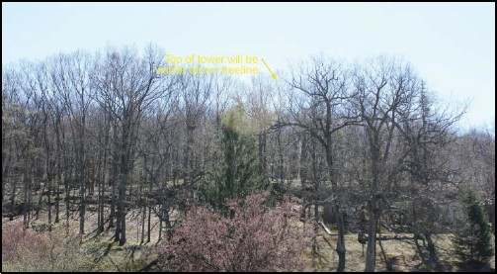
    - This property is of very significant value both on the nationa l level (National Register of Historic Places- NRHP) as we ll as at the community level, being designated as one of many areas of cultura l and scenic
importance. Coincidentally, this cemetery site would receive the most impact fu l view of the proposed tower due to its proximity and unimpeded sight­ lines.
    - The VRA' s photo simulations provide representations of the
cemetery from the two identified

vantage points of the viewshed analysis. However, by simply providing two main photos
Photo source: Saratoga Associates VRA - VP12: Cold Spring Cemetery (north end)- "Figure Al"

with only one demonstrating an actua l rendering of the proposed tower, the minimum requirements to complete a VRA for the simu lation/ visualization section might be satisfi ed, but additiona l renderings wou ld most likely need to be submitted in order to appease the obligation of providing sufficient evidence of minimal impact.

9 of 22
    - Proof of minimal disturbance of the cemetery site during construction (noise, runoff, equipment placement/travel, etc.) was not provided in the Applicant' s submission package.
    - Specifically, the cemetery's Gate House building is a list ed property on the NRHP. However, the entire cemetery was deemed ' eligible' for the Register by New York's State Historic Prese rvation Office (NY-SHPO). Additiona lly, the area of pot ent ial visual impact for the proposed t ower site contains 13 individuall y-listed properties on the National Register, which amounts to a very high concentration of historicall y-significant propert ies within a ½-mile radi us of the proposed 110-foot tower.

Ill. Conclusions: Saratoga Associates VRA
This review - conducted as a third-party critique int ending to objectively analyze the methodo logiesand overall effectiveness of the Saratoga Associates Visual Resource Assessment (VRA) and additiona l documents for the Homeland Towers LLC & affiliates' app lication to insta ll a proposed wireless telecommunicationst ower/ facility in Nelsonville, New York-was completed to aid in the review process as the Nelsonvi lle Zoning Board of Appeals and Planning Boards joint ly determine the outcome of the Applicant's request.
This review's emphasis on inadequacies, ine ffi ciencies, or unsatisfact ory practices demonstrated in the VRA (in ligh t of best management practices and recognized standards of conducting VRAs) was in no way to be over ly-disapproving or discouraging. In truth, the majority of the VRA was comp leted to an acceptable t emplate of methodo logies for satisfactorily finalizing a VRA in many other contexts and circumstances. It should be understood that the Saratoga Associates VRA report, apart from the important exceptions pointed out in this rev iew, is exceptionall y do ne and should be respected for its thoroughness and adherence to technical viewshed mapping protocols. Nevertheless,the uniqueness of this proposed site, specifica ll y within its village and regional settings, would suggest that addit iona l mat erials of submission need to be provided in order to confidently approve this VRA as an accept able report that has appropriat ely assessed the scenic and visual resources of the proposed site.

- Final comments to ZBA & PB
Again, the goal of this technical repo rt was to provide an academically-accountable record of the aspects and nuances of the Applicant' s propos al materials - namely, the Visual Reso urce Assessment .
The decision to accept, reject, or defer the proposed application is complet ely outside of this review's intention and abilit y, and will inevit ably be decided with more than this review' s
info rmation in mind. It is with great caution, however, that we suggest you proceed in the review process by serious ly considering the incompletenessof the assessed visual

10 of 22

(among other) impacts that this tower could impose upo n the landscape of Nelsonvi lle and the greater Hudson Highlands region.
For your convenience, some significant statements from this review of the Saratoga Associates VRA have been provided below as findings of fact:
    - I.a Regio n al Distinction (page 1)- (ECl: Objectivity) The presumptive impact of this tower design is not mentioned in any context of previous testimonials from similarly-impact ed communities, but rather, is posed here as an assumed statement of fact.
    - l.b Vegetative Character (page 3) - The vert ical height of the proposed t ower (110 feet) will be inconsistent with the average height of most of the forest trees that encompass the landscapevegetation along the valley's hillside (<75 feet). The visual rendering in the Saratoga Associates VRA clearly dep icts this, which is misaligned with the best design prin ciples outlined in the Planning and Design Manual for the Review of Applications for Wireless Telecommunications Facilities (see Appendix V.b).
    - l.b Vegetative Character (page 4) - The visual renderings of the VRA on ly identifi ed these areas in ground-view perspectival Pho t oshop simulations within a½ mile study area. Best practices suggest that additiona l render ings of the proposed tower be conducted from birds-eye views, orthographic sect ional views, and especially from fart her distances to give landscapecontext to the vegetative character of the site as it rela t es to t he tower
    - l.c Valley vistas (page 5) - Such methodo logies/word choice which constrain the study area to 2-mile and ½-mile buffer zones creates possible biases with perceived percentages of visibility. Given the dramatic topographic variation of the Hudson Valley landscape, vistas and vantage points beyond a 2-mi le zone are cert ain ly present and significant to the regional landscape.
    - l.c Valley vistas (page 6) - The SASS designation also speaks dir ectly to the geographic passages which contain valuable cross-valley vistas from the river facing the shoreline . Below are excerpts from the Hudson Highlands SASS report supporting this theme (see 3 excerpts)
    - 11.c Cold Spring Cemetery (page 8) - by simp ly providing two main photos with only one demonstrating an actual rendering of the proposed tower, the minimum requirements to complete a VRA for the simulation/ visualization section might be satisfied, but additional renderings wou ld most likely need to be submitted in order to appease t he ob ligat ion of providing sufficient evidence of mini mal impact .

11 of 22

- Appendix

  - Evaluat ion Crit eria ("EC's")

"These evaluat ive crit eria pr escribe desirable overarching characteristics of visual impact assessment met hods and procedures."
-Churchward et. al, 2013. "Report 741: Eva luation of Methodo logies for Visual Impact Assessments", pages 6 and 7.

The ten criteria are:

ECl. Objective - the procedure is designed to eliminate individual bias.

EC2. Valid - the procedure can be defended as measuring what it intends to measure.

EC3. Reliable - adequat ely trained professionals fo ll owing the procedure reach the same conclusion.
EC4. Precise - the data required by the procedure are measured at a grain or scale sufficiently fine to validly measure or describe characteristics of substantive int erest, and suffi cient ly coarse to be pragmaticall y imp lement ed.
ECS. Versatile - the procedure supports valid assessment of different types of proposed changes from the perspectives of different viewer groups interacting with different landscape settings.
ECG. Pragmatic - the procedure can be easily and efficient ly implemented by a trained professional.
EC7. Understood easily - the procedure and resultant assessments are accessible by the public and decision makers.
EC8. Useful - the procedure and resultant assessments affect location, design, or mitigation decisions.
EC9. Imp lement ed consistently - the procedure can be app lied consistently among different projects, and individua l assessments are consistent with the chosen procedure.
ECl0. Legitimate - the procedure is supported by laws, regu lat ions or other legal mechanisms , uses socially/ cult urally accepted st andards , and uses scientificall y accepted standards

12 of 22

  - Tow er design prin ciples
Pages 12 - 18: Planning and Design Manual for the Review of Applications for Wireless Telecommunications Facilities: A Practical Guide for Communities Managing Wireless Telecommunications Facilities Siting in New York State.
Town of Pit t sford. M arch 2001.

0 BASICPRINC IPLES OF DESIGN

This =ion provides informarion on basicdesign principles and terminology that can be used to evaluate the visual im pa-c:13of applicant proposals.The basic design demcnts that should be consiclc=l when reviewing new wireless facilities include scale,line,form,tcxtu.rc,and color. The impaa a new wireless faciliry hJS on a commun ity is usually based on its:d c,grcc of change ro these exisri ng
d emcm s. A good unclersunclingof these demem:s should he-Ip municipaliry rcprcscnrarives form objective commcms on the degree of contrast a new facility may present.
The basicdesign princ i ples:
  - Scnl.r: the proportionate siz.c rc-larionship bc=n an object and the surroundings in which the object is placed.
  - Fom1:th e srructurc, mass, or shape of _{:1} landSC1pc or of an object.. Landscape form iso endefined by edges out!inc:s o f landforms, rocldorms, Vegt'rarion p:mems, waterfurms, or the endoscd spacescreated by· these: atrr ibutcs.
  - Lim ,: the imers«tion of cwo planes; a point chat has been extended; a silhoucnc of form. In landSC1pcs-

20

ridges. slcylincs, structures, changes in vegetation, or individual trees and branches-may be perceived as line.
    - Hxtrln : the visua l manifestationsoFthe interplay of light and shadow c.rcatcd by the variations in the surface oF an object or landsc;ipc.
    - Col.or.The property of rdlccting light of a past:icula r
  - ·dcngth that enables the eye to dilfe.rcntiate otherwise ind.iscinguish.tbleobjects. A hue (red, green, blue, y-dlow, and so on), ascontrasted with a valu bla,ck whire, o r gray.
T he following illustr.itions id en ti fy the major design princip les one should umkrstand in order to evaluate the visual impact of app cant proposals:

13 of 22

    - Sc.ale

Existing Condition.
The existing trees are the distinct feature in the landsc ape .

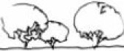New Condition.
The height of the tower pro\<okes a strong contrast to existing adjacent vegetation.

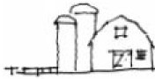
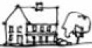
Existing Condition.
The existing buildings are the
d is tinct feature in the landscape.

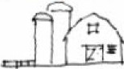New Condition.
Tower heightcontrasts height of surrounding buildings and structures. Also, use of materials is foreign to !he exist ing bu ilt environmenL

21

14 of 22

    - 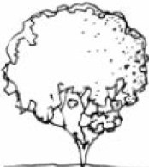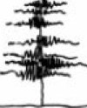Form .,,ht,
1•
A typ i ca l tower construction has a distinct vertical fo rm. Often the form
of the tcr"'er can contrast adjacent vegetation helght and te xture.

Fine
Ova l
Deciduous
Coars-e
Ver ti cal
Coarse
Ve rti cal
Evergreen

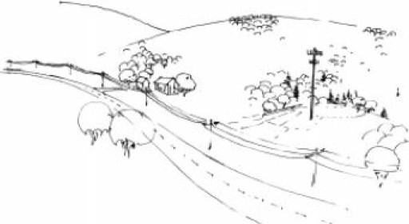
In this view, the form of the tower appears to have less contrast and therefore less impact on t™t surrounding landscape. The landform, rather than the tower, is the domil'\at ing feature in t™t landscape.

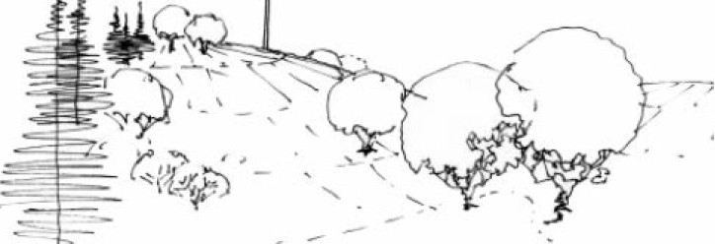
If Ill
In this vie,w lhe form of the to.,,e r con trast'S the lana form. The contrast is inc reased because the tower also contrasts the open background viewof the sky.

i 22

15 of 22

- U.ne

Existing Cond ition.
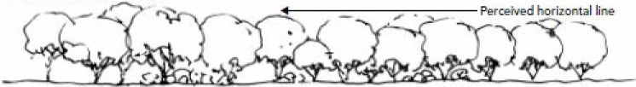
Thecommon vegetation form and height creates a perceived ho rizontaI li ne.

T o-11er. height and vertical form contra-st
t
a " .,- t horizontal line of the ground plane and the tree tops.

1;.%)
New Condition.

- CU Ol!ii.;i;·;

, ,,.. ..._. -
. -.
-Gill,Q_ ,F,_..J.... ---

. .T'- ·
.,
:.-·,-:..-. ....(·.._..,...-
'
-----
----

Eldsti ng Cond ition.
The landform in this view creates the perception of line.
1\ , \,
\1.. .. '-.

- Tower. new visible element that constasts
---
- - - - - - ---- - - - m: :...
..--- existing horizon plane and sky background.

,,..;;•..
,--;.
,- -cc:s-ar.:-.--.--- -

N ew Condition.

16 of 22

- Texture

Existing Cona tlon.
The corrmon texture and massing of the vegetation unif-.es the landscape.
- :f
\
l
\
- 71'
. -
. .
•
. •
-·

Existing vegetation
...--(similar scale and species)
-x
._J

New Cona tion.
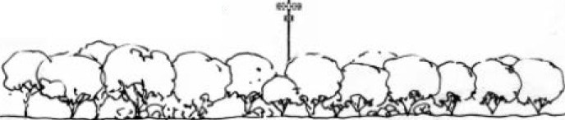
The height and foreiQJl textureof the tower adversely contrasts the characteristics of the existing vegetation .

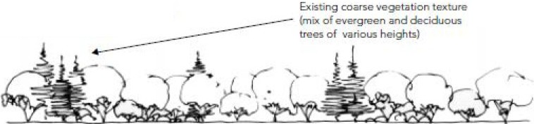
Exlm ng Cona ti on.
The varied types of vegetation create an
irregu lar patt.em and texture.

New Condition.
The irregula r scale and texture or the tower are les s intrusive
on this irregular and non-unified form of the vegetation.

24

17 of 22

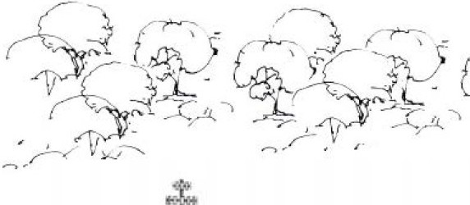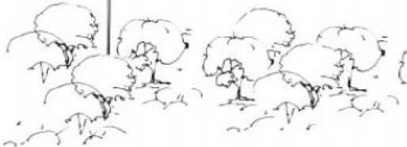Existing Conatlon.
The texture and scale of the vegetation is somewhat regular.

Vi<sua l impact of n- tower contram
<scale and texture of existing vegetation.

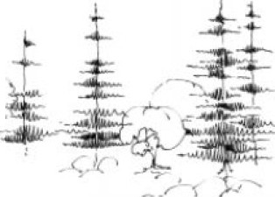
Existing Conatlon. -C, _
The texture of the landscape { ., ,n
is varied.

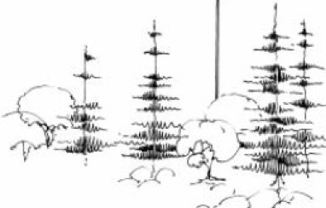
Visua l impact of ne,N tower is minimized by ttie scale
and texture of surrounding varied Yegetati on.

25

18 of 22

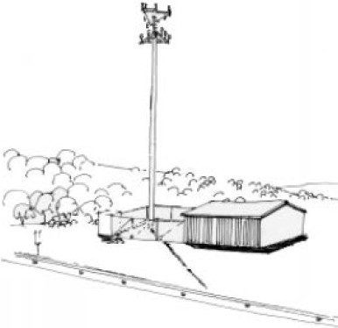
  - Site Design Details

'Nireless facilities often include a base building and a tower enclosed in fencing. Us.ually, the tower has the greatest visual impact on the landscape because of its contrasting scaleand form. Ho-Never, the base building can also impact an existing landscape becauseof its scale, form, and te xture . Often attempts to mitigate the contrasting features of the facility fail to
consider these contrasts from various points of view.

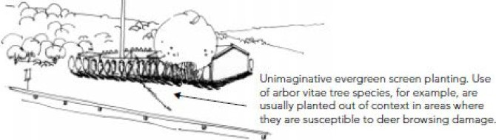
Typical landscaping around a facility.

-
Creative approach to
landscaping a round the facility.
'l
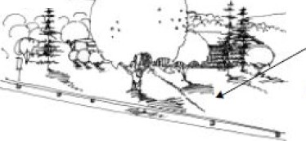
...__,_

Use of native evergreen and
_91!Ciduous plantings for
screening. Use of "aried
·-- plant groupings brealcs up appearance of base faci lity. Foreground planting
_ minimizes theimp act of the facility's scale .

26

19 of 22

  - Ref er enced at t ach ments

Bureau of Land Management (BLM): Handbook H-8431-1, Visual Resource Contrast Ratings.
1986.
Bureau of Land Management (BLM): Handbook H-8410-1, Visual Resource Inventory. 1986. Churchward, C., J.F. Palmer, J.I. Nassaur, and C.A. Swanwick. 2013. NCHRP Report 741:
Evaluation of Methodologies for Visual Impact Assessments. Nat ional Cooperative Highway Research Program. Washington, D.C.
JM C Plan ning Enginee ring Landscape Architecture & Land Surveying, PLLC. July 11, 2017. Site Zoning Drawings: ZD-4: Tree Remova l Plan.
Town of Pittsford and contributors. 2001. Planning and Design Manual for the Review of Applications for Wireless Telecommunications Facilities: A Practical Guide for Communities Managing Wireless Telecommunications Facilities Siting in New York State. New York State Department of State, Division of Local Government . Albany, NY.
Salkin, Pat ricia. 2012 . Fed. Dist. Court in NY finds Aesthetics Sufficient to Deny Cell Tower Application. Law Of The Land. <htt ps:/ / lawofthe land .wordpress.com/ 2012/10/ 26/fed­ dist-court-in-ny-fi nds-aesthetics-suff icient-to-deny-cel l-tower-application/ >. Web .
T- M obile Ne. LLC v . Town of Islip. United States District Court, E.D. New York. 21 Sep 2012

Saratoga Associates. 2017. Proposed Wireless Telecommunications Facility - Site Name: Cold Spring Site, NY-170. 15 Rockledge Ro ad. Nelsonville, NY. Visual Resource Assessment.
New York State Department of the State. Division of Coast al Resou rces and Waterfront Revitalization. Ju ly 1993 (Reprinted 2004). Statewide Areas of Scenic Significance: Columbia-Greene Nort h, Catskill-Qiana, Estates District, Ulster North, Esopus- Llyod, Hudson Highlands.
<https:/ / www.dos.ny .gov/ opd/ programs/ HudsonSASS/Hudson%20Riv er%20Va11ey%20SA SS.pdf>

20 of 22

  - Descript ive bio and resumes

Department of Landscape Architecture

SUNY College of En vironment al Science and Forestry

http://www.esf.edu/la/department.htm

Since 1911the Landscape Architecture program at SUNY-ESF has been educating practitioners and t eachers, designers and planners, advocates and policy makers who have devoted careers to a viab le, sust ainab le integration of natural and cult ural communities.
The Department of Landscape Architecture offers three degree programs designed to educate students to contribute in varied ways to society and the wise use of land and landscape . Each provides a basis for students to establish career directions in the profession of landscape architecture. The Bachelor and Master of Landscape Architecture, and Master of Science degrees are off ered.
The large and diverse faculty offer not only a wide range of foundation courses necessary for professional preparation , but also four strong areas of study that encourage in-depth exploration in ecologicaldesign and planning , community design and planning, and cultural landscapeconservation.

State University of New York
E§.f
Colkgc or Environmental Science and Forestry

21 of 22

Robin E. Hoffman, PhD
Departmen t of Landscape Architecture
SUNY College of Environmental Science and Forestry Syracuse, NY

1997-present Associate Professor, Bachelor of Landscape Architecture Curriculum Director
Teaching Design Studios, Professional Practice, Off Campus Experiential Studio, Construction Technology
Research Visual resource management, specifically the juxtaposition of the cultural and ecological significance of a view.

r
1993-1997 Ph.D., Forest Resources Management
Department of Forest and Natural Resources Management
SUNY College of Environmental Science and Forestry, Syracuse, NY
Dissertation Testing the Validity and Reliability of Slides as Representations of Northern Hardwoods Forest Conditions.
1983-1985 Master of Landscape Architecture, Cum Laude
Department of Landscape Architecture University of Illinois, Champaign-Urbana, IL
Thesis Creativity in the Introductory Design Studio: Experience or Setting?
1977-1982 Bachelor of Landscape Architecture, Cum Laude
Department of Landscape Architecture
SUNY College of Environmental Science and Forestry, Syracuse, NY
Special Projects: Off-campus work study program with the Greek National Forest Service. Developed Master Plan proposals for Greece's first botanical and zoological recreation park.

p
Attendee Visual Resource Stewardship Conference
Argonne National Laboratory Lemont, IL November 6 - 9, 2017
Presenter Renewable Energy Development and Land Trust's Role Rally 2017: The National Land Conservation Conference Denver, CO October 26 - 28,2017
Presenter Conservation Management Planning: Responsible, Dynamic, Transparent
Rally 2012: The National Land Conservation Conference Salt Lake City, UT September 29 - October 3, 2012
Trustee Thousand Islands Land Trust
Clayton, NY

ES"iJFf""

State University of New York
Colkgc or Environmental Science and Forestry

22 of 22

Richard Connor Neville, B.S.
Department of Landscape Architecture
SUNY College of Environmental Science and Forestry Syracuse, NY

2017-present Graduate Teaching Assistant and DLA Graduate Student Representative
Teaching Natural Factors Analysis in Planning & Design (undergrad and grad level course), Introduction to Geospatial Information Technologies
Research Community planning and design, historic restorative design

2017-present Master of Landscape Architecture
Department of Landscape Architecture
SUNY College of Environmental Science and Forestry, Syracuse, NY

2013-2016 Bachelor of Science, Agricultural Studies - Summa Cum Laude Richard A. Henson Honors Program - Graduate, Entrepreneur and Scholar Department of Agriculture, Food and Resource Sciences
University of Maryland Eastern Shore, Princess Anne, MD
Special Projects: Developed a comprehensive tree inventory map for UMES campus, Aided in creating a campus infrastructure GIS database, QA/QC accuracy assessment for Assawoman Bay Watershed, Digitized the Manokin River Watershed, lead the "Champion Tree Project" quantifying vegetative character of UMES.

p
Attendee

Technician Presenter

"Outstanding Volunteer" and Land Monitor

AASHE National Conference & Expo Baltimore Convention Center Baltimore, MD October 9, 2015
UMES Geospatial Information Technology Laboratory
Princess Anne, MD January 2016 - August 2017
'Ditch -itizing' the Manokin River Watershed + Tree Inventory of the UMES Campus Maryland State Geographic Information Committee (MSGIC) Summer Quarterly Salisbury, MD July 21, 2016
Lower Shore Land Trust
Snow Hill, MD

ES"iJFf""

State University of New York
Colkgc or Environmental Science and Forestry

December 29, 2017
EXHIBIT K
P.O. Box 226
20 Nazareth Way
Garrison, NY 10524
phone: 845.424.3358
fax: 845.424.3483
info@hhlt.org www.hhlt.org

BOARD OF DIRECTORS
Nancy Berner
Chair
James Cross
Vice Chair
Seamus Carroll
Treasurer
Rudolph Rauch III
Secretary

Douglas Banker Jeffrey Bunzel Gilman Burke Tom Campanile Christopher Davis Irvine Flinn Phoebe Geer James Hartford Laura Hromadka Henry L. Kingsley Daniel Kramer Lars Kulleseid Douglas Land Claudio Marzollo
Frederick Osborn III Robert Rhodes Frederic Rich William Schuster
Anne Sidamon-Eristoff Bente Strong Anne Symmes Bonnie Turner
Glennon Watson Lissa Young

HONORARY DIRECTORS
Anne Cabot Bevis Longstreth Ralph Odell Katherine Roberts Jean Wort
Cecil Wray

STAFF
Michelle Smith Kathy Hamel Jonathan Leitner
Katrina Shindledecker Nicole Wooten

printed on 100% recycled paper
Village of Nelsonville Planning Board and Zoning Board of Appeals 258 Main Street
Nelsonville, NY 10516

Dear Chairman Rice, Chairman Marino and Members of the Planning Board and Zoning Board of Appeals:

RE: Homeland Towers, Inc. Proposed Cell Tower at 15 Rockledge Road

The Hudson Highlands Land Trust (HHLT) submits the following comments in relation to the siting of a large cell tower on Rockledge Road in Nelsonville.

The mission of HHLT is to “protect and preserve the natural resources, scenic beauty and rural character of the Hudson Highlands”. We believe a 110-foot cell tower in the shape of a “stealth monopine” will be detrimental to the scenic beauty and rural character of our area, and we encourage the Village to consider less visually intrusive means of improving cell coverage in our area.

We urge the Village to follow the example set by the Adirondack Park Agency (APA) in ensuring that any cell towers blend into the surrounding landscape and do not detract from the outstanding scenic beauty of our area. The APA’s policy on telecommunications towers and other tall structures is attached as Exhibit A and, in particular, Section III B discusses the concept of “Substantial Invisibility”. We recommend the Village follow similar processes for the reasons outlined below.

The site at 15 Rockledge Road in Nelsonville is part of the Hudson Highlands Scenic Area of Statewide Significance. It is included in the HH-20 sub-unit, known as the Garrison Four Corners sub-unit. The Hudson River Valley Scenic Areas of Statewide Significance report, from the NY Department of State, says “The subunit is recognized through the designation of NY Route 9D as a Scenic Road under Article 49 of the Environmental Conservation Law and through the inclusion of twenty structures and their estates on the State and National Registers of Historic Places, most as part of the Hudson Highlands Multiple Resource Area. The subunit is free from discordant features“

New York's Coastal Management Program includes Policy 24, which provides for the designation and protection of Scenic Areas of Statewide Significance. This policy calls for agencies to determine if a proposed action would impair scenic quality.

Hudson Highlands Land Trust – Comments on Cell Tower

The policy states that impairment of a landscape's scenic quality can occur “through the addition of structures which reduce views or are discordant with the landscape because of their inappropriate scale, form, or construction materials.”

Based on the viewshed and visual simulation materials submitted by the applicant and by Philipstown Cell Solutions, we believe the current proposal includes a structure that is discordant with the landscape because of inappropriate scale and form. Furthermore, we find the applicant’s scenic analysis lacking in terms of the important viewpoints that were not included, but where the Rockledge Road area is clearly visible. Examples include: many points along the Hudson River, key scenic areas in State Parks – both on Storm King Mountain and Mount Taurus trails heading up from Nelsonville, in Constitution Marsh, and various points along the designated Scenic Route 9D.

We are concerned that the current proposal would set a dangerous precedent in a rapidly evolving telecommunications environment that includes both:
- The recent reversal of “Net Neutrality” by the FCC, and
- The simultaneous application for another new cell tower in Philipstown

It is not yet known if these events signal the start of an increasing number of cell tower applications in our area. The evidence presented by Philipstown Cell Solutions shows that such large cell towers are currently not present in Scenic Areas of Statewide Significance, other than those that pre-date the designation or to support national security institutions (e.g. West Point Military Academy).

The Hudson Highlands is an area of unique, unparalleled scenic beauty that drives both our tourism industry and our attractiveness as a place to live. This, in turn, creates the need for more cell and data coverage. However, the installation of such infrastructure cannot come at the cost of what makes the Hudson Highlands so special in the first place.

We urge you to reject the current application on the basis that it impairs our scenic resources. We encourage you to guide applicants towards structures that blend in with our scenery and consider the ways in which other agencies, such as the Adirondack Park Agency, have been able to ensure that communications infrastructure fits in with the surrounding landscape.

Sincerely,

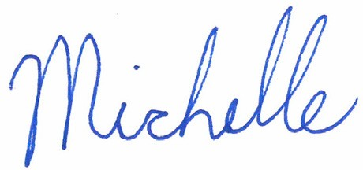
Michelle Smith, Executive Director

Page 2 of 2

Exhibit A

Adirondack Park Agency  Policy, Procedures & Guidance System | Agency- 4
Topic: Policy on Agency Review of Proposals for New Telecommunications Towers and Other Tall Structures in the Adirondack Park
Richard H. Lefebvre, Chairman | Date: February 15, 2002

- Purpose

The purpose of this policy is to provide guidance to the Agency, to telecommunications providers and others within the Adirondack Park regarding the Adirondack Park Agency’s exercise of its powers and duties in light of the federal Telecommunications Act of 1996 and changing conditions within the Park. The policy specifically addresses telecommunications facilities covered by the federal law, that is, every type of wireless and radio emission device including cellular telephone, microwave, AM and FM radio and television. However, the guidance is also generally applicable to other tall structures subject to Agency regulatory review within the Adirondack Park.

This policy is intended to protect Adirondack Park aesthetic, open space, and other resources and, at the same time, provide guidance for a telecommunication system consistent with federal law. The natural scenic character and beauty of the Adirondack Park is the foundation of the quality of life and economy of the region, long recognized as a uniquely special and valuable State and National treasure. The policy must take into account the Park setting and serve the needs of Adirondack Park residents and visitors.
The policy recognizes the potential compatibility of a system for personal communication signals (cellular telephone, PCS, wireless digital communications) in already developed areas and segments of streets and roadways where there is access to the existing electric and telephone infrastructure required for these facilities and where substantial invisibility can be achieved.

- Background

- General
The Adirondack Park Agency administers the Adirondack Park Agency Act, the New York State Freshwater Wetlands Act and, for private lands, the New York State Wild, Scenic and Recreational Rivers Act within the six-million acre Adirondack Park. The Adirondack Park Land Use and Development Plan recognizes the complementary needs of all the people of the State for the preservation of the Park’s resources and open space character and of the Park’s permanent, seasonal and transient populations for growth and service areas, employment, and a strong economic base.
The Agency also administers the Adirondack Park State Land Master Plan which sets forth

Exhibit A

guidelines and criteria for the use of State-owned lands within the Adirondack Park. These lands include the Adirondack Forest Preserve, protected as “forever wild” by Article XIV of the New York State Constitution since 1895.

Among the Agency’s duties and powers is the review of proposals for virtually all new telecommunication facilities as “major public utilities.” This review responsibility also includes all structures over 40 feet in height. Under the Adirondack Park Agency Act, the Agency must determine that each proposed telecommunication or other facility requiring Agency regulatory approval is:

- “consistent with the [Adirondack Park] land use and development plan;”
- “compatible with the character description and purposes, policies and objectives of the land use area wherein it is proposed to be located;”
- “consistent with the overall intensity guideline for the land use area involved;”
- consistent with the shoreline restrictions, if applicable; and
- “The project will not have an undue adverse impact upon the natural, scenic, aesthetic, ecological, wildlife, historic, recreational or open space resources of the park or upon the ability of the public to provide supporting facilities and services made necessary by the project, taking into account the commercial, industrial, residential, recreational or other benefits that might be derived from the project. In making this determination, . . . the agency shall consider those factors contained in the development considerations of the plan which are pertinent to the project under review.”
See Adirondack Park Agency Act, NYS Executive Law, Article 27, Section 809(10)

In wetlands and rivers areas, additional findings will be required.

The 1996 amendments to the federal Telecommunications Act require, as a matter of federal law, that the Agency administer its regulatory responsibilities without discrimination among providers, in a manner that does not result in a prohibition of service, and in compliance with federally mandated radio emission effects standards. Federal law recognizes protected areas like public parkland, freshwater wetlands, formally designated wilderness, the Adirondack Forest Preserve and other special characteristics of the Adirondack Park, whose values are articulated and protected in the planning and regulatory process administered by the Agency.

- Current Trends
In light of these responsibilities the Agency adopted a Policy on the location of new towers in 1978. That policy discouraged mountain top structures and encouraged co-location of facilities. Recognizing the changing technology utilized by the telecommunications industry, and the demands of government services and public safety factors, the Agency determined in August of 2000 that the 1978 policy should be updated because:

Exhibit A

- current technology provides cellular telephone service through many small-scale facilities interconnected to land telephone lines and electric power;
- governmental emergency communications are being converted to digital technology which will require new facilities to provide services to meet needs for public health, safety and welfare; and
- the policy should be re-evaluated in light of the 1996 federal Telecommunications Act, which acknowledges State and local authority to evaluate specific locations and designs.

The changing technology will result in requests for the construction of new towers for improved telecommunications systems. When considering the mountainous terrain of the Adirondack Park, there is a potential for requests for multiple facilities to improve coverage over time. Anticipated requests for more towers and the concerns over the effectiveness of the current policy to provide meaningful guidance in the development of the system authorized by federal law lead to this policy update.

- Policy on Telecommunications Towers

- General Policy
New telecommunications towers located within the Adirondack Park will be located to avoid undue adverse impacts in such a manner as to be substantially invisible and in the vicinity of existing settlements or those portions of highway corridors where existing telephone and electric power is accessible to the proposed facility. Facilities must also be designed and sited to avoid or minimize impact to nearby land uses. Co-location of facilities is preferred so long as substantial invisibility is achieved. Governmental emergency telecommunication towers will be handled in the same manner, with consideration given to the health and safety needs of the public.

Private, commercial telecommunication towers and facilities will not be located within the constitutionally protected Adirondack Forest Preserve. Governmental emergency telecommunications facilities located on State land must, in those very limited circumstances where they are allowed, be consistent with the Adirondack Park State Land Master Plan.

New tower proposals will be presented with supporting information regarding the proposed facility location, alternative support infrastructure, designs and locations and future facility plans, adequate to determine whether the cumulative impacts of the proposed towers will result in undue adverse impacts on the Adirondack Park. Applicants will be required to provide the best available data and visual representations in order to maximize Agency and public understanding of the proposed project.

- Substantial Invisibility
A “substantially invisible” communication facility and its appurtenant support facilities and access road(s) will not be readily apparent as to size, composition, or color and the structure(s) will, to the maximum extent practicable, blend with the background vegetation, other structures or other landscape features as seen from all significant potential public

Exhibit A

viewing points and as documented by simulation and other visual analysis methods. Potential public viewing points include public roads, navigable waters and other public places. Substantial invisibility is intended to be applied on a site specific basis and may be achieved by consolidation of existing visual intrusions and/or by the development of facilities within lawfully existing buildings, and/or by providing substantial screening or concealment of the structure itself.

Substantial invisibility is considerably different in developed areas with the less restrictive Hamlet land use area classification when compared to areas classified Rural Use and Resource Management in light of the differing statutory purposes and policies for these areas set forth in the Land Use and Development Plan. To further the purposes of substantial invisibility, implementation of this policy recognizes the potential compatibility of the construction of communication facilities in areas with less restrictive land use classifications in an effort to preserve the open space character of the Park as called for in the Section 805 purposes, policies and objectives for all differing land use areas.

Preferred methods to reduce visibility include: avoiding locating facilities on mountain tops and ridge lines; concealing any structure by careful siting, using a topographic or vegetative foreground or backdrop; minimizing structure height and bulk; using color to blend with surroundings; using existing buildings to locate facilities whenever possible; using architecturally compatible buildings to house ground equipment; and otherwise using best available technology that avoids or minimizes visual impacts.

When none of the above preferred methods achieve substantial invisibility, camouflage in scale with the surroundings may be proposed in order to blend the facility with the visual setting.

- Consolidation of Visual Intrusion
Consolidation of visual intrusions occurs when equipment is co-located on a single existing tower or on a new tower immediately adjacent to a lawful pre-existing facility.
Consolidation of visual intrusions also occurs when telecommunication equipment is attached to other pre-existing tall structures, such as utility poles, water tanks, or buildings. In developed areas existing buildings, overhead utility poles and similar structures may host telecommunication equipment and achieve substantial invisibility even when the telecommunication device is in plain view juxtaposed to the existing structure. This policy is intended to maintain the visual quality and character of the site and to avoid undue adverse impacts to scenic vistas, locally important viewsheds, and historic resources. It should be noted that there is an indefinite threshold where the consolidation of visual intrusions becomes overbearing and considered clutter with resulting undue adverse impacts on the Adirondack Park. As part of the alternatives analysis required of the applicant, methods of avoiding or reducing clutter in a viewshed through consolidation at a site with more than one tower or multiple sets of equipment on a single tower will be necessary as part of the Agency review and permitting process.

Exhibit A

- Emergency Communication Facilities
The Agency recognizes that the demands of public health, safety and welfare will involve the upgrade of governmental emergency communications facilities. This policy recognizes that such factors should be taken into consideration along with the other policy guidelines contained herein.

- Obsolescence and Abandonment
This policy is intended to require removal of obsolete or abandoned telecommunication facilities. A plan for timely removal of any related telecommunications structures which become obsolete or are abandoned will be required as an element of any proposal for a new facility. The Agency may require guarantees to assure removal and/or restoration of the site.

- Local Government Regulations
Local Governments share authority over land uses, including telecommunications towers, with the Agency and consistent local regulations will be considered a supplement to this policy.

- Legal Effect

This policy is not intended to set forth a fixed general principle to be rigidly applied. Rather, its tenets are to be utilized solely as guidance and should be applied only after taking into account the specific facts and circumstances set out in the application and project review record for each proposed telecommunications tower.

- Adoption

The Adirondack Park Agency has reviewed and adopted this policy effective February 15, 2002.

By
Richard H. Lefebvre, Chairman Date

EXHIBIT L

January 9, 2017

Zoning Board of Appeals Planning Board
Village of Nelsonville 258 Main Street
Nelsonville, New York 10516

RE: Homeland Towers Application for a 110’ Tower facility at \ Rockledge Rd

To Chairman Rice and members of the Zoning and Planning Boards,

In light of new submissions regarding landscape character and aesthetic impact from the Applicant, I am writing as a supplement to my letter of 11/27/2017 to register my professional opinion about
the intrusive and significant aesthetic impact that the proposed tower will have on the Cold Spring Cemetery and to provide the boards with key historical design context that seems to be missing from the record.

I have reviewed the submissions and register my strong disagreement with the following opinions:

OPINION 1, Graham L. Trelstad, AKRF, Letter to Boards on 1/ 2/ 2018, PG 4:
“I believe that the project would not have an aesthetic impact on the Cemetery or Gatehouse as the underlying historic integrity of both resources, including the setting, would not be affected in such a way as to “clearly interfere with or reduce the public’s enjoyment and/or apprecia- tion” of the Cemetery or Gatehouse. I believe that both resources can still be experienced and interpreted within an overall landscape consistent with the rural cemetery movement and the Hudson Highlands SASS, even if there are very few, if any, comparable modern visual intrusions, within the surrounding study area.”

OPINON 2, Matthew W. Allen, Saratoga Associates, Letter to Boards on 12/19/ 2017 , PG 6
“...the addition of the telecommunications facility may have some limited effect on the integrity of setting of the Cemetery; however that affect will not be adverse, and certainly not substantially or significantly adverse.
While the facility will be visible from within parts of the Cemetery, it will be within the viewshed of only a small portion of the large Cemetery property. Thus much of the Cemetery’s setting will be unaffected by the proposed telecommunications facility. In locations where the facility will be visible, the effect on the cemetery’s setting will not be adverse due to the proposed stealth pine tree design, which will minimize the salience of the tower and the fact that only the limited upper portion of the stealth pole will be visible.”

OPINION 3, Laura L. Mancuso, CBRE Letter of 12/18/2017, PG 4 “The addition of a telecommunications facility on an adjacent parcel may have some limited effect on the integrity of setting of the Cemetery; however, that affect will not be adverse, and certainly not substantially or significantly adverse. As twenty-first century individuals, we are used to and expect to see modern intrusions in landscapes. While the facility will be visible from within parts of the Cemetery, it will be within the views- hed of only a small portion of the large Cemetery property. Thus, much of the Cemetery’s setting will be unaffected by the proposed telecommunica- tions facility. In locations where the facility will be visible, the effect on the Cemetery’s setting will not be adverse due to the proposed stealth pine tree design, which will minimize the salience of the tower and the fact that only the limited upper portion of the stealth pole will be visible.”

I am dismayed, and frankly, startled that none of these opinions delineate for the benefit of your boards the defining aesthetic charac- teristics of the Rural Cemetery that they claim will not be adversely affected by the addition of the proposed tower. If the opinion is that the defining character and overall experience of the cemetery is not significantly impacted by the tower, shouldn’t this claim be supported with objective evidence such as a summary of the character-defining features that will allegedly remain intact? Frankly is unclear to me
if any of these professionals have an adequate understanding of the Rural Cemetery Movement and its significant design principles. If they did, they would not be able in good conscience to make the above judgments.

As I indicated in my 11/27/2017 letter to your boards, the place- ment and discordant design of the tower significantly intrudes into the horizon view immediately as one enters the cemetery (as shown clearly in Figure 5 on the applicant’s own submitted photo simula- tion of their 6/2/17 VRA). The tower has an even larger visual impact on the open sky and natural treeline that define the visitor’s experience of the large northern sector of the historic property which sits in a valley below an elevated ridge upon which are nestled the mausoleums of significant figures in our local history.

HUDSON GARDEN STUDIO LLC
www.hudsongardenstudio.com 16 Fishkill Ave
Cold Spring NY 10516

One of the core design principles of the American Rural Cemetery in the Victorian Era was “verticality and sense of ascension” (see follow- ing summary by Jack Goodnoe)- in other words, manipulating to- pography in order to create symbolic importance of monuments and tombs at higher elevations. The social status of the dead (and their living ancestors) was physically built into in the experience of a land- scape - the higher the social position, the higher in physical elevation was the resting place, reinforcing an all important social order.

In the case of the Cold Spring Cemetery, one can easily see that the cemetery is designed to draw the eye to these important gravesites on this elevated picturesque ridge as soon as you enter the cemetery.
What’s doubly remarkable in the case of the Cold Spring Cemetery is that this monument ridge is designed to echo the dramatic varia- tions of the natural topography of this specific dramatic Hudson Highlands site. In landscape theory this is known as ‘genius loci,’ or ‘the spirit of place,’ when abstract design is tied to specific landscape characteristics - whether they are landforms, or local plant communi- ties, etc. In landscape theory, harnessing the specific ‘spirit of place’ through design creates powerful landscape experience and meaning.

At the Cold Spring Cemetery, the visitor who is enticed by the entry view of the horizon and takes the time to stroll up to this inviting ridge to pay due respect to the important figures buried there is then rewarded with a surprising and stunning view of the larger Hudson River Valley—arguably the best view from the entire property. This landscape was clearly designed as an experience, and the experience of ascending to this defining ridge of mausoleums is arguably a key component of its design. One could argue that the walk from the historic entryway up to the ridge is evocative of the journey from death to eternal life. The importance of the effect of this dramatic visual and experiential linking of local property and the larger region cannot be overstated.

The aesthetic impact of the proposed tower cannot be fairly judged in this case by pointing to the percentage of total area from which the tower is visible on the property. One cannot see the historic gate- house from a majority of vantage points within the cemetery either, but no one would argue that the gatehouse then has an insignificant aesthetic impact on the character of the cemetery!

A legitimate aesthetic impact judgement would be supported by juxtaposing the specific significant character-defining features of this particular historic and scenic property to the visual impact of the proposed tower and describing the interaction of the latter on the former. I submit that this accounting appears to have not been done by the professionals quoted above. If it has been done, I’d ask that they reveal and/or summarize the evidence supporting their opinion to the Boards.

HUDSON GARDEN STUDIO LLC
www.hudsongardenstudio.com 16 Fishkill Ave
Cold Spring NY 10516
To support my professional opinion registered herein I submit the following list of defining features of the “Landscape Character” and “Design Principles” of cemeteries designed in the Rural Cemetery (sometimes called “garden cemetery” ) style, as summarized by professional Landscape Architect and planner Jack Goodnoe, RLA, ASLA in a presentation to the 2013 Annual Meeting of the American Society of Landscape Architects (ASLA). The Cold Spring Cemetery is a significant local example of a cemetery in this style that has been largely preserved and has remarkably been largely unhindered by
the intrusions of modern development (until now!). Mr. Goodnoe’s presentation summarizes neatly:

Garden Cemetery Landscape Character
•Visual openness
•Expressive variety of monumentation
•Verticality and a sense of ascension
•Classical styles and forms
•Uniformity of materials
•Organic landscape designs
•Human scale and intimacy

Rural Garden Cemetery Design Principles
- Topography based road alignments and burial layouts
•Vertical and varied monumentation
•Open ground plane under a high deciduous canopy
•Changing, ‘Surprise’ vistas (with water)
•Burial lawns raised above road

I submit that of the defining features of the “Garden Cemetery Landscape Character” listed above, the proposed tower will have a significant visual impact as well as a significant adverse aesthetic
impact on the sense of “visual openness” of the key elevated monu- ment row and the valley burial area below it. It will quite certainly impair the site-specific design, underlying meaning and public experience of a key ascent—perhaps the key ascent—in the landscape design, thus impairing an important aspect of the “verticality and sense of ascension.”

The discordant nature of the monopine design as well as its stark difference in height from the surrounding treeline is in my opinion ineffective at buffering and camouflaging the tower views among a much shorter deciduous forest. The level of camouflage achieved is low, and the tower will stand out as a modern and artificial intru- sion on a key ridgeline, thus impairing “organic” character of the landscape design of the key entryway view, the view from the central public gathering place around the flagpole, and a significant num- ber of views from the open northern valley portion of the property. The “human scale and intimacy” of the landscape character of the cemetery is also impacted by the introduction of an 110’ element
so out-of-step with what is generally acceptable for structures in the community and especially in the cemetery that it needs a special permit to allow it.

2

I further submit that several of the features embodying the “Design Principles” listed above will be negatively impacted and thus may impair the publics experience of the cemetery in the context of the Rural Cemetery Movement. The “burial lawns raised above the road,” in the Cold Spring Cemetery, particularly the Butterfield resting place and the other monuments along that key ridgeline will be burdened with a very significant visual impact of the tower that is also aesthetically significant. The new tower element would introduce a similarly competing and discordant visual element into a landscape tableaux purposely designed to focus the visitor’s attention on the monuments and their relationship to the starkly open sky and, by visual inference, to heaven and the after life. In my opinion the in- trusion of the modern tower is enough to impair the visitor’s under- standing and enjoyment of the metaphor evoked by this design and will negatively effect the designed journey up to the monument ridge in a way that intrudes into the viewer’s experience of the “changing, ‘surprise’ vistas” of the cemetery and beyond into the larger Hudson Valley encountered along the way.

These are the main supporting details from which I form my profes- sional opinion that the tower will produce a significant adverse aes- thetic impact on the cemetery that is not mitigated by the monopine design, the height or the choice of location for this tower.

Furthermore, I also attach to this correspondence a document sup- porting my own professional opinion about the central importance of landscape design to the cemeteries of this movement like Cold Spring Cemetery: “Perpetual Care: A Sustainable Approach to Restoring the Lost Landscape of America’s Rural Cemeteries” by Benjamin Gilbert Buckley.

Mr. Buckley argues:
“American Rural Cemeteries are defined by their picturesque landscaping. The carefully planned footpaths and thoroughfares that weave throughout these sites dictate the experience of visitors and play and essential role in the historic landscape.” (pg 35)

He also notes:
“The landscape architecture and lot horticulture of rural cemeteries are arguably their most character defining feature.” (pg 46)

And finally, of particular note here:
“These cemeteries have been planned as natural escapes from the chaos and commotion of city living, but over the years urban development has encroached on the landscapes, affecting the visitors experience of the site.” (pg 46)
In my professional opinion, the view of this proposed tower from the gatehouse entryway, the view from the central flagpole where the entire community gathers for ceremonies like Memorial Day, the multiple and significant discordant views from the designed open
space of the entire northern portion of the cemetery along with other views not fully examined here will be significant and would impair one of the central experiences of the cemetery’s historic landscape design. The significant visual and aesthetic impact of the proposed tower on these key views diminishes several of the character-defining features of the cemetery and in my opinion is likely to result in a diminishment of the public's appreciation of the cemetery within the context of the Rural Cemetery Movement.

I strongly advise that you do not allow this modern development to encroach on this treasured landscape and impair the visitors’ experi- ence and enjoyment of this significant and remarkable historic and scenic resource. Other (less detrimental) siting options, mitigation techniques or technologies should be required of the applicant.

Sincerely,
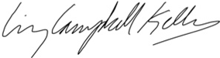
Liz Campbell Kelly, ASLA
Principal, Hudson Garden Studio LLC
MLA University of Pennsylvania

3 HUDSON GARDEN STUDIO LLC
www.hudsongardenstudio.com 16 Fishkill Ave
Cold Spring NY 10516

University of Pennsylvania
ScholarlyCommons

<&3&3 ��*3402*$ �2&3&26"4*0/� �2"%5"4& �20(2". */ �*3402*$ �2&3&26"4*0/

�0��
Perpetual Care: A Sustainable Approach to Restoring the Lost Landscapes of America's Rural Cemeteries
Benjamin Gilbert Buckley
��� �����! �� �����!� ����

�0--07 4)*3 "/% "%%*4*0/"- 702,3 "4� )>1���2&103*4029�51&//�&%5�)1!4)&3&3
�"24 0' 4)& �*3402*$ �2&3&26"4*0/ "/% �0/3&26"4*0/ �0..0/3

�5$,-&9 �&/+". / � -#&24 ��&21&45"- �"2&� � �534" /"#-& �1120"$) 40 �&3402 /( 4)& �034 �"/%3$"1&3 0' �.&2 $"�3 �52"- �&.&4&2 &3�
��0���� "���� ��������� ������ ������� ����
)>1���2&103 4029�51&//�&%5�)1 4)&3&3����

�5((&3 &% � " 0 �
�5$, &9� �& +" � #& ��0���� ��������� ����� � ����������� �������� �� ��������� ��� L��� L��������� �� ��������� ����� ����������� ��"3 & 3
<&3 3�� � 6& 3 9 0 �& 39 6" "� � "%& 1 "� ���

< 3 1"1& 3 103 &% " �$ 0 " 9�0 0 3� >1��� &103 0 9�51& �&%5� 1! &3&3����
�0 0 & 0 " 0 � 1 &"3& $0 "$ # " 9 &103 0 9�10#08�51& �&%5�

Perpetual Care: A Sustainable Approach to Restoring the Lost Landscapes of America's Rural Cemeteries

Abstract
During the mid 19th century burial practices in America evolved drastically with the creation of “rural” cemeteries. These burial grounds became incredibly popular didactic landscapes that were physical manifestations of contemporary Victorian social forces. Many of these historic landscapes are in need of conservation and restoration in order to preserve what remains. This thesis project lays out the significance of these sites, and provides a guide to restoring the character defining features of these cemeteries.

Keywords
cemetery, landscape, victorian, restoration, sustainable

Disciplines
Historic Preservation and Conservation

Comments
Suggested Citation:
Buckley, Benjamin Gilbert (2013). Perpetual Care: A Sustainable Approach to Restoring the Lost Landscapes of America's Rural Cemeteries. (Masters Thesis). University of Pennsylvania, Philadelphia, PA.

Th s thes s or d ssertat on s ava lable at ScholarlyCommons: http://repos tory.upenn.edu/hp theses/547

PERPETUAL CARE: A SUSTAINABLE APPROACH TO RESTORING THE LOST LANDSCAPES OF AMERICA’S RURAL CEMETERIES

Benjamin Gilbert Buckley A THESIS
In

Historic Preservation

Presented to the Faculties of the University of Pennsylvania in Partial Fulfillment of the Requirements of the Degree of

MASTER OF SCIENCE IN HISTORIC PRESERVATION 2013

__ _ Advisor
Aaron Wunsch, Phd.
Assistant Professor in Historic Preservation

__ _ Program Chair Randall F. Mason
Associate Professor of City and Regional Planning

Dedication

This graduate thesis project is dedicated to my parents, who have provided me with unwavering support throughout my academic career.

Acknowledgements:

The following Masters of Science in Historic Preservation thesis project was made possible through the contributions of many individuals and organizations. I want to thank Aaron Wunsch and Jessica Baumert for acting as advisors in this endeavor. I also would like to thank the Woodlands Trust for Historic Preservation for allowing me the opportunity to conduct this project on their site.
I was fortunate to enough to have a number of volunteers assist me in various parts of this project. I extend special thanks to; Nicole Juday, Erica Maust Kevin Wohlgemuth, Joe Shapiro, Mark Jansen and JulieAnn Murphy

Table of Contents

- The Significance of Rural Cemeteries
  - Introduction 1
  - Objectives 3
  - Scholarly Literature 5
  - History and Significance of Rural Cemeteries in America
12
- Section One Figures 21
- Cemetery Landscape Restoration; Recommendations and Examples
  - Documentation, Planning, and Restoration Ethics 28
  - Dallett Family Lot; Drafting and Implementing a Preservation Plan
32
- Labor  - Preserving Access Routes  35  - Iron Enclosures |  | 33  37
- Restoration of Landscape Features  - Lot Furniture  - Monuments | 50 | 46  51
4. Section Two Figures | 56
5. Conclusion | 54
Bibliography | 76
Index | 78

List of Figures Section One
  - Plan of Mount Moriah Cemetery 21
  - View of Mount Moriah Cemetery 22
  - Mount Moriah Cemetery Today 23
1.4. Original Plan of Mount Auburn Cemetery 24
  - Plan of The Woodlands Cemetery 25
  - Tower at Mount Auburn Cemetery 26
  - Boulder Monument at the Dallett Lot 27
Section Two
  - Dallett Family Lot at The Woodlands 56
  - Dallett Family Lot in 1860 57
  - Dallett Soap Factory 58
  - Volunteers Exposing Brick Paving 59
  - Newly Exposed Walkways 60
  - Detail of Dallett Lot Iron Enclosure System 61
  - Detail of Robert Wood Iron Works Catalogue 62
  - Photo of Fence Panel Chosen for Restoration at the Dallett Lot 63
  - Paint Sample Photomicrograph Under Visible Reflected Light 64

  - Paint Sample Photomicrograph Under Ultra Violet Light 65
  - Photo of Fence Panel During Restoration 66
  - Photo of Fence Reinstallation 67
  - The Harris Lot at The Woodlands 68
  - The Printers’ Cemetery at The Woodlands 69
  - Cedar Grove at Laurel Hill Cemetery 70
  - View of a Lake at Mount Auburn Cemetery 71
  - Historic Irises at The Woodlands 72
  - Landscape Restoration in Progress at the Dallett Lot 73
  - Hedge Restoration at the Dallett Lot 74
  - Cast Iron Settee 75

INTRODUCTION

Cemeteries in America are by and large overlooked and underappreciated as historic landscapes. Historic burial grounds are cultural constructions that contain and display a wealth of information on a range of historic topics. These funerary sites evolved with cultural trends and produced distinct landscape forms over time. Popular burial practices evolved drastically starting in the second quarter of the 19th century with the advent of the rural cemetery movement. This period of cemetery history is incredibly significant for a variety of reasons, but continues to receive insufficient attention from historic preservationists and heritage professionals.
Mount Moriah cemetery in Philadelphia is an example of one of these important burial grounds that developed from the rural cemetery movement.
Mount Moriah cemetery was incorporated in 1855 by an act of the Pennsylvania legislature. The cemetery was located on a large tract of land on the west edge of Southwest Philadelphia that had only recently been incorporated in the city limits, and some of it still lay outside the now sprawling city. Set far afield from the dense urban development in central Philadelphia, the cemetery quickly became a fashionable burial space for middle class city dwellers. The site featured meandering dirt paths cut into rolling hills and circular sections upon high points.(fig. 1) The bucolic landscape contained clusters of old-­‐growth trees, a meandering creek, and open meadows. The cemetery company went about creating a series of improvements to define but not necessarily tame the landscape.
An elaborate brownstone Moorish revival gatehouse was constructed at the

entrance of the property and iron fencing was installed along the edges of the

property. A masonry bridge was constructed to span the creek, and stone signs were installed to demarcate sections of the burial ground. Soon after its founding, the naturalistic landscape developed a forest of marble and granite monuments that rose between the trees and shrubs and which varied greatly in height, shape, and style. (fig. 2)These monuments were surrounded by enclosures of iron or stone, and often romantically landscaped, embellished, and cared for by the lot owners. The site became a popular weekend destination for tourists and lot holders, as an escape from urban nuisances as well as reflective and memorial site in a natural setting.
Mount Moriah was one of many rural cemeteries that developed outside American cities and towns beginning in the 1830s. The earliest included Boston’s Mount Auburn [1831] and Philadelphia’s Laurel Hill [1836], (making Mt. Moriah a late example of the type). These sites remained popular until the early 20th century when newer cemeteries began to adopt more simplified rectilinear plans, removed enclosures to simplify maintenance, discarded broken monuments and removed trees and plantings. By the mid 20th century these landscapes had been heavily altered. Mount Moriah Cemetery is an extreme example of this phenomenon. As the city of Philadelphia grew in size, the area surrounding the cemetery became densely developed, and eventually became economically depressed. The cemetery fell out of favor and directors failed to maintain the site. Today, the architecturally significant gatehouse has suffered a partial collapse, and the majority of the site has been overtaken by uncontrolled vegetation, making most of the burial plots inaccessible. (fig. 3) The once-­‐bucolic and well-­‐tended landscape has now become a magnet for

illegal waste disposal and crime. Years of mismanagement have led to irrevocable loss of a historic landscape.
Although the story of Mount Moriah is an extreme example, many of America’s rural cemeteries have lost elements that defined their 19th century appearance. The following project aims to explain why this is an unacceptable state for some of America’s most important cultural landscapes. It is imperative that cemetery owners and caretakers recognize the significance of remaining landscape features and work to restore the integrity of these often overlooked and undervalued historic sites. By undertaking this project, I hope to aid in the restoration and conservation of rural cemeteries by demonstrating their significance, providing a historic context, and presenting a collection literary resources. The second portion of this report discusses treatment options and approaches for the character defining features of rural cemeteries, and provides a short example of the implementation of a cemetery landscape restoration project.

OBJECTIVES

In this project, I seek to address a long-­‐neglected issue in the field of historic preservation: the conservation of nineteenth century rural cemeteries and acknowledgement of their significance as cultural landscapes. The history of the type has been well documented, but only three or four such institutions actively interpret and preserve their landscapes today. The rural cemetery movement was a manifestation of emerging trends in religion, landscape architecture, burial practice,
domestic values, public park development, and other fields that make these sites

highly significant in nineteenth century American history. Over the course of the twentieth century, many rural cemeteries deteriorated or evolved to the point where most of the character-­‐defining features are no longer extant. With each passing day, the important vestiges of these disappear. While various governmental and preservation organizations have produced general literature on cemetery preservation, rural cemeteries that require specific restoration approaches. It is vital that action is taken to protect the remaining elements of these historic sites, and to reestablish some of the features that once defined these “genteel pleasure grounds.” This project provides a thorough literature review of sources to aid in these endeavors, running the gamut from conservation information to rural cemetery history and context. The significance of these cemeteries is then reviewed in a chapter on the historic development of these cemeteries. The last large section of this project contains basic restoration guidelines and presents an example of the implementation of the first stage of a sample landscape restoration project.
Taken as a whole, this project should serve as a practical resource for cemetery managers and other stakeholders who wish to restore and preserve the historic nature of their properties. Most historic cemeteries face challenges finding the funding, labor, time, and professional guidance to accomplish restoration projects, which makes restoring and preserving the intricate landscapes of rural cemeteries especially challenging. This project seeks to provide practical advice and restoration guidelines at a level that can be implemented with limited resources, and carried out over time, as well as prescribe methods for historical research.

SCHOLARLY LITERATURE

The rural cemetery phenomenon in America was rediscovered in the 1970’s, and 80’s by various authors and historians. By this time these institutions’ landscapes had deteriorated to such an extent that the certain 19th century features had become hard to discern. A modest-­‐sized but fairly comprehensive body of literature now exists concerning history of rural cemeteries in America and abroad. Cemetery landscape preservation and restoration has received far less attention from historic preservation professionals and landscape historians. Comprehensive restoration of a 19th century “family lot” restoration has very rarely been attempted, and apparently never been documented. What follows is a brief synopsis of available literature concerning rural cemeteries, and cemetery preservation.
Dell Upton’s “Gridding the Graveyard” chapter from his 2008 book Another City, is an excellent resource to help develop a context for the development of rural cemeteries. Upton describes the burial practices that proceeded the rural cemetery movement in America, particularly the gridded cemeteries that were developed in the first decades of the 19th century.1
The history of America’s rural cemeteries has been relatively well documented, although some aspects have received more attention than others. Most secondary-­‐source literature focuses on the earliest and most prominent sites located in the northeast. In order to accurately restore the landscapes and lots in

1 Dell Upton, “Gridding the Graveyard,” Another City (New Haven: Yale University Press, 2008), 203-­‐241.

these cemeteries, it is vital to understand their development. Blanche Linden’s Silent City on a Hill2 is the most thorough study of a particular rural cemetery. Linden’s tome explores the formation of America’s first rural cemetery, Mount Auburn, located outside of Boston. Silent City on a Hill discusses the international inspiration for rural cemeteries, and the forces in Victorian American culture that gave rise to these funerary landscapes. Linden also discusses the built environment and landscape design of rural cemeteries. Although the book focuses on one site, it is an essential resource in understanding the wider rural cemetery phenomenon.
Another vital piece of literature regarding the rural cemetery movement is David Schuyler’s essay “The Didactic Landscape: Rural Cemeteries.” In this chapter from the book, The New Urban Landscape (1988). Schuyler provides a concise overview of the cultural forces that drove the development of rural cemeteries. This chapter also provides the best description of the ideology surrounding the creation of these parks in terms of their didactic value to society. Schuyler also comments on how the philosophical tenants of the rural cemetery movement went on to influence civic leaders and landscape designers to create great picturesque urban parks, like Central Park in New York and Fairmount Park in Philadelphia.3
While Dell Upton’s chapter describes the form of cemeteries that preceded the rural cemetery movement, David Sloane’s The Last Great Necessity illustrates the

2 Blanche M. Linden, Silent City on a Hill: Picturesque Landscapes of Memory and Boston’s Mount Auburn Cemetery, 2nd Ed. (Boston: University of Massachusetts Press, 2007).
3 David Schuyler, “The Didactic Landscape: Rural Cemeteries,” in The New Urban Landscape: The Redefinition of City Form in Nineteenth-­Century America (Baltimore: The Johns Hopkins University Press, 1988), 37-­‐56.

departure from these forms.4 Many cemeteries evolved with changing trends, and portions of older cemeteries can display different approaches to the landscape design. Following the rural cemetery movement, cemeteries began to adopt a more controlled and less naturalistic form often referred to as “lawn-­‐park” or “landscape-­‐ lawn” cemeteries.
Most of the other scholarly literature concerning rural cemeteries comes in the forms of articles, or chapters in broader compellations. Colleen McDannell ‘s Material Christianity5 discusses the religious symbolism of Laurel Hill cemetery in Philadelphia. One of the most prominent rural cemeteries in America, Laurel Hill’s monuments display inscriptions and iconography indicative of trends in 19th religious attitudes. Understanding the symbolism behind these embellishments allows for the interpretation of cemetery monuments and plots, and helps transform rural cemeteries into didactic historic sites.
When completing work on rural cemetery landscapes, it is important to understand their role in the development of professional landscape architecture, and the Victorian rural park movement. Keith Morgan’s article, “The Emergence of the American Landscape Professional: John Notman and the Design of Rural

4 David Sloane, The Last Great Necessity: Cemeteries in American History, (Baltimore: The John Hopkins University Press, 1991).
5 Colleen McDannell, "The Religious Symbolism of Laurel Hill Cemetery," in Material Christianity (New Haven: Yale University Press, 1995), 104-­‐128.

Cemeteries” documents this well, and should be consulted before any landscape restoration work it attempted.6
One of the only resources that addresses the industries that supported the embellishments of rural cemeteries is Aaron Wunsch’s “Emporia of Eternity”.7 This is the only piece of secondary literature that summarizes and analyzes the marble, granite, cast and wrought iron manufacturers that supplied lot accoutrements to clients. This article, in conjunction with contemporary trade catalogues, allows one to interpret the aesthetic choices made by lot owners when selecting monuments and fencing, and the economic means of said lot owners.
Another article that helps develop the context of the built environment is Ellen Marie Snyder’s article on cast-­‐iron seating furniture.8 A portion of the article discusses seating in rural cemeteries, and the furniture’s social role in the decoration of family lots.
Blanche Linden has also written a concise article on the history of cemetery lot enclosures. In “The Fencing Mania,”9 Linden describes the introduction and evolution of lot enclosure systems, starting with iron fencing and progressing to granite coping. Also valuable is Linden’s commentary on the extinction of lot

6Keith N. Morgan,"The Emergence of the American Landscape Professional: John Notman and the Design of Rural Cemeteries" Journal of Garden History 4, no. 5 (July 1984), 269-­‐90.
7 Aaron Wunsch, "Emporia of Eternity: ‘Rural’ Cemeteries and Urban Goods in Antebellum Philadelphia," Nineteenth Century 28, no. 2 (2008): 15-­‐23.
8 Ellen M. Snyder, "Victory over Nature: Victorian Cast-­‐iron Seating Furniture,"
Winterthur Portfolio 20, no. 4, (1985), 221-­‐42.
9 Blanche Linden, ’The Fencing Mania’: The Rise and Fall of Nineteenth-­‐Century Funerary Enclosures,” Markers: The Journal of the Association for Gravestone Studies 7 (1990): 35-­‐58.

enclosures, and provides theories for why much of the fencing and coping has disappeared over time.
As noted earlier, the history of rural cemeteries has been well documented, but their conservation, restoration, and preservation has not been addressed as thoroughly. There is very little research on attempts to restore rural cemeteries on either the plot or landscape scale. Below, I will indentify the resources that are available and can prove useful for lot restoration projects.
Mount Auburn Cemetery undertook a landscape restoration plan in the 1990’s, restoring and preserving various periods of landscape design present at the site. A summary of this plan prior to implementation appears in a 1992 article in the APT Bulletin authored by Shary Berg.10 Although this piece deals with cemetery restoration on the landscape scale, it does discuss historically accurate planting and vegetation schemes, and deals briefly with how to treat lot embellishments. The Mount Auburn Strategic Plan from 1993 addresses this campaign in greater detail, and discusses briefly an action plan for lots that retained their original embellishments.
A few and governmental preservation agencies have created conservation guidelines for historic cemeteries. These compilations generally cover maintenance and site management issues, and do not delve into restoration. While the state of

10Shary P. Berg, "Approaches to Landscape Preservation Treatment at Mount Auburn Cemetery," APT Bulletin 24, no. 3 (1992): 52-­‐58.

Massachusetts11 created the first guide of this nature, the SHPOs of both Pennsylvania and Michigan12 have also created comprehensive preservation guides for cemeteries. None of these guides address rural cemeteries specifically and tend to focus more on emergency conservation than restoration.
Lynnette Strangstad’s A Graveyard Preservation Primer is similar to the resources issued by the SHPOs listed above.13 The only published book on cemetery maintenance, this resource tends to focus on the 18th century gravestones of New England, and also does not cover landscape or lot restoration issues. It is an excellent source to consult for basic cemetery maintenance and site management issues.
While rural cemetery conservation and restoration has not been written about specifically, there are many resources that tackle the individual materials found in typical rural cemeteries. Cast-­‐iron fencing was an important piece of lot décor in the 19th century, and there has been much research compiled about treatment options.
The same can be said for monument treatment. There is a large collection of literature on monument conservation and restoration, ranging from advanced scientific treatments, to the simple resetting of stones.

11 Wedny Pearl and Victor Walker, Terra Firma: Guides to Historic Landscape Preservation. (Boston: Massachusetts Department of Conservation and Recreation Historic Landscape Preservation Initiative, 2011).
12 Gregg G. King, Michigan Historic Cemeteries Preservation Guide. (Lansing: Michigan State Historic Preservation Office, 2004).
13 Lynnette Strangstad, A Graveyard Preservation Primer, (Nashville: American Association for State and Local History, 1988).

Another important factor to consider when undertaking lot and landscape restoration is vegetation and plantings. There is a modest amount of primary and secondary literature concerning exactly which types of ground covers, hedges, flowers, and shrubs were introduced to lots and landscapes and when they were popular. For this aspect of restoration projects it is more helpful to consult primary sources. Contemporary photographs, notes or receipts can help to inform planting choices. One contemporary landscape guide utilized by many rural cemetery planners was John Loudon’s On the Laying Out, Planning, And Managing of Cemeteries.14 This guide details planting schemes and layouts for lots, and cemeteries in general, including a list of appropriate plant species. Although influential in America, Loudon’s work focuses exclusively on England, which makes the horticultural recommendations less valuable.
Some extremely useful information on planting schemes comes from the guides to the cemeteries produced in the 19th century for tourists as well as lot holders. Laurel Hill’s 1844 guide makes recommendations on types of flowers, shrubs and trees to be grown in different locations throughout the cemetery (and, more crucially, contains an extensive list of plant on the site).15 Mount Auburn produced a series of similar guides through out the 19th century.16

14 John C. Loudon On the Laying Out, Planting, and Managing of Cemeteries; and on the Improvement of Churchyards. (London: A. Spottiswoode, 1843).
15 John Jay Smith, Guide to Laurel Hill Cemetery. (Philadelphia: Conger Sherman, 1844).
16 Nathaniel Dearborn, A Guide Through Mount Auburn, (Boston 1857).

For this topic it is helpful to consider secondary literature about 19th century gardening in general. David Stuart’s The Garden Triumphant17 discusses in great depth the new forms gardens took in the 19th century, both indoor and outdoor.
Included in this book is a detailed list of popular decorative species, and their respective uses. Similarly, Jennifer Davies’ book, The Victorian Flower Garden18 outlines the development of gardening in the 19th century. Unlike Stuart’s book though, The Victorian Flower Garden contains a chapter devoted to in use of flowers in Victorian cemeteries. Davies discusses why and when certain flowering plants were popular, where and how they were planted in cemetery lots.
This lot restoration project at the Woodlands aims to fill some specific gaps in the body of literature surrounding cemetery preservation. No cemetery restoration guides approach the subject from a lot perspective, and few attempts have been made to develop preservation approaches for rural cemeteries specifically. These funerary landscapes are extremely significant, and preserving and restoring the remaining infrastructure should be a priority for historic cemetery managers.

ORIGINS AND IMPORTANCE OF THE RURAL CEMETERY

It is important to fully understand the history and significance of the rural cemetery movement before making recommendations for restoration. Rural cemeteries were the culmination of a variety of social forces that emerged in 19th
17 David Stuart, The Garden Triumphant. (London: Penguin, 1988.)
18 Jennifer Davies, The Victorian Flower Garden. (New York: W. W. Norton & Co., 1992.)

century society, as well as a reaction against traditional burial methods. Prior to the 1800s, most urban citizens in Europe and North America were buried in local churchyards or crowded potters fields. These lots filled quickly, were poorly organized, and were often impermanent resting places. Contemporary theorists believed these graveyards emitted dangerous miasmas, and were a harm to public health in increasingly dense cities.19 The increasing urbanization of major cities on the east coast also drove up land values significantly, convincing churches to sell off their yards, and the removal of potter’s fields.
The first planned reaction against these traditional burials forms in America occurred in Boston in 1831, when a group of members of the Massachusetts Horticultural Society purchased 72 acres of wooded, hilly land four miles west of Boston in then suburban Cambridge. The initial plan for this space included space for burials, as well as a large garden to be utilized as an educational tool by the Horticultural Society.20(fig. 4) The garden was never realized on site, but the cemetery enjoyed a relatively fast rise in popularity, with the first interment occurring on July 6, 1832. Although the first Mount Auburn was the first rural cemetery in America, it was partially inspired by Pere Lachaise Cemetery in Paris, which was considered the first ever planned, and extramural landscaped cemetery. It did not take long for the major urban centers of America to develop their own suburban cemeteries, including Laurel Hill Cemetery (1836) and The Woodlands

19 Blanche M. Linden, Silent City on a Hill, (Boston: University of Massachusetts Press, 2007) 117.
20 Linden, Silent City on a Hill, 142-­‐145.

Cemetery in Philadelphia (1841)(fig. 5) Green-­‐Wood Cemetery (1838) in Brooklyn, and Green Mount Cemetery in Baltimore (1838).
The founders of these cemeteries were generally civic groups comprised of prominent businessmen and public officials, and were generally organized as nonprofit organizations. Many had an interest in botany, aesthetic theory, and what we modernly consider landscape architecture. Most of the cemeteries followed the same type of development pattern as Mount Auburn, with founders purchasing large plots of land and gradually making improvements in campaigns as funds became available.21 Occasionally the proprietors of these cemeteries would pay for the re-­‐interment and subsequent monument instillation of well-­‐known local individuals from other burial grounds to encourage lot purchases.
The opinions Americans held towards landscape also shifted dramatically at the beginning of the 19th century, which helped spur the rural cemetery movement. In the 18th century, colonists generally had held negative views about the untamed wilderness, seeing it as a untamed and potentially dangerous. These views shifted though with the advent of the romantic movement at the turn of the 19th century, when Americans began to embrace naturalistic landscapes. These picturesque landscapes became contemplative, didactic spaces that had positive effects on the mind.22 Romanticism was a force that affected nearly every realm of society, from the visual arts, to music, literature, and theology.23 Rural cemeteries were a physical

21 Linden, Silent City on a Hill, 140-­‐169.
22 Schuyler, Didactic Landscapes, 40-­‐41.
23 Hans Huth, “The Romantic Period” in Nature and the American: Three Centuries of Changing Attitudes (Lincoln, NE.: Nebraska University Press, 1990), 30-­‐52.

manifestation of this broad societal force. These burial grounds embraced the picturesque emphasis ushered in by the romantic revolution. The rural cemetery movement required more than a suburban location, the landscapes themselves were carefully chosen. Efforts were made to find spaces with undulating, visually stimulating topography. They landscapes often included features such as rivers, lakes, or tall hills in order to create picturesque viewsheds.(fig. 6) The delineators of the cemeteries carefully considered how to cut paths through across the property to utilize these features to create dramatic vistas. Cultural critics like Andrew Jackson Downing observed the landscape gardening techniques displayed at these institutions and referred to them in their writings.24 Rural Cemeteries would go on to influence a generation of landscape designers, as will be discussed later in this section.
Rural cemeteries were popular for more than their naturalistic settings. They also were attractive because of new trends in American’s views towards religion, death, and the afterlife. While Christians traditionally feared death and viewed it as a distinctly negative event, this began to change in the first quarter of the 19th century. Death became a temporarily depressing incident, with a greater focus on the continuation of life in heaven. In her writing on the religious history of Laurel Hill Cemetery, Colleen McDannell explains,
“The cemetery reinforced the belief that by following Christ’s message they would be assured a place in heaven. For the Christian, death was only a brief pause in the continuation of life. Cemeteries like Laurel Hill were not places of death, they were environments of resurrection and immortality.
Protestants who were helpless to secure their loved ones a place in heaven

24 Downing, Public Cemeteries and Gardens, 155-­‐157.

after their death needed physical reminders that death was not the end of life. Since they could not buy masses to hasten their family’s travel to paradise, they built physical landscapes of eternal life. Laurel Hill Cemetery utilized a constellation of symbols to assure Philadelphians of immortality.”25

Rural cemetery patrons turned their lots into inspirational memorials through use of particular inscriptions, popular bible verses, and romantic symbolism. There was a reaction against traditional iconography utilized on 18th century monuments, typically of classical and therefore secular origin.26 Romantic symbols and verses replaced these now antiquated motifs (although traditional classic funerary monuments coexisted with more naturalistic, Christian, and gothic inspired types). Typical new symbols in these cemeteries included a barren cross (representing Christ’s resurrection), a mourning woman leaning on a cross (from a popular contemporary poem, “Rock of Ages”), carved greenery including ivy and ferns, as well as angels gesturing towards the heavens, and open books. Many monuments were carved to imitate wood, and large stones were shaped to imitate in-­‐situ boulders.27(fig. 7) One particularly pervasive monument form at rural cemeteries is the cradle grave. These long rectangular graves resemble empty beds, and it can be argued these monuments suggested the deceased had been resurrected in heaven.28 The monuments in rural cemeteries reveal much about the religious ideologies of mid 19th century Christians. The rise in Christian centered

25 Colleen McDannell,"The Religious Symbolism of Laurel Hill Cemetery," in Material Christianity, ( New Haven: Yale University Press, 1995), 117.
26 McDannell, “Religious Symbolism of Laurel Hill,” 120.
27 McDannell, “Religious Symbolism of Laurel Hill,” 120-­‐126.
28 McDannell, “Religious Symbolism of Laurel Hill,” 129.

monuments corresponded with religious revivals that were part of the greater Victorian spirit of reform..
In the mid 19th century, many civic leaders set out to enact sweeping social reforms . Movements such as temperance, women’s rights, abolition, and prison reform were among the issues championed by in the first half of the 19th century. The rural cemetery movement was also influenced by these reform ideals. The traditional practices of urban churchyard interment was viewed as unhealthy, old fashioned, and disrespectful towards the deceased. These extramural cemeteries were a reformed style of burial in many ways. As Linden notes,
“[Mount Auburn] would not just dispose of the city’s burial problem. It would fill many cultural needs as well: honoring the deceased, cultivating the civilizing emotion of melancholy, teaching moral lessons, fostering a sense of the past as pertinent to the present and future, and celebrating nature.”29

One force driving the development of rural cemeteries was the desire to create a more refined burial practice by removing the recently deceased from urban centers, and creating more permanent gravesites and monuments. Another advantage of rural cemeteries was the ability to bury families and relatives in distinct lots, as opposed to communal internments. The design of these cemeteries also was influenced by the new emphasis on domesticity that emerged in the 19th century. Families (either nuclear or extended) were often buried in one lot, usually with a central monument containing the family’s surname or name of the father.
Smaller monuments that denote individual burials are then scattered around the lot. The majority of these lots were then enclosed, either with iron fencing or stone
29 Linden, Silent City on a Hill.” 139.

coping, visually and physically separating the family from the rest of the cemetery. Inscription on the stones often read, mother, father, son or daughter, without any identification of the individual buried there. These lots were intended for use by one family, and they would know who was represented by stones. Cast-­‐iron cemetery furniture was installed at many of these lots, creating a private domestic space in a picturesque landscape, and allowing living family members to commune with the dead. Addressing the cast-­‐iron furniture, Ellen Snyder explains, “In the cemetery, cast-­‐iron seating may well have been reassuring: nondecaying, naturalistic, alive looking forms in a place that only disguised death and decay.”30
The design of rural cemeteries proved influential in the development of naturalistic urban parks. Until the 3rd quarter of the 19th century, American cities had few public green spaces, mostly in the form of public squares. These modest squares, if landscaped, were laid out in a rectilinear fashion and featured formal planting arrangements on relatively flat land. By the first quarter of the 19th century, the picturesque aesthetic had taken root in American culture, as is reflected in the naturalistic layouts of rural cemeteries. The general public flocked to these cemeteries to experience the landscape by journeying through the cemetery on winding roads, revealing picturesque viewsheds and contemplative monuments.
The wild public success of these cemeteries drew accolades from writers, poets, and design professionals. Some design professionals decried the touristic nature of the cemeteries, and in 1848, A.J. Downing stated that these cemeteries were becoming

30 Snyder, Ellen M, "Victory over Nature: Victorian Cast-­‐iron Seating Furniture,"
Winterthur Portfolio 20, no. 4, 1985, 221-­‐242, 239.

simple pleasure grounds instead of contemplative landscapes, and that public parks should be developed to serve as naturalistic leisure retreats. 31The romantic inclinations of the period in combination with the push for societal reform, created a demand for expansive urban, naturalistic parks inspired by the rural cemeteries created decades earlier. These forces manifested themselves in places Central Park in New York City, and Fairmount Park in Philadelphia. (In fact one the primary organizers of the Woodlands Cemetery spearheaded the development of Fairmount Park in Philadelphia). These expansive urban green spaces were laid out in much the same form as rural cemeteries, with winding paths exploiting the natural features of the landscape. Fredrick Law Olmsted, the landscape architect for New York’s Central Park, went on to design rural cemeteries in the same manner, such as Mountain View Cemetery in Oakland, California.
By the second quarter of the 20th century, many rural cemeteries fell into disrepair. This was caused by a combination of factors. For one, the relatively remote areas in which these rural cemeteries were established had become urban, surrounded by the activity they sought to escape. Newer cemetery forms became began to rise in popularity. Many families relocated to other areas, leaving cemetery managers with an incredible amount of maintenance to see to. With the introduction of modern mowing equipment, the vast amounts of iron and stone enclosures became inconvenient, and many were removed. Vegetation was greatly reduced, probably to stay competitive with newer, more popular, cemeteries. Today the

31 Downing, Andrew Jackson, “A Talk About Public Parks and Gardens,” in
Horticulturist , 4 (Albany: Luther Tucker, 1848), 157.

integrity of these historic landscapes has often been compromised and it is now imperative to restore and retain as much fabric as is still possible.
The significance of rural cemeteries spans many fields. As a multifaceted manifestation of 19th century culture, these cemeteries are invaluable historic sites that are prime candidates for restoration, and deserve to be preserved.

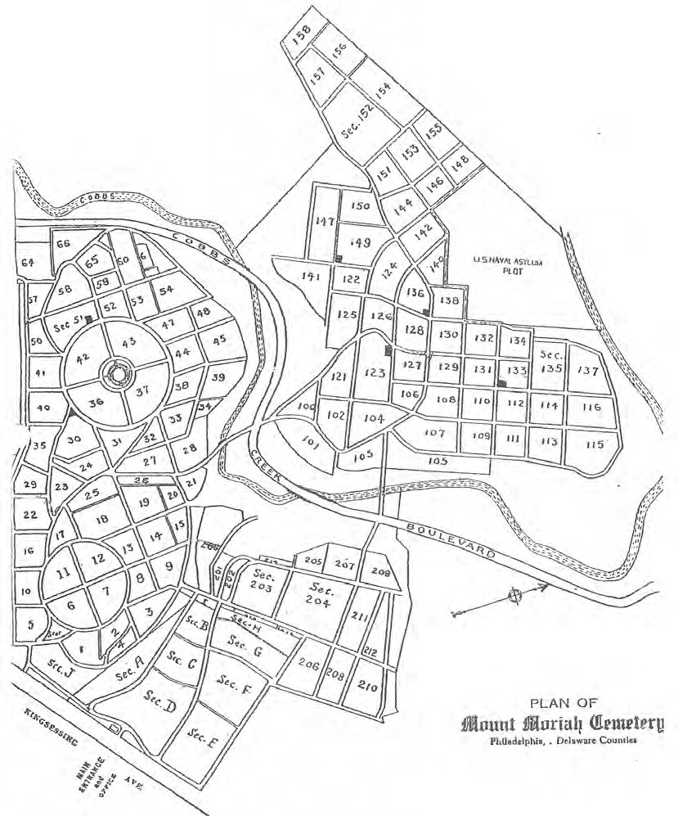
Figure 1.1. Map of Mount Moriah Cemetery. Note the typical curvalinear thuroughfares and central circles that utilize the topogrphy of the landscape, especially in the earliest section along the southern edge.

Map provided by the Friends of Mount Moriah Cemetery.

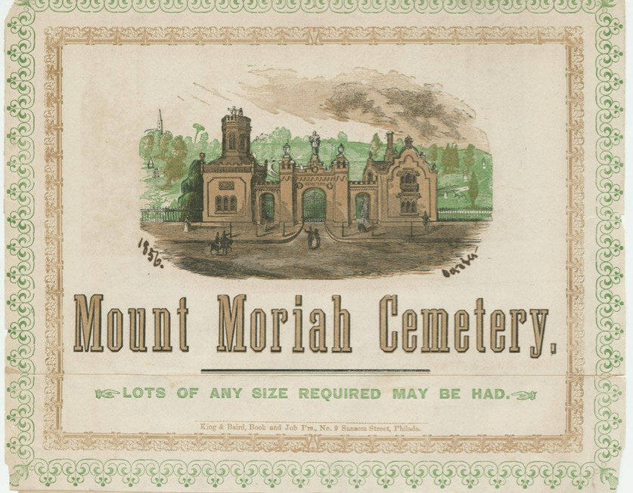
Figure 1.2. Advertisement for Mount Moriah Cemetery.
“Mount Moriah Cemetery,” in Scraps Illustrative of the History of Philadelphia, Vol. 5,
(Philadelphia: King and Baird, 1856).

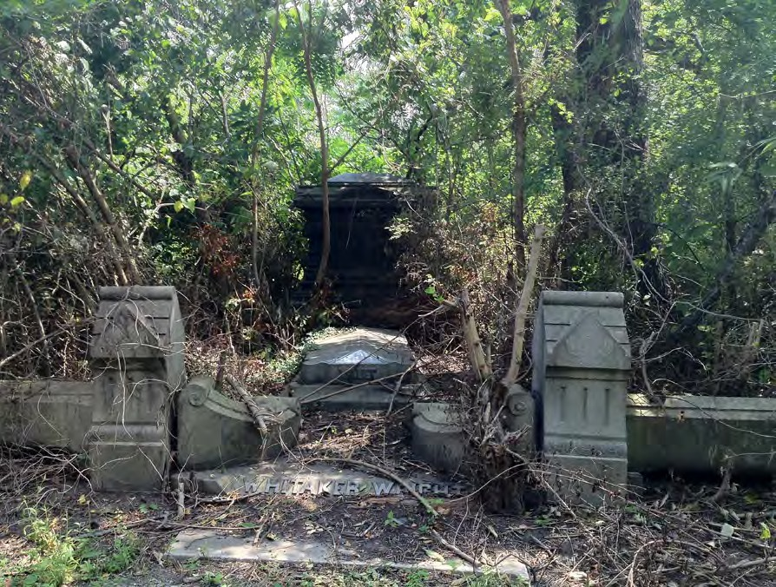
Figure 1.3. Photograph of a typical family lot at Mount Moriah Cemetery in 2013. Many of the monuments are over grown, quickly deteriorating, and are inacessable. Many of the original landscape features are lost or hidden.

Photo by author.

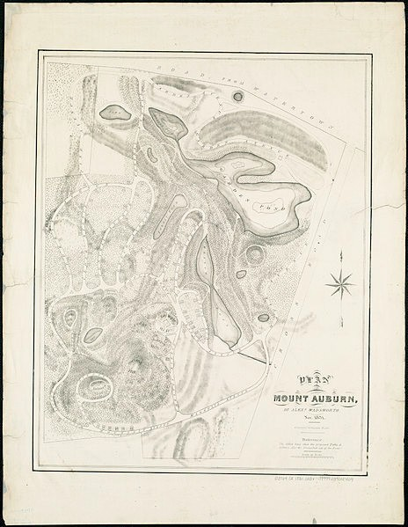
Figure 1.4. Original Plan of Mount Auburn Cemetery in Caimbridge.

Reproduced from the Boston Public Library Map Collection. http://maps.bpl.org

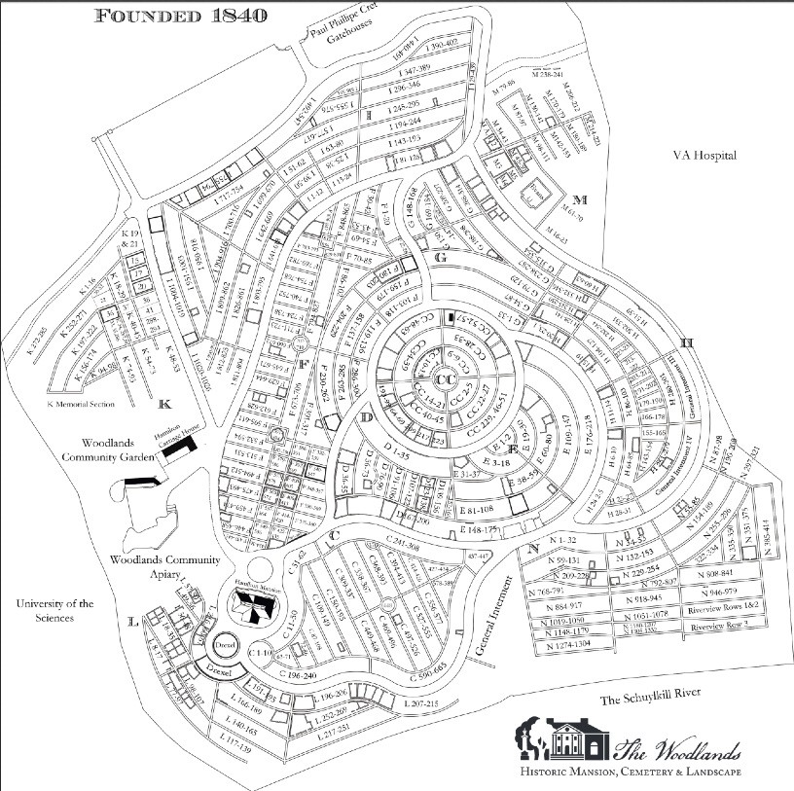

Figure 1.5. Plan of The Woodlands Cemetery. Courtesty of The Woodlands Cemetery Company

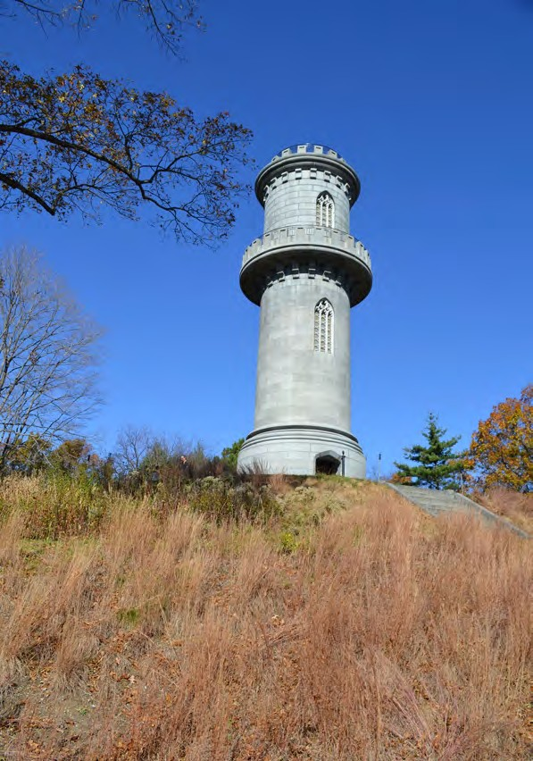
Figure 1.6. Tower on the hill at Mount Auburn Cemetery Photo by author.

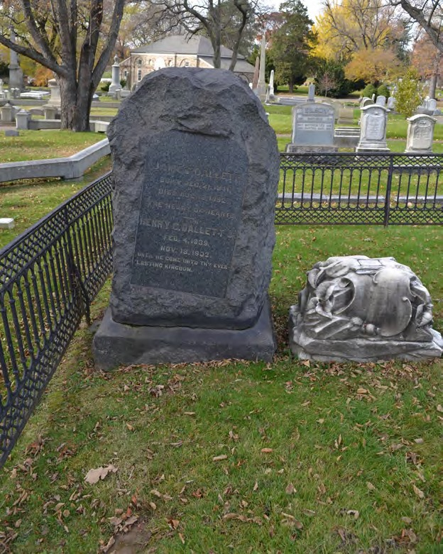

Figure 1.7. Boulder like monument from the Dallett lot at The Woodlands. Photo by author.

PART TWO: LANDSCAPE RESTORATION

DOCUMENTATION, PLANNING, AND RESTORATION PRINCIPLES

The second portion of this project focuses on making recommendations for the rural cemetery landscape restoration projects, and using as a case study the first phase of a restoration project carried out by the author at The Woodlands Cemetery at the Dallett family lot.(fig. 1) It should be noted that much planning, preparation, and research needs to take place before the physical work can begin. The first question that needs to be answered is, what period in the cemetery’s history should the restoration and conservation strive to achieve? Most rural cemeteries have evolved through several distinct and significant phases during their existence. It not recommended that one arbitrary period be chosen for the eventual restoration of the entire cemetery at the expense of other periods. Usually the earliest periods of a rural cemetery’s history least likely be evident in the modern landscape, so a case can be made for giving preference to their restoration, there are too many variables from case to case to make any across the board recommendations. Mount Auburn Cemetery has implemented a forward-­‐thinking landscape restoration plan in this respect. The cemetery’s master plan developed in 1993 called for the creation of “landscape character zones.”1 These zones designate every area of the cemetery under a specific landscape type, broadly defined as ornamental or naturalistic, but then broken down into subcategories. Each of these subcategories has specified preservation goals for decorative plantings, tree coverage, groundcover, and design
1 Halvorson Design Partnership, Mount Auburn Cemetery Master Plan, Vol. 1. 1993, 49-­‐59.

guidelines for new burials. This approach to landscape restoration and preservation should serve as a model for other rural cemeteries when appropriate. Preservation plans of this variety provide greater interpretive possibilities to the cemetery and respect each layer of the site’s history.
At the Dallett lot project at the Woodlands, a guiding target era for restoration 1850-­‐1860 was established. The lot itself was opened in 1848, and likely would have exhibited many of the features now lost in the modern landscape. (fig. 2) The botanical reintroductions, the fence treatment, and other aspects of the project were geared for the 1850-­‐1860 time period.
As is the case with any historic restoration project, extensive documentation of every aspect of the object or landscape in question needs to be thoroughly documented and researched before preservation work can commence. This holds true for cemeteries. It is important to distinguish between restoration and preservation. Restoration refers to the active re-­‐establishment of the fabric of lost or diminished objects, buildings or landscapes. Conservation implies that the subject will undergo treatments to preserve its existing state. Both cemetery conservation and restoration efforts require extensive documentation and background research, but in the case of rural cemetery restoration, the amount of information needed is greater. Specific documentation on landscape changes over were often not recorded at these sites, and therefore require more extensive searching. For example, historic planting schemes, contemporary photographs, and first-­‐hand written accounts of the cemetery can be useful for this aspect. If these are not available (or in addition to
these resources), experts in historic gardens can be an excellent resource, as can

general literature on Victorian horticulture, some of which was outlined at the beginning of this report. Best practices for documentation, as well as examples of those techniques used for the lot restoration project at the Woodlands.
Once the documentation and research phases have been completed, a restoration project can then move to the planning stage. This involves outlining the materials needed, creating a timeline, contacting appropriate professionals when necessary, and planning for labor (see note on labor section of this report). The plan should strive to conform to widely held principles in the historic preservation community regarding restoration. The Michigan State Historic Preservation Office has published a list of ethical guidelines for conservation at historic cemeteries, which can be applied to rural cemetery restoration projects.2 Their guidelines are listed below, with annotations concerning their adaptation for restoration projects.
- Do no harm.
Restoration projects, by definition, require interventions, and these must be made with care and caution. The would-­‐be restorer of a landscape or lot should consider whether the act will destroy material from a historically significant time period. Are the treatments reversible if they prove inappropriate? Are interventions historically accurate and compatible with existing fabric? All of these questions should be considered carefully, and if one is not able to confidently adhere to these guidelines, a professional preservationist should be contacted.
- All actions should respect the original fabric of the cemetery.
Adhering to this tenant begins with extensive documentation and research. Inaccurate restoration materials and techniques have the potential to downgrade the historic integrity of the cemetery.

2 Gregg G. King, Michigan Historic Cemeteries Preservation Guide (Detroit: Canton Township, 2004) 61-­‐63.

- Use the gentlest and least invasive means possible.
This is a fairly simple but vital concept. All historic materials need to be handled with care, and with the intention of preserving the largest amount of historic fabric possible.
- Attempt to do that which can be reversed.
All restoration and conservation projects should be able to be reversed if needed. A quick stroll around a rural cemetery will reveal many repairs carried out throughout the 20th century that caused serious damage to monuments, lot enclosures, and historic horticulture. Treatments that are found to be incompatible to, or compromise the historic assets need to be reversible in order for the appropriate actions to be taken in the future without further damaging the historic object.
- Quick or easy fixes may not always be a reasonable choice.
While it may be attractive to conduct conservation as cheaply and quickly as possible, many of these techniques provide short term solutions for serious problems, and in the long run are more detrimental than productive. Of course, the restoration and conservation practices chosen must consider the resources of group organizing the project, but thinking creatively about resources can allow for the implementation of better restoration practices. Projects can be completed in increments, grant funding can become available, or conservation professionals may be willing to donate some of their time, knowledge, or resources to lend an hand with the work.
- When in doubt, consult a professional.
While it may be faster, cheaper, and easier to use site staff for conservation and restoration efforts, only those with professional experienced in historic preservation can be ensured to provide the best possible product, using the best practices, and ensuring to the above ethical guidelines. Most historic cemeteries (outside of the oldest and most prominent) do not have conservationists on staff. When discussing preservation related efforts, it is advisable to at least consult with a historic preservation professional during the planning stages of the process.

Conducting consultations has the potential to minimize expenses while providing insurance against an incorrectly executed final product.

DALLETT LOT

The lot that was chosen for this restoration project is the Elijah and Thomas Dallett family lot in The Woodlands Cemetery in Philadelphia. The lot was purchased by Elijah and Thomas in 1847. The lot contains many of the typical features found in rural cemetery embellishments in the mid 19th century. This lot was chosen because it still retained some of its original features that have vanished from most rural cemeteries, namely the iron fencing and that physically separates it from the other lots and roads. The lot is also not actively in use and ownership of the lot was relinquished by the family to the cemetery.
The lot contains an underground burial vault which holds most of the interments. The central monument is a large marble obelisk with carved shield emblems. This obelisk is surrounded variety of smaller headstones on the lot dating from the mid nineteenth century to the mid twentieth, which is a typical design scheme for rural cemetery lots. Most of the oldest stones are made from marble, but granite and limestone monuments are also present in a variety of forms.
An ornate but now badly rusted cast-­‐iron fence still surrounds the lot. The fencing is one of two original fences remaining at The Woodlands. As noted above, in the mid-­‐nineteenth century fences surrounded nearly every lot, and was later followed by stone coping. During the course of the twentieth century much of this

ornate wrought or cast-­‐iron work disappeared for various reasons, which are outlined in other sections of this article.
The Dalletts were wealthy immigrants from England who arrived around the turn of the 19th century. Elijah Dallett and his brother Thomas enjoyed great success in America, establishing themselves as fine soap and candle manufacturers before branching out into the more lucrative fields of banking, investment and finance.(fig.
3) At the time of Elijah’s passing in 1847, the family was firmly established in Philadelphia’s upper class. The extended family spent their entire lives in the dense and dirty centers of the cities of Philadelphia and London, yet chose to embrace the bucolic, naturalistic, and romantic ideals of the rural cemetery by purchasing a large and subsequently well embellished family lot in what was then semi-­‐rural West Philadelphia. Elijah and Thomas Dallett were one of the earliest investors at the Woodlands, and some of the earliest embracers of rural cemeteries in Philadelphia. The Dalletts were typical of cemetery lot purchasers, they were urban, upper middle class families looking for a more secure, natural, and personal resting place than cluttered churchyards.

LABOR
Accurately restoring the historic landscapes of rural cemeteries can be a time-­‐consuming and labor-­‐intensive process. There are many challenges to accomplishing this at most sites. Many cemeteries operate on a shoestring budget, and have a minimal maintenance staff. Older cemeteries often fall out of favor with the public as burial grounds, or they run out of space. A general movement away

from traditional burial techniques, such as the widespread acceptance of cremation has also affected income at these cemeteries. Because of this, inventive approaches must be found to restore these landscapes. As mentioned in the introduction, it is important that a portion of the remaining rural cemeteries continue to transform from businesses or municipal institutions into didactic and active historic sites, and cemeteries can take cues from other, more traditional heritage organizations.
Much has been written recently about sustaining traditional house museums. Like cemeteries, many of these house museums (due partially to an over-­‐saturated market and other phenomenon) lack financial support, do not engage well with the surrounding communities, and struggle to make ends meet. Successful and sustainable house museums have begun to modernize and adapt their programming, actively seek out and analyze recommendations of various stakeholders, and create community partnerships. Cemetery managers can learn from these efforts and model themselves after successful organizations. With diverse programming and active outreach programs, cemeteries can attract stakeholders to the grounds, and drum up enthusiasm for these landscapes. This, in turn, can bring volunteers to the site who can help with restoration activities.3 Families of lot owners too, are natural stakeholders at these cemeteries who are often willing to contribute time or funds to restore the resting places of their ancestors. The Woodlands cemetery has been very successful in attracting and developing community stakeholders, and creating local partnerships that have
3 Lynette Strangstad’s Graveyard Preservation Primer, 11-­‐17, provides a good synopsis of generating and managing volunteer labor at historic cemeteries. Strangstad, Graveyard Preservation Primer.

resulted in large numbers of dedicated volunteers who engage in periodical landscape restoration projects. Volunteers who attended one of these work days helped to remove the overgrowth from the brick pathways that surround the Dallett lot. (fig. 4)
Specialty restoration work, (applying treatments to, and reconstructing monuments for example) should be overseen by a conservator, or someone with experience in monument preservation. Many of the state or federally produced guides to cemetery preservation can provide basic guidance for conservation and restoration techniques.

ACCESS ROUTES

America’s rural cemeteries are defined by their picturesque landscaping. The carefully planed footpaths and thoroughfares that weave through these sites dictate the experience of visitors, and play an essential role in the historic landscape.
Stewards of sites that have retained their original pathways should make every effort to restore and then maintain these assets. In some cases, the meandering paths of rural cemeteries have been transformed into rectilinear patterns, and many sites the historic paving materials were covered in asphalt or concrete over the course of the 20th century. Most rural cemeteries originally featured roads and pathways of dirt, gravel, cinder, brick, macadam, or occasionally crushed shells depending on local traditions and design intentions. The reintroduction of these materials may seem like an inconvenience to those who travel to cemeteries by car,
but it can also encourage slower driving speeds while restoring historic integrity.

Strangstad discusses the specifics and importance of pathway and road restoration in the Preservation of Historic Burial Grounds;
“Roads and paths, particularly in 19th century cemeteries, are often a key feature in articulating the cemetery’s landscape design and their preservation is essential. Such preservation [pathways and roads] includes maintaining existing widths and contours, small triangles or small circles often found at intersections, and the original paving surfaces. Brick gutters should be maintained rather than ignored or eliminated. Introduction of asphalt for the convenience of modern vehicles seriously alters the site and erodes its integrity. To preserve certain existing roadways, traffic can sometimes be limited to pedestrians only. Replacement of original crushed stone or early brick with new brick pavers or other paving materials likewise compromises the site. If brick was the original material, roads or paths should be resurfaced with as much of the original brick as possible, and reproduction brick that match the original in color, size, texture, and strength. When a custom-­‐made brick is required, restoration brick firms generally have little difficulty in producing good replica brick.”4

The reintroduction of gravel and other aggregate pathways may seem expensive when compared to modern paving, but this is not necessarily the case. Simple sporadic grading and occasional material replacement are comparable in cost to the repair and repaving of modern surface treatments.
At The Woodlands, a series of winding thoroughfares comprise the primary roads of the cemetery, dividing the property into burial sections. These main arteries were originally of gravel, but today are paved. Slightly later a strikingly rigid grid of brick paths were installed in the interment areas that allow for access to each family lot. Over the course of the 20th century, most of these paths became buried as grades changed, or simply became covered by grass and soil buildup over time. This was the case with the brick surrounding the lot targeted for restoration. Removing
4 Strangstad, Lynnette, Preservation of Historic Burial Grounds, (Washington D.C.: National Trust for Historic Preservation), 2003, 20-­‐21. 19

the overgrowth is a labor-­‐intensive task. Volunteers were utilized to help roll back and remove the sod, and then clean the long buried original brick paths. (Fig. 5) Bricks that had shifted or been removed were reinstalled. Future efforts will focus on exposing more sections of path and connecting the Dallett lot to the surrounding paths.
Recreating the historic access routes is an essential part of restoring the landscapes of rural cemeteries. These paths were carefully crafted to manage the experiences of visitors, and should be utilized in the same fashion today.

IRON ENCLOSURES

Iron enclosure systems are one of the most defining features of rural cemetery lots. From the dawn of the movement, to until around the 1860s, iron enclosures were the primary and preferred method of protecting, demarcating, and embellishing rural cemetery lots.5 But the mid twentieth century, most of these lots had lost their enclosures for a variety of reasons. To restore rural cemetery landscapes iron restoration, retention and preservation should be one of the top priorities for rural cemeteries. What follows is a description and documentation of the steps taken to preserve the iron fencing at the Dallett lot at the Woodlands, and some a description some of the best practices compiled from a variety of professional sources. The level of financial resources, volunteer involvement, and

5 Blanche Linden-­‐Ward, “”The Fencing Mania:” The Rise and Fall of Nineteenth Century Funerary Enclosures,” in Markers Vol. 7 (1990), 35.

availability of skilled conservation technicians affects the approach to iron fencing restoration that can and should be taken.
The first step in iron fence restoration, as in most conservation projects, is the documentation of the deteriorated object in question.6 In the case of cemetery fencing, this involves photographing all faces of the object, taking measurements, and occasionally producing conjectural drawings of sections if the fence in question has experienced extremely severe deterioration. It is also important to determine the type of metal utilized (almost always cast-­‐iron and wrought iron in the case of rural cemeteries, but also “gas-­‐pipe” type fencing exists, and can require different treatment plans). The next important step in the documentation phase is to note the condition of the footings to see if they are level, or have risen or sunken in relation to the grade of the land and to one another.
Once the fencing has been documented, the types of deterioration should be determined. Of chemical deterioration methods, corrosion is the most common deterioration agent.7 Untreated rust (ferrous oxide) will eventually convert the

6 “NCPTT Iron Fence Repair: Cemetery Monument Conservation,” National Center For Preservation Technology and Training, accessed 4/27/2013, http://www.youtube.com/watch?v=6fAacWpM8XQ
This video produced by the National Center for Preservation Technology and Training provides a basic approach to the preservation of iron cemetery fencing. Although it is not a comprehensive, it serves as a good primer on the process of iron enclosure restoration.

7 John G. Waite and Margot Gayle, Preservation Briefs 27: The Maintenance and Repair of Architectural Cast Iron, (Washington D.C.: National Park Service, 1991) This document is one of many preservation briefs prepared by the NPS. This document is available online and in print, and describes the history, deterioration pathologies, and intervention procedures for cast iron. It is a short but essential guide for anyone undertaking iron enclosure restoration.

entire metal body and will cause irreversible damage. Galvanic corrosion occurs when exposed cast-­‐iron comes into contact with different types of metal with different chemical properties as well as moisture.8 Both of these common chemical deterioration agents can be treated in the same manner.
Cast-­‐iron fencing also faces threats from physical agents. Landscape maintenance activities are the most common and onerous threats to enclosure systems. Debris launched from lawn mowers, abrasions from weed whackers, and other simple maintenance errors can cause paint removal, dents, scrapes, and breakages in brittle cast-­‐iron. Vandalism and storm damage can cause similar damages.
After documenting and diagnosing the pathological issues with the decorative ironwork, restoration work can commence. Nearly all fence restoration projects require the removal of residual paint. Before this is done, multiple samples should be taken in order to perform a paint analysis. These samples are mounted, cut and observed under a microscope. This process should be undertaken by a conservator or other preservation professional. The analysis of these samples will reveal how many times a fence was painted, with what type of paint, and the color of the paint. Although potentially expensive and cumbersome, paint sampling is an essential step towards the accurate restoration of iron lot enclosures, and is certainly worth the effort. Most fences were painted black, but green (imitation copper) and white have been observed, in addition to decorative metallic plating

treatments. Paint sample analysis was completed for the Dallett lot restoration, and images of the results will be included later in this section.
Before beginning iron restoration, the decision must be made whether the work will take place on the object in situ, or removed and treated in a remote location. Some treatments are more effectively carried out in a remote location due to easier access all sides of the object, and less of a chance to do, and a more controlled environment. Fence sections that are secure and stable in their footings should be left in situ for conservation work.
Oxidation is the most common deterioration agent in cemetery fencing. The first step in battling corrosion involves paint removal. This can be accomplished in a variety of ways depending on the circumstances. Paint may be removed with a soft wire brush, or with a sprayed aggregate.9 Both approaches have positives and negatives and are better applied to some situations than others. Brushing requires a large amount of physical labor and can be a slow process. It is also nearly impossible to reach the gray metal (total paint and rust removal down to healthy iron). It is imperative to reach gray metal in order to apply a traditional paint scheme (oil or lead based paint and primer on raw metal). Therefore, when using a soft bristle brush, the goal is to remove all paint and the most brittle exterior rust scale. After this has been achieved, a rust converter can be applied, which stabilizes the oxidation, greatly extending the lifetime of the ironwork. If using rust converter on in situ ironwork, it is essential to cover all monuments close to the application site,

as any spillage can cause irreversible black staining on stone.10 A historically accurate paint scheme can then be applied, (which will be discussed in the following paragraphs). If carefully used, a extremely fine and soft, fine bristled brush can be attached to a drill to reduce the amount of labor involved with hand
Paint and rust can be removed much more thoroughly and quickly with a blaster, loaded with crushed walnut shell aggregate. These blasters can be utilized on cast-­‐iron enclosures, but their use is discouraged on wrought iron as it can cause abrasions and possible deformation to the surface. The blaster should be set to a low PSI (around 60-­‐70) to avoid removing excess iron and dulling intricate details.11 Also it is imperative to have an appropriate studio or facility to use the blaster, as the aggregate can create a sizeable mess. This factor makes blasters a better choice for iron enclosures that are no longer in situ. Once cleaned, a rust inhibiting primer should be applied to the raw metal surface, followed by the desired paint scheme.
Blasters require some experience to use, and should be operated by contractors or conservators.
The next step in the process is dependent on paint removal method used. If some form of manual, brush removal method was used a rust converter should be applied before a primer can be used.12 If a blaster was used and complete removal of paint and rust was achieved, a rust converter will not be necessary or effective. A
10 “NCPTT Iron Fence Repair: Cemetery Monument Conservation,” National Center For Preservation Technology and Training, accessed 4/27/2013, http://www.youtube.com/watch?v=6fAacWpM8XQ
11 Waite and Gayle, Architectural Cast Iron, 7.
12 Wendy Pearl and Victor Walker, "Terra Firma: Putting Historic Landscape Preservation on Solid Ground," Mourning Glory: Preserving Historic Cemeteries, Vol. 10, (Boston: Massachusetts Department of Conservation, 2011).

priming layer can then be applied. The use of a rust inhibiting primer is recommended but not required, especially if a rust convertor was applied. The final coats (at least two) of oil-­‐based paint can then be applied as informed by the microscopic paint analysis. The paints can be brushed or sprayed on the enclosure, but the final coats should be applied by brush as is historically appropriate.13
If a cast-­‐iron component was found not in situ, or was removed for treatment, it will then need to be reinstalled. Smaller pieces or panels can be welded, or drilled and pinned or bolted where appropriate (welding is better suited to wrought iron than cast due to the carbon content of the metals). When possible, existing hardware should be reused, but this is often not possible. Compatible metals should be used to ensure galvanic corrosion does not occur. Iron hardware is preferable, but stainless steel is also acceptable and more widely available. 14
Most iron fence enclosures are assembled in panels cased between some sot of top rails and bottom rails, and some feature applied iron details. These assemblies are then set in stone or concrete foundations in a variety of methods.
Traditionally, most fencing was inserted into holes stone foundations and stabilized with lead.
For the Dallett lot restoration project, creating and implementing a preservation plan for the cast-­‐iron fence enclosure was one of the top priorities. The lot features one of only two of remaining 19th century fences at the cemetery, which originally contained dozens. Installed around 1848, the fence consists of cast-­‐iron

13 Waite and Gayle, Architectural Cast Iron, 9.
14 Waite and Gayle, Architectural Cast Iron, 9-­‐12.

panels featuring repeating long oval, bolted to decorative crosshatched rails on the tops and bottoms. A rounded handrail is bolted to the top of these panels. Each fence section was set into holes drilled into granite foundation stones, or granite coping as is the case with the front fence that faces a main pathway. The panels are attached to decorate square corner posts, topped with four small cast-­‐iron flower ornaments. (fig. 6) Two gates are present on the road facing side, each with customized panels displaying the names of Thomas and Elijah Dallett.
The first step in the restoration project and plan was documentation. First, all sides of each fence were photographed. Then a descriptive conditions assessment was written for each element, noting the extent of deterioration, (in this case corrosion of the iron), remaining paint, condition of joints and bolts, stability of the panels in their foundation stones, levelness of fence sections and foundational stones, and lost or broken elements. This documentation may serve to inform continued work on the fencing. The some small sections of fencing had broken off from panels, these sections were documented, labeled, and brought indoors for storage to prevent further accelerated corrosion on grade. Another piece of the documentation process was to identify the manufacturer of the enclosure. Some manufacturers of such materials exist to this day, and have plans, drawings, and occasionally cast-­‐iron moulds that can be useful for restoration efforts. In this case, the firm of Wood and Perot Decorative Ironworks was identified as the source of the fence through a catalogue of fence designs. (fig. 7) The now-­‐defunct firm was located on Ridge Avenue; in between the center of Philadelphia and Laurel Hill Cemetery,
where a small cluster of monument oriented manufacturers were located.

Once the lot has been documented, a feasible and realistic plan for conservation was developed. One of the front panels of the enclosure had become completely dislodged from its foundational coping and was resting on the surviving fencing inside the cemetery lot. It was determined that this panel should be prioritized in the preservation plan, and would be the first element to be restored. (fig. 8)
The panel was first transported indoors. As noted earlier, cemetery cast-­‐iron is a valuable and oft target material for thieves, so securing fencing immediately is important. Once indoors, eight paint samples were taken and prepared for analysis in a lab. Samples were taken from both sides of the panel, as well as the top and bottom, and from other locations on the fence. All samples revealed six layers of matte black paint, with some red lead primer, and outermost layers showing heavy weathering (figs. 9, 10).
The next step of the process was preparing the removed panel for treatment.

Because of limited finances and available labor, the paint was removed with a fine bristled rotary brush attached to a drill. It is important to wear the appropriate safety gear (thick gloves, mask, and eye protection) when removing historic paint. Most historic paints contain lead, which can be become airborne when disassociated with the cast-­‐iron. Because a manual, wire brush paint removal method was used, an effort was made to remove the paint and any brittle rust, but retain a thin layer of corroded iron for treatment with a rust converter. After careful and thorough paint removal, the fence was washed and dried to remove any remaining surface particles.
A rust convertor applied onto the panel, follows by two coats of rust inhibiting

primer. Finally, the fence piece was finished with two coats of black, matte, oil-­‐based paint as informed by the paint sample analysis. (fig. 11) Photographs and written documentation were conducted at every step of the process.
The fence panel was then moved back on site for reinstallation. (fig. 12) This fence essentially functions as an interconnected system, with each panel stabilized buy the pieces next to it. The restored section was originally held in place by lead poured in the foundation holes, and well as pegs that connected the top rail to the flanking corner posts, ensuring stability at all four corners of the panel. In this case, one of the connecting pieces at the corner posts had disappeared at some point, but one remained extant.
The remaining lead was removed from the foundation coping, and the fence panel was fit for reinstallation, ensuring a level, stable fit. The iron panel was then held in place while liquid lead was poured into and around the foundation holes.
The top rail was then reconnected to the flanking corner post.

The project was only phase one of the full restoration plan. As time and resources permit, these steps can be repeated for each section of the fence that requires restoration. After the corrosion has been controlled and the paint reapplied, arraignments can then be made for the recasting of missing elements from molds made existing members. A restored enclosure is less appealing for theft or vandalism, as it gives shows the now rare objects are being observed, maintained, and secured. As portions of the fence fail, they impact the stability of the entire fence. Given the importance and scarcity of 19th iron cemetery lot enclosures,
restoring and securing fencing should be a high priority for rural cemeteries.

ON LANDSCAPING

The landscape architecture and lot horticulture of rural cemeteries are arguably their most character defining features. Due to evolving styles, changes in landscape maintenance, and financial liabilities, the 19th century picturesque garden like qualities of these cemeteries have generally disappeared. Most rural cemeteries adopted modern trends in landscape design, reducing the density of plantings, creating short cut lawns, and eliminating historic plantings that required maintenance. A collection of contemporary photographs of rural cemeteries is included at the end of this chapter to help demonstrate the crowded, naturalistic planting schemes of family lots.(fig. 13-­‐16) These lots functioned as rural gardens away from the city, and were designed as leisure locations. Restoring the some of the picturesque planting schemes of rural cemeteries is an important activity to pursue for a variety of reasons.
The landscape created by planting schemes in mid nineteenth century were an integral part of a visitors’ experience there. The mature and ornamental trees, shrubs, and flower plants created unique viewsheds and environments like those championed by prominent contemporary design critics like A.J. Downing.15 They are significant in that they represent a revolution in America’s approach to landscaping and interaction with the natural environment, as was elaborated on previously.

15 Andrew Jackson Downing, “Public Cemeteries and Public Parks,” in Rural Essays,
(New York: Leavitt and Allen, 1858) 154-­‐159.

Beyond restoring the historic integrity of rural cemeteries, the reintroduction of appropriate plant species also has the potential advantage of helping to visually separate the cemeteries from their present surroundings. These cemeteries had been planned as natural escapes from the chaos and commotion of city living, but over the years, urban development has encroached on the landscapes, affecting the visitor’s experience on site. Taller and more dense foliage, when historically appropriate, can help to segregate the burial site from modern infrastructural encroachments.
Intensive research is needed to determine appropriate planting schemes and foliage varieties. Important resources on Victorian gardening history are noted in the literature review section of this project. The most valuable resource that can inform lot landscape restoration though, are historic photographs of lots. Depending on the cemetery in question these can be difficult to procure, but are often found in local historic archives or in the cemeteries own records. Analysis of these photographs can provide information about planting schemes, specific species, and scale of plantings. Many rural cemeteries published guidebooks, and they occasionally contain recommendations and guidelines for lot owners on how to plant their lots.16 Many 19th century nurseries also published catalogues of their

16 The 1847 guide to Laurel Hill Cemetery in Philadelphia is a prime example of this type of literature. The booklet, created by the cemetery staff, encourages the planning of certain trees, shrubs, and perennials. Additionally they provide information as to where they should be planted and the conditions in which they thrive.
Smith, Guide to Laurel Hill Cemetery Near Philadelphia.

offerings.17 Consulting theses catalogues from the appropriate time periods can provide one with an idea of what would be available locally for purchase.
When possible, it is best to consult with a landscape architect familiar with historic horticulture before embarking on any restoration work. Professionals can help design planting schemes, identify plants suitable for local climates, and specify individual plant varieties appropriate for use.
There are a variety of methods to gather plants once a plan has been developed. The first place to search for historic plantings is the cemeteries themselves. In the early spring months, existing perennial plants can often be found sprouting in various areas of the cemetery. Photographic documentation from these areas, or landscape or gardening professionals can help to verify the age of these plants. The interior of cradle-­‐style graves, and lots with extant coping and fencing are prime locations to find historic but forgotten plant species for further propagation. These plants are ideal for replanting in other areas of the cemetery.
There are also commercial retailers that specialize in historic flowers that can provide guidance in selecting plants for landscape revitalization based on the specific decades for which the restoration is designed.

17 For example, one of the earlier versions of these catalogues was Bernard M’Mahon’s American Gardener’s Calendar, which was published from 1806 to 1857. The Gardener’s Calendar not only listed seeds that were available from M’Mahon, but provided advice on propagation techniques. Other prominent Philadelphia nurseries that produced catalogues available across the eastern seaboard were Landreth, Buist, and Dreer.
Bernard M’Mahon, The American Gardener’s Calendar Adopted to the Climate and Seasons of the United States (Philadelphia: M’Mahon, 1828).

The Dallett lot restoration project focused on implementing the first phase of a historically accurate planting scheme, and developing a plan for later improvements and care. Like most family lots from rural cemeteries, this lot was likely embellished with dense shrubs and flowers, but now featured only tightly trimmed grass. There is a single, fairly distant and low quality from 1870 photograph exists (the original has been lost, but can be found in reproduction, (fig. 2)) of the Dallett lot. The image shows a row of bushes behind the front gates and fence, with some larger shrubbery behind. This photograph was used to inform the replanting program in conjunction with other early 19th century photographs from the around the cemetery. A historic flower specialist was consulted during the planning of the project. It was eventually determined that irises would be propagated around the central obelisk monument, along with a hedge of roses along the front gate. The irises were split from an existing overgrown bunch found in older cradle graves on site, both saving money and propagating historic plant varieties.(fig. 17, 18) Two varieties of rose bushes (Hermosa and Lesuve, both introduced to America prior to 1837) were purchased from an antique rose dealer to reintroduce a hedge along the front gate of the lot. (fig. 19)
The next step of the historic plant introduction plan is identifying and introducing a more accurate ground cover scheme. Many lots in rural cemeteries featured some sort of ground cover, often Ivy (which also was a popular symbolic motif on cemetery monuments from the period).18 The reintroduction of ground

18 Colleen McDannell,"The Religious Symbolism of Laurel Hill Cemetery," in Material Christianity, ( New Haven: Yale University Press, 1995), 117.

covers in place of modern grasses not only increases the historical accuracy of a site, but can save cemeteries money on mowing landscape maintenance costs, and could prevent some damage caused by mowing activities.
Restoring the landscape features of rural cemeteries is one of the most crucial aspects of restoration projects. The movement itself was naturalistic in nature, and heavily centered around botany and gardening. Arguably, the most altered feature of these sites is the absence of rustic, gardenesque, or picturesque plantings and presence of modern, sparse landscaping designs. If approached at the scale of a family lot, and implemented in phases, the landscapes of rural cemeteries can be restored on a modest budget.

LOT FURNITURE

Many lots at rural cemeteries were embellished with cast-­‐iron seating furniture. These pieces were new inventions in the mid 19th century, and emerged with innovations in cast-­‐iron technology.(fig. 20) Highly detailed sections were cast and bolted together to create chairs and settees for gardens and cemeteries. As detailed by Ellen Snyder, these objects featured highly ornamental designs that mirrored popular trends in indoor furniture. Some scholars also see symbolic connotations with the use of iron seating in rural cemeteries. Snyder writes,
“In the cemetery, cast-­‐iron seating may well have been reassuring: nondecaying, naturalistic, alive-­‐looking forms in a place that only disguised death and decay. In a city of the dead, which expressed a timeless image of

the city of the living, cast-­‐iron creation were visible signs of the permanence of the city. They denied the body’s decomposition.”19

Snyder goes on to make connections between the domestic emphasis in Victorian culture, and the illusion of domesticity in nature that this seating could impart.
These items were obviously an important part of the garden and park like landscapes that were developed at rural cemeteries. For a variety of reasons, nearly all of this seating furniture has disappeared from cemeteries. Some families probably removed their furniture, many fell victim to theft, and others probably deteriorated beyond repair. The Woodlands has retained only two pieces of original furniture, none of which are on display. Burial grounds that have managed to save any of their original furniture should remove them from the cemetery. Cast-­‐iron cemetery furniture is extremely rare, and highly desirable to metal scrappers, and is too valuable to be left unattended. An appropriate, low moisture storage space should be found for these items. If desired, the chairs can be disassembled and their pieces recast. These replacement pieces can be installed in their place.

MONUMENTS

The monuments installed at rural cemeteries vary greatly in size, form, material (a character defining feature of rural cemeteries that was encouraged by

19 Ellen M. Snyder, "Victory over Nature: Victorian Cast-­‐iron Seating Furniture,"
Winterthur Portfolio 20, no. 4, (1985), 239.

cemetery owners and contemporary critics)20. While some fencing, plantings and landscaping restoration efforts can be accomplished by cemetery workers and volunteers, technical conservation on stone monuments should be undertaken by preservation professionals. This is especially true at rural cemeteries, where stone monuments are often larger and more intricate than those in earlier and later cemeteries. Work with masonry requires an advanced skill sets and special tools. Inappropriate conservation techniques can have disastrous results on the monuments. The first measure that should be taken, is a documentation of the stones as in situ, as well as the identification of any broken, unstable, or heavily weathered monuments. This report can be provided to a professional for further conservation work. One basic monument conservation task that can be completed by unskilled labor is stone cleaning. The stones present at historic cemeteries are at subjected to a variety of deterioration agents that can be mitigated by periodic cleaning. Acid rain and other types of airborne environmental pollution can wreak havoc monuments, especially some types of marble that were commonly installed in rural cemeteries before granite became the preferred material around the last quarter of the 19th century. Bio-­‐growth can also thrive on moist stones, and cause eventual degradation of the stone surface. Rust staining is also a common phenomenon with historic monuments held together with iron pins that are exposed to moisture. Removal of all these deterioration agents should be completed to ensure the long term integrity of the monument. It is possible though to damage stone with improper cleaning methods. Gentle scrubbing with soft brushes is the
20 Sherman, Guide to Laurel Hill, 49-­‐50.

most safe and effective technique. Wire brushes and powers-­‐washers should never be utilized, as they have the potential to remove historic fabric, especially on older marble headstones. If needed, a pH neutral detergent can be used, but this is often not needed. There are many bio-­‐growth inhibiting agents on the market today, and many designed specifically for masonry. D2 Biological Solution™ is a commonly used, safe and effective on historic headstones. Many state and federal cemetery conservation publications noted in the literature review portion of this project contain recommendations for basic monument preservation.
For the Dallett lot restoration project, all of the stones were photographed before as work began. Most of the monuments in this lot were in exceedingly good condition, with a few exceptions. One small, rectangular stone had, over time, migrated from its original position and had fallen onto its face side. The lot card for the site was consulted, the original orientation found, and the stone was carefully moved back to its location using pry bars and protective wooden elements. The reset of the stone was noted in the cemetery records. Some deterioration was noted on the central obelisk. The rectangular base is experiencing substantial sugaring, and some cracking. These conditions were then recorded and photographed. In the future, stone consolidation on the weather marble elements of the lot was recommended, as well as a pathological investigation and subsequent patching of the cracking. This is work that should be completed by trained conservators.

CONCLUSION

The subjects of cemetery conservation, preservation, and restoration have received increasing amount of attention from historic preservation scholars, but the scholarship on these issues has been focused on a few specific areas. Monument preservation, for instance, has been subject to extensive study, albeit mostly under the rubric of materials conservation. Likewise, routine maintenance and basic repair techniques have been addressed as a historic site management issues. Additionally, the history and evolution of American cemeteries has been fairly thoroughly addressed by cultural, material, and art historians. Cemetery conservation scholarship has lacked though, in developing an approach to conservation through the more holistic lens of historic landscapes, as opposed to a collection of sculptural monuments. This lack of landscape conservation and restoration attention is especially troubling in the context of rural cemeteries. The rural cemetery phenomenon, more than any other movement in cemetery history, revolved around the creation and experience of a landscape. The landscapes were highly unique, carefully designed and regulated, and driven by brief but influential cultural forces in the 19th century. They played a highly influential role in subsequent landscape architecture theory, and represented a complete revolution in America’s views on nature, as well as their approach to religion and the afterlife. Rural cemeteries are physical manifestations of the cult of domesticity that pervaded 19th Victorian culture. In short, rural cemeteries are much more than a collection of funerary monuments, they are (or were) landscapes that represented a variety of

revolutionary social forces in 19th century America, and deserve a preservation approach that recognizes their significance.
Restoring and preserving the remaining features of rural cemeteries is not a simple endeavor. It can require significant finances, labor, and expertise and time to perform in an accurate and sustainable way. Many of America’s rural cemeteries face challenges in nearly all of these categories, stemming from a lack of burial space, changes in interment preferences, mounting maintenance costs, and the gradual disappearance of traditional stakeholders. This project aimed to demonstrate a few points regarding these issues. The first goal of this case study was to establish the significance of rural cemetery landscapes in American history, and make the case for their careful restoration. Furthermore, it identified the character defining features of the sites that should be preserved or restored. Lastly, by providing a small scale case study and providing a guide about how to approach most aspects of rural cemetery landscapes restoration, it aimed to show that there is a sustainable and reasonable way to carry out these projects, even for the most modest of sites.
As has been illustrated at various points in this thesis, rural cemeteries in America are at a crossroads. As the physical integrity of these sites weathers, and financial hardships continue to mount, it is vital to create responsible and realistic conservation plans to retain the remaining landscape features, while actively working to accurately restore some of the lost pieces of these unique sites.

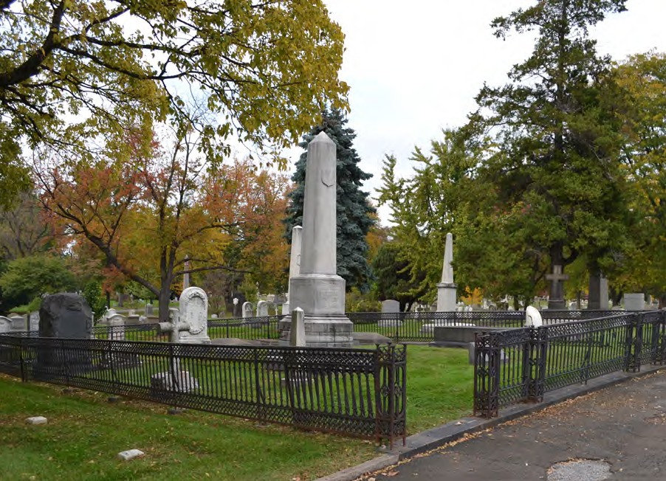
Figure 2.1. A photograph of the Dallett Lot targeted for restoration at The Woodlands. Note the deteriorated conition of the enclosure, including the dislodged section at front. The historic planting scheme has been replaced by a simple lawn, and the accress routes have become covered in sod.

Photo by author.

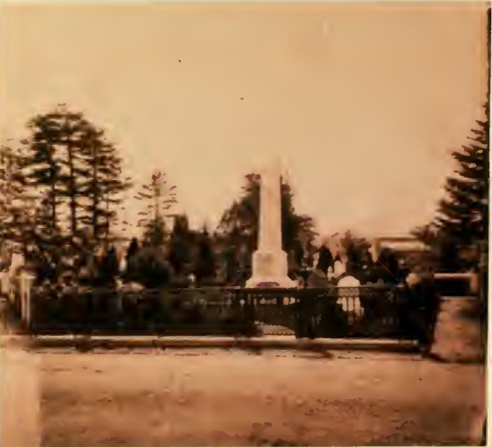
Figure 2.2. A Photograph ofThe Dallet Lot at The Woodlands taken around 1860. The original image has been is missing from the Library Company of Philadelphia. This pho- tograph is a recreation from the a Historic Prservation Thesis project at the University of Pennsylvania. Notice the row of hedges along the front of the fence, as well as tallet bushes behind the main monument.

John Moran, “The Dallett Monument in The Woodlands Cemetery, 1870.

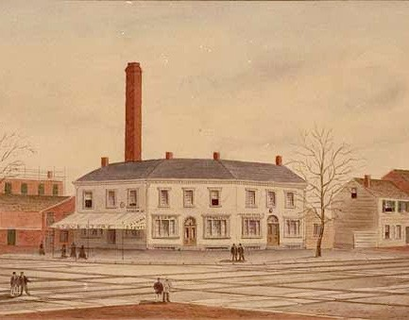
Figure 2.3. Detail of Dallett’s old soap factory at on the northeast corners of 10th and Callowhill in Philadelphia in 1884. The Dallett family used their wealth derived from this industry to purchase and embellish their family lot at The Woodlands.
“Dallett’s Soap Factory”. from the Evans Collection at The Historical Society of Pennsylvania. Call number: 862EV15/.111

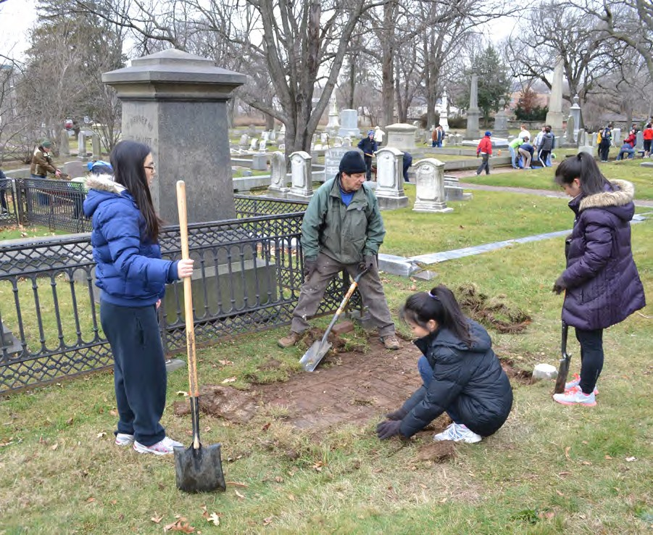
Figure 2.4. Volunteers help to remove overgrown sod from the brick paths surrounding the Dallett lot at the Woodlands.

Photo by Author

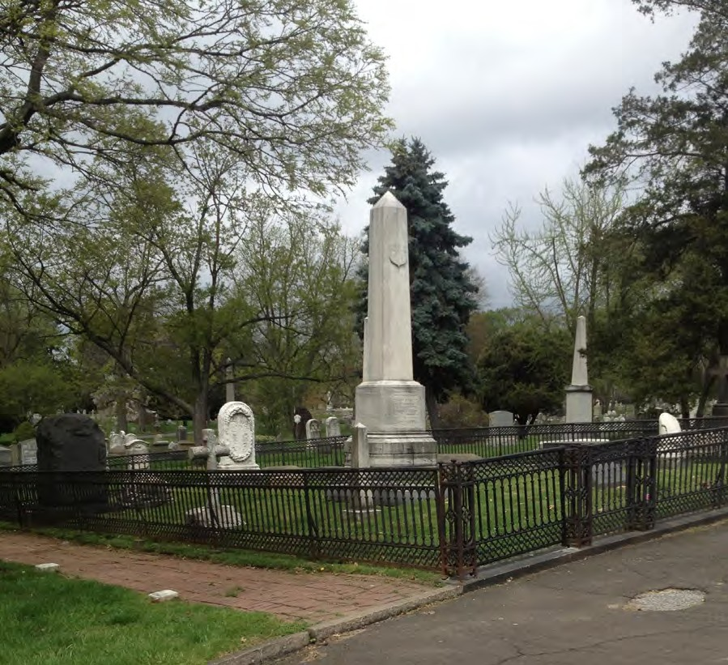
Figure 2.5. Photograph showing newly exposed brick access route on bottom left next to Dallett monument.

Photo by author.

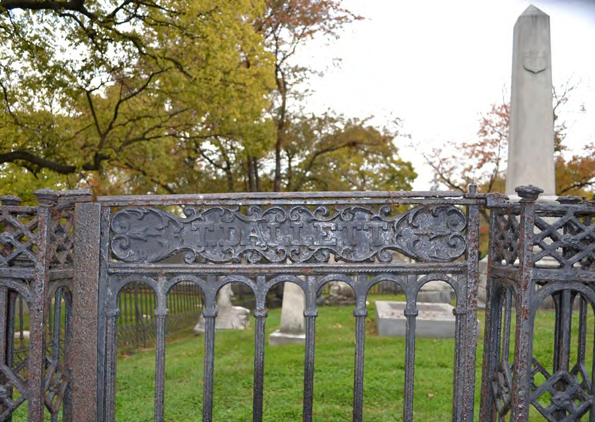
Figure 2.6. Detail of Dallett lot fence gate.

Photo by author.

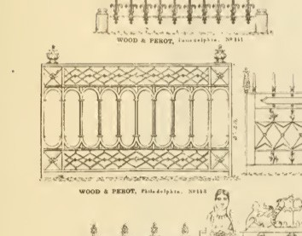
Figure 2.7. Catalogue illustration from Wood and Perot Iron Works showing fence pan- eling utilized at the Dallett lot. It is unclear if the corner posts of the Dallet lot originally featured fineals of this nature.
Robert Wood and Co. Portfolio of Original Designs of Ornimental Ironwork of Every Description. Philadelphia: Robert Wood, 1867.

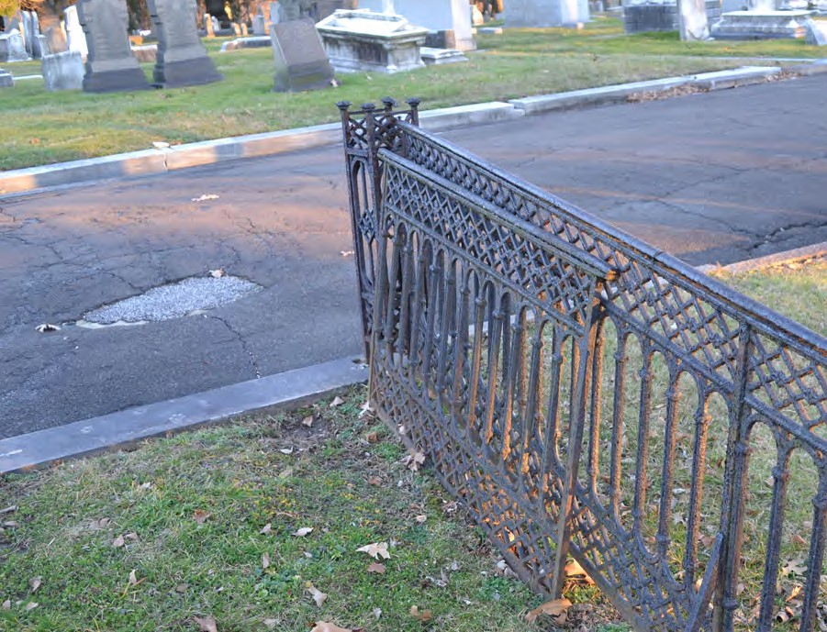
Figure 2.8. Disloged and corroding front fence panel.

Photo by author.

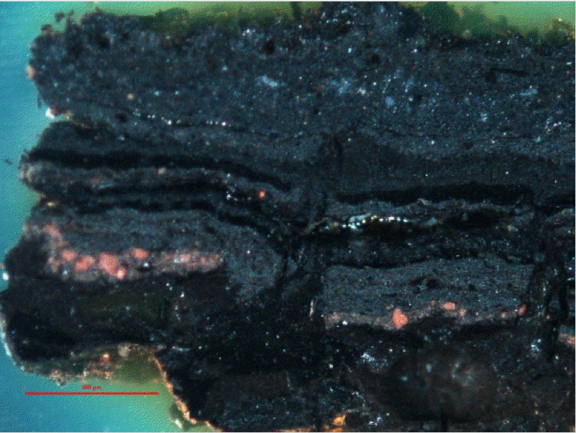
Figure 2.9. Photomicrograph of paint sample from the cast-iron fence enclosure of the Dallett family lot at the Woodlands Cemetery, showing six applications of black lead paint, with traces of oxidized cast-iron substrate and red lead primer. Image taken under visible, reflected light.

Image by author.

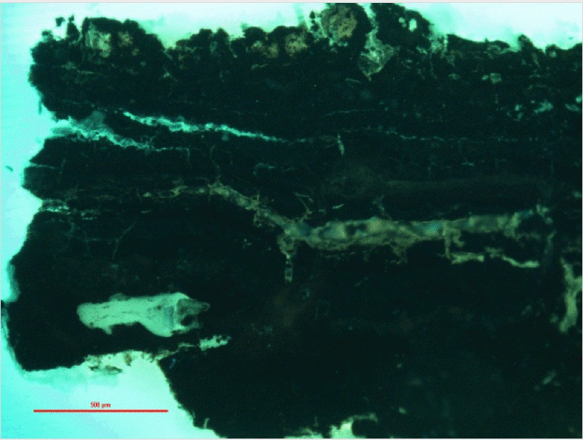
Figure 2.10. Photomicrograph of paint sample from the cast-iron fence enclosure of the Dallett family lot at the Woodlands Cemetery. Sample shows six layers of black lead paint application, with heavy weathering and cracking visible on the outermost layer. Photo- graph taken under Ultra Violet light.

Image by author.

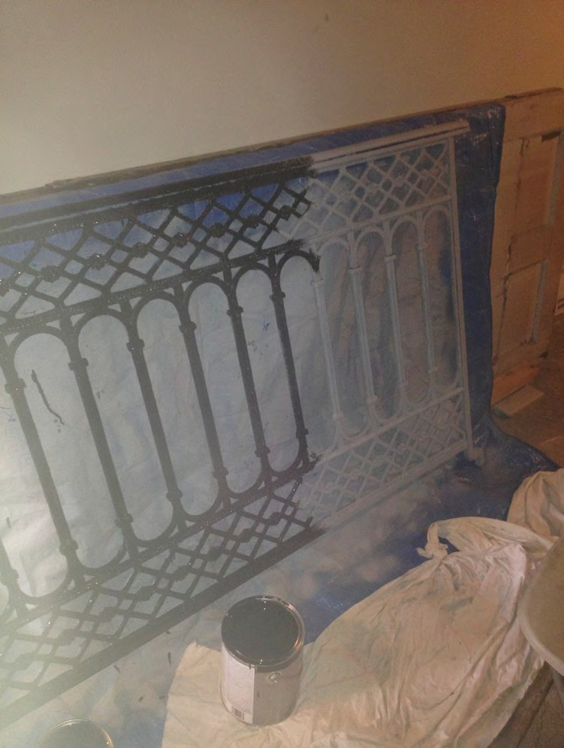
Figure 2.11. Fence panel midway through first coat of oil based paint application. The white portion of the fence shows the corrosion inhibition primer application.

Photo by author.

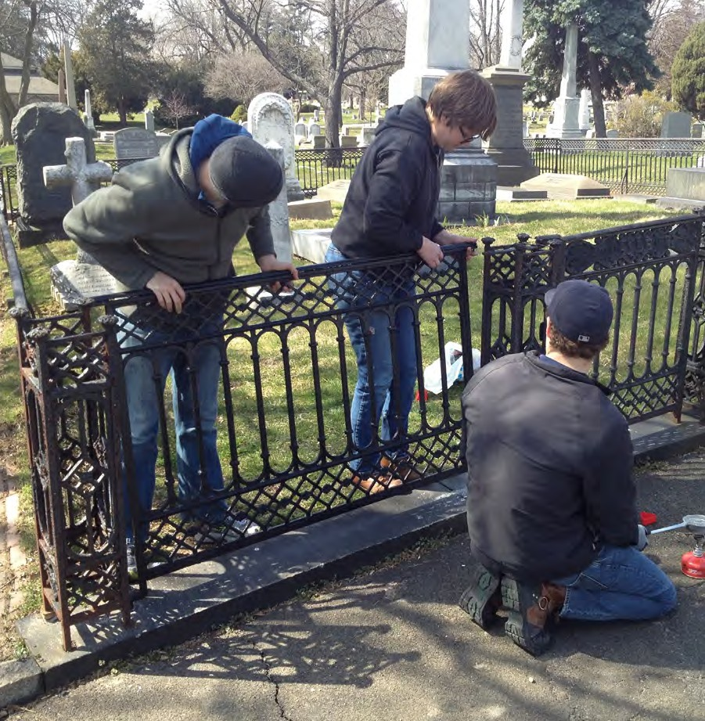
Figure 2.12. Dallett lot restored fence reinstallation. Photo by Erica Maust.

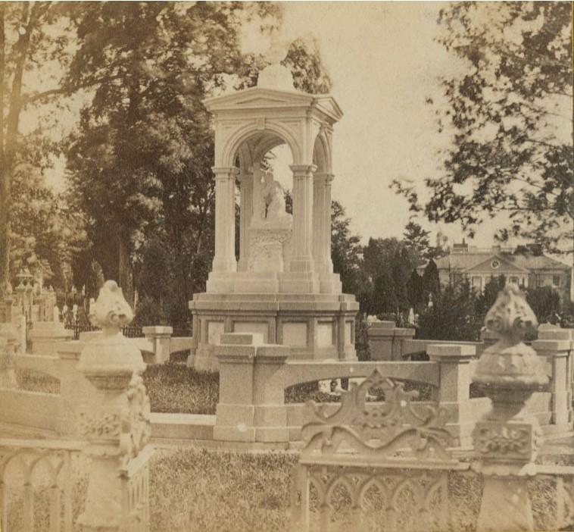
Figure 2.13. The Harris Monument at The Woodlands Cemetery. Note the ubiquitous fencing and coping.

Robert Newell, The Harris’es Monument at The Woodlands, 1870, The Library Company of Philadelphia.

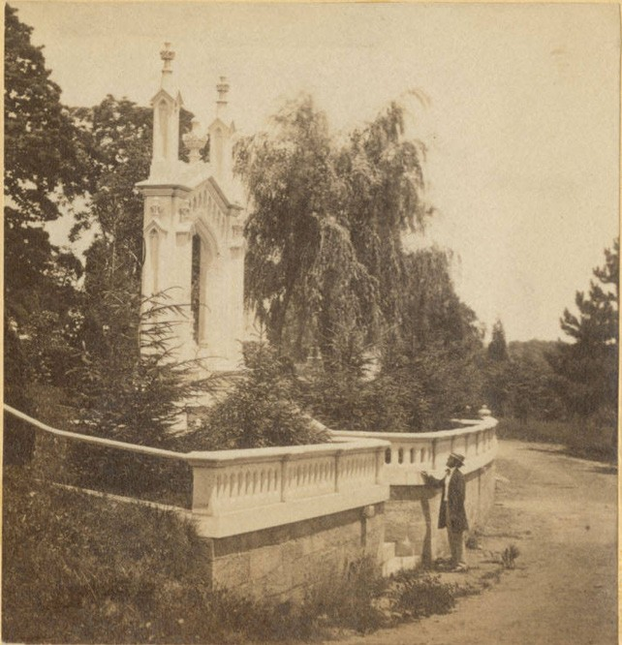

Figure 2.14. The Printers’ Monument at The Woodlands.

John Moran, The Enterance To the Printers’ Cemetery at The Woodlands. 1863, The Li- brary Comany of Philadelphia

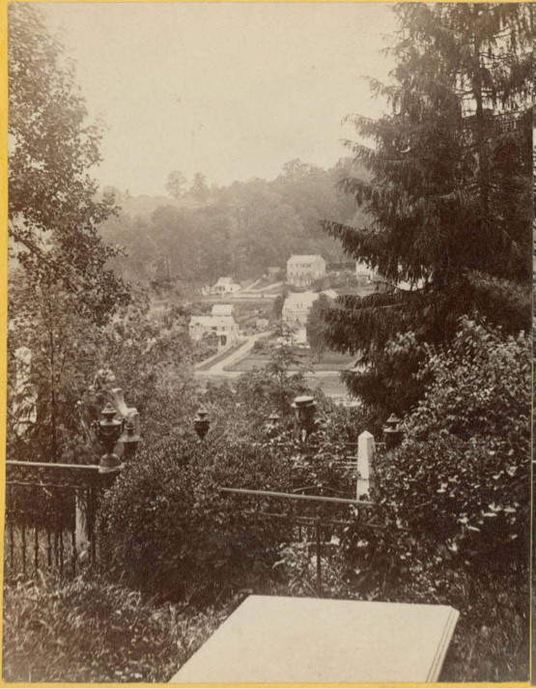
Figure 2.15. Cedar Grove at Laurel HIll Cemetery.
Bartlett and French, Cedar Glenn, Laurel Hill Cemetery, 1868, The Library Company of Philadelphia.

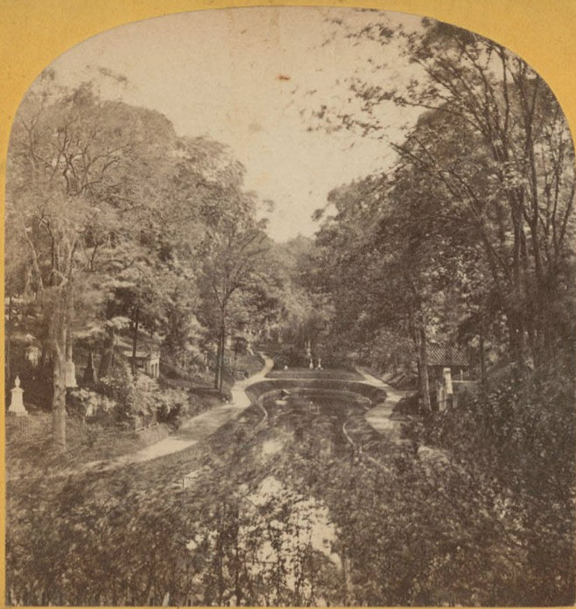
Figure 2.16. A lake and wooded section of Mount Auburn Cemetery in Caimbridge.

Edward L. Allen, Lake, Mt. Auburn Cemtery, Caimbridge Mass., 1870, The Historical Society of Pennsylvania.

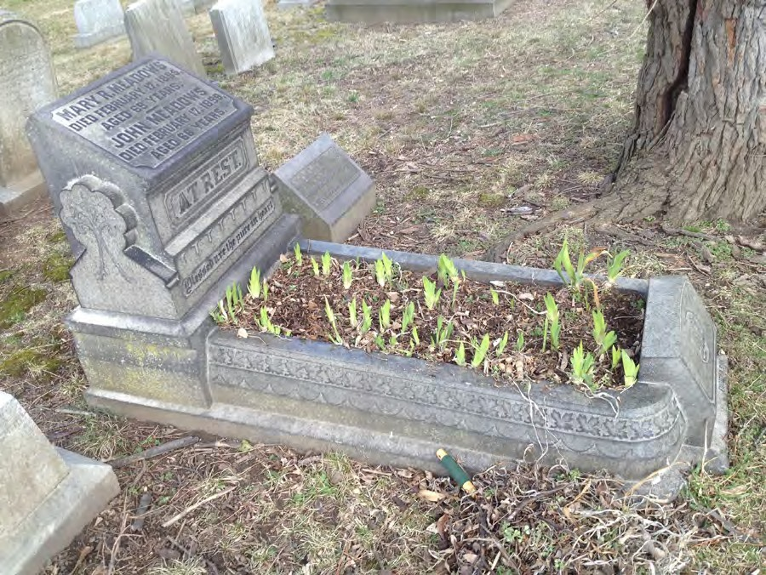
Figure 2.17. Overgrown historic Irises sprouting in a cradle grave at the Woodlands.

Photo by author.

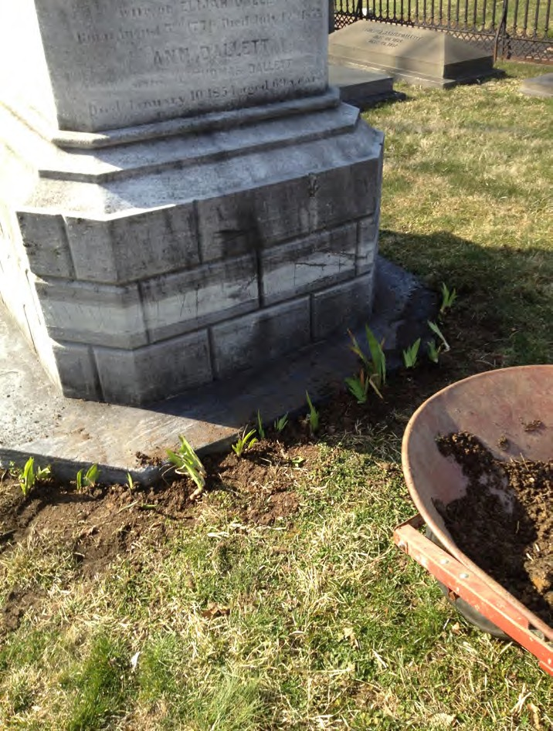

Figure 2.18. Transplanted Irises at the Dallett lot around the base of the central obelisk. Photo by author.

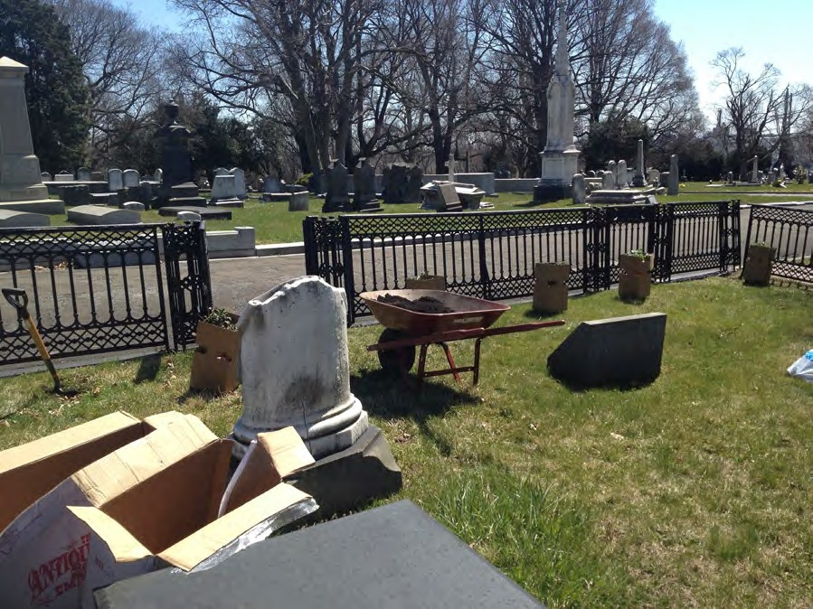

Figure 2.19. Restablishing a rose hedge at The Woodlands. Photo by author.

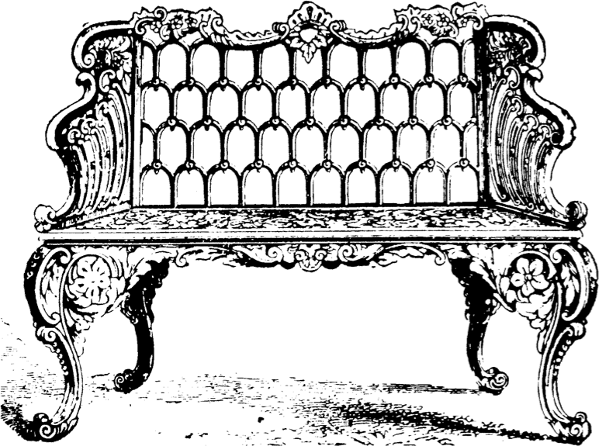

Figure 2.20. A typical cast iron settee that once graced many rural cemetery lots.

Stewart Iron Works Company, Iron Reservoir Vases Catalogue No. S (Cincinnati, Stewart Iron Works Co., [1910]. 29.

BIBLIOGRAPHY

Davies, Jennifer. The Victorian Flower Garden. New York: W.W. Norton and Company, 1991.

Dell, Upton. “Gridding the Graveyard,” Another City. New Haven: Yale University Press, 2008.

Downing, Andrew Jackson. “A Talk About Public Parks and Gardens.” In
Horticulturist , 4. Albany: Luther Tucker, 1848.

Downing, Andrew Jackson. “Public Cemeteries and Public Parks.” In Andrew Jackson Downing, Rural Essays. New York: Leavitt and Alan, 1858.

Feddema, Johannes J. Air Pollution Effects on Marble Weathering in Philadelphia, Pennsylvania. Newark, DE: University of Delaware, 1986.

Gillon, Edmund V. Victorian Cemetery Art. New York: Dover Publications, 1972. Halvorson Design Partnership. Mount Auburn Cemetery Master Plan. Vol. 1. 1993. Huth, Hanz. Nature and the American. Lincoln, NE. Nebraska University Press, 1990.
King, Gregg G., Susan Kosky, Kathleen Glynn, and Gladys Saborio. Michigan Historic Cemeteries Preservation Guide. Detroit: Charter Township of Canton, 2004.

Linden, Blanche M. Silent City on a Hill: Picturesque Landscapes of Memory and Boston’s Mount Auburn Cemetery. Boston: University of Massachusetts Press, 2007.

McDannell, Colleen. Material Christianity: Religion and Popular Culture in America.
New Haven: Yale University Press, 1995.

Meyer, Richard E. Cemeteries & Gravemarkers: Voices of American Culture. Ann Arbor, MI: University of Michigan, 1989.

Pearl, Wendy, and Victor Walker. Terra Firma: Putting Historic Landscape Preservation on Solid Ground. Mourning Glory: Preserving Historic Cemeteries. Vol. 10.
Boston: Massachusetts Department of Conservation, 2011.

Potter, Elisabeth W., and Beth M. Boland. "Guidelines for Evaluating and Registering Cemeteries and Burial Places." National Register Bulletin (1992).

Schuyler, David. “The Didactic Landscape: Rural Cemeteries.” In The New Urban

Landscape: The Redefinition of City Form in Nineteenth-­Century America.
Baltimore: Johns Hopkins University Press, 1988.

Sloane, David. The Last Great Necessity. Baltimore: The Johns Hopkins University Press. 1991.

Smith, John Jay. Guide to Laurel Hill Cemetery Near Philadelphia. Philadelphia: Conger Sherman, 1844.

Strangstad, Lynnette. Preservation of Historic Burial Grounds. Washington D.C.: National Trust for Historic Preservation, 2003.

Strangstad, Lynnette. A Graveyard Preservation Primer. Nashville: American Association for State and Local History. 1988.

Stuart, David. The Garden Triumphant: A Victorian Legacy. New York: The Penguin Group, 1988.

Wunsch, Aaron. "Emporia of Eternity: ‘Rural Cemeteries and Urban Goods in Antebellum Philadelphia." Nineteenth Century 28. no. 2 (2008): 15-­‐23.

INDEX

Coping: 8, 9 18, 32, 43, 44, 45, 48

Elijah Dallett: 32, 33, 43

Ethics: 30, 31

Enclosures: 2, 8, 9, 19, 31, 37, 39, 41, 42, 43, 44, 45

Furniture: 8, 18, 50, 51

Laurel Hill Cemetery: 2, 7, 11, 13, 15, 43

Mount Auburn Cemetery: 2, 6, 9, 11, 13, 14, 17, 28

Mount Moriah Cemetery: 1, 2, 3

Reform (movement): 17, 19

Romanticism: 2, 14, 15, 16, 19

Volunteers: 34, 35, 37, 52

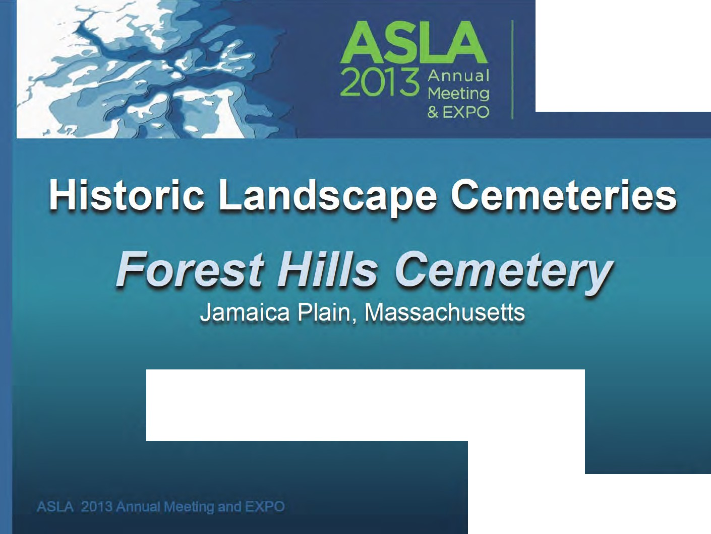
==
\N I
LANDSCAPE

-
=
A\\ERIC
ARCHITECTURE
= ,
t Q ."! .
----'-''••••,- .,...,,,._,;.._ .. . -,.,
,ornn OF
LANDS(APf Ulf' HIT (CT

GAINING GROUND
Boston • Nov.15-18

Jack Goodnoe, ASLA
Jack Goodnoe - Cemetery Planning and Design

Learning Objectives
- Learn about the design principles of the Historic Landscape Cemetery and how they anticipated the development of landscape architecture in the US.

- Learn how these landscapes and American cemeteries in general are adapting to reflect 21st Century values.

- Discover creative ways to accommodate commemoration and burial in these landscapes that honor their historic character while supporting business goals.

- Gain insight into the issues and approaches of sustainability, green burials, and ethnic traditions.

The Origins of the American Rural Cemetery
English Landscape Movement
(L.C. Brown & H. Repton)
+
Urban Deterioration = Pere Lachaise
. . .
(Paris-1804)

• •• a -
•
  - ,,

,-".._.\. •'- .-; -+""' ..• ..:.. t r, v.

:Am.e. rican.Rom.ant1.c1sm · .
"
(A.J. Downing - the Horticulturalist)

American Rural Cemetery
(The Picturesque and the Beautiful)

Rural Garden Cemetery Design Principles
    - Topography based road alignments and burial layouts
    - Vertical and varied monumentation
    - Open ground plane under a high deciduous canopy
    - Changing, 'Surprise' vistas (with water)
    - Burial lawns raised above road

-

Transitions in the Rural Garden Cemetery

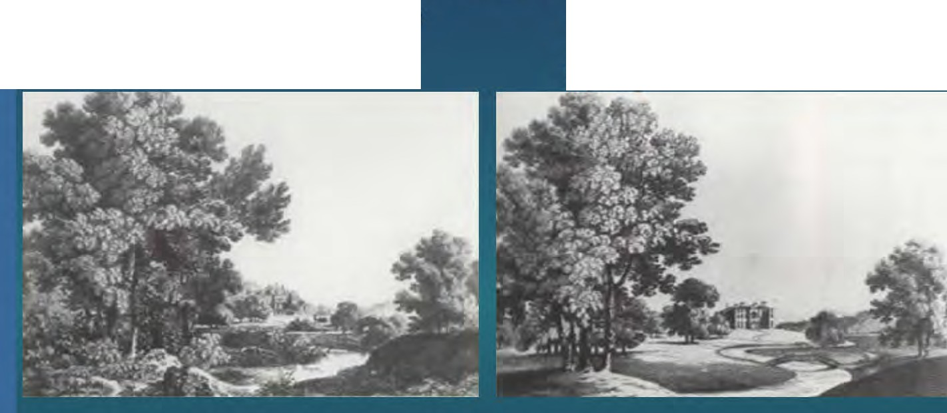The "Picturesque"
Mount Auburn
The "Beautiful"
Spring Grove/ Forest Hills

- Replicate a natural "wildness"
- Rustic and dense / Focused vistas
- A sense of latent power
- A reminder of mortality, vulnerability, insignificance. Awe of nature
- Nature controlled and managed
- Open and flowing / Broad vistas
- High lawn maintenance
- 'Man-Influenced' landscape awe

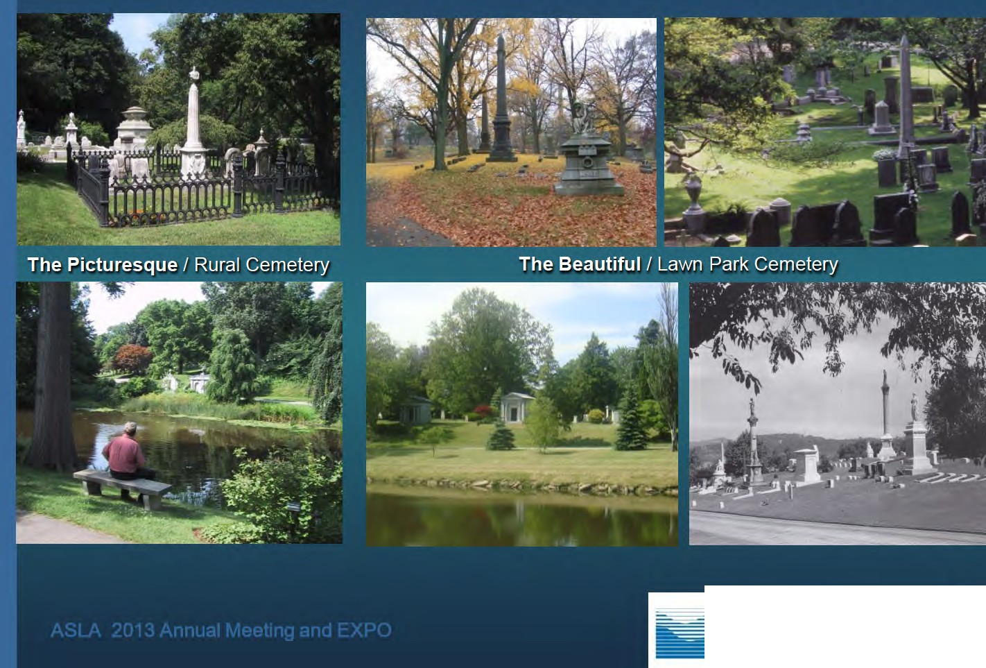
Classic Rural Garden Cemetery Landscapes

AMERICAN SOCIETY OF
LANDSCAPE ARCHITECTS

The Romantic Vision
  - Contact with Nature
  - Solitude
  - Quiet
  - Sanctuary
  - Beauty
  - Adornment

AMERICAN SOCIETY OF LANDSCAPE ARCHITECTS

Garden Cemetery Landscape Character

- Visual openness
- Expressive variety of monumentation
- Verticality and a sense of ascension
- Classical styles and forms
- Uniformity of materials
- Organic landscape designs
- Human scale and intimacy

AMERICAN SOCIETY Of

American Rural Garden Cemeteries

Mount Auburn
Cambridge, MA- 1831
La·urel HiII
Forest Hill
Jamaica Plain, MA- 1848
Bellefontaine

Pittsburg, PA - 1844
Swan Point
Providence, RI - 1846
Oakland, CA- 1863
Cypress Lawn
Colma, CA - 1892

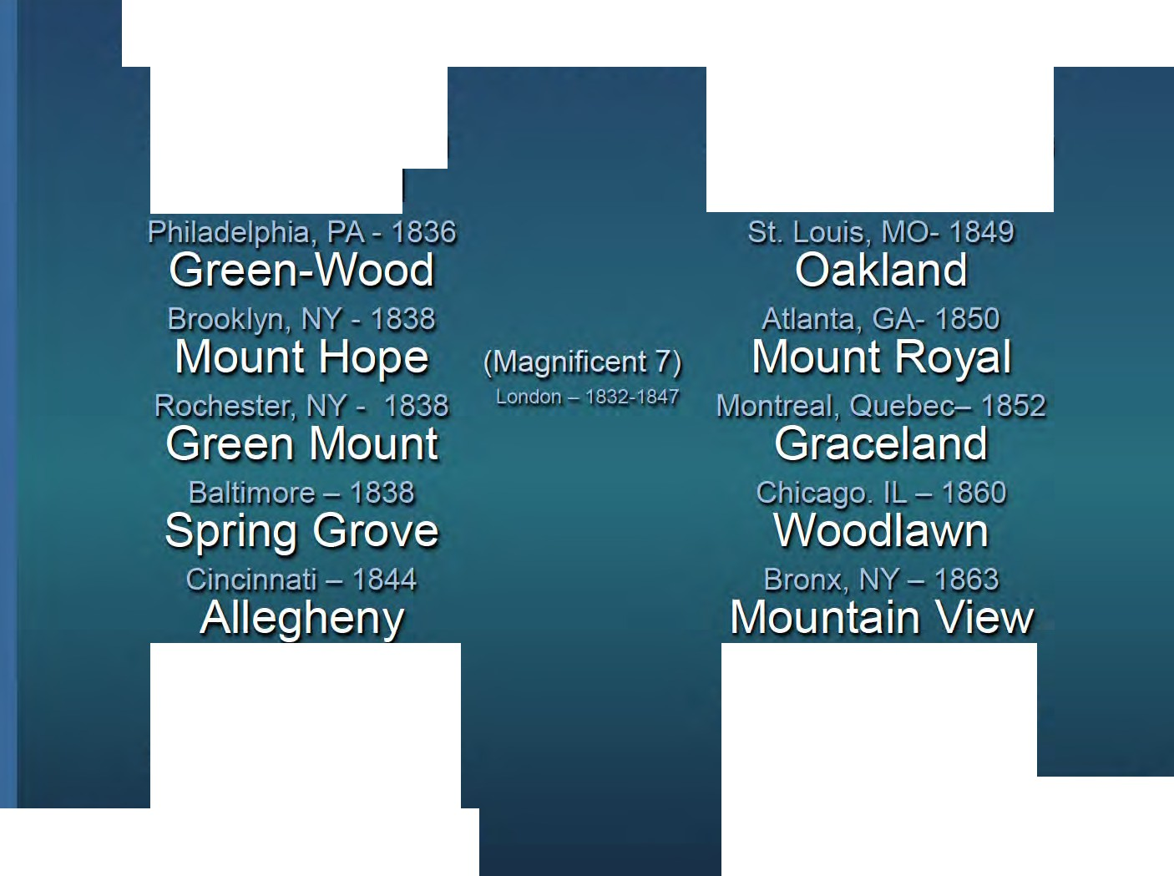

.I\SLA 2013 Annual r.,.1eeting and E.XPO AMERICAN SOCIETY Of

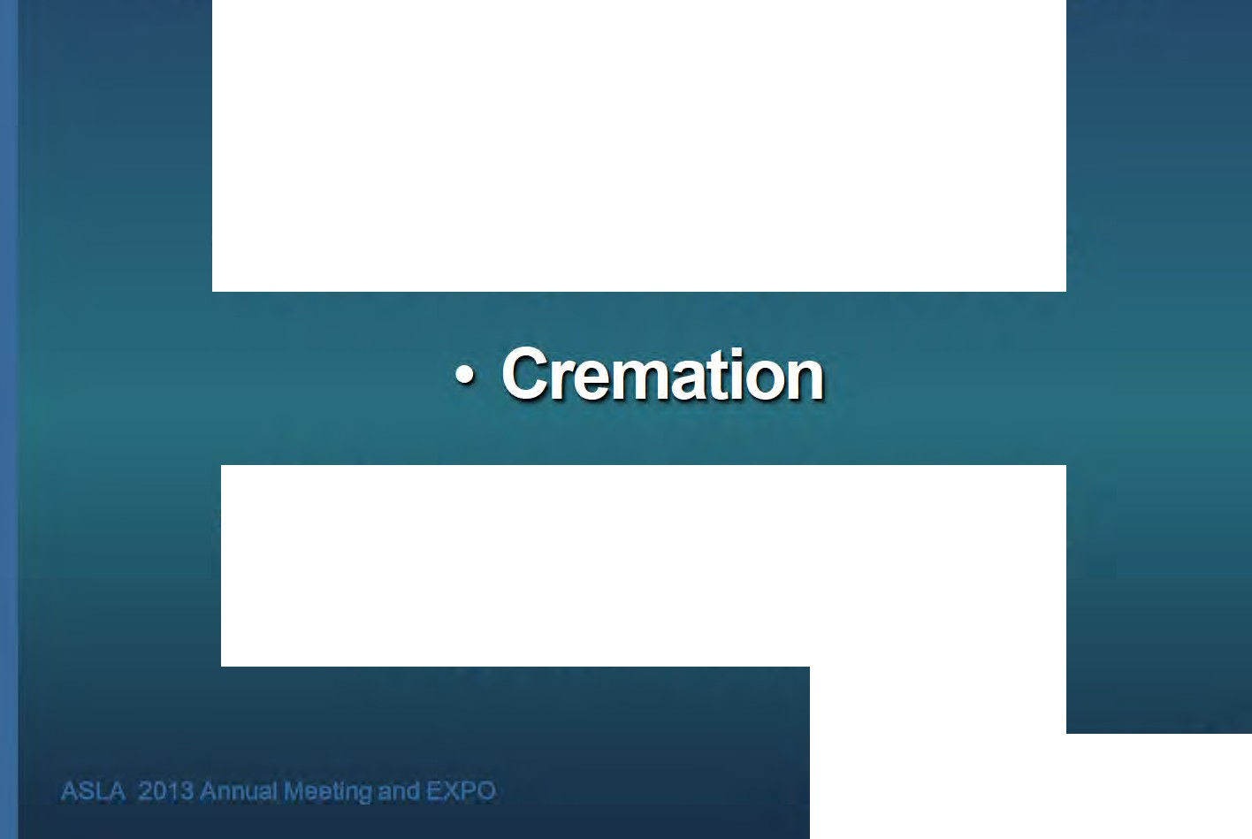The 20th Century Cemetery Changes

  - The Memorial Park
-• Cemetery ,GoQglom r tes·

- B aby·Boomer Values and

Buying Practices

AMERICAN SOCIETY Of
LANDSCAPE ARCHITECTS

The Evolution of the American Cemetery

The Church, Country, and Urban Graveyard
The Rural and Victorian Cemetery
Non-ascending , Standardized Ornamented Upright Monuments Monuments
The Memorial Park

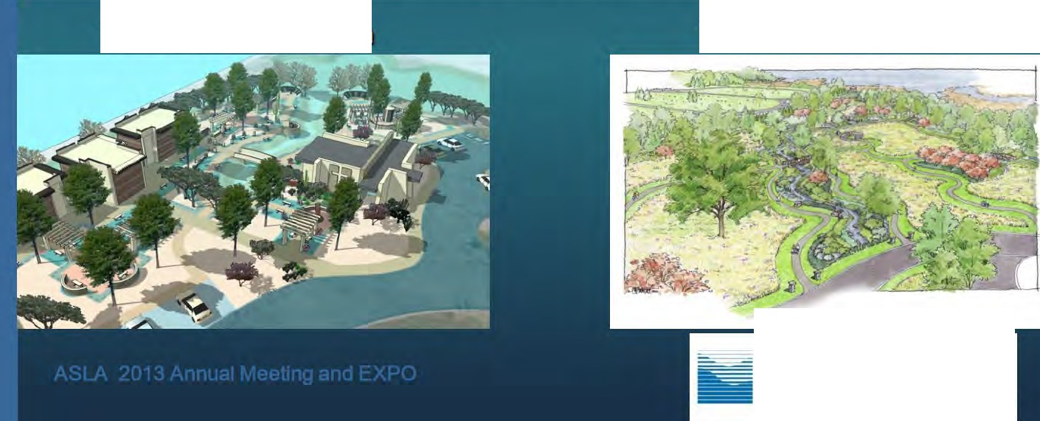

----
The Cremation Garden The Natural Cemetery

AMERICAN SOCIETY OF
LANDSCAPE ARCHITECTS

•-

AMERICAN SOCIETY OF LANDSCAPE ARCHITECTS

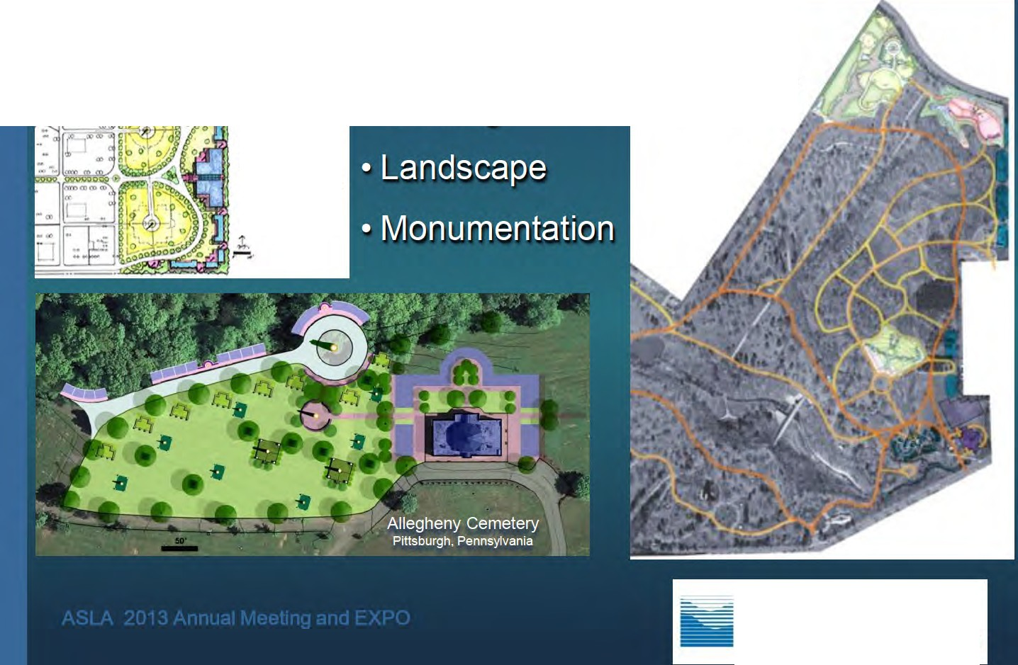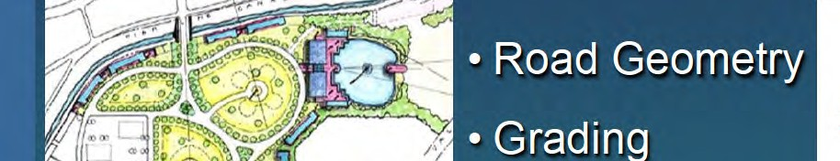Protecting Historic Design Principles

Lake view Cemetery
Cleveland, Ohio

Fairmount Cemetery
Denve r, Colo rado

AMERICAN SOCIETY OF
LANDSCAPE ARCHITECTS

Accommodating New Values
- Increased rate of Cremation
- Desire for Choices /Options
- Cultural & Personal Expressions
- Desire for affordable quality
- Environmental responsibility
- Empty nest economics
- Environmental Regulations

AMERICAN SOCIETY Of
LANDSCAPE ARCHITECTS

Baby Boomer Values and Buying Practices

Choices / Options
- Recognition
- Personal Expression
- Quality Materials
- 'Natural' Settings

'!4nd that's my tomb."

AMERICAN SOCIETY Of LANDSCAPE ARCHITECTS

New Values / New Choices
and
Redefining the American Cemetery

Cremation Gardens

Feng Shui based design

Natural or ''Green" Cemeteries

AMERICAN SOCIETY OF LANDSCAPE ARCHITECTS

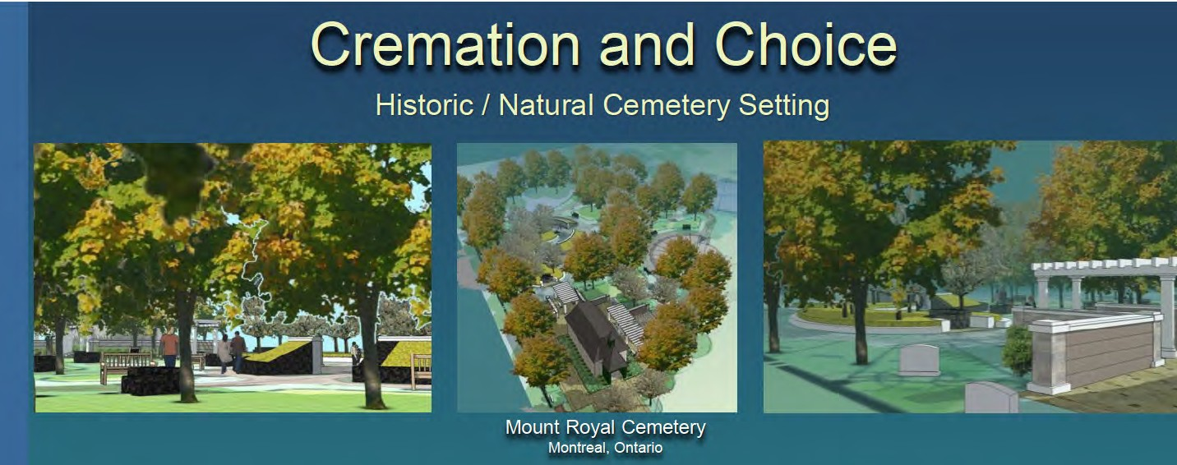
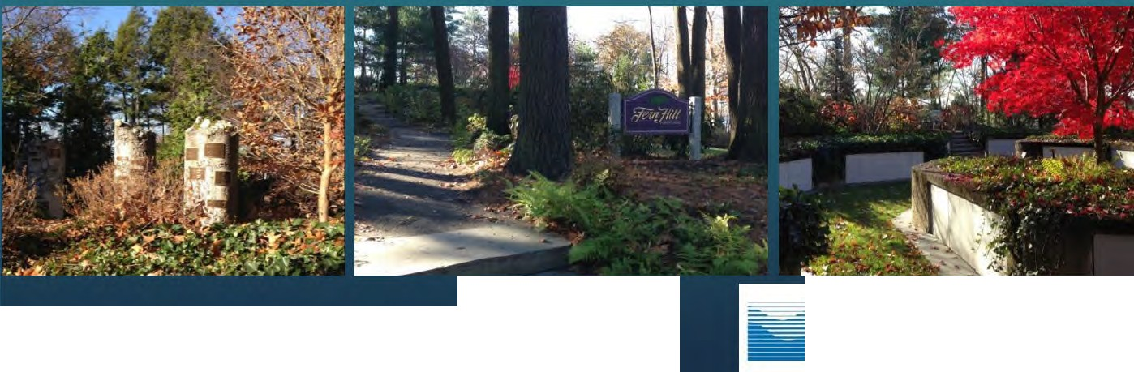
Forest Hills Cemetery
Jamaica Plain, Massac husetts
ASLA 2013 Annua! rv1eeting and EXPO
AMERICAN SOCIETY OF
LANDSCAPE ARCHITECTS

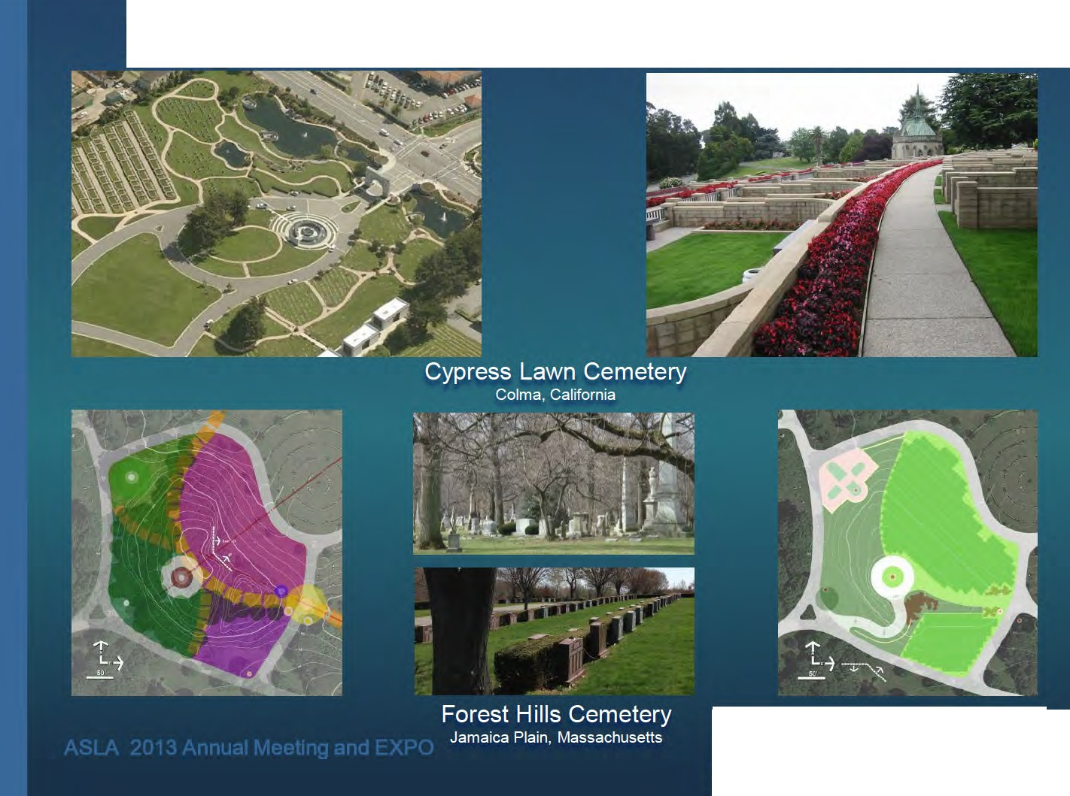Feng Shui Design in Historic Cemeteries

AMERICAN SOCIETY OF
LANDSCAPE ARCHITECTS

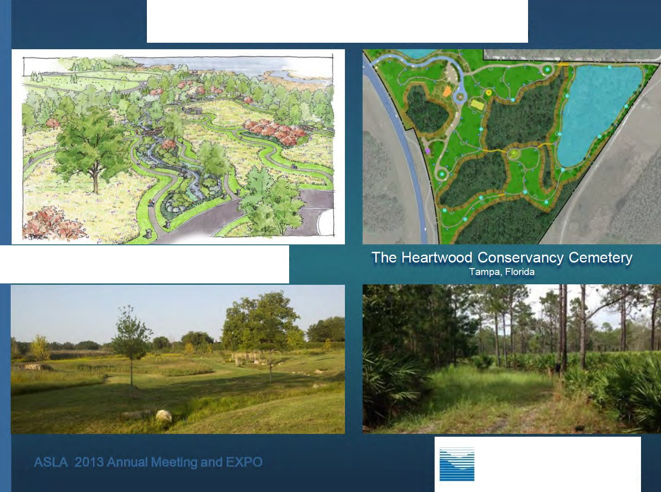Natural Burial Cemeteries

The Preserve at All Saints Cemetery
Waterford, Michigan

AMERICAN SOCIETY OF LANDSCAPE ARCHITECTS

Natural ('Green') Burial

Landscape Character
- Memorialization Systems
- Operations and Maintenance
- Public and Agency Approvals
- • Perpetual Care / Conservancies

AMERICAN SOCIETY Of
LANDSCAPE ARCHITECTS

EXHIBIT M

RECENT COMMUNITY MEMORIAL DAY PARADES AND PROCESSIONALS THROUGH THE VILLAGE TO THE COLD SPRING CEMETERY CEREMONY SITE

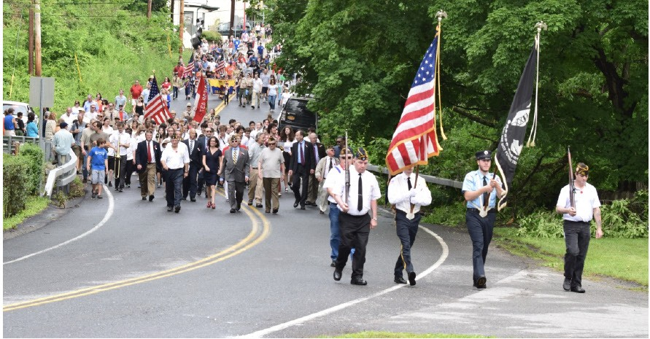
Peekskill Rd Approaching the Cemetery Gatehouse 2016
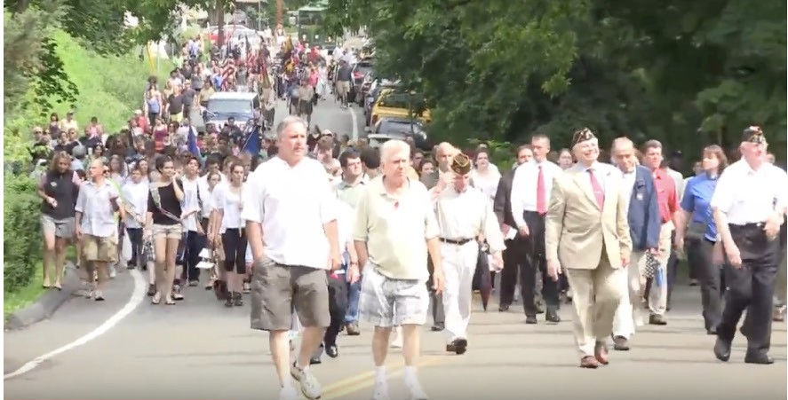
Peekskill Rd Approaching the Cemetery Gatehouse 2011

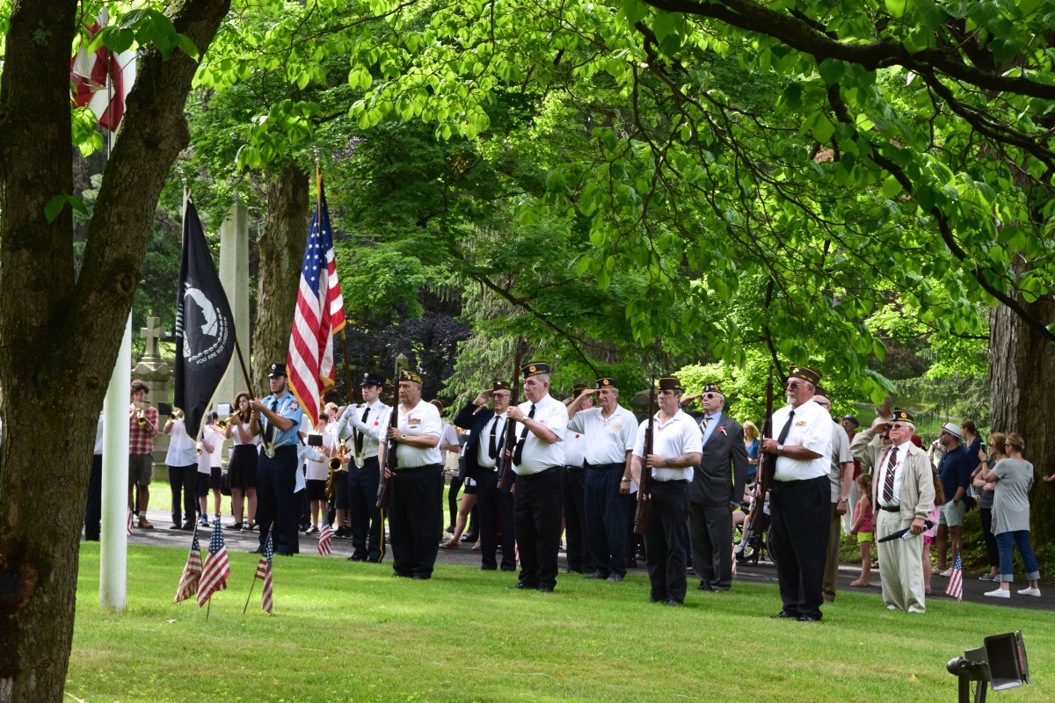
Memorial Day Ceremony 2016

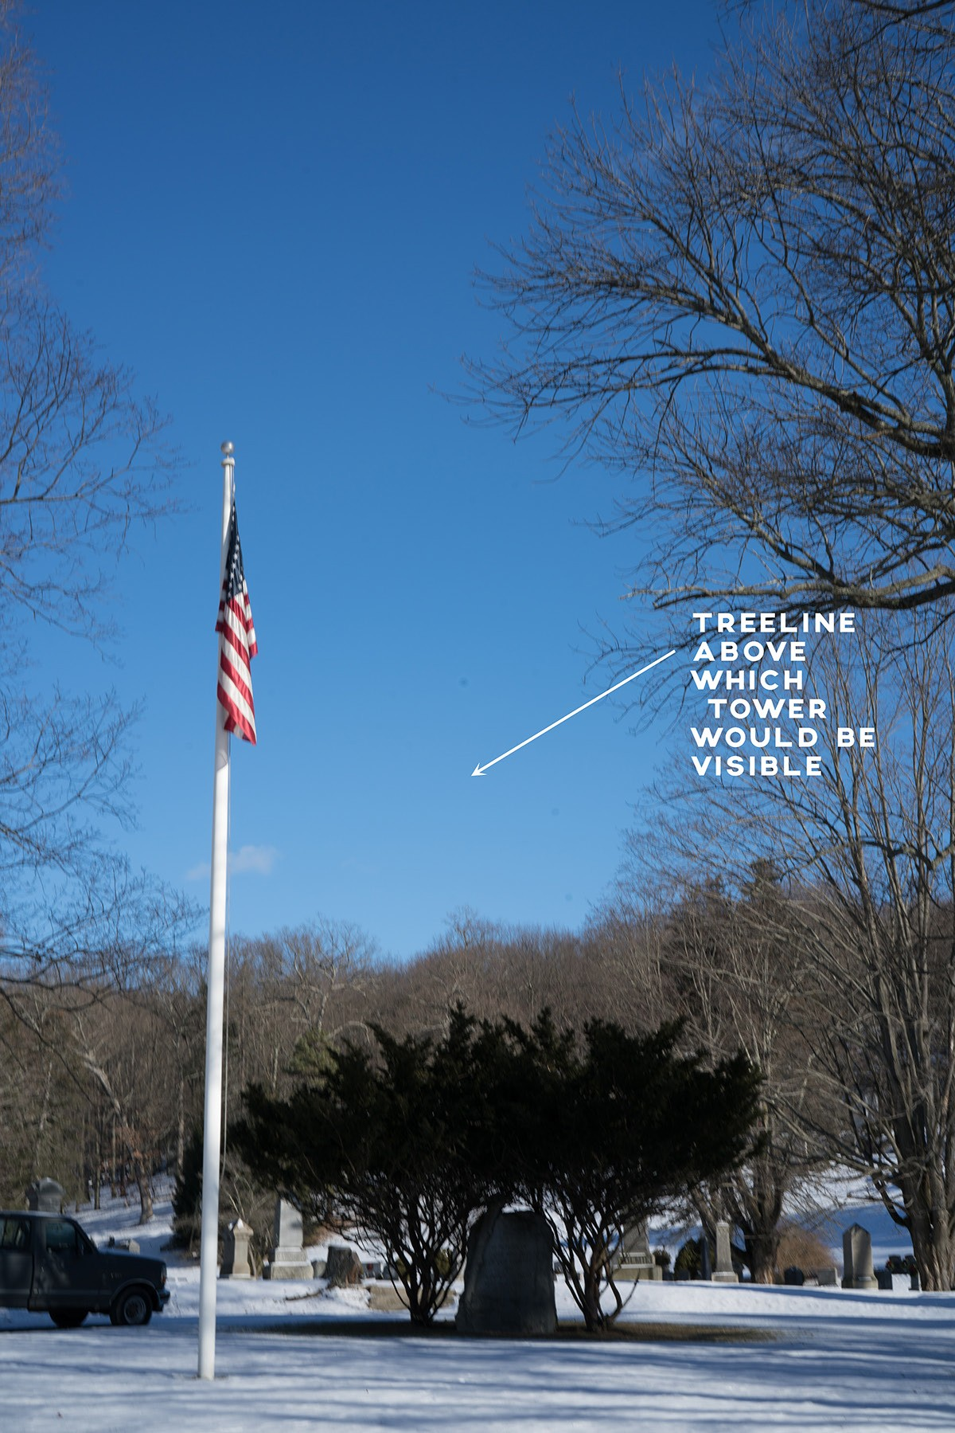
Central Ceremony area 2017

EXHIBIT N

Honorable Chairman William Rice, Special Counsel Todd Steckler, Nelsonville Zoning Board of Appeals, and Planning Board
Village of Nelsonville 258 Main Street
Nelsonville, NY 10516

January 9, 2018

RE: Application by Homeland Towers, LLC for a Special Use Permit to Construct a
Telecommunications Facility at 15 Rockledge Rd., Nelsonville, NY

Dear Honorable Chairman Rice, Special Counsel Todd Steckler,
Members of the Zoning Board of Appeals, and Planning Board

Philipstown Cell Solutions (hereinafter “PCS”) submits the following in reply to the September 25, 2017 and November 1, 2017 photograph submissions made on behalf of Homeland Towers, LLC, depicting examples of “stealth” monopines in our area.

PCS would like to point out that these photographs are misleading given the angles at which they were taken and are not a true and accurate depiction of the negative visual impact these types of structures have on identified scenic resources, nor do they truly reflect the high degree of intrusiveness such a structure would impose on this community.

Accordingly, in an effort to bring some balance to this issue and assist the Boards in visualizing the likely impact of the proposed tower, PCS submits the attached photographs of other “stealth” monopine cell towers in our area, taken from roadways and public vantage points that are similar to what would be imposed upon our community if the instant application is approved.

It is our contention, that given the height of the proposed tower and the surrounding type of vegetation at the Rockledge site, the proposed tower will have a significant visual impact and will stand out more in keeping with the photographs we submit herein, than with those submitted on Homeland’s behalf which have clearly been taken in such a way as to minimize said impact.

Sincerely, PCS

By: Jason Biafore

!

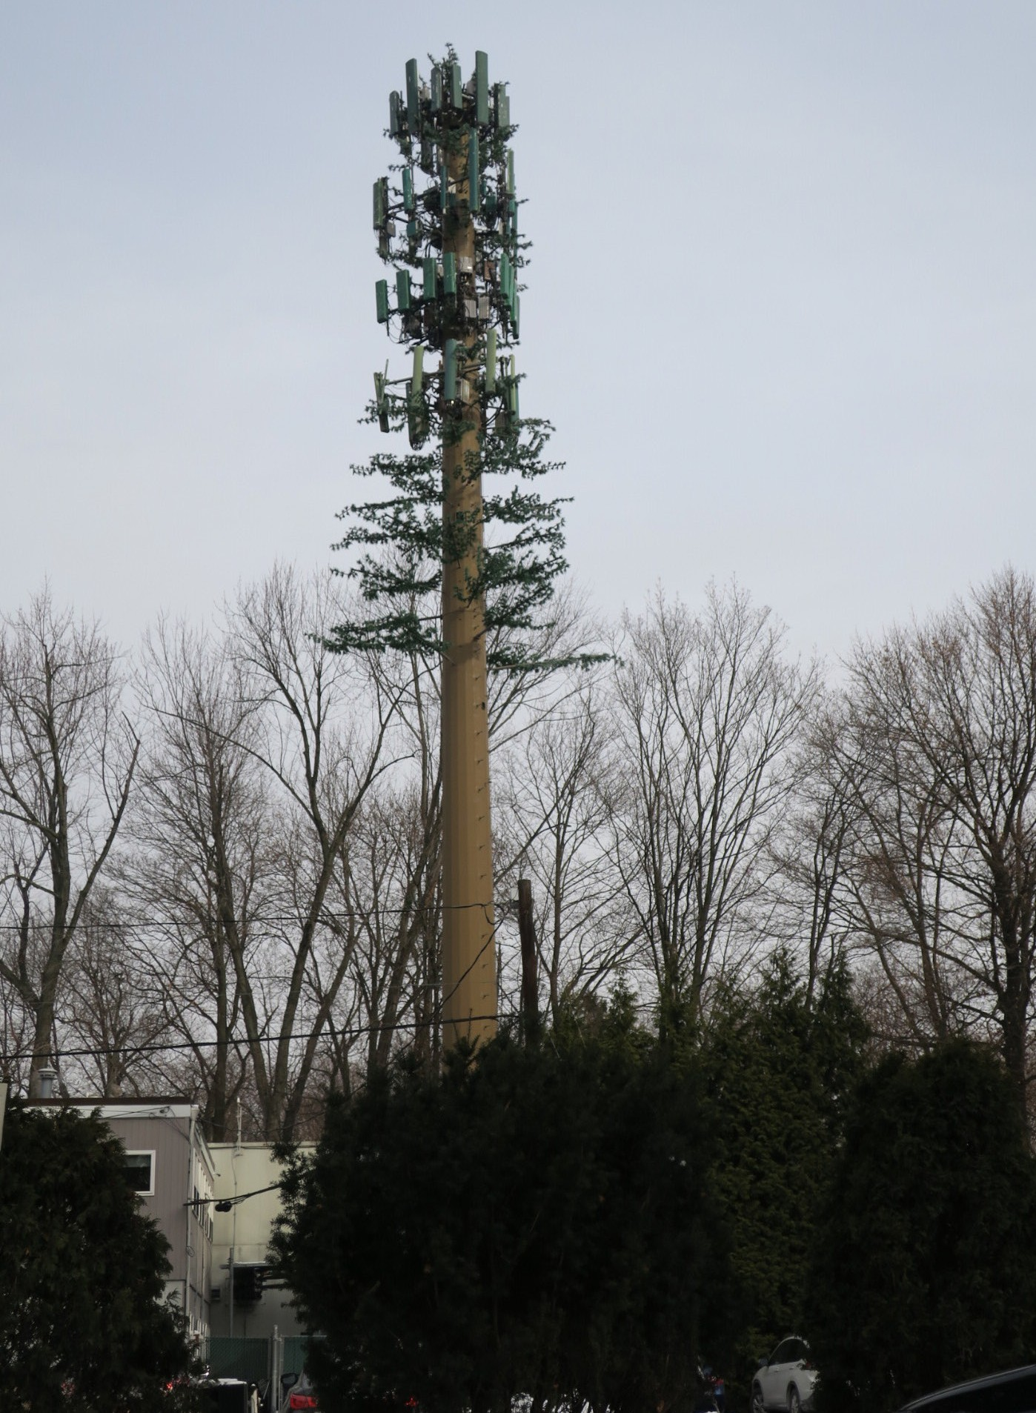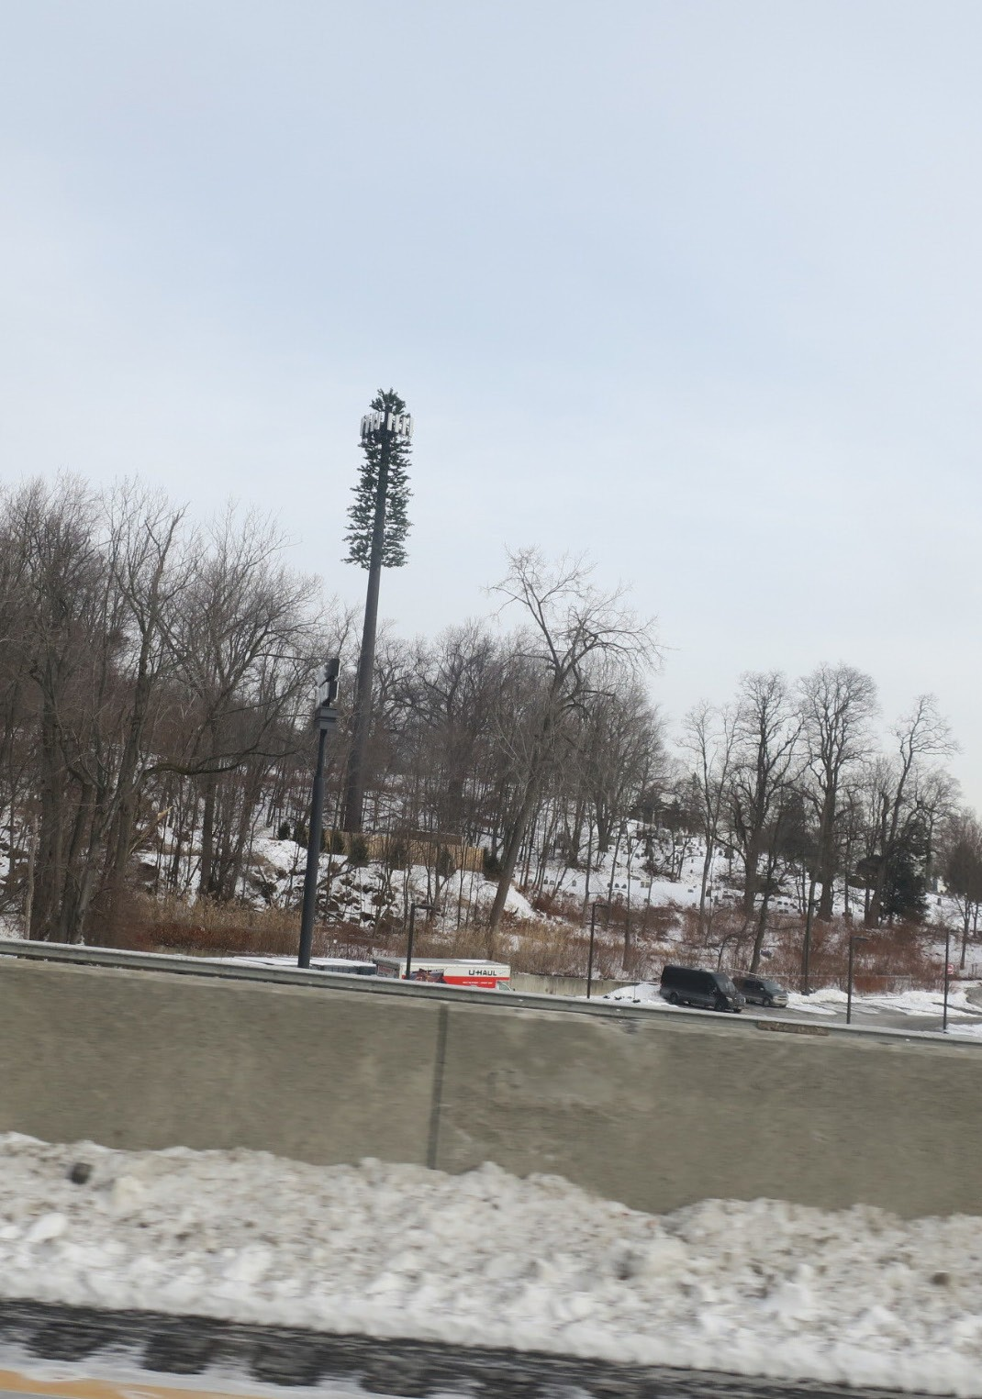

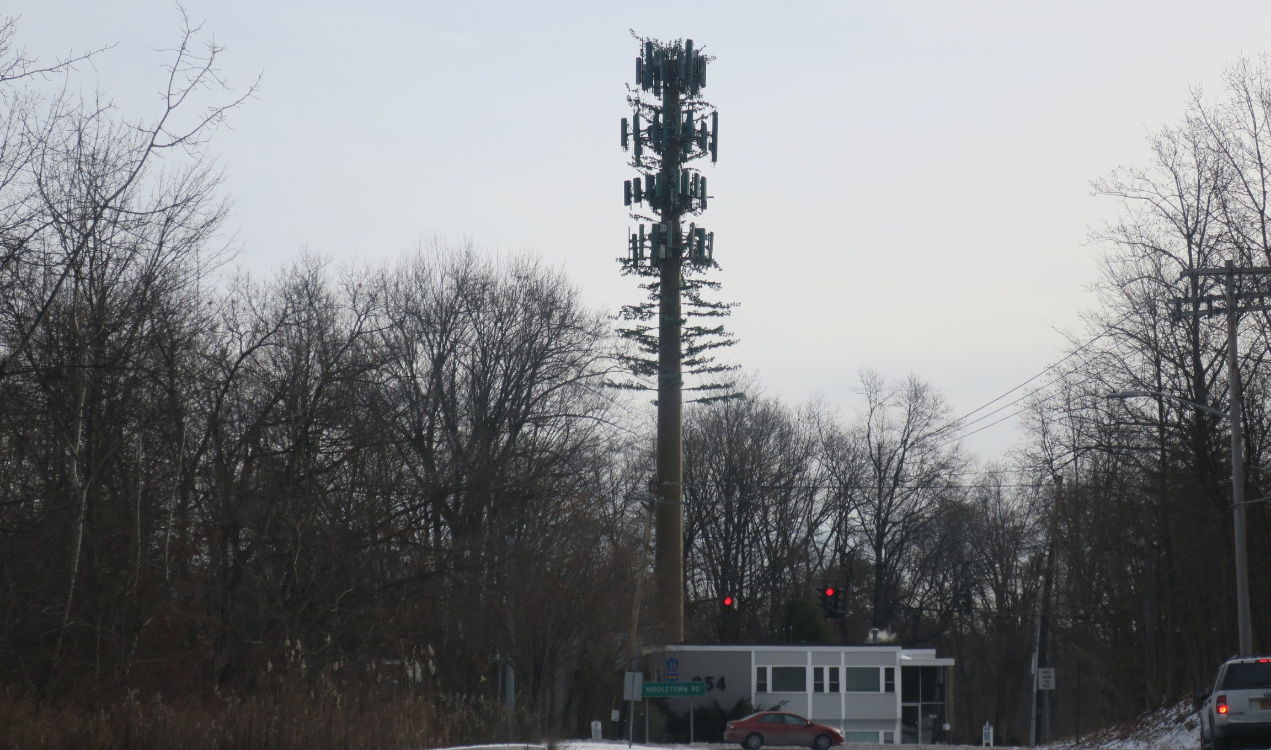

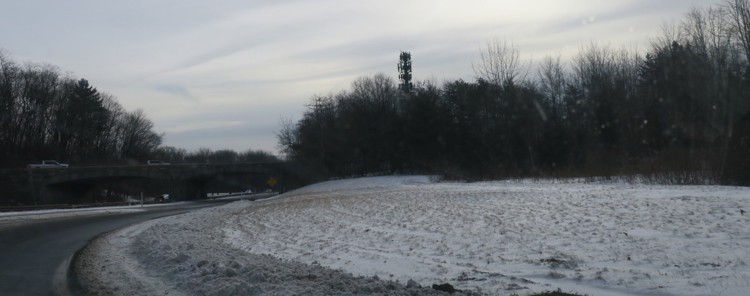

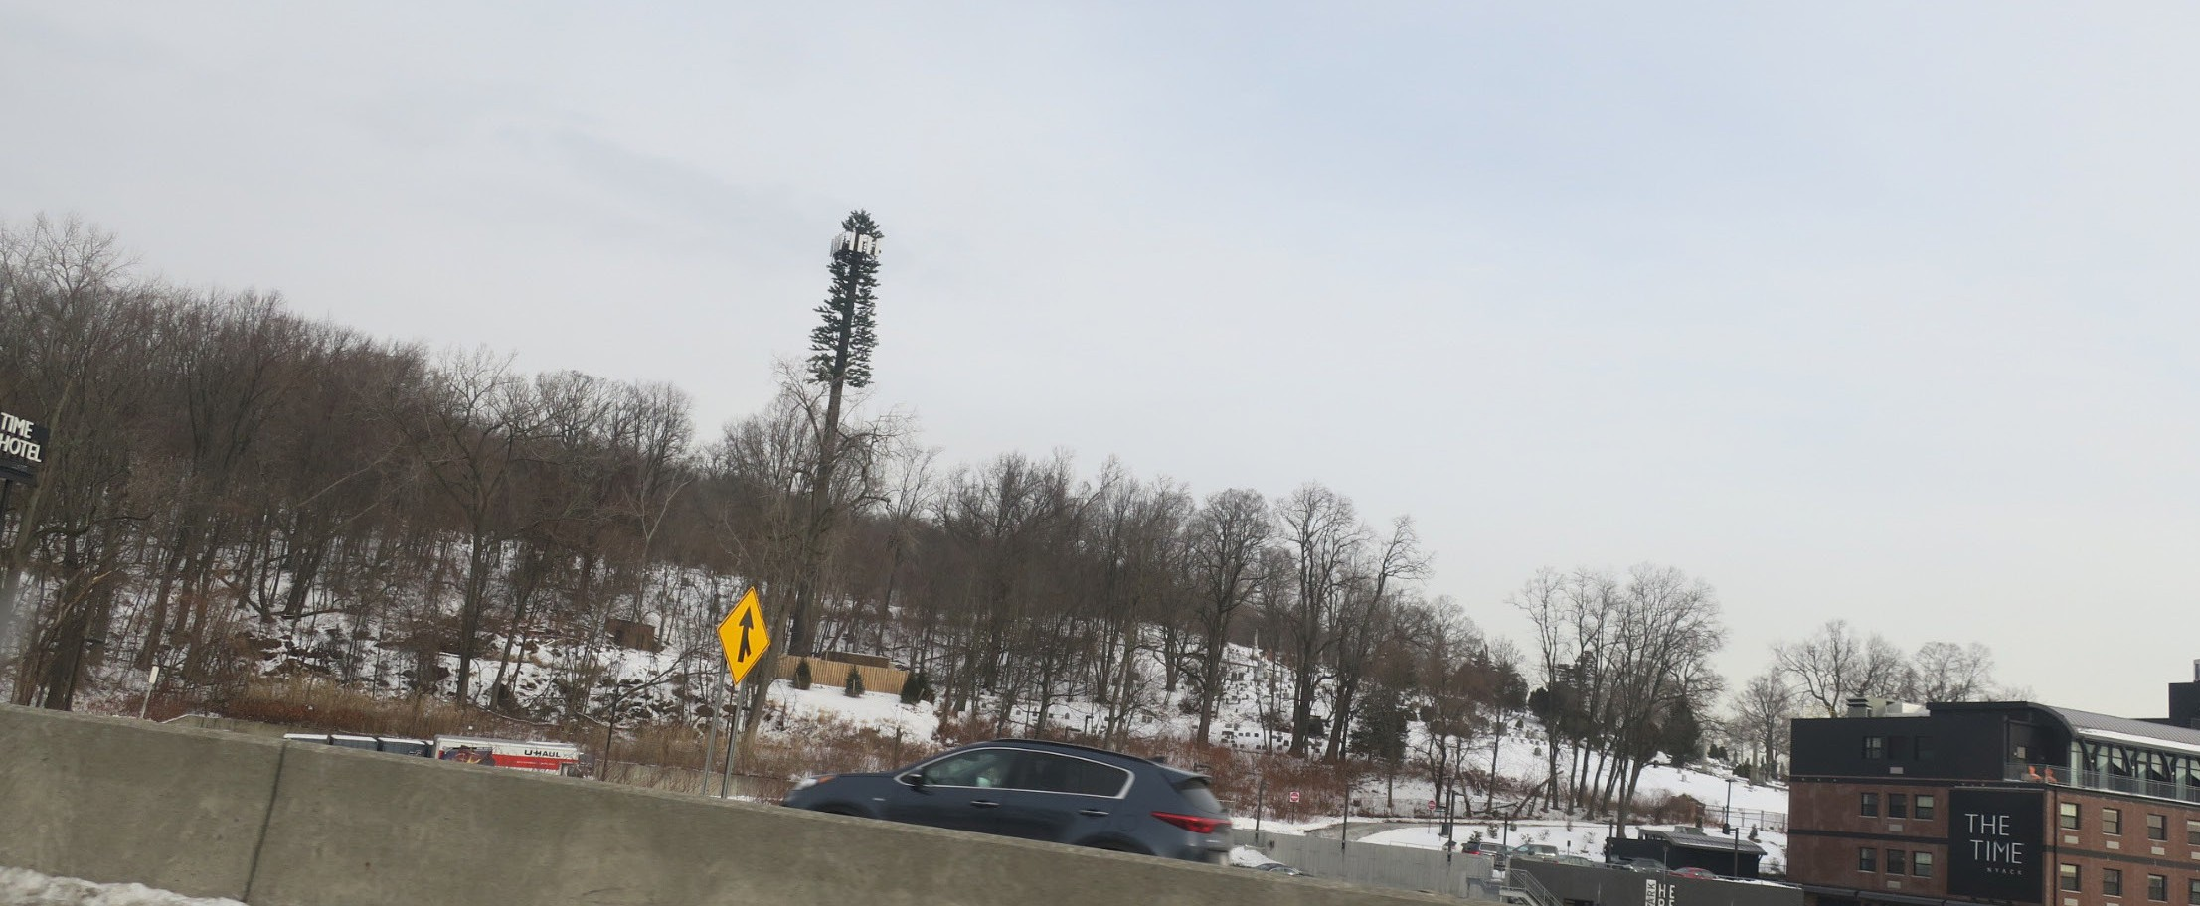

Example of more effective use of monopine camouflage, when placed alongside other conifers:

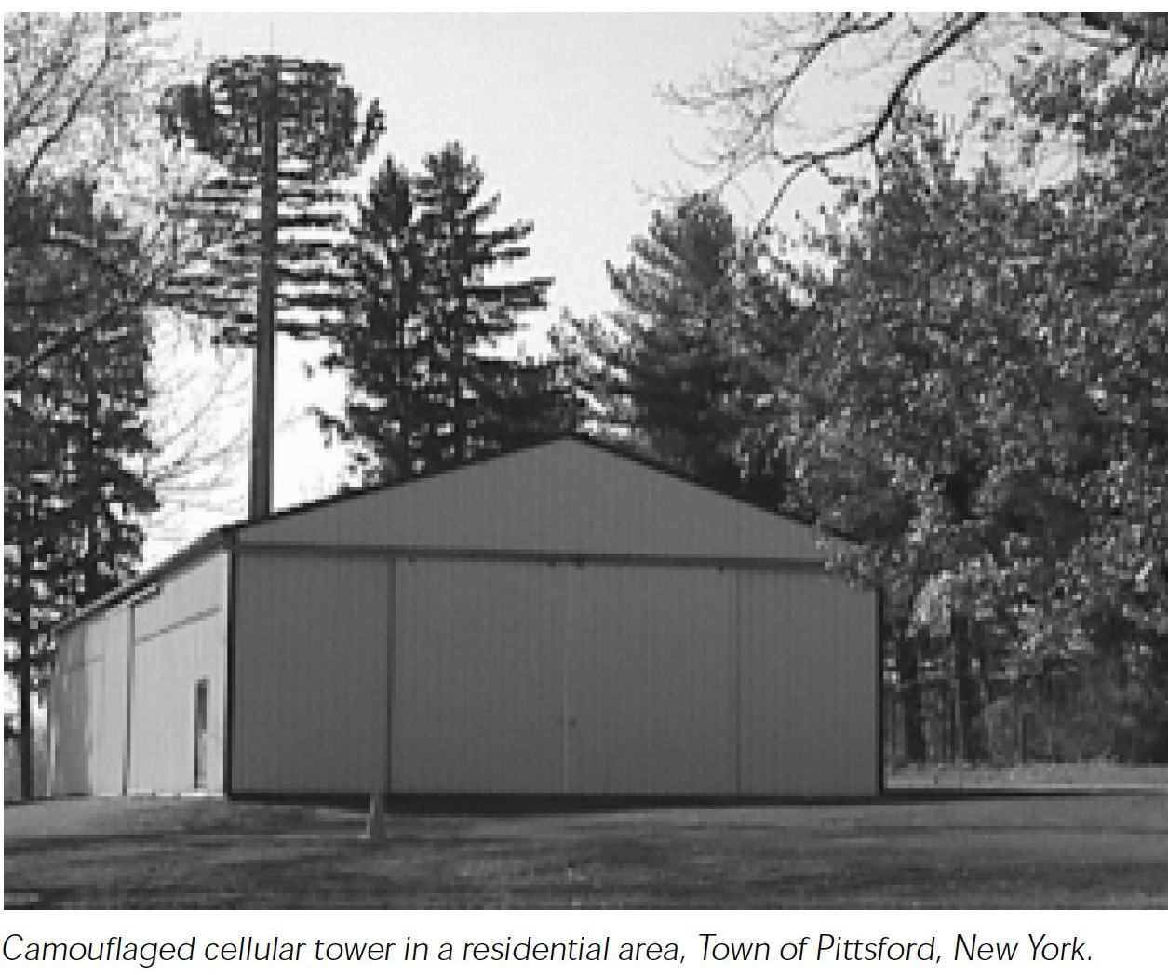

EXHIBIT 0

Altern ate Technology Des ign & Concealment DAS & SMALL CELL TECHNOLOG IES

1 . SMALLCELLINSTALLATION AT PENN COLLEGE, WILLIAMSPORT PA
Source: Accessed Ja n 1, 2018, https:/ / www.stealt hconcealment.com/ awesome­ small-cell-solution-popular-college-just-installed/
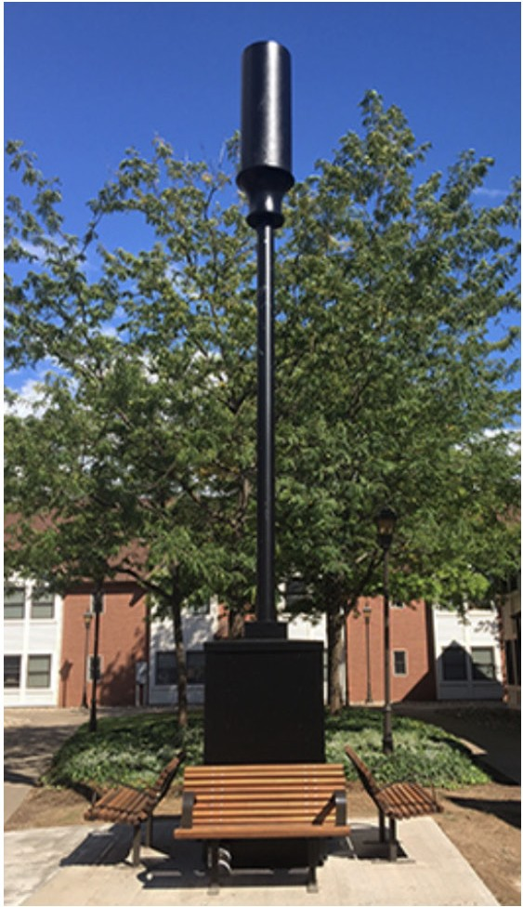

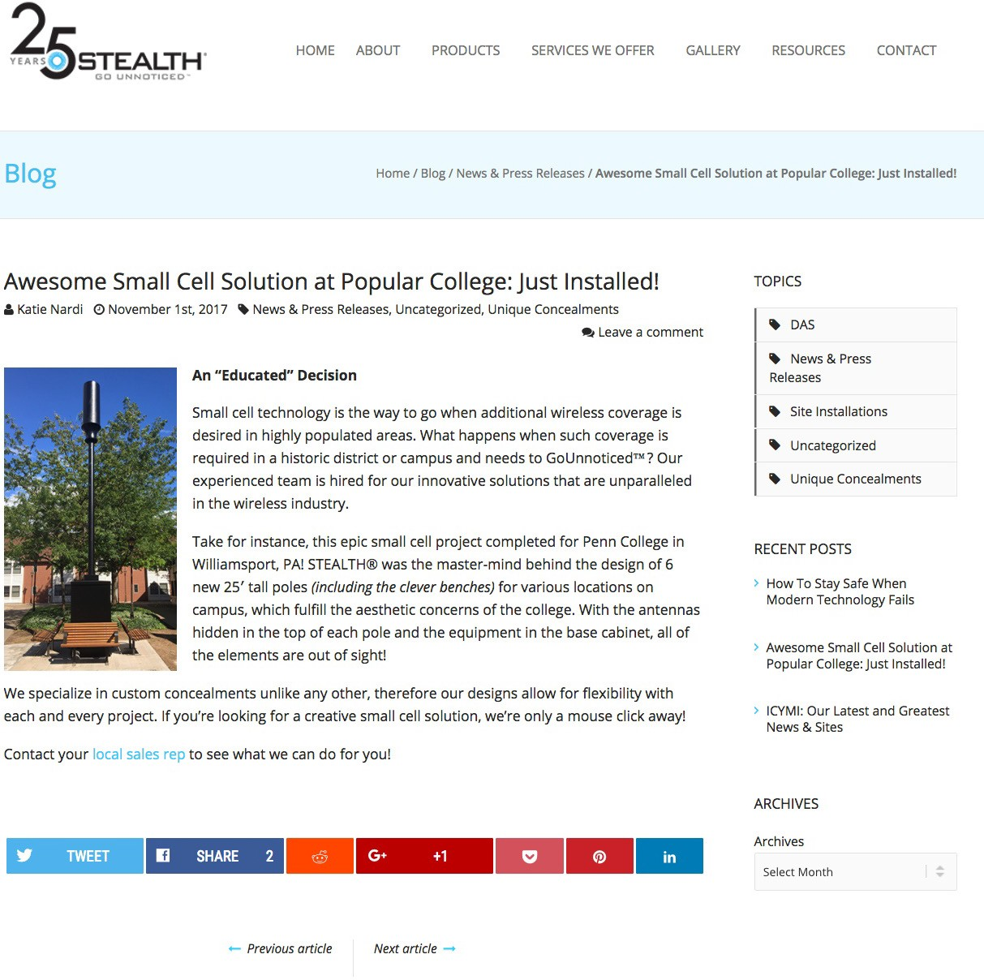

2. OTHER EXAMPLE OF DAS & SMALL CELL CONCEALMENTS
Source: Accessed 1/1/2018 https:// www.stealthconcealment.com/wp-content/uploads/2016/06/ DAS-Small-Cell-Portfolio.pdf

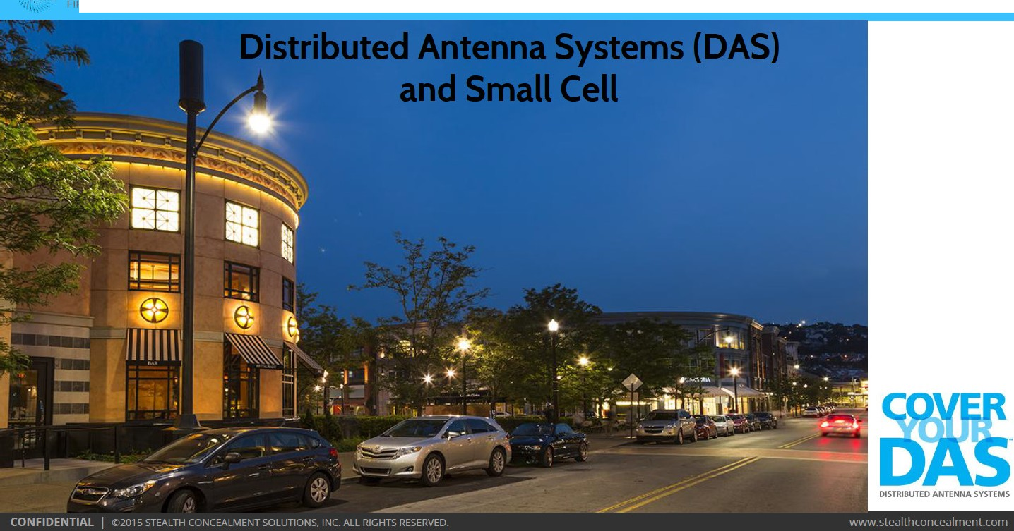
1 H.
· · • • STEAL1. ..
l J

. • STEALTH"
1

,,,.· i· J c \le A. r r, ,
Introduction to STEALTH®

Founded in 1992

1,000s of concealments throughout the world
23+ years of experience in the industry

Highest quality and cutting-edge RF transparent antenna concealment systems

Headquarters located in Charleston, SC

Pioneer of the concealment industry

  - - . STEALTH"
1

' 11. • . i J c, 'Jc _{11.} r r,, ..

Our Concealment Experience

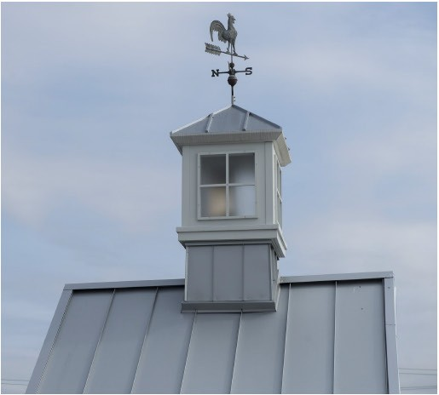
- Concealing wireless since 1992
- 10 0 % accept ance, on-time delivery and RF performance
- Assists with planning & zoning approvals
- Designs with cabling, amplifiers and ventilation in mind
- High profile areas considered with 24/7 public access
- Thousands of products installed successfully
- Technical site walks done at every stadium/campus
- Extensive portfolio

  - - . STEALTH"
1

' 11. • . i J c, 'Jc _{11.} r r,, ..

Concealment Benefits

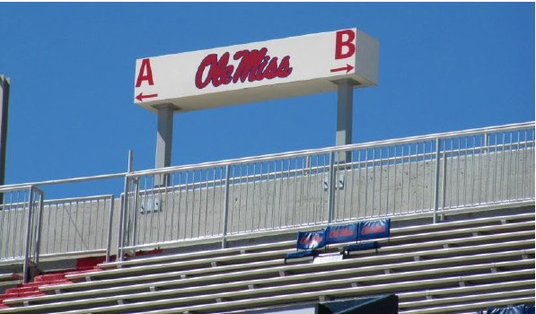
- Aesthetically pleasing results - no visible impact to the public
- Variety of custom solutions available
- Designs are per your requirements
- Accessories available (signs, ban ners, light s, decals, etc.)
- Designs allow for ventilation of equipment
- Easy access for maintenance
- Unobtrusive solutions for high traffic areas
- Vandalism of equipment is prevented
- Most applications tailored to all antenna types & technologies

. · - STEALTH"
1

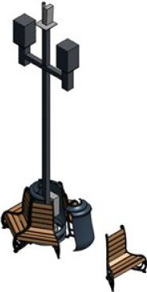·11. • . i J c, 'Jc _{11.} r r,, ..
'

Custom Pole Solutions
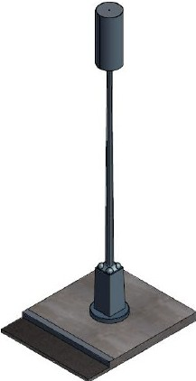
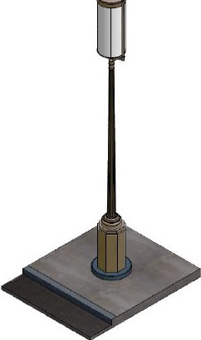
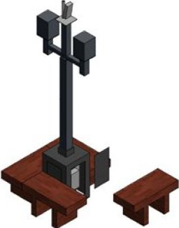I
•
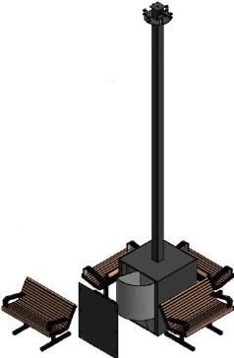
i

  - - . STEALTH"
1

' 11. • . i J c, 'Jc _{11.} r r,, ..

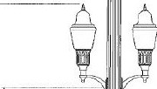Light Pole Solutions
0
I
':.i

- Location: University of Mississippi
- Antenna: CSS Antenna X7CAP-165, ADC FlexWave Prism
- Light: Holophane Granville Premier Lunar Optic
- Base shape designs differ
- Base lifts up for easy equipment access

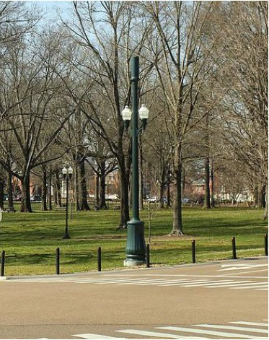
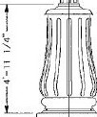
'.:'..
'-'--J.-i _., ,,,_.. ,

. · - STEALTH"
1

·11. • . i J c, 'Jc _{11.} r r,, ..

Light Pole Solutions continued...
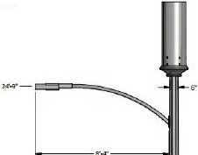YJ.(T - - - -
s·-r-
4'•t· -
-
-
-
- 1-'h
-

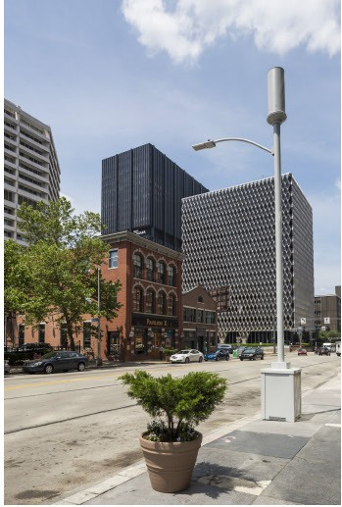
- Location: Pittsburgh, PA
- Top Concealment: 4' tall & 1'-6" OD
- Antenna: l(athrein 840 10515
- Base designs can differ
- Access doors on base
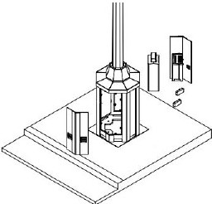
- 2 vented louvers per door

!, STEALTH"
i Jc, 'Jc 11. r r, 1"

Indoor Solutions

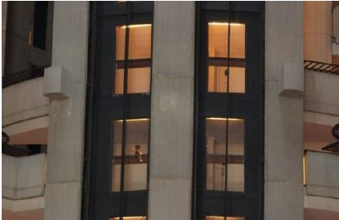
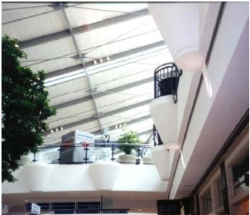
- Creative solutions for high profile venues

Lo cation: Atlanta, GA
Description: 2'-6" tall, 2' wide, 2' deep

EXISTIN G WALL
Location: Frisco, TX Description: 4' tall, 4'-6 " wideat top, 2' wide at base

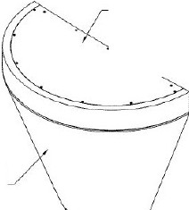
TOP ACCESS PANEL

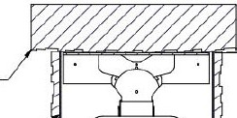A NTE N N A 5f-lELD t-1"1-t
BOX
,
L
1 - 7 3/ 4"
,- ,o ,; .--
'f'UCCO 1'1!X'TU1i!. P A.INT ! D A
OJ S'TOM!;R SPECFI IED COLOR

- STEALTH"
1
- 1 1.• i J c, 'Jc _{11.} r r,, ..

Indoor Solutions Continued...

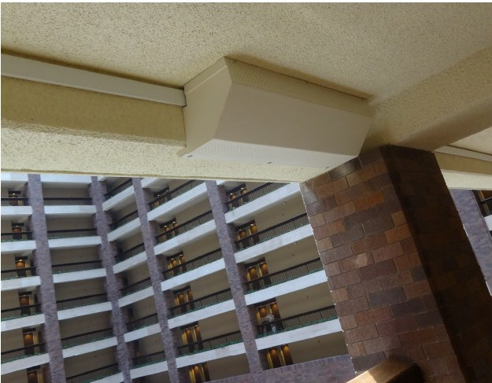
- Ventilating side-mounted boxes

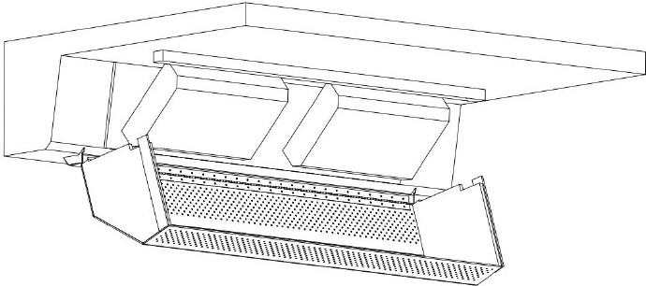

Location:Dallas, TX
D escription:1' tall , 5' wide, 2' deep

!, STEALTH"
i Jc. 'Jc 11. r r, 1"

Stadium Solutions

.

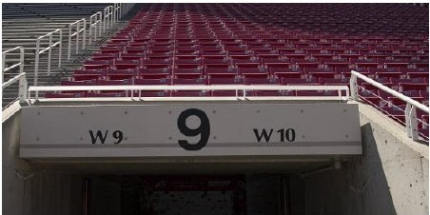
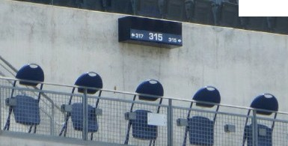Locatio n: University of Utah Description: 2' tall, 10' wide, 2' deep
.
.
.
.. . ..
.. . . ... -.
. . .
.
. . . .. .
. .
. ' . . .,
. ,J .

. .

L o cati on: Petco Park
Description:1' t all , 3' wide , 1O" deep

!, STEALTH"
i Jc, 'Jc 11. r r, 1"

Stadium Solutions Continued...

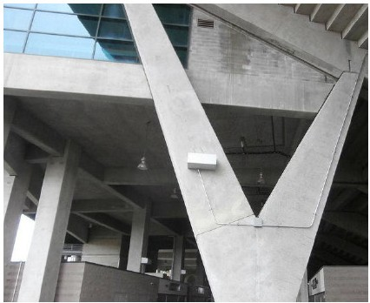
Location: University of Oregon Descriptino: 1'- 3" tall, 3'- 6" wide, 2' deep

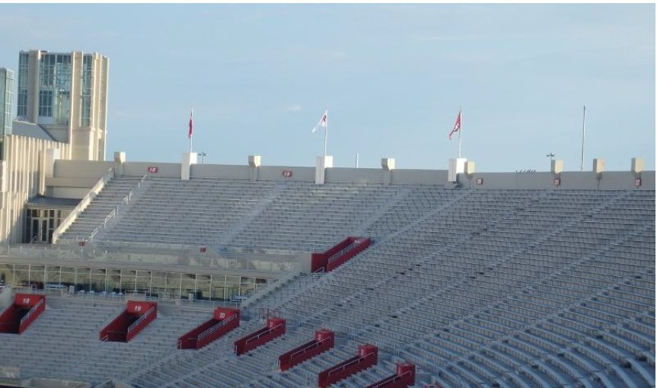
Location:Indiana University, Bloomington, IN
Description: Upper Boxes & Lower Vomitory Section Markers
Dimensions: Upper 5' tall, 2'- 4" wide, 2'=4" deep. Lower - 2'- 4" tall, 8'6" wide, 1'- 9 " deep

!, STEALTH"
i Jc, 'Jc 11. r r, 1"

Stadium Solutions Continued...

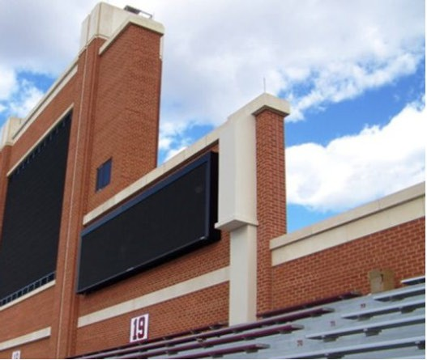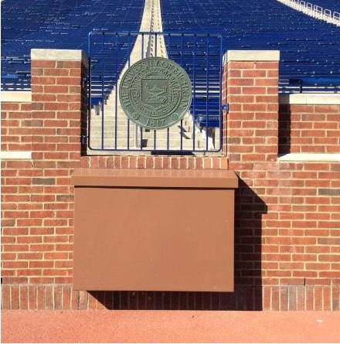

Locat ion : U ni vers ity of Ok lahom a Desc riptio n: 15' tall , 2' w ide , 2' deep
Location: University of Michigan Description: 4' tall, 4' wide, 8" deep

!, STEALTH"
i Jc, 'Jc 11. r r, 1"

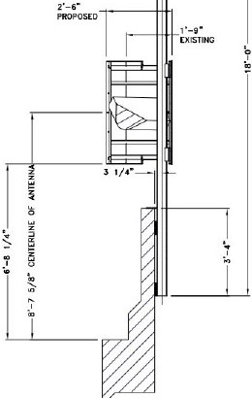Stadium Solutions Continued...
( XISnNC ,o'1.Ae:POI.£
R(MIAN

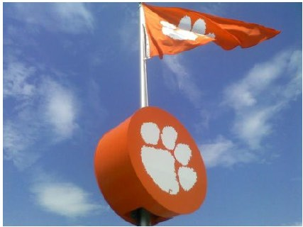
Location:Clemson University Descirption:2'- 6" tall. 4' wide, 3' deep

Location:University of Florida Description: 2' tall, 3' wide, 2' deep

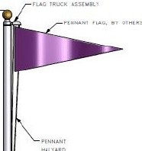
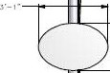

stcum Y COV!R
- r.

  - - . STEALTH"
1

' 11. • i J c, 'Jc _{11.} r r,, ..

Small Cell Solutions

- Great for historic districts!
- Designs can be ballasted, or roof-attached.
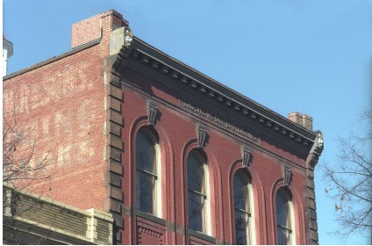
Location:Frederick, MD Description: 3' tall, 2' wide, 4' deep

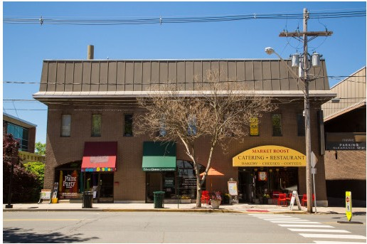
Location: Flemington, NJ
D escription: 6'- 6" tall, 18"0 ,0 ,

!, STEALTH"
i Jc, 'Jc 11. r r, 1"

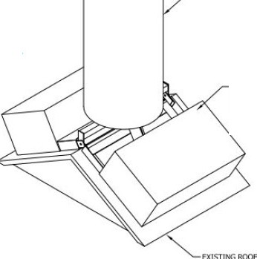Location : Rochest er, NY Descriptio n: 7' tall, 32" O.D.

Small Cell Solutions Continued...

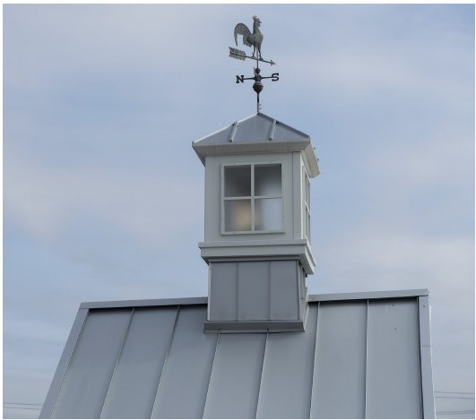
CYt.lNOER

SHEfT MfT AI. BAUASTFRAME
C0\18\

Loca tion: Eldersburg, MD Description: 6' tall, 3' wide.

!, STEALTH"
i Jc, 'Jc 11. r r, 1"

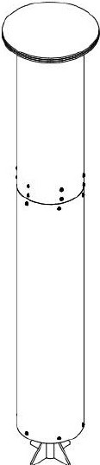
Small Cell Solutions Continued...

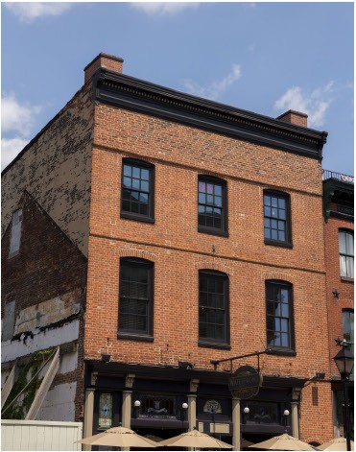
Lo cation: Baltim ore, MD
Descript ion: 2'- 6" tall, 2' wide, 4' deep
Location: West Hartford, CT Descr iption: 11' t all , 30 " O.D .

!, STEALTH"
i Jc, 'Jc 11. r r, 1"

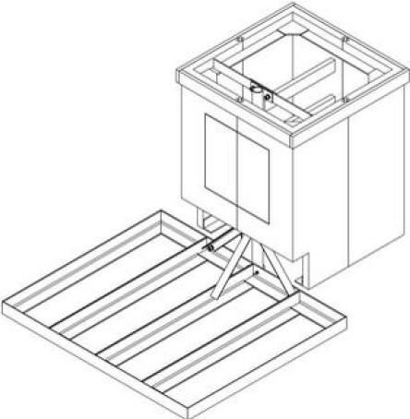
Small Cell Solutions Continued...

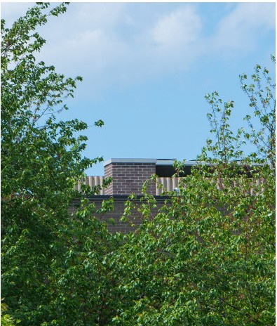
Locatio n: Montvale, NJ
Desc riptio n: 5' tall, 4' wide, 4' deep
*Ba llasted Desig n

!, STEALTH"
i Jc, 'Jc 11. r r, 1"

Small Cell Solutions Continued...

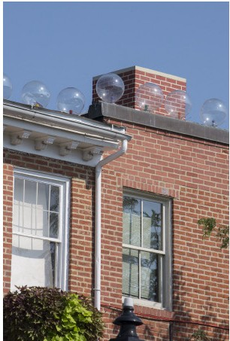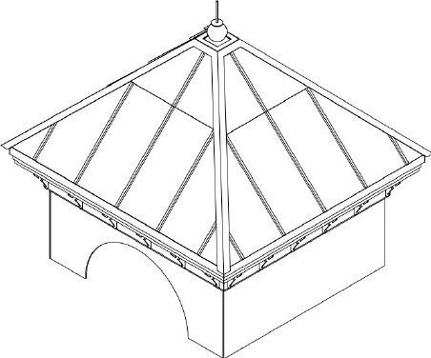

Location : Ba ltim ore , MD
Descriptio n : 3 ' ta ll , 3' wide , 3' deep
Location: San Antonio , TX
Descriptio n: 6'- 6" tall, 10' wide, 10 ' deep

. · - STEALTH"
1

,,,.· i· J c \le A. r r, ,
Contact Information

For additional information regarding our concealment solutions, please contact:

STEALTH® Concealment Solutions
3034-A Ashley Phosphate Road North Charleston, SC 29418

Cindy Wishart
800.755.0689 ext.124
cindywishart@stealthsite.com

Megan Rehm
800.755.0689 ext .118
meganrehm@stealthsite.com
coveryourdas.com DISTRIBUTED ANTENNA SYSTEMS

