PHILIPSTOWN CELL SOLUTIONS

April 15, 2018

Zoning Board of Appeals
Planning Board
Village of Nelsonville, NY
258 Main Street
Nelsonville, NY 10516

Dear Board Members:

I am writing on behalf of the Philipstown Cell Solutions (“PCS”) to urge the Boards to reject any consideration of an obelisk design to serve as a cell tower on Rockledge Road overlooking the Cold Spring Cemetery.

Today, the esteemed Village Clerk, Pauline Minners posted to the Village website a letter she sent on March 27, 2018, on behalf of the Boards, to the New York State Office of Parks, Recreation and Historic Preservation (“SHPO”) seeking review for a second time of the proposal of Homeland to erect a 125-foot obelisk in full view of the Cold Spring Cemetery. PCS knew that the obelisk design proposal was rejected by SHPO in its March 14, 2018 letter and thus had no reason or opportunity to comment on this ill-considered proposal. Had PCS been aware of Ms. Minners’ letter to SHPO prior to the April 4, 2018 hearing, PCS would have objected to this design proposal at that hearing.

There are 2 principal objections to the obelisk design proposal. One objection is to the
visual and esthetic harm this anomalous structure will have to the visual and esthetic resources of our scenic viewshed, especially because it will require the tower to rise 15 feet higher than the original monopine proposal. That issue will be addressed more fully in a separate PCS filing. The other objection is to the cultural and racial insensitivity that this design represents despite the Boards’ innocent motivation to try to “somewhat mimic the form and material of cemetery monuments within view”.

In a dark chapter in Nelsonville’s and Cold Spring’s past, the Ku Klux Klan (“KKK”) thrived here. It has long been documented. See for example the photograph below of a KKK funeral procession in our very own Cold Spring Cemetery in full-hooded KKK regalia.
(See also, e.g., http://highlandscurrent.com/2017/08/25/looking-back-local-klan/).

Both Boards are likely unaware of the history of efforts to (a) honor the Confederacy and its “Lost Cause” and (b) unify the white population against black Americans after the Civil War and Reconstruction and during the Jim Crow-era by placing hundreds and hundreds of monuments throughout cemeteries at first and then in front of courthouses around the South and elsewhere. There were 4 principal types of monuments employed. Types 1 and 2 were comprised of Confederate soldiers on pedestals. Type 3 was an obelisk. As documented in the definitive study of Confederate Monuments by John J. Winberry, entitled “Lest We Forget”, fully 48% of Confederate Monuments placed in cemeteries were comprised of Type 3 obelisks. (See: https://muse.jhu.edu/article/585508/pdf).

The white supremacist David Duke has used the Liberty Monument obelisk, which commemorates a deadly uprising by white nationalists against the biracial government in New Orleans during Reconstruction, as a rallying call to mobilize his movement of divisive hate. Duke used the obelisk as a site for his KKK gatherings. Some historians view this obelisk as a symbol of post-civil war racial tension and the introduction of Jim Crow laws. Indeed, a Dorothea Lange photo depicting part of the Liberty Monument with the caption: "One side of the monument erected to race prejudice. New Orleans, Louisiana."
(See: https://www.nytimes.com/1993/07/16/us/new-orleans-to-remove-obelisk-revered-by-white-supremacists.html; http://nymag.com/daily/intelligencer/2017/04/new-orleans-removes-monument-to-white-terrorism.html).

Recently, we have witnessed large-scale movements throughout the South to remove these obelisks as vestiges and celebrations of the morally-bereft lost cause of slavery and subjugation of black citizens through Jim Crow laws. After the white supremacists rallied in Charlottesville, these obelisks have come down in many American cities including New Orleans, Atlanta and Baltimore. Indeed, even Westchester County has joined the debate over a 60-foot Confederate memorial obelisk placed in Mt. Hope Cemetery in Hastings-on-Hudson, NY. (See http://www.westchestermagazine.com/Westchester-Magazine/November-2017/Is-the-Mount-Hope-Obelisk-Truly-a-Confederate-Memorial/).

It would be extremely unfortunate if the Boards chose a design that inadvertently gave succor to the discredited forces of racism and prejudice by erecting what may be deemed by those forces to be a celebration of the history of white supremacy and prejudice that at the same time continued an old and discredited part of our local history that made black Americans feel as unwelcome here as in the heyday of the Cold Spring Foundry when black Americans were excluded from employment there.

Sincerely,

Harold Akselrad, on behalf of PCS cc: Todd Steckler, Esq.

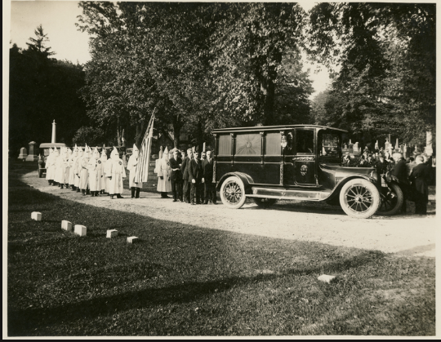

Photo courtesy of: Schomburg Center for Research in Black Culture, Photographs and Prints Division, The New York Public Library. "Funeral procession for a Ku Klux Klan member, held in Cold Spring, Putnam County, New York, 1920s." The New York Public Library Digital Collections. 1920 - 1929. http://digitalcollections.nypl.org/items/25c948b0-7d17-0130-87ad-58d385a7b928

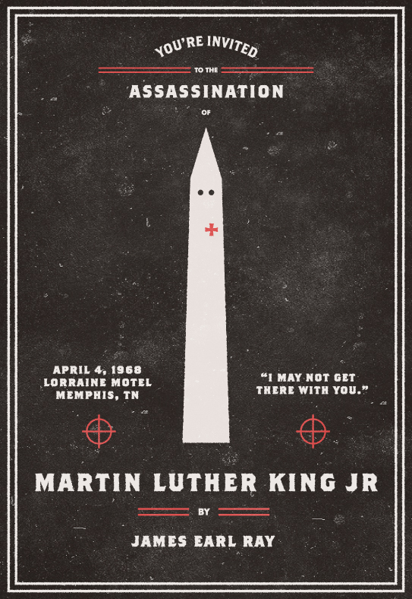

“On August 28, 1963, Martin Luther King Jr. delivered what is now considered to be one of the most famous speeches in American history. "I Have A Dream" was delivered on the steps of the Lincoln Memorial to a crowd of over 200,000 supporters. All the while King was staring out across the reflecting pool at the Washington Monument, which looks an awful lot like a Ku Klux Klan member. On April 4, 1968, King was assassinated as he stood outside his hotel home in Memphis, Tennessee.”
— http://cargocollective.com/invitationtoanassassination/Martin-Luther-King-Jr

