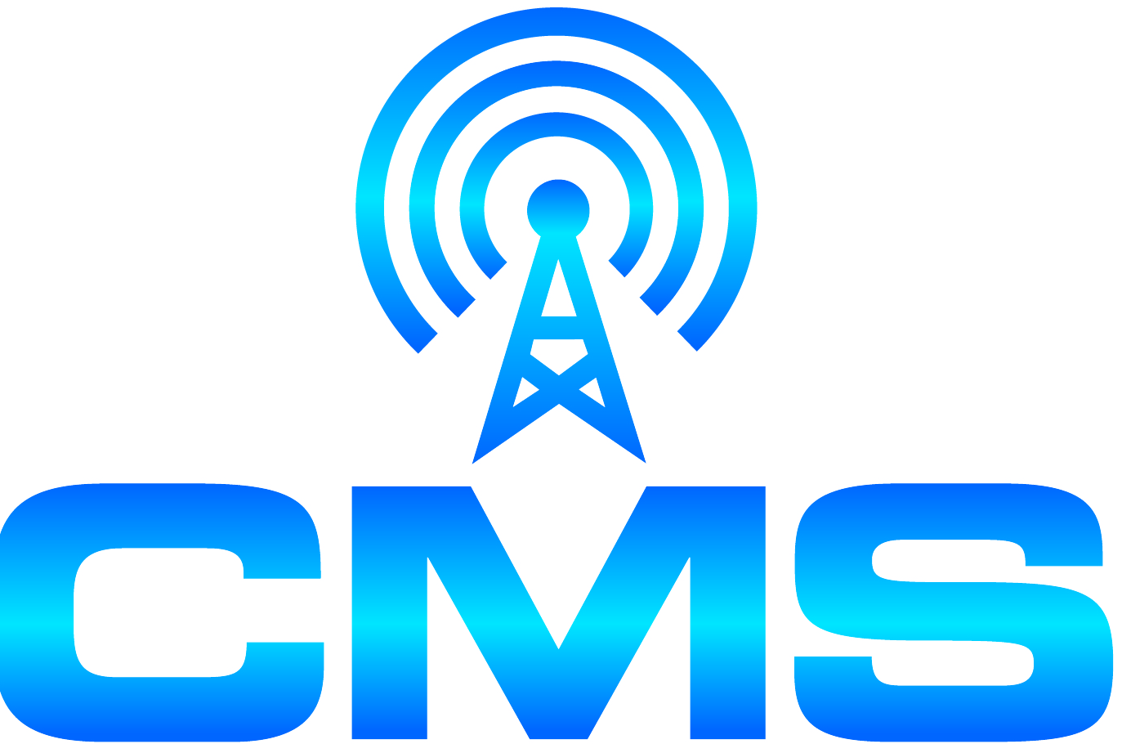
CENTER FOR MUNICIPAL SOLUTIONS
70 CAMBRIDGE DRIVE
(518) 439-3079 GLENMONT, NEW YORK 12077 FAX (518) 478-0909

February 8, 2018 (via e-mail and regular mail)

Zoning Board of Appeals/Planning Board
Village of Nelsonville, New York
258 Main Street
Nelsonville, NY 10516

Dear Board Members:

Please accept the following comments in response to issues raised at the joint ZBA/Planning Board Meeting that occurred on January 10, 2018. Homeland Towers (applicant) proposes that a 110’ monopole designed to resemble a tree is the least visually intrusive design and best means of deployment for Verizon Wireless and AT&T to provide service within the Village of Nelsonville, NY. I strongly disagree and restate my position that the need for the proposed tower location and design has not been justified by the application material submitted, and where other less intrusive designs are available but have not been offered by the applicant as alternatives for these Boards to consider.

The proposed tower is designed to resemble an evergreen tree that will stand alone in an area surrounded by deciduous trees. Several experts on the record have confirmed that the proposed tower will have a significant adverse visual impact on the cemetery and its environs.

The application material contains propagation maps that indicate more than 80% of the coverage to be provided by this tower is intended to extend beyond the Village of Nelsonville. To serve Nelsonville, there are other less detrimental deployment options and facility designs that must be considered as alternatives to the proposed tower. At the 1/10/18, Meeting, Homeland Towers stated that their parent company does install Distributed Antenna Systems (DAS) but has not offered DAS as an alternative means for the deployment of Verizon Wireless and AT&T service within the Village of Nelsonville.

Despite any claims to the contrary, it is my expert opinion that DAS would work for the Village of Nelsonville. Nelsonville is approximately one (1) square mile. The coverage area for a DAS node can be approximately ¼ mile. The placement of a few DAS nodes on existing utility poles or other eligible opportunity sites would provide wireless service within the Village without imposing a burden on the historic cemetery. These nodes represent a much smaller and less intrusive solution than the proposed tower. DAS nodes can also be concealed within streetlight structures to further reduce their visual impact. DAS does get permitted under the Village’s wireless code such that it would be subject to the jurisdiction and review of the Village’s boards. Multiple carriers can utilize each node, making the system very flexible and growth-friendly to fit the Village’s needs. (To illustrate the efficacy of an outdoor DAS installation, I have enclosed as an additional email attachment (without endorsement) a brochure prepared by American Tower that illustrates a typical DAS outdoor installation. Note that American Tower states the typical network includes “nodes that are strategically placed…every half to three-quarters of a mile within the coverage area”.)

There are also existing alternative locations that have not been proposed or adequately considered, such as church steeples and building rooftops where “small cell” facilities could be concealed within stealth structures.

The applicants have not demonstrated the need for this structure at the proposed location. There are other less detrimental options to provide wireless service within Nelsonville that have not been considered. Therefore this application is incomplete and must be denied.

Sincerely,

R.A. Comi (electronic signature)
Richard A. Comi
CMS

CC: Philipstown Cell Solutions Group (via e-mail)
Todd Steckler, Esq. (via e-mail)

