Village of Nelsonville

Public Hearing on Whether to Officially Decline the 1987 Offer of Dedication of the Property Located at 13 Gate House Road
September 14, 2022
7:00 pm

Board Members Present: Mayor Winward, Trustee Campanile, Trustee Maloney, Trustee Moroney and Trustee Zhynovitch.

Mayor Winward called the hearing to order.

Mayor Winward gave some background and a summary of the timeline of the Lyons Subdivision, per Nelsonville Village records, as follows:

Timeline of Lyons Subdivision Per Nelsonville Village Records

March 19, 1987: The Planning Board discussed the preliminary Lyons subdivision plat. Comments included concerns with flooding in lot #1 and that it was not a public roadway. Preliminary approval was requested pending final subdivision approval of map.

May 21, 1987: Nelsonville Planning Board issued final approval of the proposed subdivision by resolution, which stated that “a check in the amount of $4500 will be held by the Village Clerk until such time as the deed transfer occurs for a parcel of land being donated to the Village of Nelsonville for recreation.” A check for $4500 was received by Patti McCormack Smith, P.E. representing Harold Lyons with the deed expected on or about June 15, 1987.

February 2, 1988: The Planning Board requested that corrected drawings to include new lot dimensions per revisions dated 1/7/88 be placed on file in the Village office.

April 13, 1988: $4500 in funds were deposited into a Village Recreation Fund.

November 1, 1988: The Planning Board discussed several issues of concern regarding ‘Lyons Park’ including access, water issues, liability insurance and park maintenance. “It was pointed out that Wood Ave is only 40 feet wide which is too narrow to handle the increase in traffic safely. The possibility of using Wood Road was discussed. This road is a right of way and is not maintained by the Village.” “It was suggested that the park be fenced in so that it can be closed at night. The water problem, liability insurance, and park maintenance were also discussed.”

September 5, 1989: The Planning Board discussed Mr. Lyon’s application for a soil mining operation. The minutes state that “the area designated for the Nelsonville Village Park has not been deeded to the Village as of yet. There is a steep slope on the property that will be moved back against the aqueduct. Erosion protection will be installed and maintained until mining operation is complete.” A Planning Board member pointed out, that “there is a serious drainage problem at present time.” The proposed date of completion of the soil removal was to be September of 1992. The mining operation was to take place 5 days a week.

October 3, 1989: The Planning Board discussed the soil mining application again as well as access to the proposed park and a drainage project on Wood Avenue. The Board pointed out “that a full Environmental Assessment Form should be submitted as well as application for site plan approval
to conduct soil mining operation(s). The application will then be submitted to the Village Attorney and Village Planner for review.”

March 17, 1992: Harold Lyons met with the Planning Board to discuss access to the park. “Several possibilities were mentioned, no firm decision was made.”

March 27, 2000: Mayor William Merando wrote a letter to Harold Lyons. It stated, “In regards to your subdivision of the Gate House Road property, map #2239 filed in the Putnam County Clerk’s Office June 8, 1987, please be advised that the Village of Nelsonville is unable to accept the 4.419-acre lot reserved for recreation.”

February 21, 2003: The Village Clerk wrote a letter to Saccardi & Schiff, a planning and development firm, regarding the Lyons subdivision. She wrote, “This application is essentially a lot line realignment of a lot from a previous subdivision, and a subdivision parcel originally reserved for recreation in that same subdivision. The area in question was given to the Village as a recreation parcel as part of the subdivision approval granted in 1987. The Village planned to use the land as a park and ball field but was unable to obtain access to the property, released it, and took a recreation fee in its place.” The Village Clerk also explains that access to the lot is not a Village street, but rather an unimproved right-of-way.

March 13, 2003: The Planning Board met to discuss Mr. Lyons’ application for a waiver to re- subdivide Lot 3 into 2 lots. The application was denied based on the requirement of subdivisions to have 3 acres per lot when the sole access to a lot is given by a private street.

The mayor also went over the Village Code pertaining to the parcel.

Robert Lusardi, Village Attorney, stated that, having been the attorney at the time of the 1987 subdivision, the history of the property was accurate. He stated that at the time of the subdivision dedication of a parcel for parks/recreation purposes, there were many concerns regarding traffic and parking by neighbors in and around the subdivision. Mr.
Lusardi went on to mention the grant of property that the Village received of over 100 acres from the then Beaverkill Conservancy, which gives the Village more than enough recreation area. Additionally, the Town of Philipstown provides ample fields for sports and recreation to meet the needs of the Town and Villages. Although it is unclear to Mr. Lusardi if a board meeting was held to formally reject the offer of dedication of the Lyons Subdivision parcel for recreation purposes at that time, the lot was not suitable for this purpose.

Trustee Maloney agreed that the parcel is not usable as a recreation area, and stated that even if the property was freshly offered, it still would not be suitable for this purpose.

Mayor Winward opened the hearing to public comment.

Scott Steiner asked if the soil mining operation on the property occurred between 1989- 1992. Mayor Winward stated that she believes that it did, but would need to consult the files in Village Hall.

Mayor Winward read the Resolution to Decline the 1987 Offer of Dedication.

RESOLUTION
September 14, 2022

Whereas, an offer of dedication was made by Harold Lyons with respect to a certain 4.419 acre “Reserve Area” shown on a subdivision map dated January 29, 1987 entitled “Preliminary Subdivision Map for Harold Lyons” which map was recorded in the office of the clerk of Putnam County on June 9th, 1987 as filed map 2239; and

Whereas, the Village Board, over the course of years thereafter, considered, but never accepted, the aforesaid offer of dedication as reflected in the public records of the Village summarized in the “timeline of Lyons Subdivision” set forth at the foot of this resolution: and

Whereas, in addition to lack of accessibility and other issues previously addressed by the Village, extensive recreation lands have been dedicated to the Village by the Beaverkill Conservancy that satisfy the recreation needs of the Village;

NOW THEREFORE, BE IT RESOLVED THAT

The offer of Dedication of the 4.419 acre “Reserve Area” shown on filed map # 2239 be and hereby is declined, refused and rejected by the Village of Nelsonville absolutely and forever.

On motion of Trustee Moroney; seconded by Trustee Maloney, enacted all in favor;

Member of Board Voting

Mayor Winward Aye
Trustee Campanile Aye
Trustee Maloney Aye
Trustee Moroney Aye
Trustee Zhynovitch Aye

TOTAL AYES AND NAYS: Five Ayes
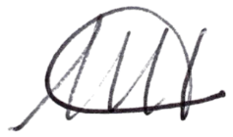
I, Melissa Harris, the duly appointed Clerk of the Village of Nelsonville, attest that the attached Resolution was approved by a majority of members of the five-member Board of Trustees on the 14th day of September, 2022

MELISSA HARRIS VILLAGE CLERK

There being no further business, the meeting was adjourned at 7:31pm, upon motion of Trustee Campanile, seconded by Trustee Zhynovitch, all in favor.

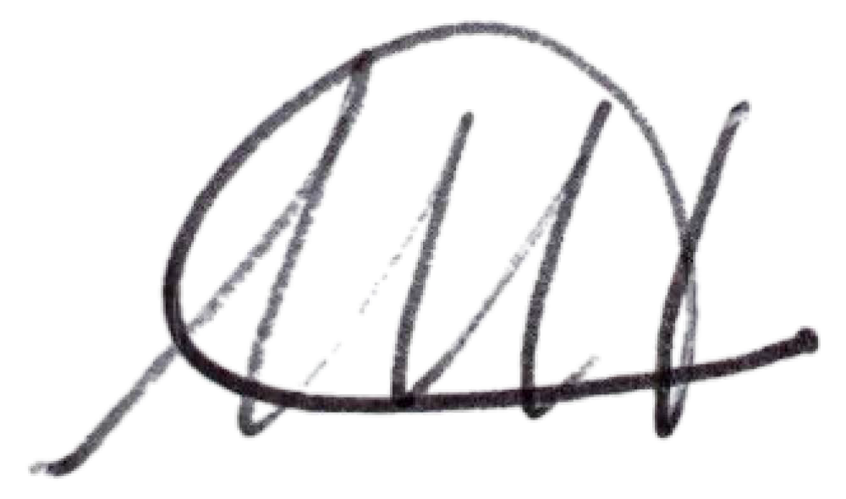
Respectfully submitted,

Melissa Harris Village Clerk

