The Village of Nelsonville Board of Trustees Meeting Minutes
Wednesday, December 17, 2025

THESE ARE NOT OFFICIALLY ADOPTED MINUTES AND ARE SUBJECT TO BOARD AND STAFF REVISIONS. ANY REVISIONS WILL APPEAR IN THE MINUTES FOLLOWING BOARD APPROVAL OF SAID MINUTES AT THE NEXT BOARD MEETING.

The Village of Nelsonville Board of Trustees met for a regular meeting on Wednesday, December 17, 2025, at 7:00 p.m. at Village Hall, with Mayor Winward presiding. Trustees Anderson, Moroney, Potts, and Zhynovitch were present.

Pledge to the Flag

The mayor led the Board in the Pledge of Allegiance.

Approval of Vouchers

Abstract #7 in the amount of $13,778.03 was audited and ordered paid by a motion from Trustee Moroney, seconded by Trustee Potts, carried all in favor.

Approval of Minutes
The minutes of the November 19, 2025 meeting were approved by motion from Trustee Zhynovitch, seconded by Trustee Anderson, carried all in favor.
Correspondence

Mayor Winward summarized correspondence received, including notification from Putnam County regarding a Climate Vulnerability Assessment survey seeking public input on flooding, severe winter storms, extreme heat, infrastructure issues, and power outages. The survey is available online and responses are due by January 5, 2026.

Mayor Winward also acknowledged receipt of a certificate from the Putnam County Executive recognizing the Village’s 170th Anniversary Celebration.

Reports
Clerk Harris
Clerk Harris read the Treasurers’ Report.

Village of Nelsonville
Treasurer's Report
30-Nov-25

*******************************************************************************
GENERAL FUND
Previous Balance
$541,336.92
Receipts:
Total $12,748.57

Disbursements:
Total $73,496.47

Current Balance $480,589.02

Checking Account $480,589.02
Savings Account $131,803.04

TOTAL $612,392.06

The Clerk also noted that Royal Carting holidays include Christmas and New Year’s Day, and that garbage collection for those weeks will occur on Saturday instead of Friday.

Mayor Winward

- Mayor Winward reported on the Village’s holiday tree lighting held on December 6, 2025, which was well attended.

-The mayor reported on the status of the Comprehensive Planning Grant application submitted earlier this year. She noted that the Village is awaiting notification of award determination from New York State, which is expected later in December.

-Mayor Winward reviewed the 2026-2027 Fiscal Year Village budget timeline, noting that budget review will begin in February 2026, the tentative budget will be presented at the March 2026 Board meeting, and a public hearing on the budget will be held in April 2026 to coincide with the regular April meeting. The final budget must be adopted by May 1, 2026.

Old Business

New Business Area Crosswalk Update and Discussion

Mayor Winward provided an update on discussions with the New York State Department of Transportation regarding the potential installation of a crosswalk near the bakery on Main Street/301. Mayor Winward explained that an engineered traffic study is required prior to submitting an application and stated that the estimated cost is $10,000. The mayor noted that grant money in the amount of $100,000 is available through Assemblywoman Dana Levenberg’s office, and the mayor is currently seeking clarification as to whether the cost of the required traffic study may be reimbursable under the grant. She advised that additional information will be brought back to the Board as it becomes available.

Code Review Update

Trustee Zhynovitch discussed progress on the Village Code Review, including proposed updates to modernize outdated provisions and consolidate redundant sections. Further review and discussion will continue at future meetings.

Gate House Road Trail Parking Update

Mayor Winward gave an update regarding Gatehouse Road trail parking, noting that the parking area remains closed due to safety concerns and the absence of a formal agreement with the property owner. Alternative trail access points remain available, and the Village will request that New York State Parks remove the parking area from online listings.

Open to the Floor

Residents of 36 Healy Road, William Ladd and Ashley Hernandez, asked the board if they would reconsider their request to put a stone wall overtop of the new guide rail in front of their home in the Village right of way. The board was in agreement that they stand by the Village attorney’s and engineer’s recommendation not to allow the alteration of the existing guiderail, and reminded them that the Village had previously offered to allow the residents to install landscaping in the Village right of way.

Adjournment

Upon motion of Trustee Moroney, seconded by Trustee Anderson, carried all in favor, the meeting was adjourned at 8:06 pm.

Respectfully presented,
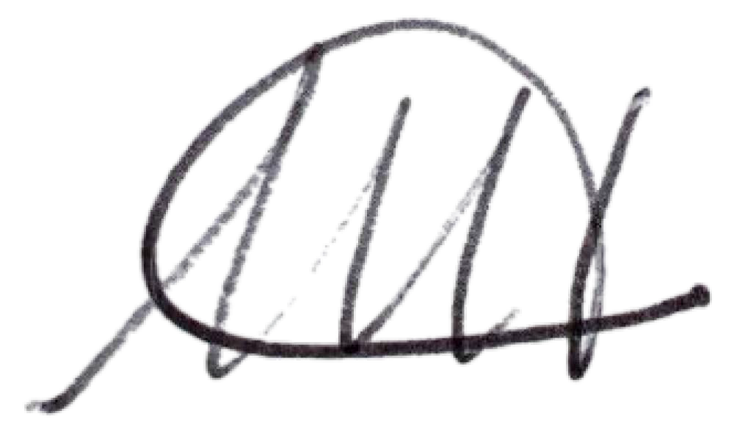
Melissa Harris
Village Clerk

