The Village of Nelsonville Board of Trustees Meeting Minutes
Tuesday, February 21, 2023

The Village of Nelsonville Board of Trustees, met at 7:30pm, on Tuesday, February 21, 2023, for their regular meeting, with Mayor Winward presiding, Trustees Campanile, Maloney, Moroney and Zhynovitch present.

Pledge to the Flag

Mayor Winward opened the meeting with the Pledge of Allegiance.

Approval of Vouchers

Abstract #9, in the amount of $20,653.60 was audited and ordered paid by a motion from Trustee Campanile, seconded by Trustee Moroney, enacted all in favor.

Approval of Minutes

The minutes of the January 14, 2023 meeting were approved by a motion from Trustee Zhynovitch, seconded by Trustee Moroney, enacted all in favor.

Correspondence

The mayor summarized a letter from Village resident Guy Lester, who requested that the Village investigate the installation of a crosswalk at the entrance to the Billy’s Way subdivision.

Reports

Clerk Harris

Clerk Harris read the Treasurers’ Report.

31-Jan-23
GENERAL FUND
Previous Balance | $359,443.33
Receipts:  Buildings | $761.00
Firehouse | $0.00
Interest | $240.07
Property Taxes | $0.00
Penalty | $0.00
Fire Inspection Fees | $450.00
STR Licenses | $0.00
Justice Court | $660.00
Pearl St. Sewer | $3,336.72
Other Unclassified | $15.00
Gov Grant - ARPA | $31,945.00
Total | $37,407.79
Disbursements: Payroll #1 | $6,354.52
Abstract #8 | $14,004.88
Total | $20,359.40
Current Balance | $376,491.72 (checking)
Savings Account | $92,245.81
TOTAL | $468,739.15

Mayor Winward reported that a joint meeting with the Town of Philipstown, the Village of Cold Spring, and the Village of Nelsonville will take place on Wednesday, February 22 at 7:30pm to discuss Central Hudson billing issues. PULP (Public Utility Law Project) is running an investigation and pursing a lawsuit into Central Hudson billing practices, and will give a brief summary of their findings. They are also asking for feedback from residents. This will be live streamed, but not Zoomed, so there will be no remote public participation. The Nelsonville Board of Trustees will be attending, and the Board will hear the Town’s resolution at the next board meeting.

The mayor also reported that the Draft Budget Workshop will be held on Wednesday, March 8 at 7:00pm.

Finally, Mayor Winward reported that Bob Lusardi, the Village Attorney, will be retiring after almost 40 years of service to the Village. The mayor and Trustee Zhynovitch have compiled a list of law firms and will be interviewing in the coming months.

Trustee Moroney

Trustee Moroney reported that the Nelsonville Woods kiosk repairs are coming along, with the roof partially completed. The repairs are being done by a local resident, who is hoping to attain his Eagle Scout rank by completing the project. It should be done in the next few weeks.

Trustee Moroney also reported that the entry way step at the Village Hall front door has begun to decay, posing a hazard. The step has been temporarily covered in plywood, and will be rebuilt and painted.

Trustee Moroney reported that the muddy portion of the Nelsonville Woods trail will be graveled when the mud dries out a bit, so that the area that tends to stay muddy can be identified and the gravel spread by Marc’s Landscaping.

Finally, Trustee Moroney reported that the problematic oak tree on North Pearl will be cut in the spring by Ian Kingsley, a local arborist with whom Mayor Winward met to discuss the situation. When a resident asked why the tree is being cut down, the mayor stated that, in Mr. Kingsley’s opinion, the tree has outgrown the space between the curb and the sidewalk, and poses a potential hazard to the adjacent home. Ian Kingsley will also be cleaning up the trees in Village Green. Trustee Moroney also reported that Central Hudson should be assessing the 3- 4 poles with wires that have tree limbs overhanging or entwined with them. The clerk will follow up to be sure that they are coming out to assess.

New Business
Reappoint ZBA Members
Upon motion from Trustee Moroney, seconded by Trustee Maloney, enacted all in favor, the following Zoning Board of Appeals members were reappointed for a two-year term:
- William Rice, Chair
- Stephen Merando
- Judy Meyer

Appoint Alternate Election Inspector

Upon motion by Trustee Campanile, seconded by Trustee Moroney, enacted all in favor, Donna Steltz was appointed as Alternate Election Inspector.

Prosecutor for Justice Court Vehicle and Traffic

Mayor Winward explained that there is a need for a prosecutor in the Village Justice Court. There has been some difficulty getting Putnam County Sheriff’s Deputies to serve in the role. The mayor, along with Trustee Moroney, met with Sheriff McConville and other representatives of the PCSO, and they suggested that the Village hire a prosecutor to work with defendants and offer pleas prior to going before the judge. The is an individual identified for the role, and the process to hire has begun. The cost will be approximately $125.00-$140.00 per hour, and the cost will be met by fine revenue. The mayor is hoping to have the prosecutor in place in time for the March Vehicle and Traffic Court, which will be held on March 27, 2023.

Old Business

Sewer Feasibility Study
Mayor Winward recapped the information regarding the Sewer Feasibility Study, which was summarized at the last board meeting. After reviewing federal guidelines, it has been determined that the Village needs two quotes for the project, one being form a woman/minority owned company. The mayor and Trustee Moroney will be meeting with the second firm next week.

Code Update

Mayor Winward stated that codifying the outdated Village Law is a priority project. Law firms, residents and others need access to an updated version. General Code has given the board an overview of the scope of the project, including an analysis of what can be edited and fixed within the outdated code. Once completed, in addition to two hardbound copies of the update Village Code, the code will be available in an online format called E-Code 360, with the first year’s cost included. After that, the cost would be approximately $1,100.00 per year. Trustee Zhynovitch explained that although the electronic platform could be useful, the Village does not pass that many laws, therefore it would be hard to justify the cost. There would also be an additional update fee when new laws are passed. Mayor Winward explained that the cost to update the Village Code would be spread over two fiscal periods, as the project can take a year or more to complete. She stated there is money for this project in the fund balance, and ARPA funds could be used to reimburse. There was a discussion among the board members, with Trustee Maloney asking for some more information before the board moved on the approval.
The matter will be table until the next board meeting.

Open to Floor

A resident stated that there is now an Environmental Club at Haldane, and the group would like to have an invasives removal event, as well as do some planting in the Nelsonville Woods. She would like to assist the group in scheduling a date for this, and stated that she will provide Mayor Winward with contact information. She also asked if the Village would be able to assist with the crossing of amphibians at the top of Fishkill Road. Mayor Winward stated that, as much as the Village supports this endeavor, it is out of the Village’s jurisdiction, and suggested that the Town of Philipstown be contacted.

Adjournment

Upon motion of Trustee Moroney, seconded by Trustee Maloney, enacted all in favor, the meeting was adjourned at 8:41pm.

Respectfully presented,
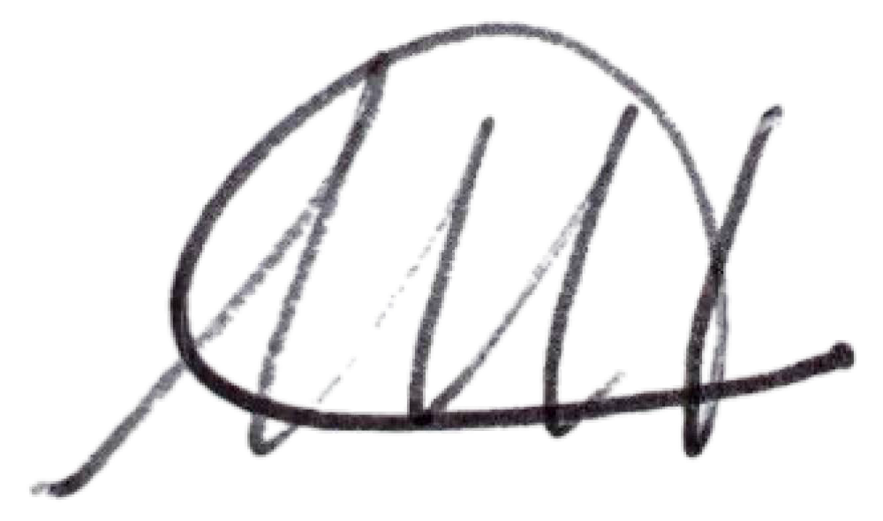
Melissa Harris Village Clerk

