The Village of Nelsonville Board of Trustees Meeting Minutes
Monday, March 20, 2023

The Village of Nelsonville Board of Trustees met at 7:30pm, on Monday, March 20, 2023, for their regular meeting, with Mayor Winward presiding, Trustees Campanile, Maloney, Moroney and Zhynovitch present.

Pledge to the Flag

Mayor Winward opened the meeting with the Pledge of Allegiance.

Approval of Vouchers

Abstract #10, in the amount of $12,850.06 was audited and ordered paid by a motion from Mayor Winward, seconded by Trustee Campanile, enacted all in favor.

Approval of Minutes

The minutes of the February 21, 2023 meeting were approved by a motion from Trustee Moroney, seconded by Trustee Maloney, enacted all in favor.

Correspondence

The mayor summarized a letter from Village resident Heidi Wendel asking that the oak tree on North Pearl Street not be removed. Mayor Winward stated that she is game to have another expert weigh in. The mayor then gave a brief history of the issues with the tree. She stated that the Village attorney’s recommendation is to take the tree down, and she is hard pressed not to take legal advice.

Mayor Winward summarized another letter from resident Jeanne Stauffer-Merle regarding the clear cutting of trees on the Downey commercial property located at 3 Brook Street. Mayor Winward stated that she called the DEC, who sent investigators and have reported that they will be sending a wetlands specialist to meet with Mr. Downey to discuss any further plans for the property.

The mayor summarized a letter from the Putnam County Youth Bureau regarding the Pegasus Program, which helps youth struggling with drug and alcohol dependence within their families.

Lastly, the mayor summarized a notice from the NYS Department of Public Service regarding the addition of a new area code for the region.

Reports

Clerk Harris

Clerk Harris read the Treasurers’ Report.

Village of Nelsonville
Treasurer's Report
28-Feb-23

***********************************************************************************************
GENERAL FUND
Previous Balance | Receipts: |  |  |  | $376,491.72
 | Buildings |  | $150.00
 | Firehouse |  | $2,600.00
 | Interest |  | $214.27
 | Property Taxes |  | $0.00
 | Penalty |  | $0.00
 | Fire Inspection Fees |  | $150.00
 | STR Licenses |  | $0.00
 | Justice Court |  | $545.00
 | Pearl St. Sewer |  | $1,112.24
 | Franchise Fees |  | $3,599.00
 | Total |  | $8,370.51
Disbursements:

Payroll #2 $6,820.76
Abstract #9 $20,653.60
Total $27,474.36
Current Balance $357,387.87

Checking Account |  | $357,387.87
Savings Account |  | $92,316.60
 | \
TOTAL |  | $449,704.47

Mayor Winward

Mayor Winward reported on the hiring status for the Village Justice Court prosecutor, who will be prosecuting vehicle and traffic tickets. The Putnam County Sheriff’s Office deputies were previously coming to court to handle their tickets, but Sheriff McConville suggested that the Village hire a prosecutor as that is common practice in other municipalities in Putnam County. The hiring process is almost complete, and the prosecutor will be a part time position. The mayor is hopeful that this hire will benefit the Village, not only in fine revenue, but by deterring speeding.

The mayor stated that, although she had already reported on the Downey property when summarizing the related email, there has also been discussion about the possibility of Mr. Downey putting a driveway to his property off of Peekskill Road. Mayor Winward stated that there has been no official filing for permits, and this is a process that would have to go before the Planning Board.

Mayor Winward reported that she, Mayor Foley of Cold Spring, and Supervisor Van Tassell of the Town of Philipstown met with Lieutenant Governor Delgado. The mayor brought up the need for funding for a sewer in Nelsonville, as well as concerns about Governor Hocul’s Housing Compact. She stated that affordable housing is important, but it is not worth the Village losing its independence.

The mayor then reported that there will be a joint meeting of the three municipalities to discuss the proposed Fjord Trail. She stated that residents haven’t felt heard, and this will be an opportunity for them. The meeting will be held at Haldane. Mayor Winward will find out if RSVP will be necessary. She recommended that residents provide written testimony to include in the record.

Trustee Zhynovitch

Trustee Zhynovitch reported that there will be an Earth Day nature walk in the Nelsonville Woods on Sunday, April 16 with educator Peter Cutul. He will identify flora, fauna, and wildlife. Meetup is at 1:30pm at the Pearl Street trailhead.

Trustee Zhynovitch also reported that Sustainable Putnam, who educates residents on all things sustainable, has been invited to speak before the board meeting at 7pm on April 17, regarding solar panels. A representative will be able to walk residents through the process of solarizing.

Trustee Moroney

Trustee Moroney reported that the yard debris pick-up will be Saturday, May 13, and reminded residents that large branches and tree limbs are not allowed. The Royal Carting bulk trash pick-up will be Friday, June 9. A list of acceptable items will be sent out via email by the clerk, and posted on the website and Village Facebook page.

Trustee Moroney also reported that the stair rails on the front steps of Village Hall are in bad shape and need to be replaced as soon as possible. He is awaiting an estimate from a local contractor. He stated that the kiosk project has been completed by the Eagle Scout candidate, Edward Bauer. The plexiglass was reversed and looks brand new, and the area surrounding the kiosk was mulched. Trustee Moroney assisted Edward, and Mayor Winward thanked other community members that contributed time and materials to the project. Trustee Campanile stated that Edward will receive his Eagle Scout rank next month.

New Business

Real Property Tax Service Contract Resolution

At a regularly scheduled meeting of the Nelsonville Village Board on Monday, March 20, 2023, the following resolution was introduced by Trustee Zhynovitch, seconded by Trustee Campanile, enacted all in favor, none opposed:

“That the Village Board hereby authorizes Mayor Winward to enter into an agreement with the County of Putnam for the purpose of printing our tax bills.”

Mayor Winward Aye
Trustee Campanile Aye
Trustee Maloney Aye
Trustee Moroney Aye
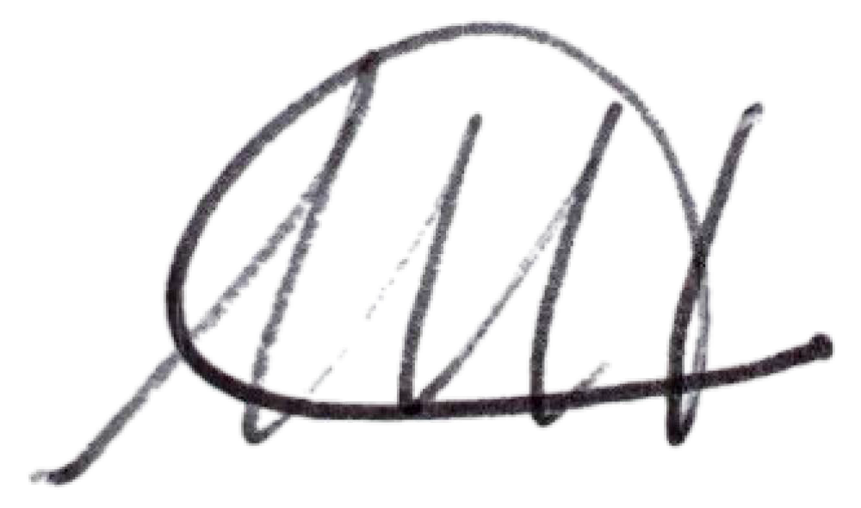
Trustee Zhynovitch Aye

Melissa Harris Village Clerk

Nelsonville, New York
March 20, 2023

Adopt Tentative 2023/2024 Budget

Mayor Winward reviewed the budget schedule, and went over the changes to the tentative budget that were discussed at the budget workshop, including the addition of a Buildings Maintenance line. The mayor filled out the tax cap form with the NYS Comptroller’s office, and the maximum tax cap that the Village can utilize is 3.4%, and the recommended minimum is 2.53%. The tentative budget utilizes a 2.99% tax cap. The official budget hearing will be held on Wednesday, April 12 at 7:00pm. Upon motion by Trustee Moroney, seconded by Trustee Campanile, enacted all in favor, the tentative budget for the fiscal year 2023/2024 was adopted.

Internal Audit

On February 24, 2023 Trustee Campanile performed and internal review of the Village finances, acting solely in his individual/personal capacity, as Trustee of the Village of Nelsonville.

Trustee Campanile reported that he looked at disbursements for June, 2022, and tied the vouchers for that month to the abstract, checkbook and payroll ledger. He stated everything looked clean. His recommendation is that an officer of the Village perform this review a few times a year.

Old Business

CCA

Mayor Winward stated that two years ago, the Village was going to enter into an agreement with Joule for alternative power supply, but the pricing was not favorable. Currently, Nelsonville has the option to join with 13 other municipalities now vying for an alternative to Central Hudson’s electricity supply. Joule has sent out Requests for Proposals, and will inform us of the options when the RFP comes back. There are two types of product rates; fixed and variable, and three options for electricity sourcing; conventional (standard option), 100% NYS certified renewable, and a 50/50 split of NYS renewable and conventional. The Village would then decide what would be the default option. Residents can choose for themselves, but the default would automatically be opted into unless residents opt out. There will be a special meeting on Thursday, March 23 via Zoom with Glenn Weinberg from Joule.

Central Hudson Billing Issues Resolution

The Villages of Nelsonville and Cold Spring, and the Town of Philipstown, held a joint meeting at Town Hall on March 2, where a representative of PULP (Public Utilities Law Project) heard the concerns of Central Hudson customers who are being affected by billing issues. The Village is lending support by approving the following resolution:

Resolution in support of actions by the New York State Public Service Commission and
New York State Senate Committee on Investigations and Government Operations to address harms caused to Village of Nelsonville Central Hudson utility customers as a result of widespread billing problems

WHEREAS, the Village of Nelsonville is located in the service territory of the Central Hudson Gas & Electric Corporation ("Central Hudson"); and

WHEREAS, Central Hudson is the only regulated transmission and distribution utility serving the Village of Nelsonville as a provider of electric and natural gas; and

WHEREAS, the Village of Nelsonville values the work of Central Hudson in maintaining transmission lines and restoring electricity to residents from downed lines as quickly as possible; and

WHEREAS, residents of the Village of Nelsonville have been experiencing problems with the bills issued by Central Hudson for utility service, such as receiving no bills for several months at a time, receiving multiple bills per month with different amounts due, and issues with estimated billing, inaccurate billing, budget billing, and uncharacteristically high bills; and

WHEREAS, these billing problems have caused confusion, frustration and financial hardship for Village residents; and

WHEREAS, Central Hudson has often failed to satisfactorily address these billing problems; and

WHEREAS, the said billing problems been experienced by customers throughout the Hudson Valley within Central Hudson’s service territory resulting numerous complaints being filed with the New York State Public Service Commission ("PSC"); and

WHEREAS, the PSC launched three investigations into Central Hudson in 2022, with one investigation focused on customer service and billing issues; and

WHEREAS, the PSC released an investigative report in December of 2022 that determined that the said problems in billing are a direct result of Central Hudson’s upgrade to its customer information and billing system on September 1, 2021; and

WHEREAS, the PSC's said report found that Central Hudson put its "upgraded" customer information and billing system into operation despite having information indicating that (1) deficiencies in training, testing, and overall readiness rendered the system incapable of handling complex billing scenarios, and (2) the system still contained hundreds of programming errors and defects; and

WHEREAS, the PSC report found that Central Hudson affirmatively represents that it has spent over $88 million dollars on this "upgrade" to its customer information and billing system and it is estimated that Central Hudson’s ratepayers will have paid $21 million dollars toward the project through increased billing fees through June 30, 2023; and

WHEREAS, the New York State Senate Committee on Investigations and Government Operations report states that the committee will monitor the enforcement proceedings and assess if clarifying legislation is needed to ensure proper penalties are levied and funds are redirected back to customers harmed by systematic billing failures;
NOW, THEREFORE, BE IT RESOLVED, as follows:
1. That the Village Board encourages Village residents who have experienced billing problems with Central Hudson, and who have unsuccessfully tried to resolve such problems with Central Hudson, to file a complaint with the New York State Department of Public Service’s Office of Consumer Services, and, thereby, to seek direct resolution of their individual customer problem or concern;
2. That the Village Board supports the PSC taking action to ensure that no further money be collected from Central Hudson ratepayers for the failed upgrade to its customer information and billing system; and
3. That if the PSC determines that imposition of fines against Central Hudson are justified, the Village Board supports the PSC imposing such fines and remitting the funds generated thereby to customers of Central Hudson who have been harmed by the aforesaid billing problems; and

4. That the Village Board supports the New York State Senate Committee on Investigations and Government Operations adopting legislation, if necessary, to ensure proper penalties are levied against Central Hudson and funds are redirected back to customers harmed by systematic billing failures; and

5. That a certified copy of this resolution shall be sent to the PSC, the New York State Senate Committee on Investigations and Government Operations, and the Village’s State Senator and Assemblymember.

Mayor Winward presented the foregoing resolution which was seconded by Trustee Zhynovitch.

The vote on the foregoing resolution was as follows:

Trustee Campanile voting Aye

Trustee Maloney voting Aye

Trustee Moroney voting Aye

Trustee Zhynovitch voting Aye

Mayor Winwared voting Aye

General Code Agreement Approval

Mayor Winward gave a recap of the Village Code update needs. Upon motion by Trustee Campanile, seconded by Trustee Moroney, enacted all in favor, the General Code agreement was approved.

NYSDOT Speed Study Update

Mayor Winward stated that back in the summer, the Village Board asked the NYS Department of Transportation to lower the speed limit on Route 301 from 55mph to 45mph. The Town of Philipstown sent a resolution to the DOT in support of this, as the area is in Philipstown. The DOT has responded with the results of their Speed Study to reduce the speed from 40 to 30mph starting at the Nelsonville Village line. For this study they state that data shows road conditions do not support a lower speed limit, with no crash history in six years. The request to reduce the speed limit from 55 to 45 is still outstanding. The mayor stated that they did repaint the two crosswalks in the Village. She also stated that the Village will be submitting applications for flashing crosswalk signs and radar speed signs.

Sewer Feasibility Study
Mayor Winward recapped the information regarding the Sewer Feasibility Study, which was summarized at the last board meeting. ARPA funds from Putnam County will be used to pay for the study, for a total of $26,500. The mayor stated that there were two firms who gave proposals for the study, and Trustee Zhynovitch stated that one firm was the clear winner, with the expertise in this area. The firm, Labella, has a long history and track record, and has the ability to assist with grant writing. They have assured the board that they will work with the Village to secure streams of funding for a sewer project. Upon motion by Mayor Winward, seconded by Trustee Moroney, enacted all in favor, the Board approved the mayor to contract with LaBella Associates to conduct the Sewer Feasibility Study.

Open to the Floor

A resident asked if some homes will be exempt from a potential sewer system. Mayor Winward stated that homes zoned Mountain Residential would not be hooked up in the initial stage. Trustee Moroney added that it would be properties on the Cold Spring water lines.

There were some other questions/comments regarding the potential sewer project, as well as some discussion on speed limits and crosswalk. A resident asked for some clarification on the North Pearl Street oak tree. Finally, there were questions related to the Downey property. Mayor Winward stated that she will keep residents informed of any updates from DEC.

Adjournment

Upon motion of Trustee Moroney, seconded by Trustee Maloney, enacted all in favor, the meeting was adjourned at 9:19pm.

Respectfully presented,
Melissa Harris
Village Clerk

