The Village of Nelsonville Board of Trustees Meeting Minutes
Monday, October 16, 2023

The Village of Nelsonville Board of Trustees met at 7:30pm, on Monday, October 16, 2023, for their regular meeting, with Mayor Winward presiding, and Trustees Biro, Moroney and Zhynovitch present. Trustee Campanile was absent.

Pledge to the Flag

Mayor Winward opened the meeting with the Pledge of Allegiance.

Approval of Vouchers

Abstract #5 in the amount of $16,320.74 was audited and ordered paid by a motion from Trustee Biro, seconded by Trustee Moroney, motion carried four in favor, one absent.

Approval of Minutes

The minutes of the September 18, 2023 meeting and the minutes of the September 28, 2023 Special Meeting were approved by a motion from Trustee Moroney, seconded by Trustee Zhynovitch, motion carried four in favor, one absent.

Correspondence

Mayor Winward summarized the following correspondence:

- Haldane School Foundation re: Turkey Trot – Trustee Biro motioned to approve, seconded by Trustee Moroney, motion carried four in favor, one absent.
- NYS Dept of Public Service re: Public Hearing on amendments filed by Central Hudson to increase annual electric delivery revenue 10/17 and 10/18

Reports

Clerk Harris

Village of Nelsonville
Treasurer's Report
30-Sep-23

***********************************************************************************************
GENERAL FUND
Previous Balance $464,138.87

Receipts:
Total $6,510.79
Disbursements:
Total $69,451.66

Current Balance $401,198.00

Checking Account $401,198.00
Savings Account $125,153.96
\
TOTAL $526,351.96

Mayor Winward

Mayor Winward reported that an Eagle Scout candidate, Daniel Campanile, installed a new flagpole, cleaned up the kiosk, and took down the juniper tree in Village Green. She plans to ask the Philipstown Garden Club to help design a flower bed where the juniper was.

The mayor stated that there was a good turnout for the Potluck Picnic, held on the rain date of Sunday, October 8. She stated that next year she may consider holding the picnic earlier, at the end of September.

Mayor Winward stated that there will be a draft sewer study workshop next month, or perhaps it will be built into the regular meeting, and LaBella Associates will give a presentation and answer questions.

Trustee Moroney

Trustee Moroney reported that leaf pick-up will be between 11/13 – 11/17. He also reported that gravel was placed on the muddy section of the Secor trail head and in the “Y”, and stated that it has been a muddy year. He also stated that Marc’s crew will fill the potholes on Village streets before winter, and lastly, he reported that low tree limbs on Pearl Street were trimmed and cut back.

Old Business

July 9-10th Storm Damage Repair Updates

Mayor Winward reported that repair on the drain on Healy Road began, and 300’ of Healy Road will be paved with temporary blacktop, approved by FEMA, to get through the winter. Bank Street was temporarily repaired, and the trail debris on the Yellow Trail will be cleared. She stated that she went to the trail with the representatives from the NY/NJ Trail Conference for their input, and has had weekly calls with FEMA, working through the different damage categories to get reimbursement as soon as possible.

Approve FEMA Consultant

Mayor Winward stated that the Village had an RFP out, and received two proposals for a FEMA consultant. One of the proposals was received from Meridian Strategic Services, first introduced by the county after the July storms, to help municipalities navigate the process of reimbursement. The mayor stated that they helped us pro bono, especially to set up process-wise getting the engineering RFP out quickly. They were the lower cost bid, and the mayor stated that they are the most professional consultant she has worked with in the last decade, and she could not recommend them more. Mayor Winward stated that the cost of the consultants is reimbursed 100% by FEMA, and she added that as a bonus, no matter who is mayor in the coming years, in what will be a multi-year FEMA process, this consultant will ensure continuity. The mayor then read the resolution to approve Meridian Strategic Services, and upon motion by Trustee Moroney, seconded by Trustee Biro, the motion to approve the resolution carried four in favor, one absent.

RESOLUTION

WHEREAS, the Village of Nelsonville solicited proposals for a professional consultant to assist in the management and coordination of disaster recovery grant funding from the Federal Emergency Management Agency (FEMA) in response to the severe storm and flooding event, DR-4723, that occurred on July 9-10, 2023 by Request for Proposals (RFP), RFP #2023-2, which had a proposal deadline date of September 27, 2023;

WHEREAS, the Village of Nelsonville timely received a Proposal from, among others, Meridian Strategic Services, Inc., located at P.O. Box 158, Esopus, NY 12429;

NOW, THEREFORE, BE IT RESOLVED, that, pursuant to such Proposal, the Board of Trustees of the Village of Nelsonville hereby approves a certain Consulting Agreement with Meridian Strategic Services, Inc., and hereby authorizes the Mayor to execute such Consultant Agreement; and

BE IT FURTHER RESOLVED, that the Mayor is hereby authorized to take all actions necessary for the Village to act in accordance with its obligations and/or rights under such Consulting Agreement.
The foregoing resolution was voted upon with all members voting follows: Mayor Winward Aye
Trustee Biro Aye
Trustee Campanile Absent
Trustee Moroney Aye
Trustee Zhynovitch Aye

Certification

I, Melissa Harris, the duly qualified Village Clerk of the Village of Nelsonville, Putnam County, New York, do hereby certify that attached hereto is a true and correct copy of the extract from the minutes of a Monthly Meeting of the Board of Trustees of the Village of Nelsonville, held on October 16, 2023 and that the Resolution set forth herein is a true and correct copy of the Resolution of the Board of Trustees of said Village adopted at said meeting.

I FURTHER CERTIFY that pursuant to section 103 of the Public Officers Law (Open Meetings Law), said meeting was open to the general public.
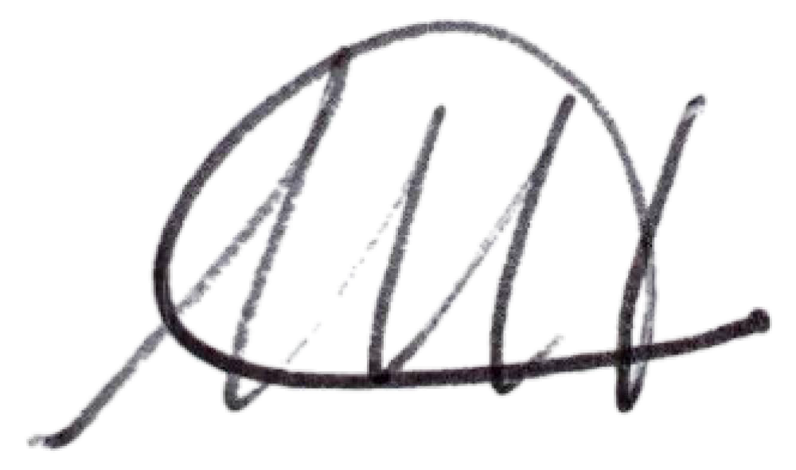
IN WITNESS WHEREOF, I have hereunto set my hand and the seal of the said Village on this 16th day of October, 2023.

Melissa Harris Village Clerk

Trail Crossings

Mayor Winward stated that when she went in to the woods with the representatives from the Trail Conference, she pointed out where the rock crossings are needed on the Green and Blue Trails. She and Trustee Campanile have taken the wooden bridge off the Blue Trail, as it was broken and dangerous. The Trail Conference will do a stone crossing there.
NYS DOT Permits for Flashing Crosswalks and Speed Radar Signs Updates

Mayor Winward stated that she received a letter from the NYS DOT, saying no to a request the Village put in a year ago to reduce the speed limit coming down Route 301, west into Nelsonville. The request was denied because there have been no deaths in the last six years.

Trustee Zhynovitch stated that she has been working on getting quotes for flashing speed radar signs, and flashing pedestrian crosswalk signs for the crosswalks at Pearl Street and Peekskill Road. The pedestrian signs will be solar powered, and the Village can pick the location for the speed radar signs. Ideally, one would face east at the entrance to the Village on Route 301, and the other would face west near the Frost property. She stated that the signs do collect data, but it is just speed data, and license plate data is not collected. The Village can access the data to see if the signs are providing traffic calming. Poles for the pedestrian signs are expensive, so it has been suggested to Trustee Zhynovitch to use existing or purchase them locally. All in, the expense looks to be about $15-20K for all the signs. NYS DOT will need the quotes and specs. She stated that she has consulted with the Village of Fishkill, and Nelsonville will be purchasing the same flashing signs, so there should not be too much of a problem with approval.

New Business

JCAP Court Grant Resolution

The clerk listed the potential projects for the court grant, as well as two completed projects the Village is hoping to get reimbursement for. Mayor Winward read the resolution to authorize the Nelsonville Justice court to apply for the grant. Upon motion by Trustee Moroney, seconded by Trustee Zhynovitch, the motion to approve the resolution was carried four in favor, one absent.
RESOLUTION
“RESOLVED, that the Nelsonville Village Board of Trustees hereby authorizes the Nelsonville Justice Court to apply to the Justice Court Assistance Program (JCAP) for up to the maximum JCAP award of $30,000 for courtroom and office improvements.”

Roll Call:

Mayor Winward Aye
Trustee Biro Aye
Trustee Campanile Absent
Trustee Moroney Aye
Trustee Zhynovitch Aye

I hereby certify that the above is a true copy of a resolution enacted by the Nelsonville Board of Trustees at a duly convened meeting held on October 16, 2023.
Melissa Harris
Village Clerk

Open to the Floor

There were no comments from the public.

Adjournment

Upon motion of Trustee Moroney, seconded by Trustee Biro, enacted all in favor, the meeting was adjourned at 8:31pm.

Respectfully presented,

Melissa Harris
Village Clerk

