The Village of Nelsonville Board of Trustees Meeting Minutes
Monday, March 18, 2024

The Village of Nelsonville Board of Trustees met at 7:30pm, on Monday, March 18, 2024, for their regular meeting, with Mayor Winward presiding, Trustees Biro, Campanile, Moroney and Zhynovitch present.

Pledge to the Flag

Mayor Winward opened the meeting with the Pledge of Allegiance.

Approval of Vouchers

Abstract #10, in the amount of $13,682.23 was audited and ordered paid by a motion from Trustee Zhynovitch, seconded by Trustee Campanile, enacted all in favor.

Approval of Minutes

The minutes of the February 20, 2024 meeting were approved by a motion from Trustee Biro, seconded by Trustee Moroney, enacted all in favor.

Correspondence

The mayor summarized an email from Village resident Heidi Wendel regarding ATV tracks in the Nelsonville Woods. The mayor stated that she spoke to State Parks the last time the Village was notified of ATV use in the woods, and it is difficult for them to catch. Heidi will follow up with the Parks Department. Mayor Winward then read the Rabies Vaccine Clinic flyer from the PCDOH. Lastly, she read the Nelsonville Fish and Fur Club’s notice regarding the Annual Kid’s Fishing Derby to be held on May 5, and their appeal for donations. Mayor Winward motioned to donate $500.00 towards stocking the reservoir with fish for the Derby, seconded by Trustee Biro, all in favor.

Reports

Clerk Harris

Clerk Harris read the Treasurers’ Report

Village of Nelsonville
Treasurer's Report
31-Jan-24

***********************************************************************************************
GENERAL FUND
Previous Balance $ 298,989.65
Receipts:
Total $10,765.94

Disbursements:
Total $36,451.10

Current Balance $273,304.49

Checking Account $273,304.49

Savings Account $126,524.34
\
TOTAL $399,828.83

Mayor Winward

Mayor Winward that she has been selected to the County Executive’s Review Committee, to review and advise on the county’s Mission Statement, Code and Charter.

New Business

Certificate of Appreciation to Eagle Scout Daniel Campanile

Mayor Winward commended Eagle Scout Daniel Campanile’s volunteer work in Village Green, which included cleaning the Korean War Veteran’s monument, installing a new flagpole, and the installation of historical photos in the kiosk. Trustee Campanile stated how proud he was that his son chose Nelsonville to do his Eagle Scout service project.

Real Property Tax Service Contract Resolution

At a regularly scheduled meeting of the Nelsonville Village Board on Monday, March 18, 2024, the following resolution was introduced by Mayor Winward, seconded by Trustee Moroney, enacted all in favor, none opposed:

“That the Village Board hereby authorizes Mayor Winward to enter into an agreement with the County of Putnam for the purpose of printing our tax bills.”

Mayor Winward Aye
Trustee Biro Aye
Trustee Campanile Aye
Trustee Moroney Aye
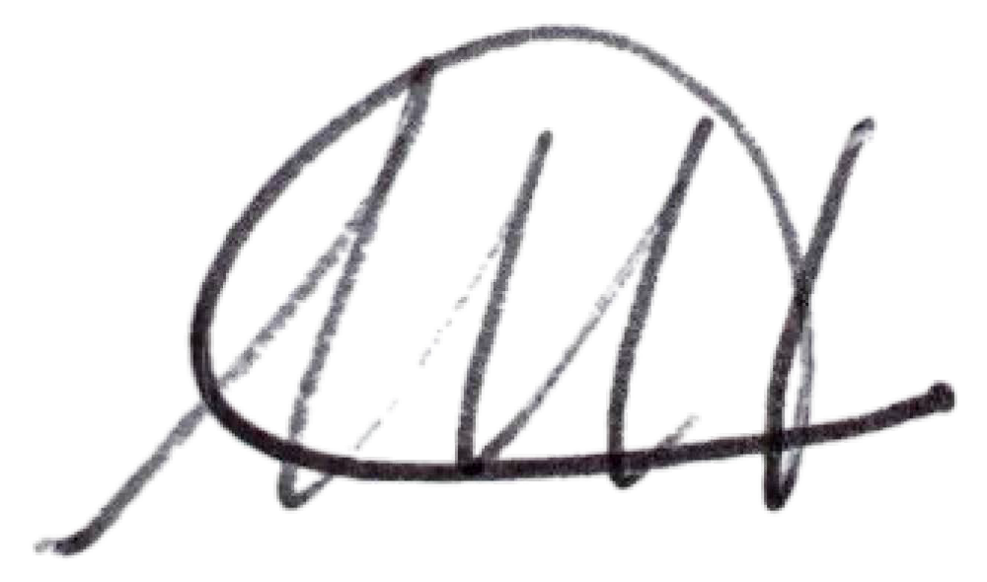
Trustee Zhynovitch Aye

Melissa Harris Village Clerk

Nelsonville, New York
March 18, 2024

Spring Street Safety

Mayor Winward stated that a resident informed the Village of a near accident at the corner of Secor and Spring Streets. She stated that the board is considering not allowing parking near the wine shop, as there is limited sight view at the turn. There was discussion among the board, with cutting of shrubs and installation of a mirror as possible remediation. The subject was tabled until the next board meeting.

Secor Street No Parking Signs

In a related matter, parking on Secor Street was discussed by the board. Mayor Winward pointed out an uptick of hikers driving and parking at the North Pearl Street trail head. She stated she would like to be prepared with signage for the next Breakneck closure, which will be around Thanksgiving of this year.

Safe Deposit Box

RESOLUTION

Resolution authorizing the current Mayor and Clerk as designated personnel to open the Village of Nelsonville safe deposit box at M&T Bank

WHEREAS, M&T Bank requires a resolution regarding the designation of the Village of Nelsonville personnel authorized to open and view the contents of safe deposit box L000152 at the Cold Spring bank branch;

WHEREAS, it is necessary to update the names and titles of those personnel authorized to open and view the contents of safe deposit box L000152;

NOW, THEREFORE, BE IT RESOLVED, that the Board of Trustees of the Village of Nelsonville authorizes Mayor Chris A. Winward and Village Clerk/Treasurer Melissa Harris
to open and view the contents of safe deposit box L000152.

The foregoing resolution was voted upon with all members voting as follows:
Mayor Winward AYE
Trustee Biro AYE
Trustee Campanile AYE
Trustee Moroney AYE
Trustee Zhynovitch AYE

Old Business

FEMA Storm Repairs Update

Mayor Winward stated that Pizzella Brothers began repair work on the Pearl Street drains. She stated she is meeting with the engineers tomorrow to go over hazard mitigation work and final approval. She stated that the state will be providing 12.5% of the 25% that is the Village’s responsibility, so approximately 88% of the total cost of repair and hazard mitigation will be covered. The mayor stated that CHIPS funding and direct federal APRP funds will help to fill the gap.

Code Review

The mayor stated that she and Trustee Zhynovitch have begun the review of the recommendations put forth by General Code, there being almost 100 questions for their review. She stated she and Trustee Zhynovitch are excited to modernize the code as they go, in addition to ensuring compliance with the state and have all laws updated in one place.

Adopt Tentative 2024/2025 Budget

Mayor Winward reviewed the budget schedule and the tentative budget for the 2024/2025 fiscal year, and went over a few changes to the tentative budget that were made since the last meeting, including a 6% raise for the clerk, who has taken on many responsibilities of the building department with the retirement of the Building Inspector. The deputy clerk will get a .50 per hour raise. The mayor noted the shifting of $2,500 from the Attorney Contractual Other/aka contingency line to the Attorney Contractual line, the increase in the Refuse Removal line due to the new contract, which was less than she had originally planned for, and the reduction in expenditures on the Building Inspector lines due to the retirement of the Building Inspector. The mayor explained some of the expenditures for the current fiscal year, including “parking” FEMA expenditures in the Street Maintenance Other line until reimbursement, and the Engineer line being utilized for the sewer study, which will also be reimbursed, by county ARPA funds. On the revenue side, the mayor noted the decrease in both franchise fees and mortgage tax. Mayor Winward stated that the Village would be utilizing the 3.44% tax cap for the approximately $10,000 increase, and noted that while she usually advocates for not takin the maximum tax cap, it will be wise to take it to help cover FEMA related work. The official budget hearing will be held on Wednesday, April 15 at 7:00pm. Upon motion by Mayor Winward, seconded by Trustee Moroney, enacted all in favor, the tentative budget for the fiscal year 2023/2024 was adopted.

Adjournment

Upon motion of Trustee Biro, seconded by Trustee Moroney, enacted all in favor, the meeting was adjourned at 8:43pm.

Respectfully presented,
Melissa Harris
Village Clerk

