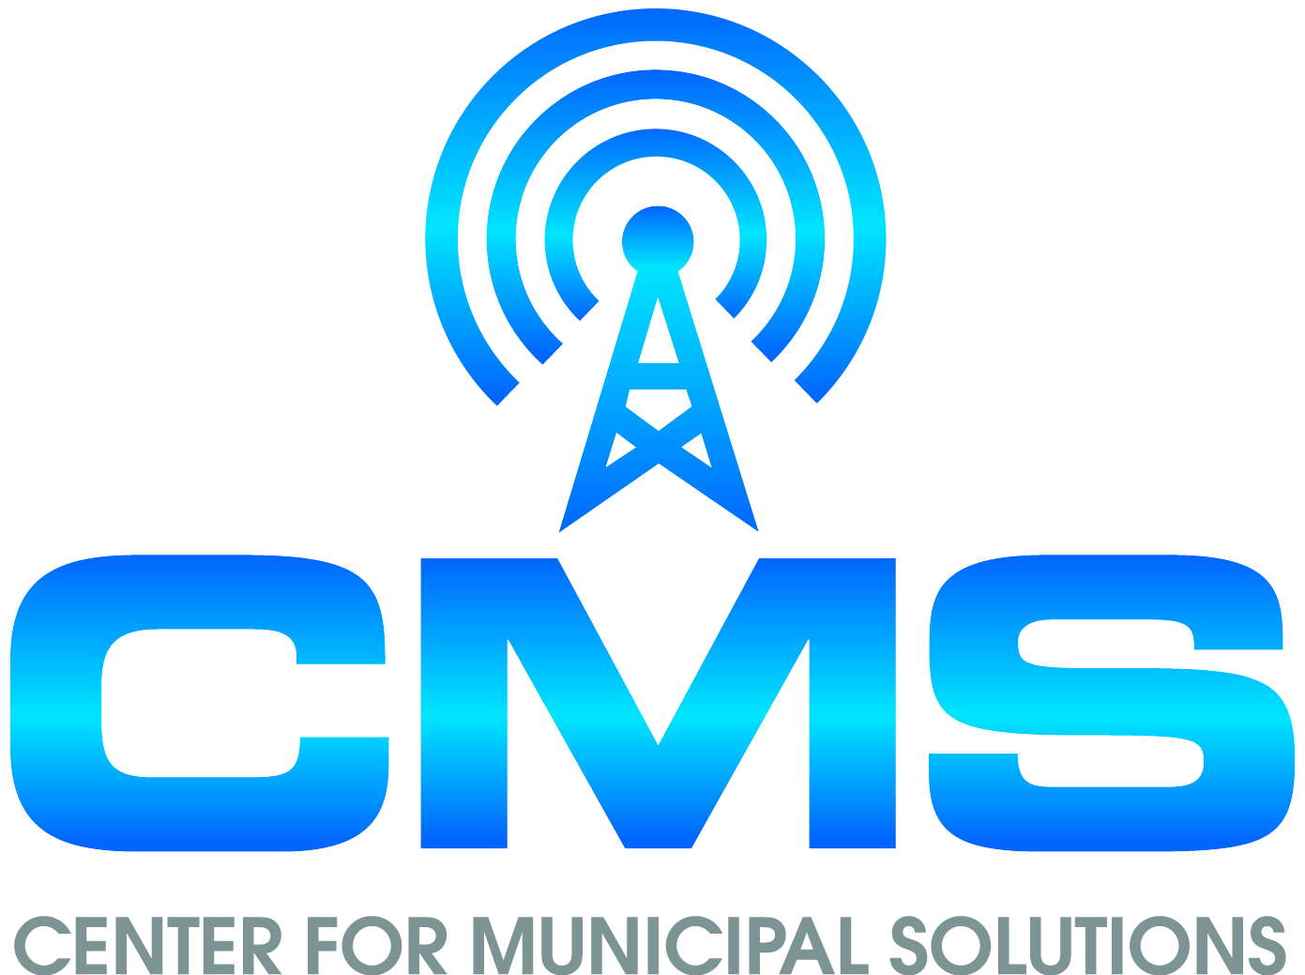
CENTER FOR MUNICIPAL SOLUTIONS
70 CAMBRIDGE DRIVE
(518) 439-3079 GLENMONT, NEW YORK 12077 FAX (518) 478-0909

January 8, 2018 (via e-mail and regular mail)

Zoning Board of Appeals/Planning Board
Village of Nelsonville, New York
258 Main Street
Nelsonville, NY 10516

Dear Board Members:

I have been retained by the Philipstown Cell Solutions Group to provide documentation to both of your Boards to assist so that you are able to make an informed decision on the application for a proposed new tower at15 Rockledge Road. I provided an overall report on December 29, 2017. In that report I stated;

No drive test data has been submitted by either carrier. Drive test data shows the actual service level at locations throughout the Village. Mr. Graiff in his December 9, 2017 submittal states “Such drive tests are nearly the “gold standard” for determining coverage be it existing or new.” It is the existing drive test results that should be provided by both carriers for the frequency bands they are stating will be at the proposed site, as well as the 850 MHz band.

I recently received some drive test material that I believe needs to be commented on.

Verizon had PierCon conduct a drive test in Nelsonville and the surrounding area on December 15, 2017. Verizon had PierCon conduct a drive test in Philipstown on February 20, 2017. Both tests are attached. Both tests were done in the winter. The tests have some overlapping areas. (Lane Gate road and near the junction of County Hwy 10 and State Hwy 301) The December 15, 2017 test for Nelsonville shows considerably less coverage. Why?

On page 8 of the December 2017 PierCon report, Mr. Feehan states “PierCon determined that a correction factor of 5 dB, which is the least conservative, is appropriate to correct measured signal levels due to foliage loss in this environment.” They offer no proof for this correction. The -5 dBm adjustment is a significant change in that every change of -3 dBm is a doubling of signal strength. Thus, a -5 dBm change is almost a 4-fold decrease in power. They apparently made no correction in the Philipstown test. Drive test data is supposed to be recorded data, not corrected data. For the maps to be useful, they should not be simply done at a fixed measurement with a yes/no binary analysis of whether the location signal strength exceeds a selected number they would show actual signal strength measurements at every location.
This is not valid drive test data and there is still no AT&T drive test data and no test for all frequency bands they are stating will be at the proposed site, as well as the 850 MHz band.

Sincerely,

R. A. Comi (electronic signature)
Richard A. Comi
CMS

CC: Philipstown Cell Solutions Group (via e-mail)
Todd Steckler, Esq. (via e-mail)

